PIZZA SALES SQL QUERIES

1. KPI’s
2. Total Revenue:

SELECT SUM(Total_Price) as TOTAL_REVENUE FROM DBO.PIZZA_SALES;

1. Average Order Value:

SELECT SUM(TOTAL_PRICE) / COUNT(DISTINCT ORDER_ID) AS AVERAGE_ORDER_VALUE FROM DBO.PIZZA_SALES;

1. Total Pizzas Sold:

SELECT SUM(QUANTITY) AS TOTAL_PIZZAS_SOLD FROM DBO.PIZZA_SALES;

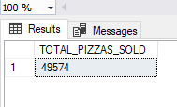

1. Total Orders Placed:

SELECT COUNT(DISTINCT ORDER_ID) AS TOTAL_ORDERS_PLACED FROM DBO.PIZZA_SALES;

1. Average Pizzas Per Order:

SELECT CAST(CAST(SUM(QUANTITY) AS DECIMAL(10, 2)) / CAST(COUNT(DISTINCT ORDER_ID) AS DECIMAL(10, 2)) AS DECIMAL(10, 2))

AS AVERAGE_PIZZAS_PER_ORDER FROM DBO.PIZZA_SALES;

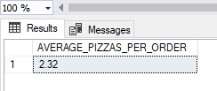

1. Charts
2. Daily Trend:

select DATENAME(DW, order_date) as order_day, count(distinct order_id) as total_order_per_day from pizza_sales group by DATENAME(DW, order_date);

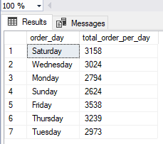

1. Hourly Trend:

select datepart(hour, order_time) as hour_order_time, count(distinct order_id) as hourly_order_count

from pizza_sales group by datepart(hour, order_time) order by datepart(hour, order_time);

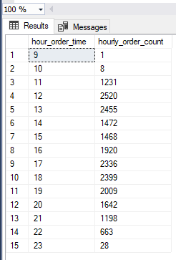

1. Percentage of sales by pizza categories:

select pizza_category, sum(total_price) as total_sales_category, cast(sum(total_price)*100 /

(select sum(total_price) from pizza_sales where MONTH(order_date) = 1) as decimal(10, 2))

as percentage_sales_by_category from pizza_sales where MONTH(order_date) = 1

group by pizza_category order by pizza_category;

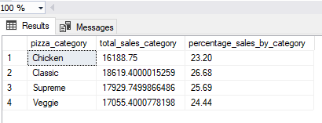

1. Percentage of Sales by pizza size:

select pizza_size, round(sum(total_price)*100 / (select sum(total_price) from pizza_sales), 2) as piza_size_sales

from pizza_sales group by pizza_size order by pizza_size;

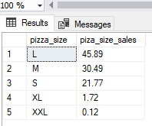

1. Total Pizzas Sold by Pizza Category:

select pizza_category, sum(quantity) as total_pizza_sold_category_wise from pizza_sales group by pizza_category order by sum(quantity) desc;

1. Top 5 best sellers pizzas in terms of total pizzas sold:

select top 5 pizza_name, sum(quantity) as pizza_count

from pizza_sales group by pizza_name order by count(pizza_name) desc;

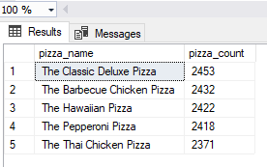

1. Top 5 worst sellers pizzas in terms of total pizzas sold:

select top 5 pizza_name, sum(quantity) as pizza_count

from pizza_sales group by pizza_name order by count(pizza_name) ASC;

