EXP: 2
Design a User Interface Prototype for a Mobile Station Using Figma
Aim
To design a user interface prototype for a Mobile Station using Figma, providing a simple, attractive, and user-friendly interface for mobile services.
Procedure
- Open the Figma website and create a new design file.
- Select the Frame tool and choose a mobile phone screen size.
- Design the home screen with a title, logo, and navigation menu.
- Add interface elements such as buttons, icons, text fields, and service options.
- Apply suitable colours, fonts, and layouts to improve the appearance.
- Create additional screens and connect buttons using Prototype mode.
- Test the prototype by clicking the buttons and checking the navigation between screens.
- Save the design and present the completed prototype.

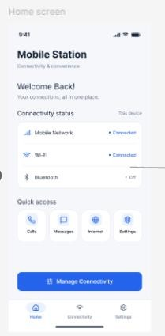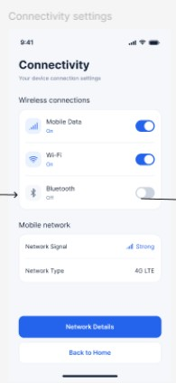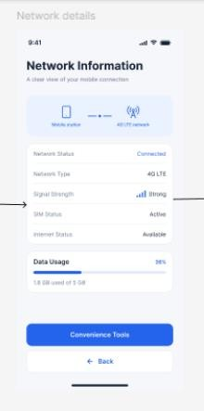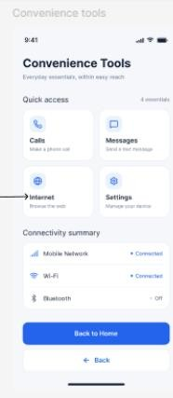

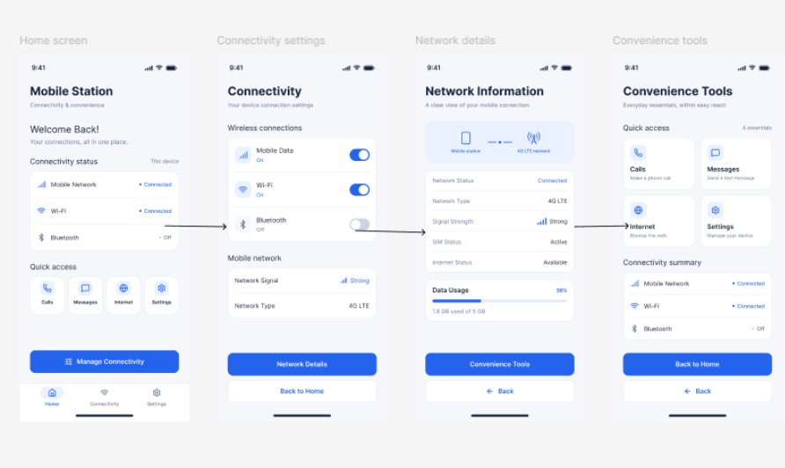

RESULT
Thus, a mobile station user interface prototype was designed using Figma, incorporating connectivity features and convenient navigation for an improved user experience.

