# Excitation propagation at myocardium modelled by a Cellular Automaton

Bioinformatics - Assignment

Authors: Anna Friedl, Kerstin Pegler, Ingo Weigel

## Anatomy and Physiology of the human heart and its conduction system

The human heart (Figure 1) has a heartbeat of 60 to 100 beats per minute, which is coordinated by the sine node. It is located between the Vena cava superior and the right atrium. By reaching a threshold potential of -40 mV (resting potential = -70 mV) an action potential is triggered starting the excitation propagation throughout the entire heart and initiating a heartbeat. Over the left and right atrium, the excitation propagates to the atrioventricular node. Expanding from there the depolarization travels through the his-bundle, left and right bundle branch and Purkinje fibers, finally reaching the myocardium. [1] [2]

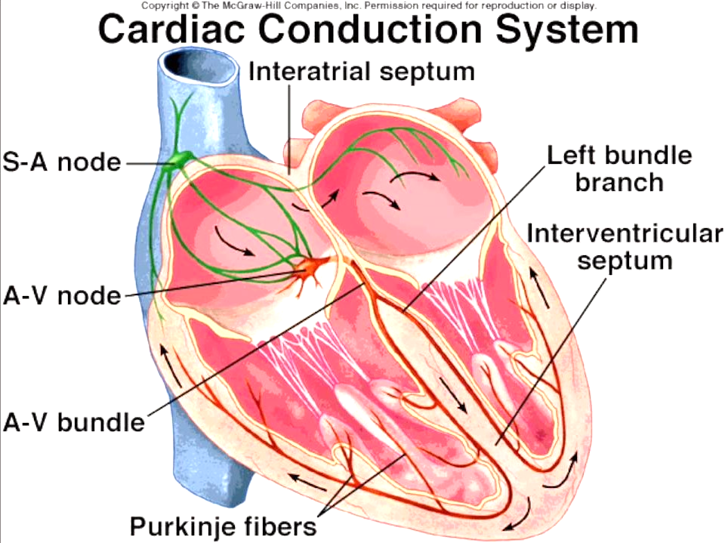

Figure 1: Anatomy of heart and its conduction system

Heart muscle cells are not isolated against each other and forward the stimulus through so called gap junctions. When an electrical impulse is given the entire heart reacts to it (all-or-nothing contraction). The excitation of the heart always goes from the inside to the outside and from the apex to the base of it. [3]

After the sine node was activated it takes a total of 225 ms for the impulse to reach every cell of the myocardium (Table 1). Each cell is depolarized for 200 ms and subsequently has a refractory period of 300 ms where it cannot be triggered by its neighbors again.

Table 1: Overview of excitation propagation of human heart in regard to the propagation time, speed and location.

|  |  |  |  |
| --- | --- | --- | --- |
|  | Time [ms] | Propagation Speed [m/s] | ECG |
| **Sine Node** |  |  |  |
| Impulse Creation | 0 | 0,05 | P – Wave |
| Impulse Arrival (right Atrium) | 50 | 0,8 – 1,0 in Atrium |  |
| Impulse Arrival (left Atrium) | 80 |  |
| **AV-Node** |  |  |  |
| Impulse Creation | 50 | 0,05 | P – Q Interval |
| Impulse Propagation | 125 |
| **His-Bundle activated** | 130 | 1,0 – 1,5 |  |
| **Bundle-Branch activated** | 145 | 1,0 – 1,5 |  |
| **Purkinje-Fibers activated** | 150 | 3,0 – 3,5 |  |
| **Myocardium** |  |  |  |
| Myocardium inside (right Ventricle) | 175 | 1,0 in Myocardium | QRS - Complex |
| Myocardium inside (left Ventricle) | 190 |
| Myocardium outside (right Ventricle) | 205 |
| Myocardium outside (left Ventricle) | 225 |

## Cellular Automata

Cellular automata (CA) describe collective dynamics of multiple party acting according to a specific rule. By creating an abstract computational system, complex systems (e.g. excitation propagation of heart) can be simplified and modeled through local interactions. CA patterns are often characterized by stable or oscillating structures running for a long period of time. It is comprised of numerous cells within a cellular space (grid) and is configured by the initial state. Cells take on a specific state each point in time and transit between them according to local rules. Each cell influences its neighborhood.

## Implementation

For the python implementation different classes were created: cell, heart, finite state automaton.

## Cell and Cell Space (class Cell and class Heart)

Since different anatomical and physiological structures are included into the excitation propagation of the heart these were also mapped in the CA (using Excel). As visible in Figure 2 each cell was colored according to its specific structure: purple – sine node, green – AV-node, blue – his-bundle, yellow – bundle branches, orange – Purkinje fibers, red – muscle cells, white – not-involved cell.

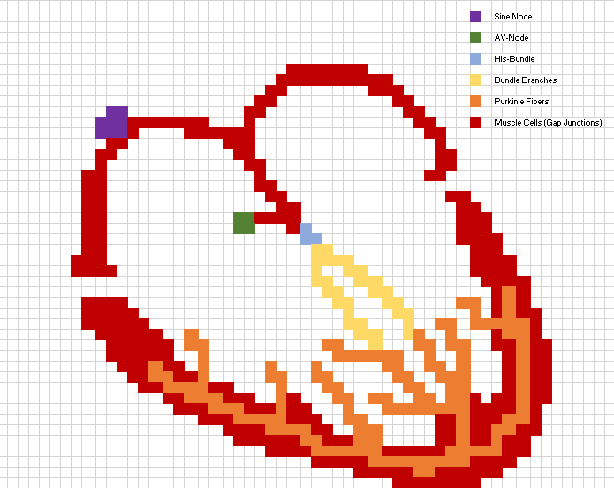

Figure 2: Structure of each cell type of the excitation propagation of the heart within a cell space of a CA.

Within the class heart a grid (49x67) was created and each space was given a cell (from class cell) with the following parameters:

* Cell type: no_heart_cell, sine_node, right_atrium, left_atrium, av_node, his_bundle, bundle_branch, Purkinje_fiber, myocardium
* Cell color (depending on cell type)
* Variable isTriggered (by neighboring cell)
* State:
  + Polarized (1): waiting from trigger impulse of neighboring cell
  + Depolarizing (2): is trigger and building up action potential
  + Depolarized (3): is fully activated
  + Refractory (4): can’t be triggered by neighboring cells
* Time of excitation: 200 ms
* Time of refraction period: 300 ms
* Depolarizing Time (how long from state (2) to (3) – calculated by propagation speeds (Table 1) and steps (Figure 2) to reach next structure:
  + no_heart_cell: 0 ms
  + sine_node: 1 ms
  + right_atrium: 4 ms
  + left_atrium: 3 ms
  + av_node: 35 ms
  + his_bundle: 3 ms
  + bundle_branch: 2 ms
  + Purkinje_fiber: 1 ms
  + Myocardium: 5 ms

## Initial state, Neighborhood

Since the frequency of a healthy heart is e.g. 60 beats per minute (1 beat per second) a time frame for one heart cycle of 1000 ms was chosen. At the beginning all cells are polarized (1) and wait for a signal from their neighboring cells (Moore Neighborhood). At step 1 (heart.__init__) of each time frame the sine node gets triggered and shifts into state (2). As soon as the cells are fully activated (3) the neighboring cells sense that signal and get triggered themselves. This propagation proceeds throughout the entire conduction system of the heart.

## Rule set and finite state automaton

Every cell is constantly checking for the neighboring cell (8 cells by which it is surrounded) if it is depolarized (3). If so, it gets triggered. The cell then checks with the finite state machine and analyzes if it should change its state depending on its own state and the current simulation step.

1. State = polarized (1) and isTriggered = true
   1. Change into state depolarizing (2) and remember time stamp
2. State = depolarizing (2) and (current time – time stamp) > propagation speed
   1. Change into state depolarized (3) and remember new time stamp
3. State = depolarized (3) and (current time – time stamp) > excitation time
   1. Change into state refractory (4) and remember new time stamp
4. State = refractory (4) and (current time – time stamp) > refractory time
   1. Change into state polarized (1)

This means that each millisecond every cell that has a neighboring cell in state depolarized (3) is triggered but only changes its status when it is susceptible (polarized, state = 1) to a new signal. The finite state machine refreshes each cell’s state every step.

Exceptions of these general rules are:

1. Sine node: never gets triggered by neighboring cells, only manually every 1000 ms (heart.__init__)
2. His-Bundle: does not get triggered right away, only if all AV-node cells are depolarized (3) and then obeys to neighboring rule
3. Myocardium: does not get triggered right away, but waits until all cells of Purkinje Fibers are depolarized (3) and then obeys to neighboring rule
4. No-heart Cells: no state change, never triggered

## Visualization

For the visualization, the library matplotlib was used. At first, the image of the heart gets plotted with the function imshow() and an initial state of the heart visualization matrix gets added on top with an opacity of 80%. To further update the visualization, the animation class of matplotlib was implemented. As the program creates a list of visualization data in advance, the purpose of the animation is to every millisecond, make one step within the list and update the heart visualization matrix that is plotted. Figure 3, Figure 4 and Figure 5 show the CA simulation in a polarized state, as well as in a partial and complete state of depolarization.

|  |  |
| --- | --- |
| Figure 3: Simulated CA of conductive system with every cell polarized | Figure 4:Simulated CA of conductive system with sine node and parts of atriums depolarized |
| Figure 5: Simulated CA of conductive system with entire heart depolarized (sine node already in refractory state). | |

## Challenges and Difficulties

The approach included a step by step improvement of the CA. At the beginning physiological parameters were searched for and brought into context as well as combined to the python implementation of the cellular automaton. The visualization was based on real anatomic structures and brought into a simplified form. One of the difficulties encountered was the definition of a specific rule to which all cells obey. A state machine helped with this process and combined consistent time with the changing cell state, where the finite state machine and the heart model as a whole are actually step discrete. The biggest issue we encountered was the time delay of the simulation. It took such a high amount of computational effort to complete the simulation that efforts were made to reduce that. By only running the simulation once, storing the matrices and repeatedly plotting it the visualization could be accelerated and appears now as a physiological conductive system of the heart.

## Bibliography

[1] “Erregungsleitungssystem des Herzens - DocCheck Flexikon.” [Online]. Available: https://flexikon.doccheck.com/de/Erregungsleitungssystem_des_Herzens. [Accessed: 23-Apr-2020].

[2] “Das Herz: Anatomie & Physiologie - Onmeda.de.” [Online]. Available: https://www.onmeda.de/anatomie/herz.html. [Accessed: 08-May-2020].

[3] “Medizinfo®: Erregungsleitung des Herzens.” [Online]. Available: http://www.medizinfo.de/kardio/herzrhythmus/erregungsleitung.shtml. [Accessed: 23-Apr-2020].