

**Southwestern State College**

**Tribhuvan University**

**Faculty of Humanities and Social Science**

**Online Job Portal**

**A Project Report**

***Submitted to***

**Department of Computer of Application**

**SWSC - Basundhara, Kathmandu**

*In partial fulfillment of the requirements for the Bachelor in Computer Application*

***Submitted by***

Name: Arbeen Timilsina

TU Reg No: 5-20-530-5-2020

Name: Shisham Poudel

TU Reg No: 5-20-530-30-2020

# ABSTRACT

Job portal service was developed for creating an interactive job vacancy form for candidates. This web application manages update both from the job seekers as well as the companies. It’s unique development methodology helps in acquiring the client and candidate information and separating them according to the job requirements and vacancies.

The online access to it provides details of the job. An employer being registered in the web site has the facility to use the services. Being an authorized user, he can publish vacancy details and can search no of Employees on portal and also, he can search candidates on basis of the key skill which employee provides on registration.

***Keywords:*** *Job portal, candidates, companies, development methodology, job requirements, vacancies, etc.*

TABLE OF CONTENTS

ABSTRACT ii

LIST OF FIGURES v

LIST OF TABLES vi

LIST OF ABBREVIATIONS vii

INTRODUCTION 1

**Objective** 1

**Problem Statement** 2

**Scope** 2

**Methodology** 2

LITERATURE REVIEW 3

**Existing Systems** 3

**Comparison** 5

**Requirement Collection Method** 5

SYSTEM ANALYSIS 6

**Requirement Identification** 6

**Functional Requirement** 6

**Non-functional Requirement** 6

**System Requirement** 7

**Feasibility** **Study** 7

**Technical Feasibility** 8

**Operational Feasibility** 8

**Economic Feasibility** 8

**Schedule Feasibility** 9

**Tools and technique** 10

SYSTEM DESIGNS 11

Use case diagram 11

ER diagram 12

EXPECTED OUTCOME 13

CONCLUSION 14

REFERENCES 15

# LIST OF FIGURES

Figure 1: Gantt chart 9

Figure 2: Waterfall Model 10

Figure 3: Use case diagram 11

Figure 4: Er-diagram 12

# LIST OF TABLES

Table 1: Software Requirements 7

Table 2: Hardware Requirements 7

# LIST OF ABBREVIATIONS

**CSS:** Cascading Style Sheet

**CV:** Curriculum Vitae

**ER:** Entity Relationship

**HTML:** Hypertext Markup Language

**PHP:** Hypertext Preprocessor

**SQL:** Structured Query Language

**UI:** User Interface

# INTRODUCTION

The job market is constantly changing, and as technology has developed, the job search procedure has also advanced. An online job portal project is a web-based platform that allows job seekers to search for job opportunities and employers to post job vacancies. This project aims to bridge the gap between job seekers and employers by providing a common platform where they can easily connect and fulfill their requirements. Online job portals have become increasingly popular in recent years, as more and more people turn to the internet to find employment opportunities.

There are several benefits of online job portals for both job seekers and employers. For job seekers, online job portals provide a convenient and efficient way to search for job opportunities. They can browse job listings, filter job listings by industry, location, salary, and other criteria, and apply for job openings, all through the convenience of their own computer or mobile device.

For employers or companies, online job portals can be a cost-effective way to reach a large pool of qualified candidates quickly and efficiently. They can post job openings on these portals and then search for and review applications from interested candidates. This enables employers to easily manage job postings, track applicant data, and communicate with potential hires.

The future of online job portals is bright, and they are expected to continue to grow and evolve in the years to come. One of the key trends in the future of online job portals is the use of Artificial Intelligence (AI) and Machine Learning. AI can help to automate the hiring process, making it more efficient and effective. AI can also help to improve the matching of job seekers with job openings, ensuring that candidates are matched with jobs that fit their skills and experience.

## **Objective**

* To create a platform where job seekers can easily find their respective jobs.
* To offer a cost-effective and convenient method for job vacancies.

## **Problem Statement**

The world has become more competitive, and the job market has gotten more difficult. With the increase in unemployment, job seekers are having difficulty finding suitable job prospects. Traditional methods of job searching, such as classified advertising, job fairs, and word-of-mouth, can be time-consuming and inefficient.

To address these issues, we suggest creating a job portal that connects job seekers and employers while also providing a platform for them to look for and apply for job openings. The portal will include tools for creating and uploading resumes or CVs, as well as sophisticated search and filtering capabilities.

This project's primary aim is to develop a user-friendly and efficient job portal that simplifies the job search process for both job seekers and employers.

## **Scope**

Our goal is to reach the people who are seeking for job based on their skills and the companies who are searching for manpower for the growth and development of their company. Job portals provide employers with a cost-effective and efficient way to advertise job openings. It can save time and resources for both job seekers and employers. User can find the jobs within a couple of seconds and applying process is going to be super easy.

## **Methodology**

* Conduct a thorough analysis of existing job portals to identify strengths and weaknesses
* Create the database structure and user interface designs
* Develop the server using PHP and MySQL, and the frontend using HTML, CSS and JavaScript
* Test the system thoroughly for functionality, usability, and security

# LITERATURE REVIEW

A job portal is a website that connects job applicants and employers. With the growing use of the internet, job portals have become a popular way for people to find and apply for jobs. In this review, we will look at the research and literature on job portals and their impact on the employment market.

## **Existing Systems**

1. **JobAxle.com**

JobAxle.com is a platform for career development and recruitment that matches "right jobs" and "right people.” After doing a thorough analysis of the job market, Tech Axis Pvt Ltd founded Job Axle in 2018, with the goal of offering the best options for hiring and career development.

With its user-friendly and resourceful website jobaxle.com, JobAxle aims to advance the recruiting process. JobAxle respects the unique needs of Employers, Freelancers, Senior Job Seekers, and Freshers.

It works diligently to meet the diverse needs of each individual. To give job seekers individualized job recommendations, JobAxle features a distinct page for IT and Non-IT Jobs.

JobAxle uses sophisticated search algorithms to give job seekers and employers a smooth experience [1].

Some of the disadvantages of the JobAxle.com are listed below:

* Poor UI design
* A site with No job listing
* Not particularly a job portal but a mixture of all stuff

1. **Kantipurjob.com**

Kantipurjob.com is the continuously updated online job site in Nepal where you can post job, vacancies and requirements for free. The company [Operated by Kantipur Management Private Limited] has been providing Human Resource Management and related solutions to organizations across the country since 2012.

Serving the users with services like HR Consulting, Staffing, E-recruitment, Business Process Outsourcing, Training and Development, Kantipurjob has all the things a job portal should have but still has some limitations. [2]

Some of the disadvantages of Kantipurjob.com are as follows:

* Very Less Jobs Listing
* Too many confusing stuffs
* Very Less Engagement

1. **Easyjoblink.com.np**

Easy Job Link is a one stop recruitment solution for all our occupational needs. With the sole objectives of playing a vital intermediary role between job seekers and employers, since their establishment in 2008, they have been catering services of high standards in bridging gaps between job seekers and job employers.

EasyJobLink work as a catalyst to prepare the raw human resources into a competent workforce and supply to the job market. They also cater the need of various organizations through outsourcing, head hunting and direct recruitment. [3]

But this all are limited to words only. This site doesn’t have anything at all. For example:

* There is not a single posted job
* The Navigation bar is not designed well.
* Hardly 5 categories available.

## **Comparison**

The main aim of our system is to ensure that our system meets the needs of its users while also correcting any weaknesses and limitations in the previous systems and add some new features that could be achievable. After reviewing various systems, we discovered that existing systems lacked the ability to create good UI, post many Job vacancies and have a good engagement in the website which we have planned to implement.

## **Requirement Collection Method**

The requirements for the project were acquired through the collection methods such as Internet, analyzing the existing job portals, gathering their faults and interviewing friends and teachers who have used other job portals. Also we reviewed some documentations and journals related to online job portals.

# SYSTEM ANALYSIS

It will investigate the tools and technologies, as well as the data sources and computer languages used, and why. The project will be explained using dataflow diagrams, flowcharts, use-case diagrams, connection and entity diagrams, and so on.

## **Requirement Identification**

### **Functional Requirement**

* Jobseeker and Company shall register
* Jobseeker and Company shall login to the system
* Jobseekers and Admin shall be able to view the jobs
* Jobseekers shall be able to upload their CV/Resume
* Jobseekers will be able to search the jobs.
* Jobseekers shall be able to apply for the job
* Jobseekers and Admin shall view their applied jobs
* Company and Admin shall view the CV/Resume
* Company shall view if their posted jobs have been applied
* Admin shall approve the jobs

### **Non-functional Requirement**

* The system must have an intuitive UI.
* The system must be secured.
* The system must have a good response.
* The system must be compatible with different systems and devices
* The system must be maintainable with clear documentation

## **System Requirement**

Table : Software Requirements

|  |  |  |
| --- | --- | --- |
| **SN** | **Software** | **Purpose** |
| 1 | Visual Studio Code | Code Editor |
| 2 | MySQL | DBMS to store data and information |
| 3 | Microsoft Word | Documentation |
| 4 | Snipping Tool | Screenshots |

Table 2: Hardware Requirements

|  |  |  |
| --- | --- | --- |
| **SN** | **Hardware Requirements** | **Specification** |
| 1 | Processor | Intel Core i3 2.0 GHz or higher |
| 2 | RAM | 2 GB or higher |
| 3 | Internet Speed | 3-5 Mbps |

## 

## **Feasibility** **Study**

### **Technical Feasibility**

The technical feasibility study is concerned with specifying equipment and software that will effectively satisfy the user requirement; the system's technical requirements may differ significantly. The ability to create outputs in a given amount of time. Our project is a web-based application that is built on a client-server architecture. Every page in this program is rendered as output from server to client, so the page must be rendered on time. As a result, I've been avoiding more and more code in the page-load event.

### **Operational Feasibility**

The operation feasibility test is used to determine whether the project is operationally feasible or not. Our initiative differs from the other system primarily due to its web-support feature. So, the measure for operational feasibility is something different from other system. In general, operational viability is linked to organizational factors. The change determination is that early products were either a man or a collection of men or a job-based manual, but now with the advent of Internet technology.

### **Economic Feasibility**

The cost and benefit of the suggested system are determined by economic feasibility. A project is economically feasible if its development costs less than its anticipated cost. These advantages and disadvantages may be physical or intangible. Job Portal is a cost-effective project because there is less chance of intangible costs so there is no difficulty to determine the cost of the project.

### **Schedule Feasibility**

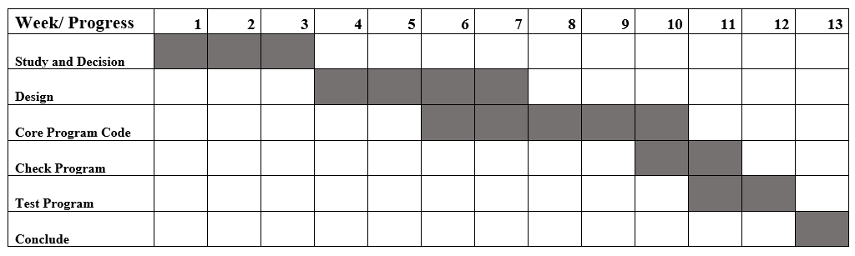

Figure 1: Gantt chart

## **Tools and technique**

To implement the project, we are going to use the waterfall model (outcome of one phase acts as input for next phase). Our project's description is stable. Since we have well known, clean and fixed requirements therefore its best fits for the software development. This model is simple, easy to comprehend and user friendly. Phases are processed and finished one at a time in this model, and they do not overlap. The waterfall model works well for smaller tasks with well-defined sequences.

The following illustration is a representation of the different phases of the Waterfall Model.

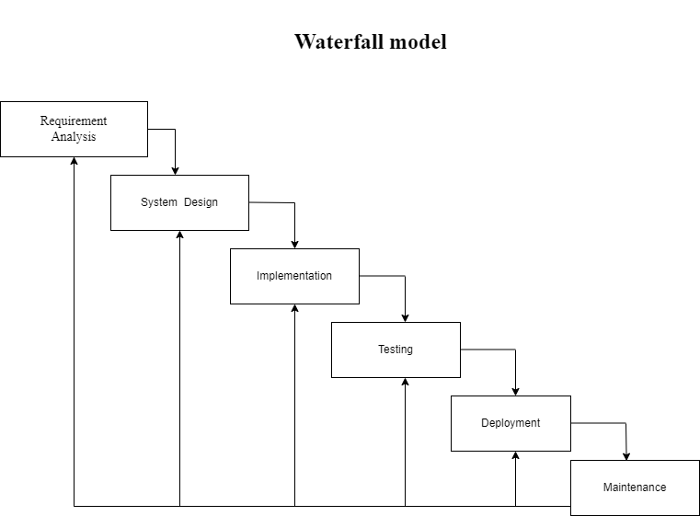

Figure 2: Waterfall Model

# SYSTEM DESIGNS

## Use case diagram

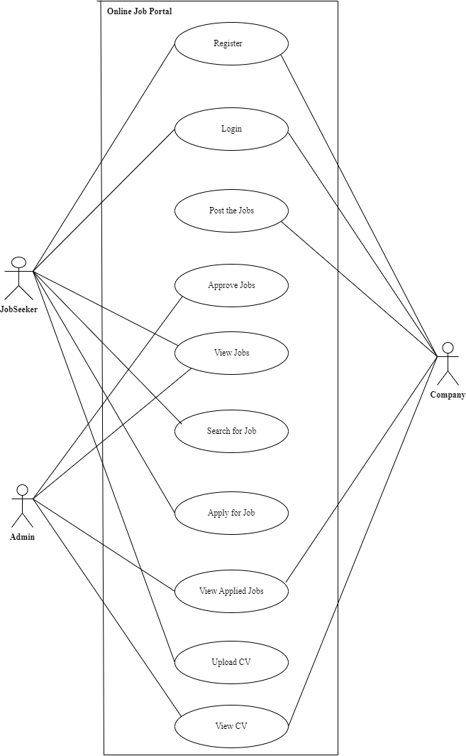

Figure 3: Use case diagram

## ER diagram

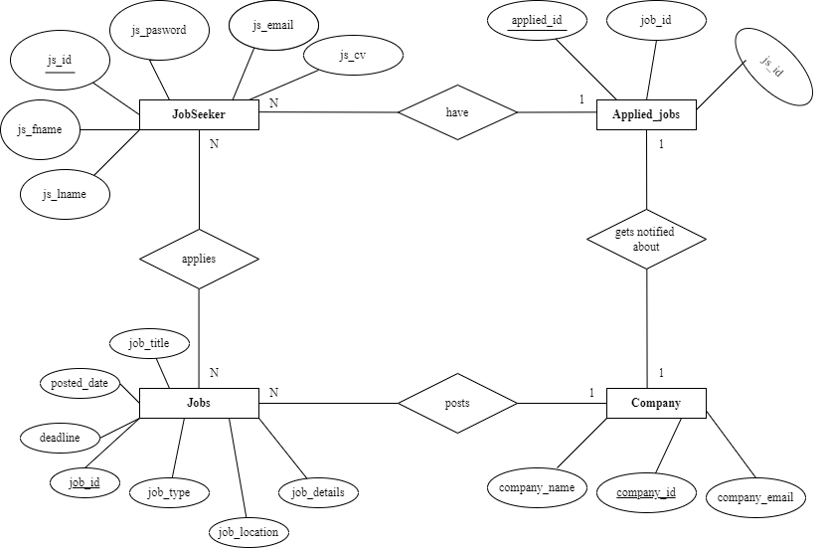

Figure 4: Er-diagram

# 

# EXPECTED OUTCOME

The proposed online job portal system is expected to benefit both job seekers and employers. It will provide a platform where employers can post job vacancies and job seekers can apply for them easily. This will make the hiring process more efficient and transparent. Employers will have access to a larger pool of qualified candidates, and job seekers will be able to find relevant job opportunities with ease.

The online job portal system will also increase transparency and fairness in the recruitment process. All job postings and applications will be stored in a central database, making it easier for employers to manage applications and ensure that all candidates are evaluated fairly. Job seekers will also be able to track the status of their applications and receive notifications when new job opportunities become available. Overall, the proposed online job portal system has the potential to revolutionize the way employers recruit talent and job seekers find employment.

# CONCLUSION

This job portal can help job seekers and recruiters overcome the challenges of today's labor market. This project proposal seeks to create a user-friendly, secure job portal that connects job seekers to a diverse variety of job opportunities across industries and sectors. Recruiters will also be able to use the employment portal to submit job openings, manage their candidate database, and communicate with job seekers. We think that this project will benefit both job seekers and recruiters and will help to grow the job market.

# REFERENCES

|  |  |  |
| --- | --- | --- |
| [1] |  | JobAxle, "Jobaxle a step and beyond," 17 07 2019. [Online]. Available: https://jobaxle.com/. |
| [2] |  | [Online]. Available: https://kantipurjob.com/. |
| [3] |  | [Online]. Available: https://www.easyjoblink.com.np/. |