Bank Name

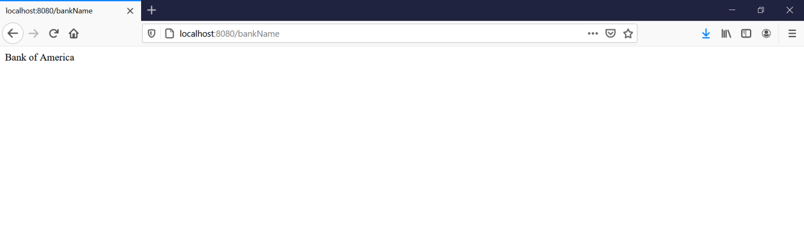

Bank Address

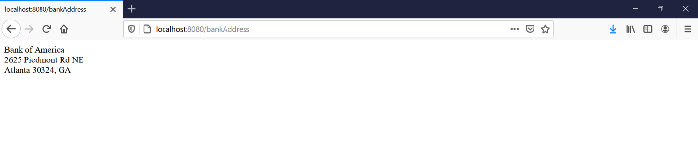

Beans

