A Comparative Study of TF-IDF and BanglaBERT
for Bangla Cyberbullying Detection
NLP Project Report
Submitted by
Md. Mosaddek Ali (Roll: 2107027)
MD Jubayer Alam (Roll: 1807110)
September 2026
Abstract
Bangla social-media comments contain harassment, sexual aggression, hate speech and violent extremism, and the language has few well-tested detection tools. This project builds a leakage-controlled pipeline on a 44,001-comment Bangla dataset labelled with five classes. After validation, Unicode normalization, documented label-conflict resolution and exact and near-duplicate removal, 41,312 comments remain, split 70/15/15 with stratification. A character n-gram TF-IDF + Logistic Regression baseline, tuned on the validation set, is compared with fine-tuned BanglaBERT on identical splits and a single shared evaluation function. BanglaBERT reaches a test macro-F1 of 0.8352 against 0.8121 for TF-IDF (+0.023; McNemar p = 0.0035; 95% bootstrap CI [+0.012, +0.034]), and the gain holds across three training seeds (0.8357 ± 0.0034). The largest gains are on Violent Extremism (+0.063 F1), Hate Speech (+0.030) and long comments. Most remaining errors lie on the Neutral–Harassment boundary, and in 493 of the 627 test comments that both models misclassify, both predict the same alternative label, which points to annotation noise. Reaction counts are 65% zero and almost independent of the label (η² = 0.0008), so this data does not support text-only engagement prediction.

Contents
1. Introduction 3
2. Dataset 3
3. System Architecture 3
4. Data Preparation 4
4.1 Cleaning and Unicode normalization 4
4.2 Near-duplicate removal 5
4.3 Regex preprocessing: two text views 5
4.4 Stratified split 6
5. Exploratory Data Analysis 6
6. Text Representation and Models 7
6.1 From text to vectors 7
6.2 TF-IDF + Logistic Regression 8
6.3 BanglaBERT fine-tuning 8
7. Results 9
7.1 Test-set performance 9
7.2 Statistical significance 10
7.3 Seed robustness 10
7.4 Leakage sanity check 10
8. Error Analysis 11
9. Deployment and Reproducibility 12
10. Limitations and Future Work 12
11. Conclusion 12
References 13

1. Introduction
Abusive comments on Bangla Facebook and YouTube pages target actors, singers, politicians and ordinary users. Manual moderation does not scale, and most tools are built for English. Bangla text adds its own problems: several Unicode encodings of the same conjunct, mixed Bangla and Latin script, slang and heavy spelling variation.
The project has four objectives:
- O1 — Classification. Assign each comment to one of five classes: Neutral, Harassment, Sexual Aggression, Hate Speech or Violent Extremism.
- O2 — Engagement. Test whether the reaction count of a comment can be predicted from its text.
- O3 — Model comparison. Compare a traditional pipeline (TF-IDF + Logistic Regression) with a contextual transformer (BanglaBERT) under one split and one evaluation protocol.
- O4 — Error analysis. Find where and why the models fail.
The main contributions are a documented cleaning pipeline that removes exact and near-duplicate leakage, a tuned baseline, a statistically tested comparison with seed-robustness checks, an error analysis that separates model errors from likely annotation errors, and a demo application that reproduces the training preprocessing exactly.

2. Dataset
The dataset holds 44,001 Bangla social-media comments in five columns (Table 1). Only the comment text is a model input. Category and Gender are metadata and are used for EDA only: Section 5 shows that Category is strongly tied to the label and would leak target information.
Table 1. Dataset columns and their role
Column | Content | Role in this project
Text | Bangla comment (mean 16.6 words, median 9, max 210) | Model input
Label | 5 cyberbullying classes | Target, O1
Comment React Number | Reaction count, 0–428 (3 missing) | Target, O2 analysis
Category | Actor, Social, Singer, Politician, Sports | EDA only
Gender | Female / Male (one lowercase "male") | EDA only

Validation of the raw file found 7 corrupted texts (Excel errors such as #NAME?), 142 fully identical rows, 601 duplicated texts, 48 texts carrying conflicting labels (109 rows), 1,869 texts with stray whitespace, 231 with URLs and 443 comments that are less than 50% Bangla script. The label distribution is imbalanced: Violent Extremism has 9.1 times fewer comments than Neutral (Figure 2), so macro-F1 is the headline metric.

3. System Architecture
Figure 1 shows the full pipeline. A shared trunk validates, cleans, deduplicates and splits the data once. The split is saved to disk, and both models read the same files. Cell 5 produces two text views of the same rows, one tuned for each model family. Each branch then turns text into vectors in its own way: sparse character n-gram TF-IDF for the traditional branch, and subword embeddings contextualized by a 12-layer transformer for BanglaBERT. Both branches report through one evaluate() function. Hyperparameters and the best epoch are chosen on the validation set, and each model touches the test set only once.
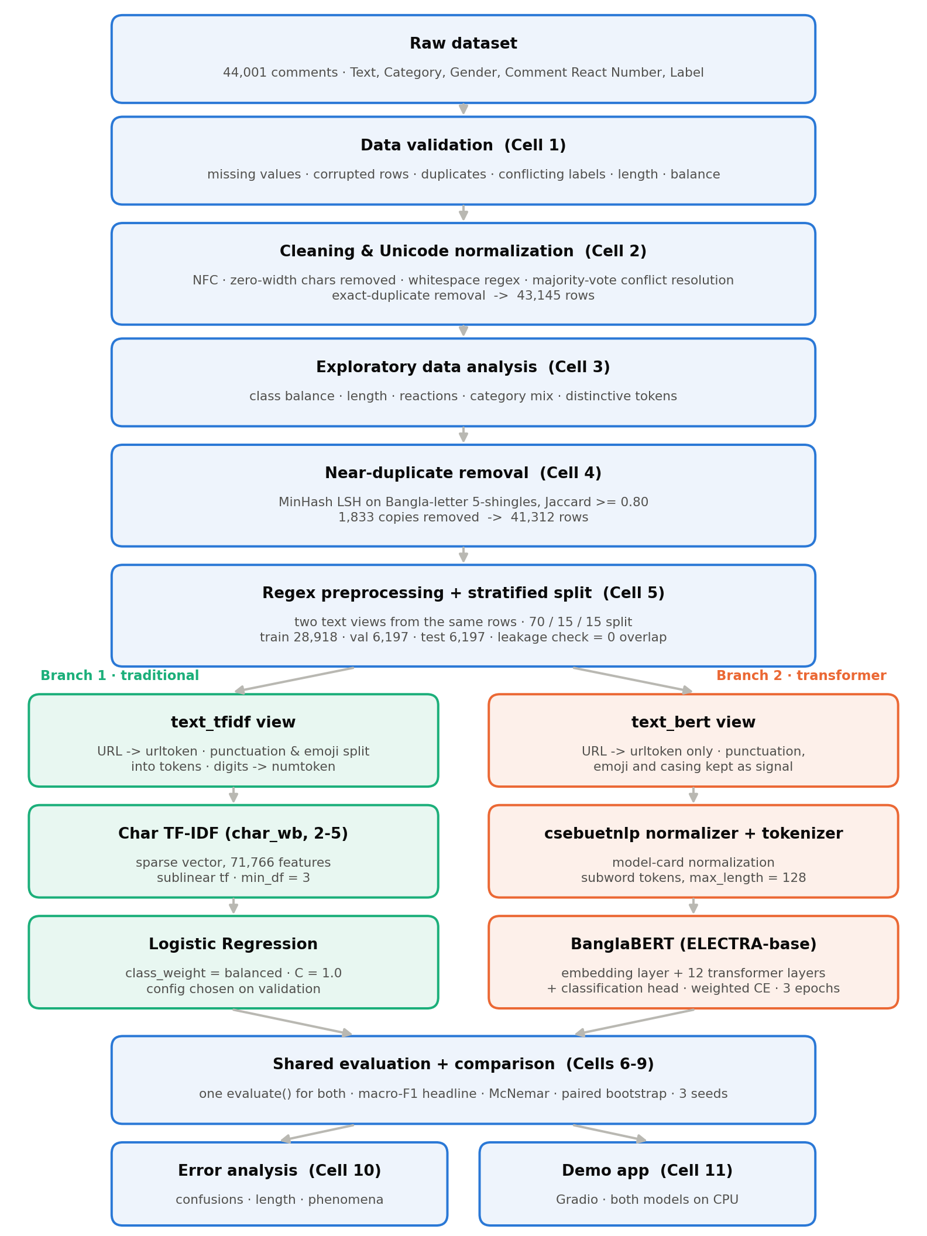
Figure 1. End-to-end architecture. Blue: shared stages; green: TF-IDF branch; orange: BanglaBERT branch. Cell numbers refer to the project notebook.

4. Data Preparation

4.1 Cleaning and Unicode normalization
Bangla conjuncts and vowel signs can be stored in composed or decomposed Unicode form. Two comments that look identical may therefore differ byte by byte, and duplicate detection and regex matching would miss them. Every text is converted to NFC, zero-width characters (U+200B/C/D) are removed and runs of whitespace are collapsed with the regex \s+. Normalization runs before deduplication so that visually identical texts compare equal.
Conflicting labels are not dropped silently. The full conflicting set is archived to conflicting_labels.csv. A text whose copies have a clear majority label keeps that label; a text whose labels tie has no annotation consensus and is removed. After normalization, 52 texts (113 rows) conflicted: 5 were resolved by majority vote and 47 ties (94 rows) were dropped. Exact duplicates were then removed, keeping the first occurrence. Very short comments are kept: 1,049 single-word comments remain because short slurs carry strong signal. Table 2 gives the audit trail.
Table 2. Cleaning audit trail
Step | Rows affected | Rows remaining
Raw file | — | 44,001
Corrupted text removed (#NAME? etc.) | 7 | 43,994
Missing reaction counts filled with 0 | 3 | 43,994
Label conflicts: majority-resolved / tie-dropped | 5 texts / 94 rows | 43,900
Exact duplicate texts removed | 755 | 43,145
Near-duplicates removed (Section 4.2) | 1,833 | 41,312

4.2 Near-duplicate removal
Exact deduplication misses copy-paste comments that differ by a prefix, an emoji or punctuation. If such copies land in both train and test, the test score is inflated. Each comment is reduced to a fingerprint of its Bangla letters only, split into character 5-shingles and indexed with MinHash LSH [4] (128 permutations, Jaccard threshold 0.80). Union-find groups the matches into clusters. Out of 42,773 indexed comments, 2,844 rows formed 1,011 clusters. 95.2% of clusters carry a single label, while 49 mix labels, a first sign of annotation inconsistency. One representative per cluster is kept, which removes 1,833 rows. The largest clusters were a 32-copy Hate Speech comment, 26 variants of "মাশাআল্লাহ♥" and 24 of "নাস্তিক". Every cluster is archived for audit.

4.3 Regex preprocessing: two text views
Preprocessing is deliberately conservative and uses only regular expressions (Table 3). BanglaBERT was pretrained on raw text and uses punctuation, emoji and casing as signal, so its view only replaces URLs. The TF-IDF view keeps the same information but makes it token-friendly: punctuation and emoji become separate tokens instead of being deleted, and every number collapses to one token so that "১০০", "২০২৩" and "৫" do not each take a vocabulary slot.
Table 3. Regex rules applied in Cell 5
Rule | Pattern | Action | View
URL | https?://\S+|www\.\S+ | replace with urltoken | both
Emoji variation selector | \ufe0f | delete | TF-IDF
Punctuation / emoji | [^\u0980-\u09FFa-zA-Z0-9\s] | surround with spaces | TF-IDF
Digits (Latin + Bangla) | [0-9\u09E6-\u09EF]+ | replace with numtoken | TF-IDF
Whitespace | \s+ | collapse to one space | both

Table 4. Example of the two views
View | Text
raw | অরে বাবা, এই টা কোন পাগল????
text_bert | অরে বাবা, এই টা কোন পাগল????
text_tfidf | অরে বাবা , এই টা কোন পাগল ? ? ? ?

Stopwords are not removed. Bangla second-person pronouns carry politeness: the informal তুই / তোর / তোরে is often derogatory, while আপনি / আপনার is formal. Standard Bangla stopword lists contain all of them, so removing stopwords would delete one of the strongest harassment cues. Section 8 confirms this: comments with তুই-forms are where BanglaBERT gains most over TF-IDF.

4.4 Stratified split
The 41,312 comments are split 70/15/15 with stratification on the label (seed 42). A leakage check confirms zero exact text overlap between any pair of splits. Class weights for training are computed from the training split with the "balanced" formula (Table 5).
Table 5. Split sizes per class and training class weights
Class | Train | Val | Test | Share | Class weight
Neutral | 9,840 | 2,109 | 2,108 | 34.0% | 0.588
Harassment | 7,051 | 1,511 | 1,511 | 24.4% | 0.820
Sexual Aggression | 5,913 | 1,267 | 1,268 | 20.5% | 0.978
Hate Speech | 4,972 | 1,065 | 1,066 | 17.2% | 1.163
Violent Extremism | 1,142 | 245 | 244 | 4.0% | 5.064
Total | 28,918 | 6,197 | 6,197 | 100% | —

5. Exploratory Data Analysis
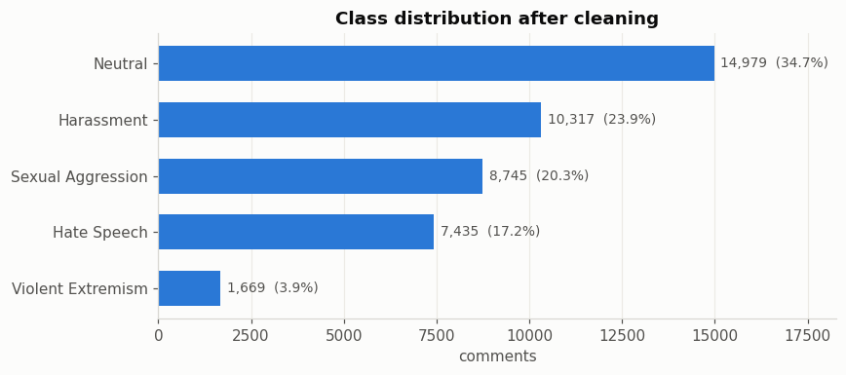
Figure 2. Class distribution after cleaning (43,145 comments).
Length. Comments are short and right-skewed: the median is 9 words, p90 37 and p95 58 (Figure 3). Hate Speech comments are the longest. BanglaBERT subword sequences have p95 = 80 tokens, so max_length = 128 truncates only 1.7% of comments.
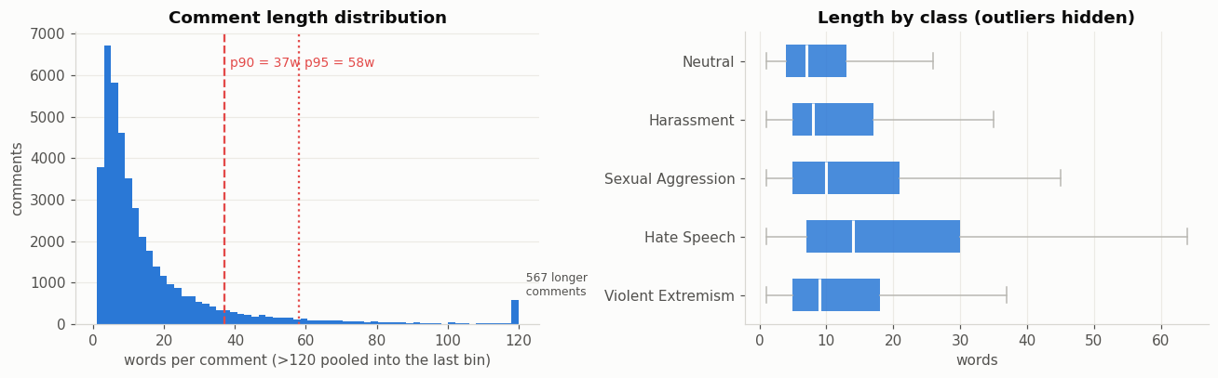
Figure 3. Comment length overall (left) and per class (right).
Category confound. The label mix changes sharply by target category (Figure 4). 92% of Sports comments are Neutral, while Actor comments are mostly abusive. A model given Category would learn "who is targeted" rather than "what is said", so the column is excluded from the features.
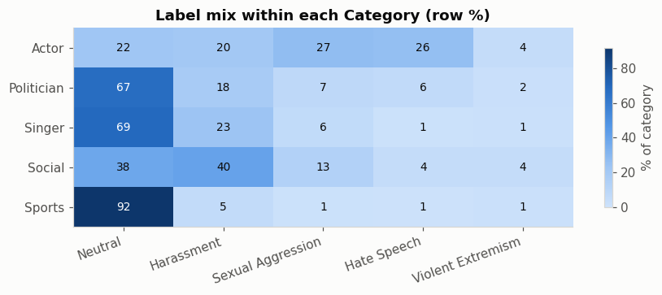
Figure 4. Label mix within each target category (row %).
Distinctive vocabulary. Log-odds against the rest of the corpus give the most class-specific tokens (Table 6). Neutral vocabulary is topical (brands, political names, religious greetings). Harassment uses animal and insult words. Violent Extremism centres on beating and execution. Sexual Aggression tokens are explicit terms and numbered spam and are omitted here.
Table 6. Most distinctive tokens per class (log-odds vs rest)
Class | Top tokens
Neutral | হুয়াওয়ে, অভিরাম, বিনম্র, বঙ্গবন্ধু, সজীব, ওয়াজেদ, মোবারক, ফিতরের
Harassment | পাগলী, পাগলে, ছাগল, বান্দরের, বাটপার, ময়দা, টোকাই, ফাউল
Hate Speech | নাস্তিক্যবাদ, মুনাফিকের, নাস্তিক, ইহুদী, মূলনীতির, কাফিরকে, পরিগণিত
Violent Extremism | জুতাপেটা, জবাই, পেটা, জুতা, বিতারিত, ফাসি, জুতার, পিঠা

Engagement (O2). Reaction count is severely zero-inflated: 65.2% of comments have no reaction, and the median is 0 for every class (Figure 5). Word count correlates with reactions at only r = +0.087, and the label explains η² = 0.0008 of the variance. The drivers of reactions (post reach, page followers, timestamp, thread position) are not in the dataset. The evidence therefore does not support predicting reaction count from text alone, and the project concentrates on classification.
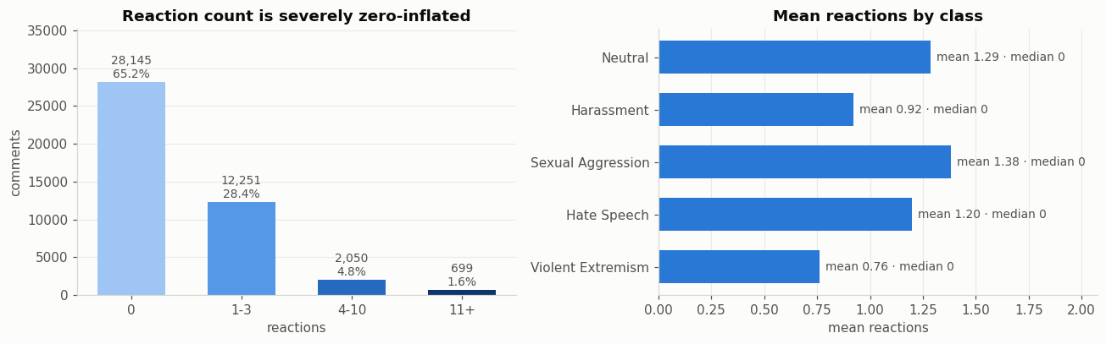
Figure 5. Reaction-count tiers (left) and mean reactions per class (right).

6. Text Representation and Models

6.1 From text to vectors
A classifier cannot read text, so after preprocessing and normalization every comment must become a numeric vector. The two branches do this in different ways (Table 7). TF-IDF counts character n-grams and weights them by rarity, which gives a sparse, interpretable vector without learning. BanglaBERT maps each subword to a learned embedding vector, adds position embeddings and refines the sequence through 12 self-attention layers, so each token vector depends on its context. The embedding layer is part of the model and is fine-tuned together with the classifier. Neither branch needs a separate embedding step.
Table 7. The two text representations
 | Char TF-IDF | BanglaBERT
Vector type | Sparse, 71,766 dimensions | Dense, 768 dimensions per token
Unit | Character 2–5-grams inside word boundaries | Subword tokens
How obtained | Counted: sublinear tf × idf | Pretrained, then fine-tuned
Word meaning / context | No / no | Yes / yes
Robust to spelling variation | Partly (shared n-grams) | Partly (shared subwords)
Classifier | Logistic Regression | Classification head on the [CLS] vector

6.2 TF-IDF + Logistic Regression
The baseline is tuned so that the comparison is fair: an untuned baseline would inflate BanglaBERT's advantage. Three feature sets and two regularization strengths were compared on the validation split (Table 8). Both are built with scikit-learn [3], and the classifier uses class_weight="balanced". Character n-grams (char_wb, 2–5) with C = 1.0 were selected.
Table 8. Baseline selection on the validation split
Features | C | Features (n) | Val macro-F1 | Time (s)
char_wb 2–5 | 1.0 | 71,766 | 0.8098 | 18.9
char_wb 2–5 | 4.0 | 71,766 | 0.8046 | 23.0
word 1–2 + char 2–5 | 1.0 | 100,926 | 0.7968 | 22.5
word 1–2 + char 2–5 | 4.0 | 100,926 | 0.7940 | 27.3
word 1–2 | 1.0 | 29,160 | 0.4743 | 6.5
word 1–2 | 4.0 | 29,160 | 0.4612 | 10.6

The word-level scores are low for a technical reason, discussed in Section 10: the default scikit-learn token pattern splits Bangla words at dependent vowel signs. The selected character configuration is not affected.

6.3 BanglaBERT fine-tuning
BanglaBERT [1] is an ELECTRA-base discriminator [2] pretrained on a large Bangla corpus. Input text first passes through the model's own normalizer (csebuetnlp/normalizer), as the model card requires. Training uses Hugging Face Transformers [8] with a manual PyTorch loop with class-weighted cross-entropy, mixed precision and the best epoch chosen by validation macro-F1 (Table 9). Validation macro-F1 was 0.7955, 0.8274 and 0.8256 after epochs 1–3, so the epoch-2 weights were kept. Each epoch took about 3.8 minutes on one Tesla T4.
Table 9. BanglaBERT training configuration
Setting | Value | Setting | Value
Checkpoint | csebuetnlp/banglabert | Optimizer | AdamW, weight decay 0.01
Max length | 128 subwords | Learning rate | 2e-5, linear, 10% warm-up
Batch size | 32 | Loss | Cross-entropy, class-weighted
Epochs | 3 (best = 2) | Stability | fp16 autocast, grad-clip 1.0

7. Results

7.1 Test-set performance
BanglaBERT beats the tuned baseline on every overall metric (Table 10) and on every class (Table 11). The largest per-class gains are on the two classes where context matters most: Violent Extremism (+0.063 F1), the smallest class, and Hate Speech (+0.030). Sexual Aggression is almost a tie because its vocabulary is explicit enough for character n-grams to capture.
Table 10. Overall test results (6,197 comments)
Model | Accuracy | Macro-F1 | Weighted-F1 | Macro-F1 (clean subset)
TF-IDF + LogReg | 0.8299 | 0.8121 | 0.8301 | 0.8019
BanglaBERT | 0.8431 | 0.8352 | 0.8438 | 0.8265
Δ | +0.0132 | +0.0231 | +0.0137 | +0.0245

Table 11. Per-class test precision / recall / F1
Class | Support | TF-IDF P / R / F1 | BanglaBERT P / R / F1 | Δ F1
Neutral | 2,108 | 0.852 / 0.862 / 0.857 | 0.882 / 0.844 / 0.863 | +0.006
Harassment | 1,511 | 0.770 / 0.763 / 0.767 | 0.768 / 0.797 / 0.782 | +0.016
Sexual Aggression | 1,268 | 0.838 / 0.826 / 0.832 | 0.828 / 0.838 / 0.833 | +0.001
Hate Speech | 1,066 | 0.900 / 0.884 / 0.892 | 0.926 / 0.917 / 0.922 | +0.030
Violent Extremism | 244 | 0.680 / 0.750 / 0.713 | 0.734 / 0.824 / 0.776 | +0.063

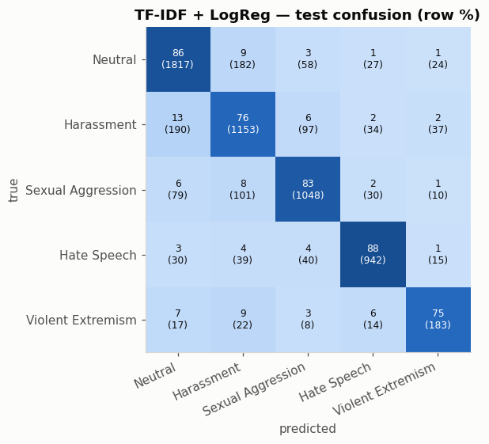 | 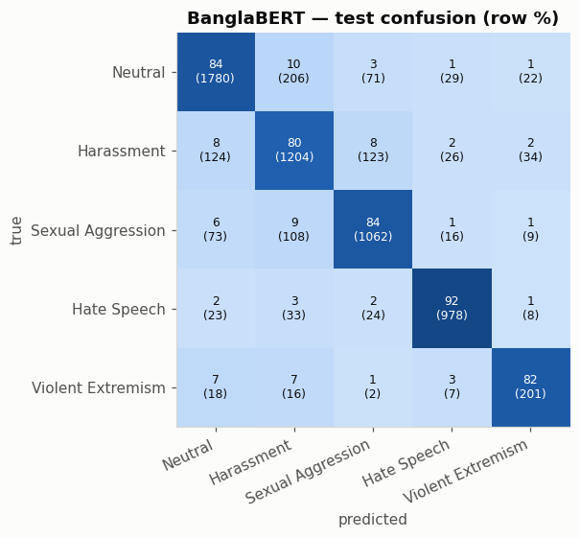
Figure 6. Test confusion matrices (row %, counts in brackets): TF-IDF + LogReg (left) and BanglaBERT (right).
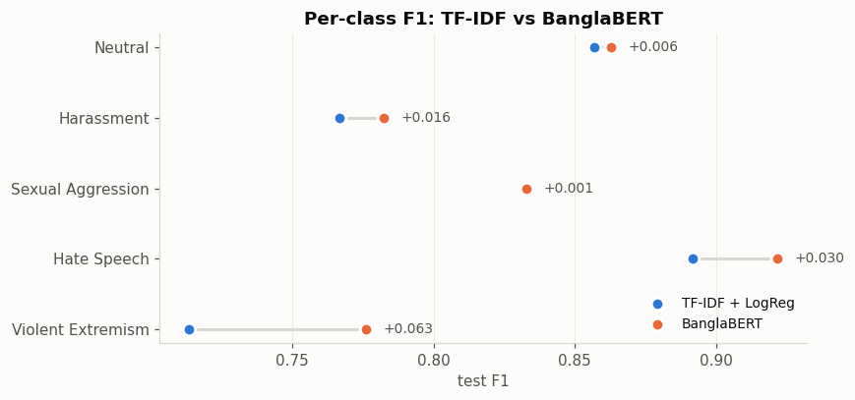
Figure 7. Per-class test F1 of both models; the label gives BanglaBERT's gain.

7.2 Statistical significance
A 2.3-point gap on one test set could be sampling noise, so two paired tests were run on the same 6,197 predictions (Table 12). The exact McNemar test [5, 7] compares only the comments where the models disagree: BanglaBERT alone is right on 427, TF-IDF alone on 345. A paired bootstrap [6] with 2,000 resamples gives a 95% confidence interval for the macro-F1 difference that excludes zero.
Table 12. Paired significance tests
Quantity | Value
Both correct / both wrong | 4,798 (77.4%) / 627 (10.1%)
Only TF-IDF correct / only BanglaBERT correct | 345 / 427
McNemar exact p-value | 0.0035
Macro-F1 Δ, 95% bootstrap CI | +0.0231 [+0.0120, +0.0339]
Verdict | Significant at the 5% level

7.3 Seed robustness
The significance tests cover test-set noise but not training noise, because fine-tuning depends on the random seed. BanglaBERT was retrained with seeds 13 and 87 using the identical configuration (Table 13). All three runs beat TF-IDF, and each is significant by McNemar. The worst seed (0.8325) is still 0.020 above the baseline.
Table 13. BanglaBERT across three seeds (test set)
Seed | Val macro-F1 | Test macro-F1 | Clean macro-F1 | Accuracy | VE F1 | McNemar p
42 | 0.8274 | 0.8352 | 0.8265 | 0.8431 | 0.7761 | 0.0035
13 | 0.8327 | 0.8393 | 0.8304 | 0.8462 | 0.7902 | 0.0003
87 | 0.8291 | 0.8325 | 0.8236 | 0.8435 | 0.7617 | 0.0026
Mean ± sd | — | 0.8357 ± 0.0034 | 0.8268 ± 0.0034 | 0.8443 ± 0.0017 | 0.7760 ± 0.0142 | —
TF-IDF | 0.8098 | 0.8121 | 0.8019 | 0.8299 | 0.7135 | —

7.4 Leakage sanity check
Near-duplicate removal used a strict threshold, so some paraphrased copies can still cross the split. For each test comment, the highest character TF-IDF cosine similarity to any training comment was measured. 477 test comments (7.7%) have a training neighbour at similarity ≥ 0.80, and TF-IDF is 94.6% accurate on them against 82.0% on the rest. Scores are therefore also reported on the clean subset (5,720 comments with similarity < 0.80). Both models drop by about one point there, and BanglaBERT's lead grows slightly to +0.0245 (Table 10). The conclusion does not depend on residual leakage.

8. Error Analysis
Where the errors are. Both models confuse mostly the same pairs (Table 14). The Neutral ↔ Harassment boundary alone accounts for over a third of all errors. BanglaBERT makes 82 fewer errors overall and is less likely to label harassment as neutral, but it flags more neutral comments as harassment.
Table 14. Most frequent test confusions (true → predicted)
Confusion | TF-IDF errors | BanglaBERT errors
Harassment → Neutral | 190 | 124
Neutral → Harassment | 182 | 206
Sexual Aggression → Harassment | 101 | 108
Harassment → Sexual Aggression | 97 | 123
Sexual Aggression → Neutral | 79 | 73
Neutral → Sexual Aggression | 58 | 71
All errors | 1,054 | 972

Length. The two models are equal on short comments, but the TF-IDF error rate climbs with length while BanglaBERT's stays flat. On comments longer than 50 words, the error rate is 26.1% for TF-IDF and 18.2% for BanglaBERT (Figure 8). A bag of n-grams dilutes a single abusive clause in a long text. Self-attention can focus on it.
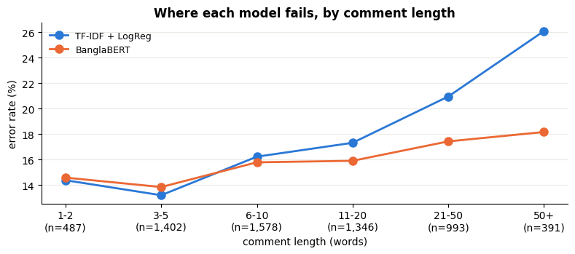
Figure 8. Test error rate by comment length.
Table 15. Error rate by linguistic phenomenon
Subset of the test set | n | TF-IDF error | BanglaBERT error
All test comments | 6,197 | 17.0% | 15.7%
Question mark (rhetorical / sarcastic) | 695 | 23.9% | 20.0%
Informal pronoun তুই / তোর / তোকে / তোদের | 753 | 14.7% | 12.2%
Very short (≤ 2 words) | 487 | 14.4% | 14.6%
Contains emoji | 167 | 6.6% | 8.4%
Code-mixed (≥ 30% Latin characters) | 54 | 20.4% | 20.4%
Near-twin in train (similarity ≥ 0.80) | 477 | 5.5% | 4.6%

Phenomena. BanglaBERT helps most on questions, which are often rhetorical or sarcastic, and on comments with the informal pronoun, where the address itself is part of the insult (Table 15). TF-IDF is slightly better on emoji comments, because the TF-IDF view turns each emoji into a separate token. Code-mixed text is equally hard for both, which suggests a target for future work. By class, BanglaBERT wins more one-sided disagreements on Harassment (net +51), Hate Speech (+36), Violent Extremism (+18) and Sexual Aggression (+14). TF-IDF wins on Neutral (net −37).
Likely annotation errors. 627 test comments (10.1%) are misclassified by both models. In 493 of them (78.6%), the two very different models agree on the same alternative label. Agreement like this is the typical signature of a gold-label error rather than a model error. The largest groups are gold Neutral predicted as Harassment (100) and gold Harassment predicted as Neutral (83). This matches the 49 mixed-label near-duplicate clusters in Section 4.2. A 140-comment sample was exported for manual review. The measured scores are therefore probably a lower bound on true model quality.

9. Deployment and Reproducibility
Both trained models are served by a Gradio demo application that runs on CPU. The app reimplements the Cell 2 and Cell 5 preprocessing in a separate module. Its output was checked to be identical to the training views on all 6,197 test comments, and its predictions agree 100% with the saved test predictions on a 300-comment sample, for both models. Library versions are pinned (Python 3.12, PyTorch 2.10, Transformers 5.0, scikit-learn 1.6.1).
The pipeline was first developed on Google Colab and then rerun end-to-end on Kaggle. All deterministic stages reproduce exactly. BanglaBERT differs only in the third decimal, as expected from different GPU and library stacks (Table 16).
Table 16. Kaggle rerun vs original Colab run
Check | Kaggle | Colab | Status
Rows after exact dedup | 43,145 | 43,145 | match
Rows after near-dedup | 41,312 | 41,312 | match
Train / val / test | 28,918 / 6,197 / 6,197 | 28,918 / 6,197 / 6,197 | match
TF-IDF test macro-F1 | 0.8121 | 0.8121 | match
BanglaBERT (seed 42) test macro-F1 | 0.8352 | 0.8339 | close

10. Limitations and Future Work
- Word-level TF-IDF tokenization. The word configurations used scikit-learn's default token pattern \b\w\w+\b. Python's \w does not match Bangla dependent vowel signs or the hasanta, so words are split into fragments ("পাগল" becomes "গল"). This explains the 0.47 validation score of the word model. The selected char_wb model splits on whitespace and is unaffected. The word and word+char configurations should be rerun with the whitespace pattern \S+, which could raise the baseline.
- Engagement prediction. No regression model was trained for reaction count, because the diagnostic in Section 5 shows that the text carries almost no signal about reactions. Predicting engagement would need metadata the dataset lacks, such as post reach, followers and timestamps.
- Label noise and a single dataset. Mixed-label clusters and agreeing double errors suggest annotation noise, mostly on the Neutral–Harassment boundary. Results come from one dataset, and generalization to other platforms is untested.
- Further baselines. A static word-embedding baseline (Word2Vec or FastText with averaged vectors) and a BiLSTM would complete the gradient from count-based to contextual representations. Relabelling the 493 agreed double errors and handling romanized Bangla are further directions.

11. Conclusion
On 41,312 cleaned and deduplicated Bangla comments, fine-tuned BanglaBERT detects five cyberbullying classes with a test macro-F1 of 0.8352, against 0.8121 for a tuned character TF-IDF baseline. The gain is small but real: it is significant by McNemar and bootstrap, it holds across three seeds and on a leakage-free subset, and it is concentrated on Violent Extremism, Hate Speech and long or sarcastic comments, where context matters. The character TF-IDF baseline is still strong, cheap and competitive on explicit vocabulary. Most remaining errors sit on the Neutral–Harassment boundary, and many look like annotation disagreements rather than model failures. Reaction count cannot be predicted from comment text in this dataset.

References
[1] A. Bhattacharjee, T. Hasan, W. U. Ahmad, K. Samin, M. S. Islam, A. Iqbal, M. S. Rahman and R. Shahriyar, "BanglaBERT: Language Model Pretraining and Benchmarks for Low-Resource Language Understanding Evaluation in Bangla," in Findings of NAACL, 2022.
[2] K. Clark, M.-T. Luong, Q. V. Le and C. D. Manning, "ELECTRA: Pre-training Text Encoders as Discriminators Rather Than Generators," in ICLR, 2020.
[3] F. Pedregosa et al., "Scikit-learn: Machine Learning in Python," Journal of Machine Learning Research, vol. 12, pp. 2825–2830, 2011.
[4] A. Z. Broder, "On the resemblance and containment of documents," in Proc. Compression and Complexity of Sequences, 1997.
[5] Q. McNemar, "Note on the sampling error of the difference between correlated proportions or percentages," Psychometrika, vol. 12, no. 2, pp. 153–157, 1947.
[6] B. Efron and R. J. Tibshirani, An Introduction to the Bootstrap. Chapman & Hall, 1993.
[7] T. G. Dietterich, "Approximate statistical tests for comparing supervised classification learning algorithms," Neural Computation, vol. 10, no. 7, pp. 1895–1923, 1998.
[8] T. Wolf et al., "Transformers: State-of-the-Art Natural Language Processing," in Proc. EMNLP: System Demonstrations, 2020.

