**Satellite Imagery Aided Damage Analysis Post Hurricanes**

**Team Outliers : Rajat, Shishir, Nanda, Prayash**

**Model**

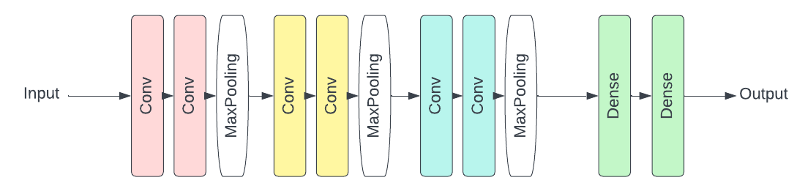

**Layout for Customised CNN model**

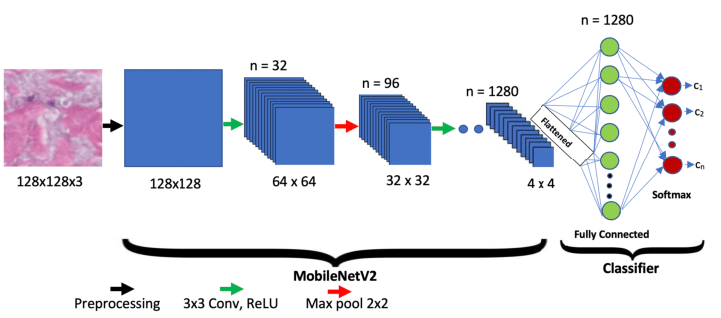

**A further Transfer Learning Approach with pre-trained MobileNetV2**

**Conclusion**

**and Future Work**

* Summing up the important takeaways from both the models, we have trained efficiently our own curated CNN model architecture on 5000 images from the training data over sufficient epochs ensuring less overfitting of the model. This fast-trained light model gave good results overall on different test sets.
* The pre-trained MobileNetV2 architecture was considerably better at the classification task, even though it took similar training times as compared to the previous model. It also focused on more significant areas of the images such as house-tops, the debris around the house, etc. which aided in its better results.
* For future, further analysis of these models can be done by applying them to more real-life data from Hurricanes in different regions of the world, where images can have a variety of objects in them. This can be achieved by using Satellite data from Hurricane Delta :

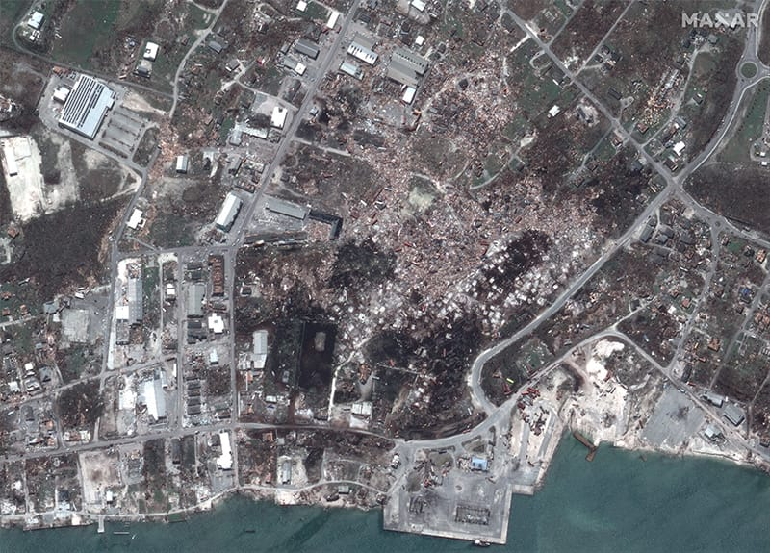

**Motivation and About the Project**

Hurricane Iota was a devastating late-season Category 4 Atlantic hurricane which caused severe damage to areas of Central America already devastated by Hurricane Eta just less than two weeks prior.

With the dataset collected from satellite imaging, we are trying to ascertain the damaged houses by visualising the top of the houses from the satellite image. Manually, this task is both time and cost expensive. Thus, we are trying to build an Image classifier CNN model which will be able to do so by just looking at the image data collected by the satellite imagery.

**References**

1. Data taken from : <http://dx.doi.org/10.21227/sdad-1e56>
2. Class attribution map approach : <https://github.com/jacobgil/keras-cam/blob/master/cam.py>

**Results**

* The Customised model with just 6 convolutional layers gave an accuracy of nearly 88% on the balanced set, while it had a recall of about 81% for the imbalanced class and combined f1 score of 0.77.
* The pre-trained model improved accuracy upto 93% on the balanced set and also showed improvement on recall for the imbalanced class, going upto 87%.
* Various visualization techniques were applied to both the models like Grad-CAMs and saliency mapping, which gave us insight that the pre-trained model was focusing at much better areas of the image to influence classification.

**Data and Labels**

The dataset is divided into 4 categories: train_another; validation_another: the validation data; and 2 sets of test datasets.

The training data comprises of 5000 satellite images of houses with labels ‘damage’ and ‘no damage’.

The test data has 2 sets, one with balanced no. of the two classes and another with huge imbalance in the favour of damage class (8000/1000).