**Screenshots**

**kubectl get pods and services**

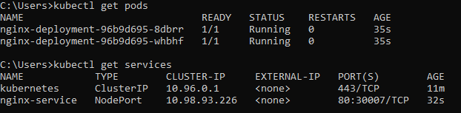

**Kubectl scale**

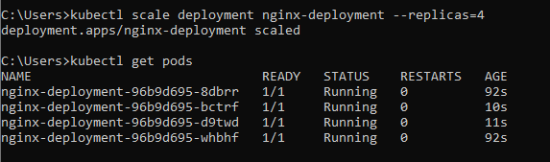

**Kubectl describe deployment nginx**

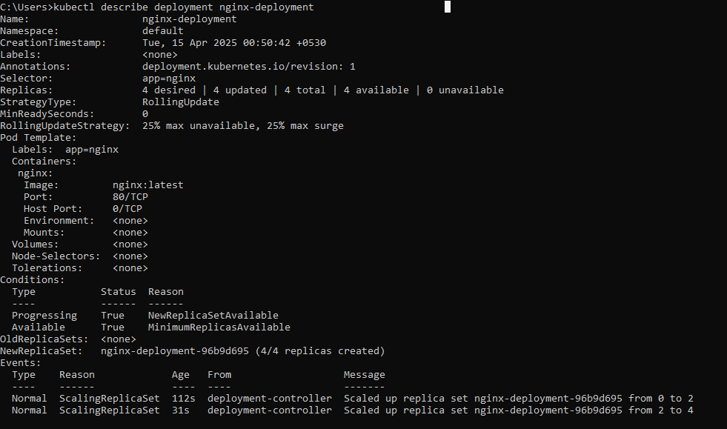

**Kubectl describe service nginx**

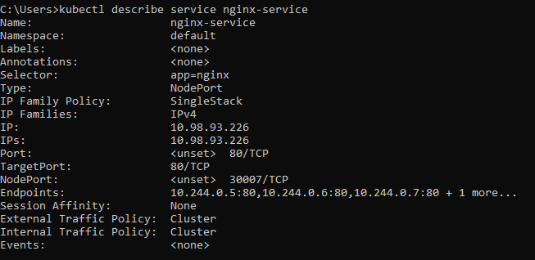

**Kubectl logs**

