Game Design Document

Fill up the following document

1. Write the title of your project.

Go to Alton Towers Resort

1. What is the goal of the game?

Get enough money (£50) from doing problems to go to AT resort

1. Write a brief story of your game.

You want to go to Alton Towers Resort, but there is one problem: you

have no money to buy a ticket. To get money you must do some questions

questions from bots correct each of which will earn you money.

1. Which are the playing characters of this game?

* Playing characters are the ones who respond to the user based on the input from the user.
* Cars, monkeys, dinos, wizards, etc., are the playing characters in the game.

|  |  |  |
| --- | --- | --- |
| Number | Character Name | What can this character do? |
| 1 | You | Answer Questions |
| 2 |  |  |
| 3 |  |  |
| 4 |  |  |
| 5 |  |  |
| 6 |  |  |
| 7 |  |  |
| 8 |  |  |

1. Which are the Non-Playing Characters of this game?

* Non-Playing characters are the ones that don't have an action or behavior when the user interacts with the game.
* Hurdles, stones, bananas, coins, etc., are non-playing characters in the game.

|  |  |  |
| --- | --- | --- |
| Number | Character Name | What can this character do? |
| 1 | Question Bots | Ask Questions |
| 2 | Explaining Bots | Explain wrong answers |
| 3 |  |  |
| 4 |  |  |
| 5 |  |  |
| 6 |  |  |
| 7 |  |  |
| 8 |  |  |

Draw your imagination of this game. What does this game look like?

* Draw the game either on your computer or on paper.
* Add images of the game scenes to show each of the playing and non-playing characters at least once.

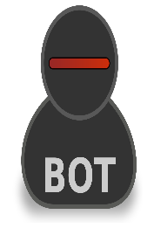

[This Photo](https://commons.wikimedia.org/wiki/File:Gnome-stock_person_bot.svg) by Unknown Author is licensed under [CC BY-SA](https://creativecommons.org/licenses/by-sa/3.0/)

15*14

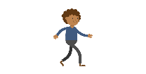

[This Photo](https://commons.wikimedia.org/wiki/File:Black_Man_Walking_Cartoon_Vector.svg) by Unknown Author is licensed under [CC BY-SA](https://creativecommons.org/licenses/by-sa/3.0/)

How do you plan to make your game engaging?

Making the bots look really funny.