Hello TA,

The GUI has two tabs. Please find below the instructions sequence for each tab-

1) Upload Tab-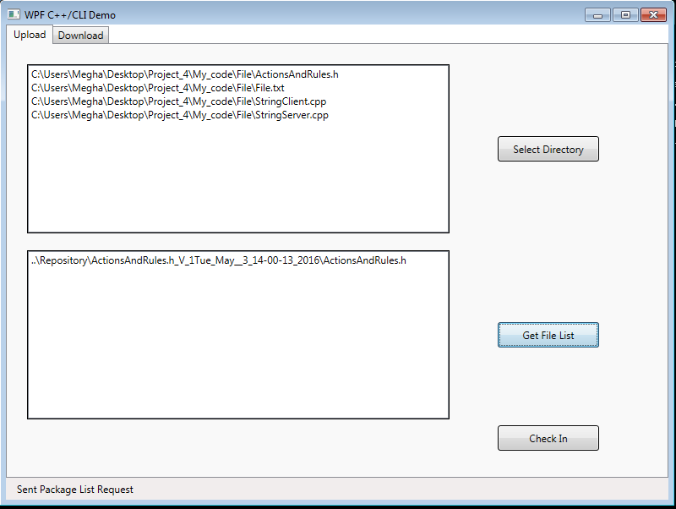

1. First select the directory from where you want to select the file by clicking “**SELECT DIRECTORY**”.
2. You can select at max one file from the list of the files.
3. Then click on “**Get File List**”. This will give you the current files in the server. So that you can select the dependent files. You can select more than one file in this.
4. Once you have selected one file to check in and zero or more dependent file you can click on check in.

** Please note if till don’t select any file to check in the check in button won’t work.

Download Tab-

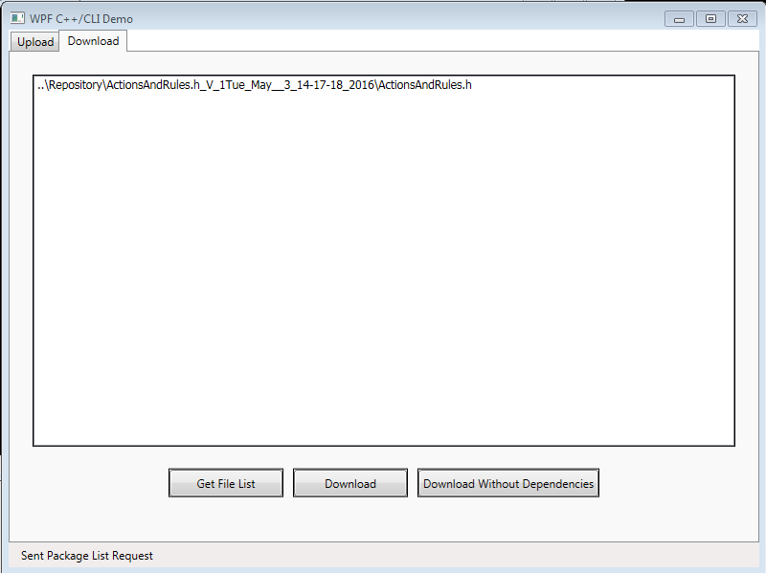

1. Please click on “**Get File List**” to refresh the list of current file in Repository
2. Select a File from the List.
3. Click on “Download” if you want file with dependency
4. Click on “Download without Dependency” if you want the selected file alone.

**Please note that both “Download” and “Download without dependency” will only work when you have selected a file.

I would also request to please use only documents with text data only. Though the application can handle over type of file too, but the reason for making the Repository

Was to check-in code.