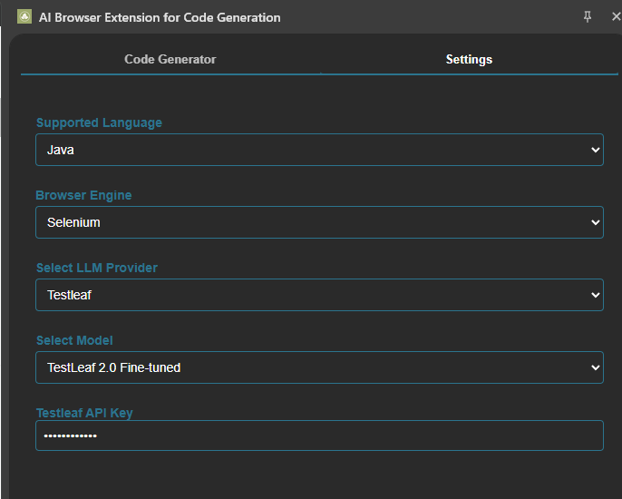

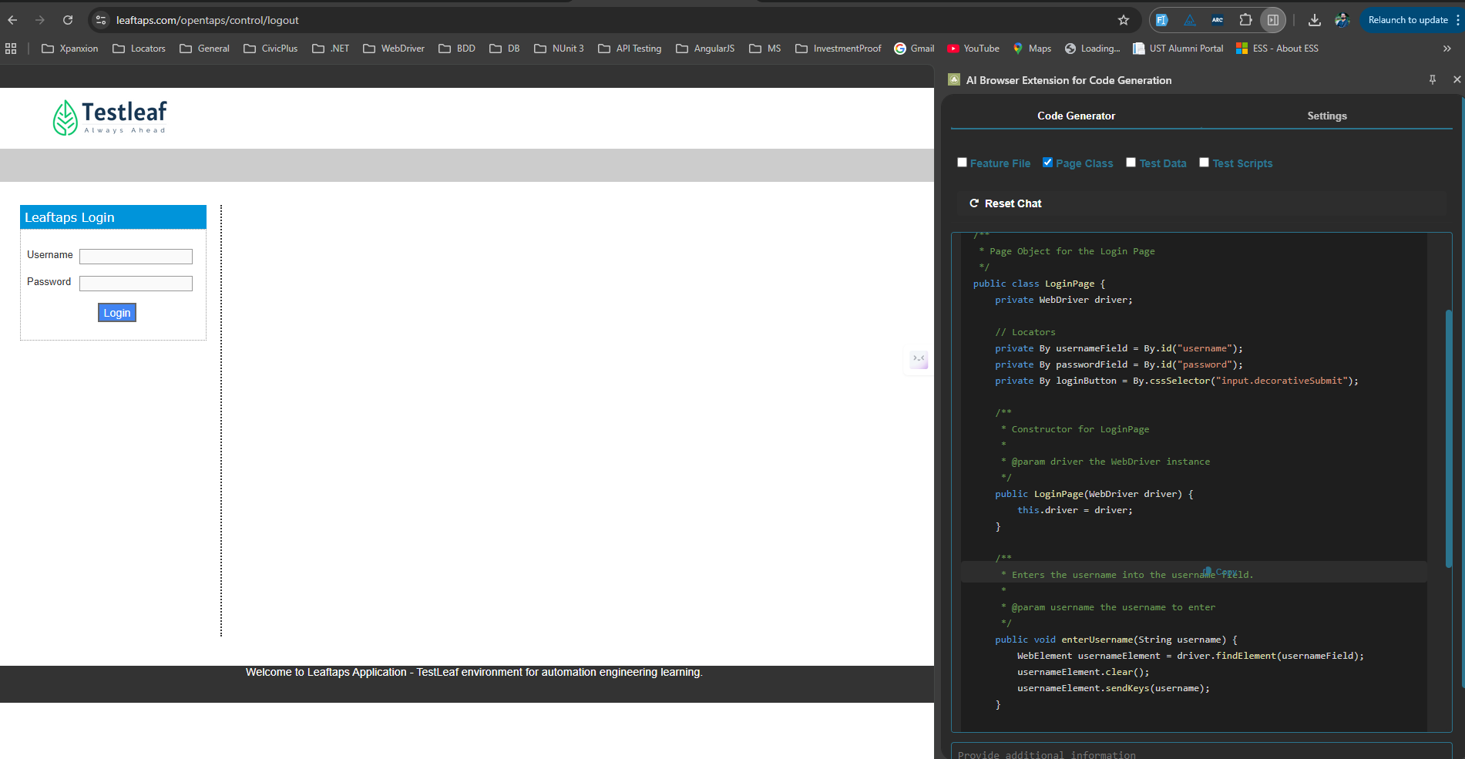

Page class:
package com.testleaf.pages;

import org.openqa.selenium.By;
import org.openqa.selenium.WebDriver;
import org.openqa.selenium.WebElement;

/**
* Page Object for the Login Page
*/
public class LoginPage {
private WebDriver driver;

// Locators
private By usernameField = By.id("username");
private By passwordField = By.id("password");
private By loginButton = By.cssSelector("input.decorativeSubmit");

/**
* Constructor for LoginPage
*
* @param driver the WebDriver instance
*/
public LoginPage(WebDriver driver) {
this.driver = driver;
}

/**
* Enters the username into the username field.
*
* @param username the username to enter
*/
public void enterUsername(String username) {
WebElement usernameElement = driver.findElement(usernameField);
usernameElement.clear();
usernameElement.sendKeys(username);
}

/**
* Enters the password into the password field.
*
* @param password the password to enter
*/
public void enterPassword(String password) {
WebElement passwordElement = driver.findElement(passwordField);
passwordElement.clear();
passwordElement.sendKeys(password);
}

/**
* Clicks the login button to submit the form.
*/
public void clickLoginButton() {
WebElement loginButtonElement = driver.findElement(loginButton);
loginButtonElement.click();
}
}

