Smart RFID and Servo Motor-Based Security Lock System Using Arduino
Mahrab Farhan (22-46983-1), SK. Shaker Shahid (22-46530-1),
Atif Ashab (21-45914-3), Touhid A Akbar (23-51149-1),
Md Kamruzzaman Rafi (24-56323-1)
Department of Computer Science and Engineering American International University–Bangladesh (AIUB)

Abstract—This paper presents the design and implementation of a Smart RFID-Based Security Lock System using an Arduino Uno microcontroller. The system uses RFID (Radio Frequency Identification) technology for secure user authentication. When a valid RFID card is detected, the system unlocks the door using a servo motor and displays status messages on an I2C LCD. Unauthorized access attempts are denied, and appropriate feedback is shown on the display. The system is designed to be low-cost, reliable, and user-friendly, making it suitable for households and small businesses in Bangladesh. Experimental results demonstrate high accuracy and stable performance, proving its effectiveness as an affordable smart security solution.
Index Terms—Arduino Uno, RFID, RC522, Servo Motor, LCD Display, Security System

- Introduction

Security is a significant concern in modern society, particularly in developing countries like Bangladesh, where traditional lock systems are still widely used. These conventional systems are often vulnerable to key duplication, loss, and unauthorized access, making them less reliable for ensuring proper security.
With the advancement of embedded systems, smart security solutions have become more popular. RFID (Radio Frequency Identification) technology provides a fast, contactless, and efficient method for user authentication, reducing the risks associated with traditional locking mechanisms. This project presents a Smart RFID-Based Security Lock System using an Arduino Uno microcontroller. The system integrates an RFID reader for authentication, a servo motor for door locking and unlocking, and an I2C LCD display for real-time user feedback. Only authorized RFID cards are allowed access, ensuring controlled and secure entry.
The proposed system is designed to be low-cost, reliable, and user-friendly. It is suitable for practical applications such as homes, offices, and restricted areas, offering an effective and affordable security solution.
- Literature Review
Previous research on smart security systems has explored various technologies, including RFID, IoT-based locks, and sensor-based intrusion detection systems. RFID-based access control systems are widely used due to their simplicity, low cost, and fast authentication process. However, these systems may face security challenges such as card cloning if proper encryption techniques are not implemented.
IoT-based smart lock systems provide advanced features such as remote monitoring and control through mobile applications. However, these systems are often expensive and vulnerable to cyber threats due to weak network security and dependence on internet connectivity. Sensor-based intrusion detection systems improve security by detecting unauthorized access, but they increase system complexity and overall cost, making them less suitable for low-budget applications.
Based on this analysis, there is a clear need for a system that balances affordability, simplicity, and security. Therefore, this project focuses on developing a low-cost RFID-based security lock system using Arduino, a servo motor, and an LCD display to provide reliable and user-friendly access control suitable for developing countries like Bangladesh.

- Methodology
The system operates based on RFID authentication and Arduino control logic.
- RFID Authentication
A user scans an RFID card using the RC522 module. The Arduino Uno verifies the card’s unique identifier against a pre-registered database. If valid, the servo based lock opens, granting access; otherwise, access is denied.
- Access Control
If the scanned UID matches an authorized ID, the Arduino sends a signal to the servo motor to unlock the door. If the UID does not match, access is denied.

- User Feedback
A 16×2 I2C LCD display provides real-time feedback. Messages such as “Access Granted” and “Access Denied” are displayed to inform the user.
- System Architecture
  - Inputs: RFID card reader (RC522).
  - Controller: Arduino Uno microcontroller.
  - Outputs: Servo motor(lock control),LCD display
  - Power: 5V DC Supply
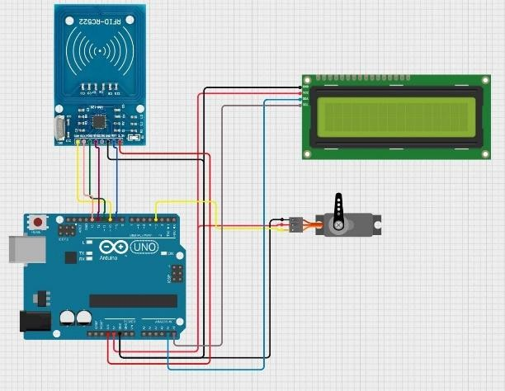
Fig. 1. Circuit diagram of the Smart RFID Security Lock System.

- Components
The system uses the following components:
  - Arduino Uno: ATmega328P, 5 V, 16 MHz
  - RFID Module (RC522): 13.56 MHz, SPI interface.
  - LCD Display (16x2): I2C interface for real-time messages
  - Servo Motor: Controls door locking mechanism
  - Power Supply: 5V sources for stable operation.

TABLE I
Key Component Specifications

Component | Specification
Arduino Uno | ATmega328P, 5 V, 16 MHz
RFID RC522 | 13.56 MHz, SPI interface
Servo Motor | 5V
LCD Display | 16x2, I2C interface
- Simulation and Experimental Setup
- Simulation
The system was tested through real hardware implementation. Multiple RFID cards were scanned to verify authentication accuracy and system response. Both valid and invalid access attempts were evaluated to ensure proper functionality.

- Hardware Prototype
A physical prototype of the system was constructed on a compact base using a breadboard for circuit connections. The RFID RC522 module was positioned at the entry point for card scanning, while the Arduino Uno served as the main controller. A 16×2 I2C LCD display was used to provide real-time user feedback, displaying messages such as “Welcome” and “Put your card.” A servo motor was integrated to simulate the door locking and unlocking mechanism. The components were interconnected using jumper wires, and the system was powered via a USB supply. Testing of the prototype confirmed reliable performance and accurate authentication under real-world conditions.
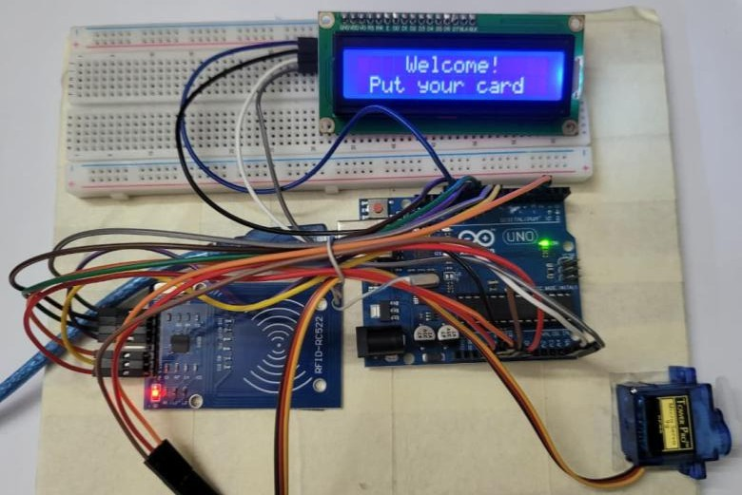

Fig. 2. Hardware prototype setup of the security lock system.

- Results and Discussion
- Survey Results
A survey of 100 Dhaka residents showed:
  - 88% willing to purchase a smart lock priced 3,000–8,000 BDT.
  - 100% valued integrated alarm systems.
  - 92% preferred LCD status feedback.

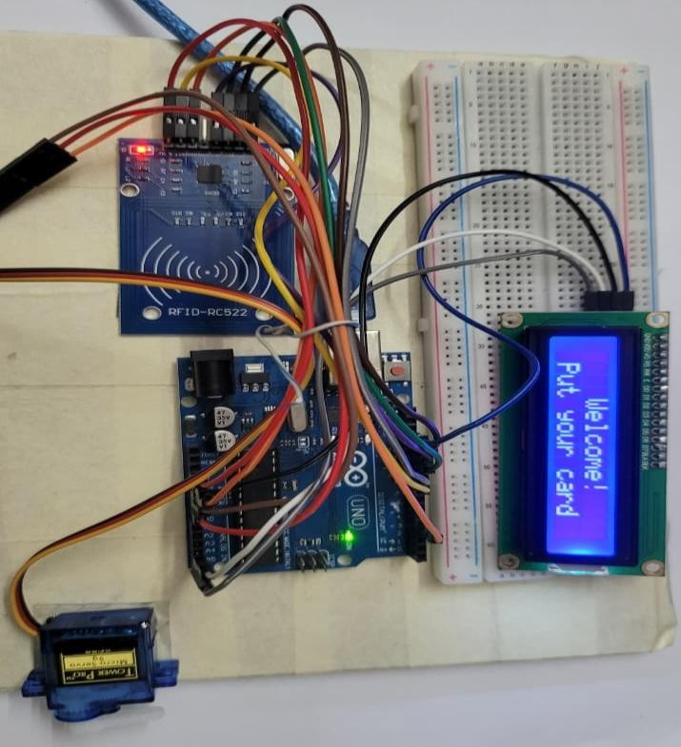
IX. Conclusion

The Smart RFID-Based Security Lock System successfully integrates RFID authentication and servo motor based lock, an affordable and reliable solution for Bangladeshi households and small businesses. High authentication accuracy, reliable detection, and low cost demonstrate its practicality. Future enhancements such as IoT and biometrics will increase its robustness and align with smart city goals.
Acknowledgment
The authors would like to express their sincere gratitude to Protik Parvez Sheikh, faculty member of the Department of Computer Science and Engineering, American International University–Bangladesh (AIUB), for his guidance and support throughout this project.

Fig. 3. Close-up view of the prototype implementation.

- Prototype Performance
  - RFID Authentication Accuracy: >95%.
  - Fast response time of the servo motor.
  - System Stability: 48-hour continuous testing with no card failure
  - Cost: 3,000–8,000 BDT.
- Discussion
Compared to prior works [2], [3], this system offers a simple and efficient access control system while remaining low-cost, unlike expensive IoT solutions [4]. Survey feedback suggests strong local demand.
- Limitations
- RFID cards may be cloned without encryption
- No remote monitoring or IoT integration
- System depends on continuous power supply
- Future Work
Planned improvements:
- IoT integration for remote monitoring and smartphone alerts.
- Biometric authentication (fingerprint, facial recognition).
- Battery or solar backup.
- Advanced encryption (e.g., AES-128) to prevent RFID cloning.
References
- A. Karim, “Urban security concerns in Bangladesh,” J. Urban Studies, vol. 12, no. 3, pp. 45–52, Mar. 2023.
- A. Singh et al., “RFID-based smart locking systems,” IEEE Trans. Consum. Electron., vol. 63, no. 4, pp. 321–329, Nov. 2017, doi:10.1109/TCE.2017.8111234.
- M. Rahman et al., “Sensor-based intrusion detection,” IEEE Trans. Secur. Syst., vol. 15, no. 2, pp. 134–142, Apr. 2019, doi:10.1109/TSS.2019.2905678.
- L. Chen et al., “IoT-integrated smart locks,” IEEE Internet Things J., vol. 7, no. 5, pp. 4123–4135, May 2020, doi:10.1109/JIOT.2020.2987654.
- R. Islam et al., “Affordable multi-layered security sys-tems,” IEEE Access, vol. 9, pp. 56789–56798, Jun. 2021, doi:10.1109/ACCESS.2021.3076543.

