
AMERICAN INTERNATIONAL UNIVERSITY-BANGLADESH
Faculty of Engineering

OEL Report
Experiment Title: Anti-Theft Alarm with Arduino and Ultrasonic Sensor

Date of Perform: | 02 September 2026 | Date of Submission: | 03 September 2026
Course Title: | Microprocessor and Embedded Systems Lab
Course Code: | EEE4103 | Section: | B
Semester: | Summer 2025-26 | Degree Program: | BSc in CSE
Course Teacher: | Protik Parvez Sheikh

Declaration and Statement of Authorship:
- I/we hold a copy of this Assignment/Case Study, which can be produced if the original is lost/damaged.
- This Assignment/Case Study is my/our original work; no part has been copied from any other student’s work or any other source except where due acknowledgment is made.
- No part of this Assignment/Case Study has been written for me/us by any other person except where such collaboration has been authorized.
by the concerned teacher and is acknowledged in the assignment.
- I/we have not previously submitted or am submitting this work for any other course/unit.
- This work may be reproduced, communicated, compared, and archived to detect plagiarism.
- I/we permit a copy of my/our marked work to be retained by the Faculty Member for review by any internal/external examiners.
- I/we understand that Plagiarism is the presentation of the work, idea, or creation of another person as though it is your own. It is a form of cheating and is a very serious academic offense that may lead to expulsion from the University. Plagiarized material can be drawn from, and presented in, written, graphic, and visual forms, including electronic data, and oral presentations. Plagiarism occurs when the origin of the source is not appropriately cited.
- I/we also understand that enabling plagiarism is the act of assisting or allowing another person to plagiarize or copy my/our work.
* Student(s) must complete all details except the faculty use part.
** Please submit all assignments to your course teacher or the office of the concerned teacher.

Group # 06
Sl No | Name | ID | PROGRAM | SIGNATURE
1 | SHISHIR MALLIK | 22-49643-3 | BSc in CSE
2 | SAIFUL ISLAM EMON | 23-55402-3 | BSc in CSE
3 | ROHIT MONDOL | 22-49774-3 | BSc in CSE
4 | MD SHAHAREAR NADIM | 23-50776-1 | BSc in CSE
5
6

Faculty use only
FACULTY COMMENTS | Marks Obtained
 | Total Marks

Table of Contents

Objectives | 3
Equipment List | 3
Circuit Diagram | 4
Experimental Output Results (Color Photographs) | 7
Discussion | 8
References | 9

Marking Rubrics (to be filled by Faculty):
Level Category | Excellent  [5] | Proficient  [4] | Good  [3] | Acceptable  [2] | Unacceptable  [1] | No Response  [0]
Title and Objectives | Able to clarify the understanding of the lab, no issues are missing and formatting is good. | Able to clarify the understanding of the lab experiment, no issues are missing but its formatting is not good. | Able to clarify the understanding of the lab experiment, but a few issues are wrong, and its formatting is bad. | Able to clarify the understanding of the lab experiment, but it lacks a few important issues of the experiment without maintaining the format. | Unable to clarify the understanding of the lab experiment. | No Response/ copied from others/ identical submissions with gross errors/image file printed
Codes and Methods | Able to explain the experimental codes and simulation methods using Proteus very well. | Able to explain the experimental codes and simulation methods using Proteus but is not formatted well. | Able to explain the experimental codes but simulation method using Proteus is not explained well. | Presents the experimental codes but didn’t explain simulation methods using Proteus clearly. | Presents the experimental codes but didn’t explain simulation methods using Proteus.
Results | Key results and images are there. Figures/Tables have all identifications and refer to them properly in the texts. | Key results and images are there. Figures/Tables have all identifications, such as the axis labels, numbers, and captions with a few minor errors; the texts refer them. | Key results and images are there. Figures/Tables lack a few identifications, such as the axis labels, numbers, and captions; the texts refer them. | Misses several key results and images. Figures/Tables lack identification, such as the axis labels, numbers, and captions; the texts don’t refer them. | Major results, such as experimental and simulation results’ images are not included. Figures and tables are poorly  constructed or not presented.
Discussion and Conclusion | Proper interpretation of results and summarizes the results to draw a conclusion, discusses its applications in real-life situations to connect with the report’s conclusion. | Proper interpretation of results and summarizes the results to draw a conclusion but didn’t discuss its applications in real-life situations to connect with the conclusion of the report. | Interpretation of results is presented. However, there is a disconnect between the results and discussion. | Misses the interpretation  of key results. There is little connection between the results and discussion. | Very poor interpretation of  the results. No connection  between results and discussions.
Question and Answer | Able to produce all questions’ answers correctly maintaining the lab report format. | Able to produce all questions’ answers but didn’t maintain the lab report format. | Able to produce all questions’ answers but wrong answers to a few questions. | Able to produce all questions’ answers but wrong/missing answers to multiple questions. | Unable to produce all questions’ answers and completely wrong answers.
Comments |  |  |  |  |  | Total Marks (25)

Title: Anti-Theft Alarm with Arduino and Ultrasonic Sensor

Abstract: This project is a Arduino based security system consists of a Arduino UNO, a ultrasonic sensor, a piezoelectric buzzer and LEDs. In this project we design and implement a security system with an ultrasonic sensor module. The ultrasonic sensor contains a transmitter and a receiver. The Ultrasonic transmitter periodically emits ultrasonic signals into an open area. If the signal ever hits any physical objects, it will be reflected back and the receiver part of the sensor will then capture it. The microcontroller unit (MCU) will constantly check for the receiver output of the ultrasonic transmitter. If the receiver output is high, the MCU will perform distance analysis of the object from the sensor using the fact that ultrasonic waves travel in air at 340m/s. The time taken for the waves to hit the object and return can be calculated as the time taken for the receiver output to be high after the transmitter has been initiated to send ultrasonic waves. Once the distance is calculated, MCU checks whether the object is within the range threshold specified within the MCU for initiating the alert. If the object is within the range threshold, the MCU initiates the buzzer and LEDs.

Keywords— Smart Parking, Microcontroller, Embedded Systems, Ultrasonic Sensor, Real-Time Monitoring, Traffic Optimization

Introduction
In today’s world, security has become a major concern for homes, offices, and restricted areas. Theft and unauthorized access can lead to significant losses, making it necessary to develop reliable and affordable security systems. Traditional security systems are often expensive and complex, which makes them less accessible for many users.
This project introduces a simple and cost-effective anti-theft alarm system using an Arduino microcontroller and an ultrasonic sensor. The system detects the presence of an object or person within a certain range and triggers an alarm. Due to its simplicity, flexibility, and low cost, this system can be widely used for basic security purposes.
  - Background of Study and Motivation
- With the rapid growth of technology, security systems have become an important part of everyday life. Theft and unauthorized access are increasing concerns in both residential and commercial areas. Many advanced security systems are available in the market, but they are often expensive and require complex installation and maintenance.
- The motivation behind this project is to design a simple, low-cost, and efficient anti-theft system that can be easily implemented by anyone with basic knowledge of electronics. Using Arduino as the main controller and an ultrasonic sensor for detection provides a reliable and flexible solution. This project aims to bridge the gap between affordability and functionality in security systems, making basic protection accessible to a wider range of users.
1.2 Objectives

- To design a simple anti-theft alarm system
- To detect motion or intrusion using an ultrasonic sensor
- To alert users through a buzzer or alarm system
- To create a low-cost and efficient security solution

1.3 Report Outline
This report is organized into several sections for better understanding:
- Abstract: Provides a brief summary of the project
- Introduction: Discusses the importance and purpose of the system
- Objectives: Highlights the goals of the project
- Components Required: Lists all necessary hardware
- Methodology: Explains how the system works
- Circuit Diagram Explanation: Describes the connections
- Background and Motivation: Explains the need for the project
- Literature Review: Reviews related existing systems and studies
- Results and Discussion: Presents the performance of the system
- Conclusion: Summarizes the overall findings and future scope

Literature Review
Several studies and projects have been conducted in the field of security systems using embedded systems and sensors. Traditional security systems often rely on infrared (IR) sensors, motion detectors, or camera-based surveillance. While these systems are effective, they may have limitations such as high cost, complex setup, or sensitivity to environmental factors.
Recent developments have shown that microcontroller-based systems, particularly using Arduino, provide a flexible and cost-effective solution. Ultrasonic sensors are widely used for distance measurement and object detection due to their accuracy and reliability. Compared to IR sensors, ultrasonic sensors perform better in varying lighting conditions.
Previous research highlights the use of Arduino with different sensors to create smart security systems. Some systems include GSM modules for sending alerts, while others integrate IoT for remote monitoring. This project focuses on a simpler approach by using an ultrasonic sensor and buzzer, making it suitable for beginners while still maintaining efficiency.

Methodology and Modeling

Methodology
The system follows a simple step-by-step process:
- The ultrasonic sensor continuously emits ultrasonic waves
- The waves reflect back after hitting an object
- The sensor calculates the distance based on the time delay
- The Arduino processes the distance data
- If the detected distance is less than a preset threshold:
  - The system identifies it as an intrusion
  - The buzzer is activated
- If no object is detected within the threshold range:
  - The system remains idle

Modeling of the System
The system can be represented in three main stages:
Input Stage:
- Ultrasonic sensor collects distance data
Processing Stage:
- Arduino microcontroller analyzes the data
Output Stage:
- Buzzer generates an alarm when intrusion is detected
This can be expressed logically as:
- If Distance ≤ Threshold → Alarm ON
- If Distance > Threshold → Alarm OFF
  - Description of the components:
- This project uses several electronic components that work together to detect intrusion and generate an alarm:
- 1. Arduino Uno
The Arduino Uno is the main microcontroller of the system. It processes input signals from the sensor and controls the output device (buzzer). It is programmable, easy to use, and widely used in embedded systems.
- 2. Ultrasonic Sensor (HC-SR04)
This sensor is used to measure distance. It emits ultrasonic waves and calculates the time taken for the echo to return. Based on this time, it determines the distance of an object from the sensor.
- 3. Buzzer
The buzzer acts as the alarm. When the Arduino detects an object within the defined range, it activates the buzzer to alert the user.
- 4. Breadboard
A breadboard is used to assemble the circuit without soldering. It helps in easy testing and modification of the system.
- 5. Jumper Wires
These wires are used to connect all the components on the breadboard and Arduino.
- 6. Power Supply
The system is powered using a USB cable or an external battery connected to the Arduino.

Experimental setup
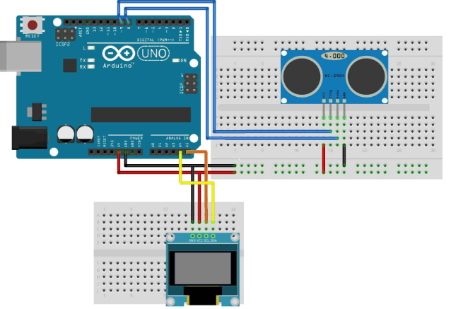
Figure 3. Arduino-Based Anti-Theft Alarm System Using Ultrasonic Sensor

Hardware Implementation:
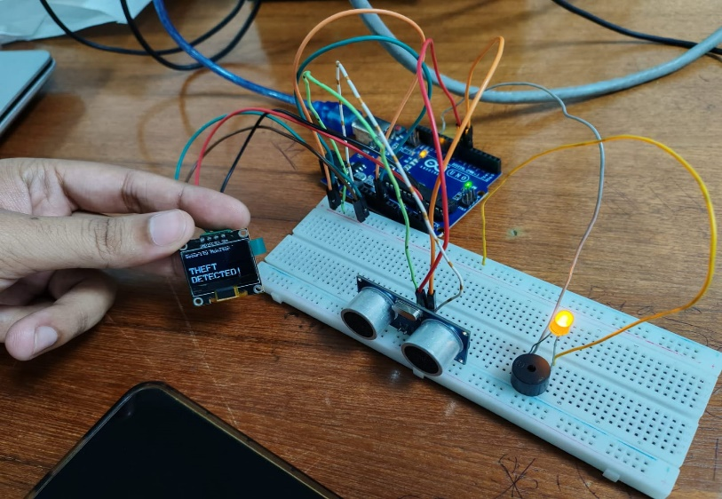
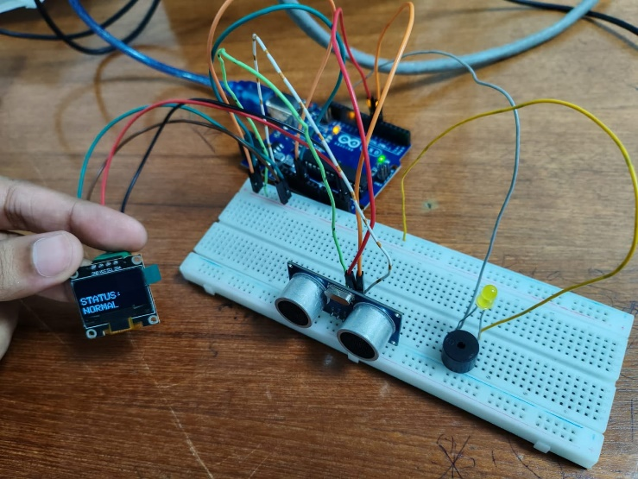

Figure 3: Arduino-Based Anti-Theft Alarm System Showing Normal Monitoring Condition

Fig 2: Arduino-Based Anti-Theft Alarm System in Normal Monitoring State

Result and Discussion

The developed system was tested under different conditions to evaluate its performance.
- The ultrasonic sensor successfully detected objects within the specified range (e.g., 20 cm).
- When an object entered the threshold distance, the buzzer was activated immediately.
- The system responded quickly and accurately in most cases.
- It worked effectively in normal indoor environments.
Discussion:
The results show that the system is reliable for short-range intrusion detection. The ultrasonic sensor provides accurate distance measurement, and the Arduino processes the data efficiently. However, slight variations in readings were observed due to environmental factors such as obstacles, angle of detection, or noise. Despite these minor limitations, the system performs well for basic security purposes.

Conclusion and Future Endeavors

Conclusion
This project successfully demonstrates the design and implementation of an anti-theft alarm system using Arduino and an ultrasonic sensor. The system is simple, cost-effective, and easy to build. It can detect nearby objects and alert users through a buzzer, making it suitable for small-scale security applications.

Future Endeavours
The system can be further improved by adding advanced features such as:
- GSM module to send SMS alerts
- IoT integration for remote monitoring via mobile apps
- Camera module for capturing images or videos
- Motion sensors for enhanced detection
- Battery backup system for uninterrupted operation
These improvements can make the system more efficient, reliable, and suitable for real-world applications.

References

Arduino. (n.d.). Arduino official website. https://www.arduino.cc
HC-SR04 Ultrasonic Sensor. (n.d.). HC-SR04 ultrasonic sensor datasheet. Retrieved from https://datasheetspdf.com
Mark Geddes. (2016). Arduino project handbook: 25 practical projects to get you started. No Starch Press.
ResearchGate. (n.d.). Embedded systems and security system research papers. https://www.researchgate.net
Electronics Hub. (n.d.). Arduino based security system tutorials. https://www.electronicshub.org

