What do I already know about this topic?
People have reported real experiences with the supernatural – Ghosts, divine intervention, OBEs, Afterlife, Devils, rituals, magic, spells, God, angels, etc.
Ghosts: Dead souls roaming the planet, sometimes interfering with the living.
Divine intervention: Messages from angels & guiding spirits, Holy ghost, God himself/herself.
OBEs: Soul leaving the body. They are able to see more than the physical world.
Afterlife: Souls undergo life review, judgement, heaven/hell, punishment, re-incarnation, growth, etc.
Devils: Satan’s minions. They tempt other physical beings to do evil and be judged. They make people suffer trying to send them to hell, do bad things to people, etc.
Rituals: Something people do to get favours from higher powers be in natural or supernatural.
Magic: Inducing some kind of supernatural events.
Spells: Something people utter to make something happen.
God: The most powerful being in-charge of the entire universe. He judges and rewards being based on their activities on earth. He can incarnate to teach people or accomplish his objectives on earth.
Angels: God’s minions. They work to accomplish God’s objectives, help people, do good, offer divine guidance. They’re in-charge of God’s people and offer support.
Powerful entities: -
UFO: -
What questions do I have about it?
- Are they real?
- How useful is it to get involved with these things?
- Where can we find the truth of these things?
- What are the things that can be termed as supernatural?
Coming up with ideas:
Read existing blog posts around the topic until an idea emerges organically. Then pick a blog post close to that idea, and iterate upon it. Make your version better, unique, and valuable.
Trending search terms:
- ghosts,
- telepathy,
- cryptids
Collecting resources:
Search for sources related to your main ideas?

Requirements:
- Site name - beyondtheveilblog.com
- Site Logo -
- Site title – Beyond the Veil
- Tagline - Uncovering the Mysteries of the Unseen World
- Header banner image
- Twitter page URL
- Instagram URL
- Posts (Main title, featured image, and excerpt per post)
- Contents for patterns:
  - Text columns pattern:
    - Sub-Heading
    - Some text content (Up to 5 paragraphs)

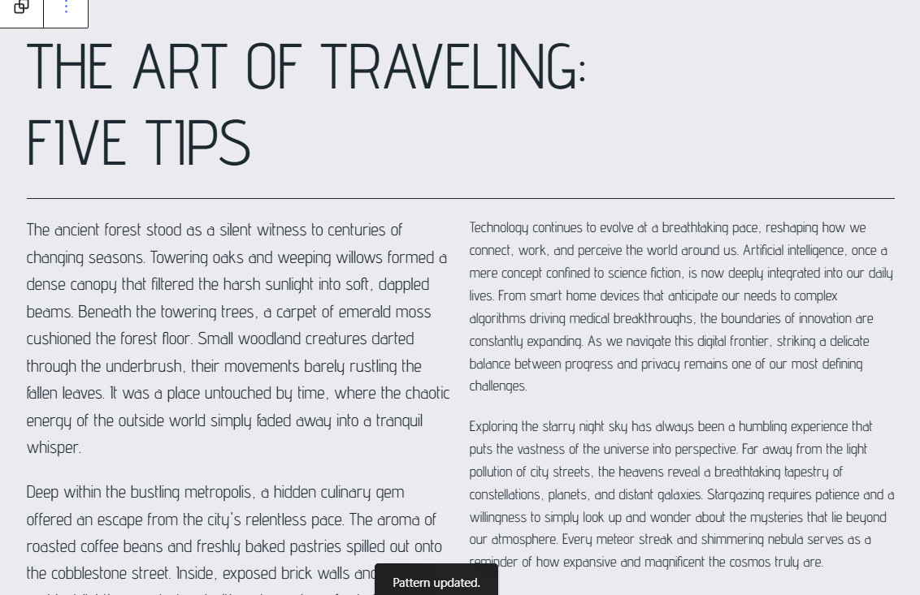
  - Media & Text pattern:
    - Image
    - Heading
    - Up to 2 paragraphs
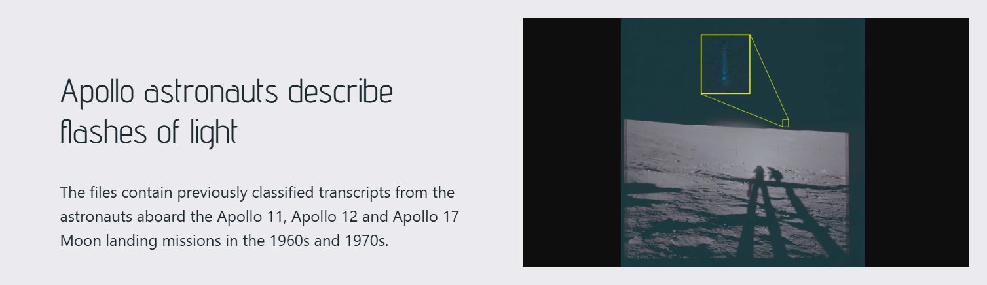
  - Columns block (up to 3 columns)
    - A short Sub-Heading per column.
    - Some text (up to 2 paras) per column
    - Image per column
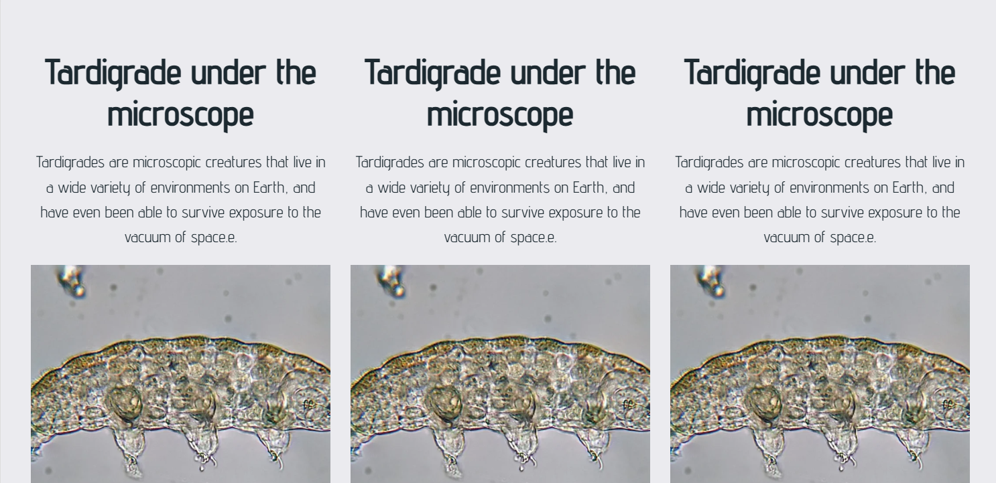
  - Cover block
    - Announcement text
    - Cover image
    - Call to action button

  - Embed Post
    - Post URL
  - Embed columns block
    - Up to 3 Embed URLs (Videos, audio, Spotify podcast, social media post, or maps)
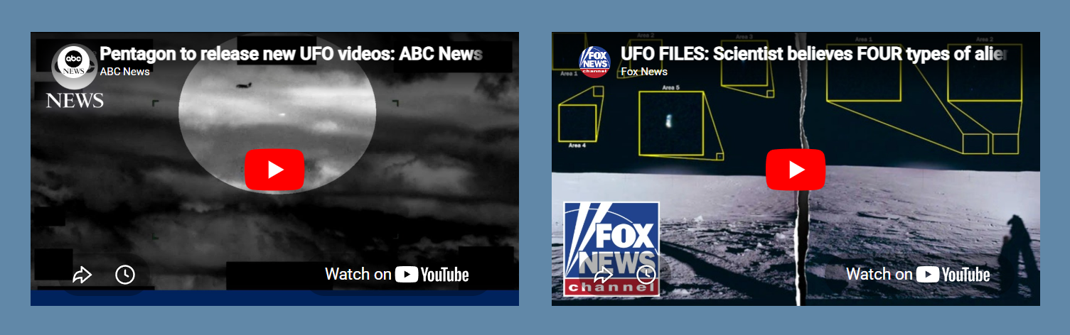
  - Lead to page block
    - Heading
    - Caption
    - Up to 2 attractive images.
    - Call to action button
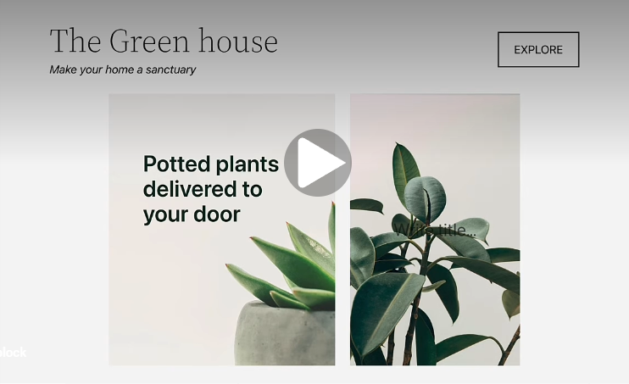
- Gallery block
  - Images
  - Title for gallery
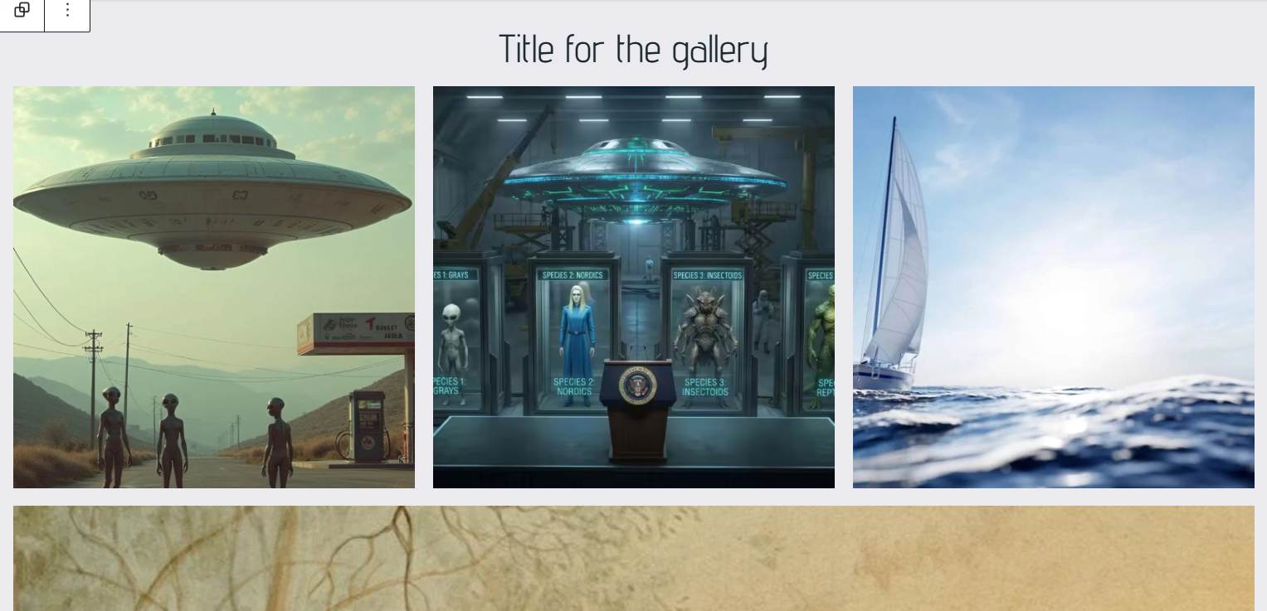

- Cool parallax effect
  - Two large images
- Category cards
  - An image per each category
  - Titles
  - Call to Action texts
- Images (must be jpeg, png, webp or avi). Use squoosh to convert image type if required. Header image size: 1200 x 628 px, Other types of images: 640 x 480 up to 1024 x 768 px
- Reduce image dimensions if possible (use tinypng.com or squoosh)
- Edit page 404 template
  - Cover image
  - A caption

- Single posts page template layout:
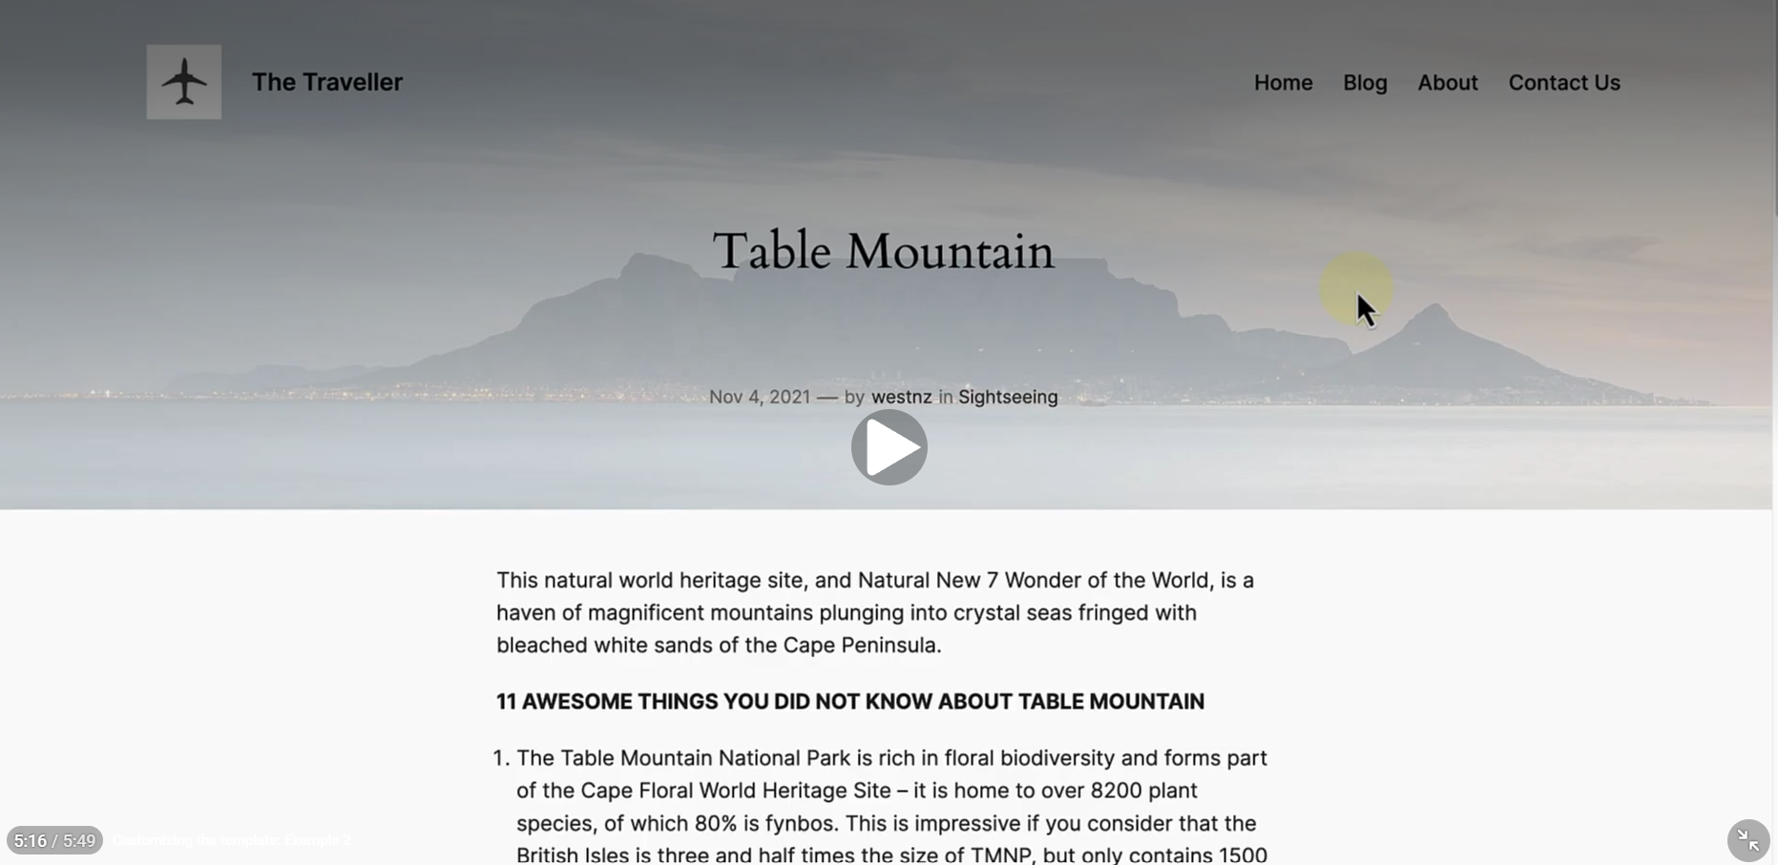

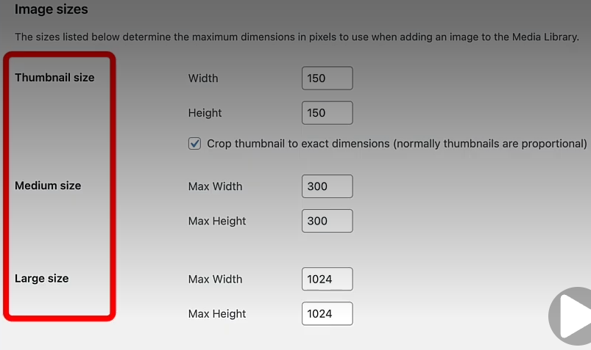
- Use tinypng or squoosh to reduce file size without compromising quality.

While researching:
- What answers or guidance will my reader be looking for?
- When was this published (is it recent or outdated)?
- Who is the author or publisher (are they known in the industry)?
- Where is the content located (on a trustworthy site or somewhere else)?
- Capture things that stand out, such as quotes, main ideas, and additional questions that come up.
- Knowing the reader's intent will help you sort valuable sources from distractions.
As you comb through your collection, you'll start to notice trends and recurring themes. These will likely become the main points in your article outline. The best outlines combine brainstormed ideas with the insights collected from research.
The last step before forming your outline is to look at what your competitors have written about your specific topic. Am I missing anything important?
Review your competitor's blog and social media profiles for the research topic to spot any important points you may have missed.
Once you've identified any important gaps, repeat steps 2 and 3 exclusively to fill the information gap.
Focus on the sources that best support your main idea and are easy for your readers to understand. Anything that may cause a reader to be confused or to follow an unrelated tangent doesn’t belong in your outline.
Many outlines follow this format:
Introduction to the main idea.
Additional context about the topic.
What’s important for your reader to know before getting to the major points.
Body of blog post, usually consisting of several related points:
- Point 1, supported by research.
- Point 2, supported by research.
- Etc.
A summary or conclusion that reiterates the main idea.
A solid outline will include a list similar to the one above, with a sentence or two about each main point along with links, files, or images to support each one.

Musings:
There should be plenty of media channels hogging on google search engines looking for trending topics. This might be a great opportunity to create in-demand content and generate a good amount of site traffic.
How to monetize site traffic? – Ads
How to find advertisers? – They will find you. You share it (attention) for a price.
[
Keep on improving SEO strategies -> Define new design & technical requirements -> Implement new designs and technical requirements -> Find & Add new content
Keep on increasing site traffic -> Keep on sharing it for increased prices
]
How does site traffic work on social media platforms like Instagram and facebook?
Learn Instagram SEO and Facebook SEO to learn about latest trends so that you can better strategize your content on those platforms. The content format would depend on the platform.
Instagram or Facebook content – Images and Short video formats (video & audio editing, camera recording, videos and audio, speech recording, etc) focuses more on entertainment and eye-catching content.
Google – Text, Images and videos focus more on the knowledge.
Youtube trends can be accessed via Google since Google owns Youtube now.
I am feeling unsure how long this takes to generate actual revenue and I am running out of money. I have to generate results quickly (in 2 months). The last time I was in the same situation, I had gotten a job out of nowhere. I was trying to create a website during the unemployment phase and dropped it as soon as I got hired. I was not in control whatsoever. I didn’t even apply to the company. I got a call from nowhere.
The manager who interviewed me was also surprised that I had no idea about the client company, nor the consulting company. I was so desperate that the whole process of getting hired and working for the company felt like I was being dragged across a tar road for 3 whole years.
This time, before that happens, I will be ready with my new strategy: Listening first, waiting and responding. It was Listening -> Responding immediately (without waiting) and sometimes talking/responding without even listening.
I am not sure if I should keep trying or I should just wait for something to happen. The job descriptions usually never say the interesting part. I have to guess how python or a programming language will be useful.
If I refer to official documentation for the programming languages, they don’t have anything interesting going on there. They appear too monotonous and directionless. Ultimately all the companies are looking to generate revenue.
In the physical world, it is about identifying the trends and strategizing product creation. Whereas in software, it is about identifying trends and strategizing content creation.
So where is the programming languages used? – In the tools they use like maintenance, migration, modifications, new features or enhancements. It is usually repeating or modifying with minor often negligible differences. The main portion of revenue generation happens in the tool usages.
Then why do we have so many software engineering jobs? – Most people don’t know how to use the tools correctly and lack proper direction. They suck at strategizing or don’t strategize at all. They get stuck in a never-ending cycle of iterating over existing features thinking they are working, while they are just passing the time to get a pay check.
Reason for company close downs – They are mostly start-ups, not real companies. They are just doing the above thinking they’re making any difference. If working feels like you’re being scratched on a vegetable peeler, it’s a fake company.
How to identify fake companies – They don’t have a real product you can try out for free. You cannot tell what the company is really about. The content on their website is too generic.
Why does interacting with people (and life itself) feels like working in a fake company – Because it’s a fake world. It’s full of temptations and traps.
How to navigate this fake world safely – Be very careful to not give your attention to seductive women; Do not get carried away with the events of this world. Be in the present always. You can use the clock to check-in every 10 minutes.
How to deal with people around you – Do not speak first. Let them speak, wait for them to finish and only then respond.
How to deal with your past bad memories – Use it as a reminder that you should not speak first.
How to prepare resume for real jobs – Put words that matches your relevant past experience. Add fillers for correct grammar. Use any template that looks decent.
How to prepare a portfolio – Add details about your past projects you have worked on to your resume.
How to join the right company – Find a company that matches your interests using google search. It’s usually easy to find. You will find straight forward instructions in their website on how to join them. Everything will be transparent.
To stay out of depression – Do not speak. Listen – wait – respond
How to deal with sexual urges – Drink water, eat light, stay away from any kind of feminine visuals, remind yourself that it is temporary. Keep yourself engaged by working on your goals.
How to speed up the process – Be active in the jobs page. Just follow their instructions.
Where can I find instructions on job search from real companies – In their jobs page.
How can I find the right job – Search for areas you’re most familiar with or something you’re interested to work on.
How can I find a suitable job – Just look around and find an action item. Perform the action and repeat this process until you feel comfortable.
The interview process is too intensive. I am not at all that passionate about programming in python or other languages – Every job interview requires preparation. It gets easier as you prep for the interviews.
The interview process takes too long. Is there a way to make money by other means in the meantime – Apply for less demanding roles.
How can I find less demanding job roles – Apply for sub-tier companies instead of targeting giant parent companies. Where can I find such companies – Use google search for job postings. Assess the companies by looking at what they’re offering, clarity and specificity. And follow their jobs page.
What keywords to use in google search – jobs, software engineering, python, web development.
Is there a way to use tools available on line for free to generate income while I try to get a job – No. Cashflow is not in your control. Do I need to struggle looking to get hired – No. You will do it anyway because of peer pressure and the need to act.
How to write a cover letter – Introduce yourself. How – Say your name, your background, your intention, interests.
I am tired of applying to jobs. I feel depressed. What to do – Prepare for assessments
What to do with depression – Wait for 5 nights.
How to pass 5 nights – Be present, check-in every 10 minutes to pass the time quickly.
What tool or framework should I start preparing for – Pick the most important tool from the job description, explore use cases and implementation.
How to achieve astral travel anytime – You have to bring your awareness outside your body. How – You have to close all your senses and forget your body. How – Block your sensory inputs (wearing eye mask and ear plugs). Make an attempt to check the time every 10 minutes and confirm whether you’re in a dream or reality. Continue to do the same even while sleeping. How to do this in sleep where you don’t have access to a watch or time display – Just guess. The time duration between every check need not be exact.

Job application for tomorrow: https://careers.ibm.com/en_US/careers/JobDetail?jobId=110842&source=WEB_Search_INDIA
I feel bored & depressed, not sure what to do – check every 10 minutes.
Why do I feel worthless - I feel undesirable. You're too restless around people. Stay relaxed, move slowly (physically).
Why do I feel stuck in this house - You've settled here. It will take a lot of time and effort to move elsewhere.
------
Why can't I get lucid dreams - Your mind is too restless.
How to relax the mind to get lucid dreams - Effortlessly fixate on something.
On which object can I effortlessly fixate my mind - Job search at the moment.
------
Why do I feel uncomfortable around them - Because you attention is pulled in their direction.
Can I consider myself on retention - You had 2 full nights to recover. You ate food, drank water, You are on retention. Carry on. But don't look at women.
------
I get asked only data related questions like what time we left the house, how long did it take for X, etc . How can I be ready with answers - Observe time, place, duration, counts, names, relationships.
How to find interesting movies on Ott platforms - check description
It feels like I lost all respect from others including my wife - I am unable to find a job and I am running out of cash. I don't feel desired anymore -
Do not get peer pressured. Move at your own pace. Pressure, urgency, desires and guilt are like catalysts for deception. They are created and used to deceive you later.
I still feel lethargic, unsure what to do. I don't feel excited for anything - wait for 2 more days. How to spend 2 more days - check every 10 minutes.

I got sent a weird job that I hate - apply if you feel like. Leave the result to chance.
I feel so like shit right now, depressed, rejected, unwanted, etc I'm unable to feel happy.
I don't feel desired.
Continuous retention for 30 days (don't look at women)
Daily workout
Daily meditation
Stay relaxed
Keep trying for a job you desire
Remove facial hair
----
Removed facial hair and tried for a job, still feel depressed.
Did you stay relaxed?
How to stay relaxed - move slow physically.
----
Why did we need money to live - because we are used to cooked meals and factory-made foods and items.
All of this come from a higher power beyond your comprehension. They control the population with money.
Why am I in shortage of money - it's for your own well-being. Too much of it may be harmful to you. Everything is being controlled and managed. You can only watch.
What is our purpose, what do they want with us - It's a simulation. Like a game, they are trying to maintain it. They're trying to give everyone platform to live and experience their lives.
Why India is dirty - it's hard to clean our garbage.
Why is our garbage unbearable - Too much fat and oil in our foods.
Why are there so much oil and fats in our foods - tropical climate drains away a lot of energy too quickly due to heat and we generally require more fats to maintain our body.
I can’t find the right job – Keep looking.
I feel so depressed and undesired or uncool – Let it be, don’t push it. Everything takes a lot of time. Wanting to be desired/cool or happy all the time is a trap and deception anyway.
How to enjoy an outing, especially with other people in a lunch gathering – Stay quiet, let others do all the actions. Let them butt heads, run their mouths and bodies, shake, drag, etc. You can just rest on it and ride it, watch the scenery. What if they notice it and complain – Pitch in, say something. Push it to continue turning the wheel and sit back and enjoy the ride again.
I feel like I’m being dragged down – You’re just low in energy. Also, when your senses are hyper-engaged, this happens.
I can’t figure out how the tools that are mentioned in the job descriptions are being used – Visit their website, read their suggested use cases.
Everything already exists. What should I even do – check every 10 minutes. Watch/Listen/Consume.
N1 I feel so powerless – Yes. Against life, you’re powerless. Why am I being attacked – You’re blocking people. You’re generally slow. You make people wait. How to unblock them – Stay out of their purview. How – Declutter, walk outside, move away from them whenever possible.
What to do or handle during my bad punishment phase – Look down, read something, come back to 10-minute checks.
How to enjoy the books – Explore more data by expanding on the text in multiple directions if needed.
I have noticed that I feel very sad and depressed from waking time till noon. And it gets progressively better by evening and much better by night. How to reverse this or fix my mornings – Read N1.
Living with Sharanya’s mother is hard. I feel sad, irritated, angry all the time - Read N1.
I really like this job Python developer How to can I apply successfully - Curate your resume according to the JD, provide all the details and apply. How to curate my work experience with the job – Read the responsibilities section. Add anything that clicks.
I have found an automation tool called Codex. Now I don’t know what outcome to accomplish. I know I can’t ask it to just give me a job – You can automate your daily tasks. Note down all the tasks you are doing every day for a month. Try to automate your tasks using Codex. I wake up, go out for a walk, meditate, workout, eat food, cook sometimes, buy vegetables, supplies, groceries, pay bills, reply to people, answer messages, phone calls, apply to jobs, attend interviews, watch cricket, YouTube, movie, read books – explore ideas by branching out to find audio visuals online, document interesting ideas.
- Buy vegetables, supplies, groceries
- Pay bills – Electricity bill, Maintenance, Maid fees, internet bill, phone talk-time recharge
- Reply to WhatsApp messages
- Apply to jobs
- Attend interviews
- Read books - explore ideas by branching out to find audio visuals online, document interesting ideas
I don’t know what to do right now. My in-law and my wife are screaming about useless topics. I don’t know how to deal with this harsh situation. Every moment is scary. I don’t know how to avoid this situation or get out of it. Nobody is there to save me as well. I am in the spotlight of the discussion. – Let them talk, don’t add ghee to the fire.
In this world, every day seems to be like the survival of the fittest. I hate this aspect of life – Don’t play to win. You can play to lose.

How to find my own interest – Your goal is right below. It’s SEO, web content strategy, Word press site design & development.
I still don’t know how to get results with tool usage. I have worked for 3-4 hours without any result. Today you found the tool, tomorrow, you will learn to use it. There are hundreds of tools out there. Finding the right tool and learning the tool will take at least 10 days. 5 tools will take 50 days. Then, using the tools to get results will take some more time. How long? – 1 month at minimum. With distraction, set aside at least 3 months (or 80 days) to get any result.
How many months do I have? – With a budget of 15K per month, you have 8 months at max.
Clear plan – Spend 8 hours each day on the guideline.

Find tool or sub-tool -> Learn to use -> Use it (Times 5) – 15 times 5 = 75 days

Fine-grain plan – Revealed after finding all the tools and sub-tools
Tools:
Research: notebooklm, grok.com (Find & Add new content)
Trending topics:
- Roblox
- NBA
- Real madrid
- Weather
- Claude AI
- Hantavirus
- Spurs
- 67
- Arsenal
- Palmeiras
- Poki (Games)

Search terms related to supernatural topic:
supernatural beings
supernatural events
supernatural things
best supernatural movies
supernatural examples

- Automated routine manual processes to decrease both costs and time investment.
- Analysed and applied large complex SQL queries to produce essential reports for business users.
- Created tailored features and solutions regularly alongside on-site business users and product managers.

