BMI270 + IIS2MDC: Measured vs Datasheet
Test data, 6 to 7 October 2026

Test conditions
Item | Value
Supply / interface | 3.3 V, I2C 100 kHz, Arduino Uno
BMI270 settings | Accel +-8 g, 100 Hz, normal filter. Gyro +-2000 deg/s, 200 Hz, performance mode
IIS2MDC settings | 50 Hz, high-resolution, offset cancellation on, LPF on, temperature compensation on, BDU on
Run 1 (BMI270) | Still segment 1 to 27 s, 127 samples, ~5 Hz
Run 2 (BMI270) | 37 s still, 188 samples, ~5 Hz
mag1 (IIS2MDC) | 40 s still, 2014 samples, 50 Hz
proj1 (IIS2MDC) | Multi-orientation tumble, 33,275 samples, 50 Hz
Datasheets | BMI270 BST-BMI270-DS000-08, IIS2MDC DocID030986 Rev 1

1. BMI270 accelerometer
Parameter | Datasheet | Run 1 | Run 2 | Result
Zero-g offset (as |a| - 1 g) | +-20 mg (Table 2, p.12) | +1.3 mg | -0.2 mg | Pass
Noise, X | ~1.0 mg rms * | 0.9 mg | 0.9 mg | Pass
Noise, Y | ~1.0 mg rms * | 1.1 mg | 1.4 mg | Pass
Noise, Z | ~1.0 mg rms * | 1.0 mg | 1.0 mg | Pass
|a| noise |  | 1.0 mg | 1.0 mg
Mean X / Y / Z |  | +0.002 / -0.049 / +1.000 g | +0.014 / +0.044 / +0.999 g | Tilt, not error
Sensitivity error | +-0.4 % (Table 2, p.12) | Not measured | Not measured | Needs 6-position test
Cross-axis | 1 % (Table 2, p.13) | Not measured | Not measured
Offset temp drift | +-0.25 mg/K (Table 2, p.12) | Not measured | Not measured
* Noise density 0.16 mg/rtHz (Table 2, p.12) x sqrt(~40 Hz bandwidth). Measured noise is limited by the 0.001 g print resolution.
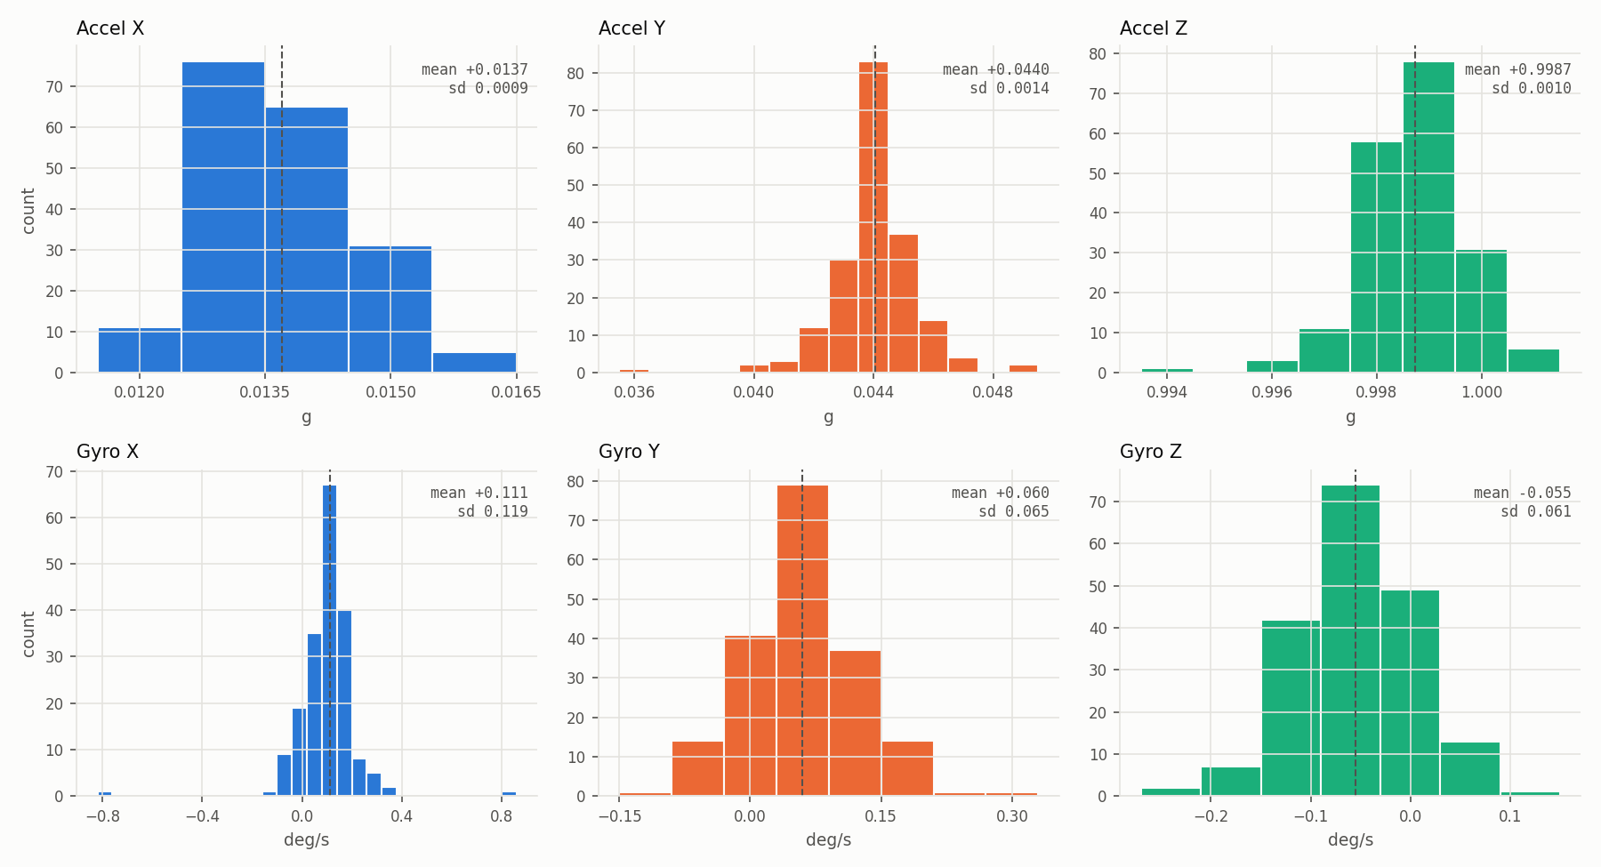
Figure 1. Run 2 value histograms, accelerometer (top) and gyroscope (bottom).

2. BMI270 gyroscope
Parameter | Datasheet | Run 1 | Run 2 | Result
Zero-rate offset X | +-0.5 deg/s (Table 3, p.14) | +0.113 | +0.111 | Pass
Zero-rate offset Y | +-0.5 deg/s | +0.072 | +0.060 | Pass
Zero-rate offset Z | +-0.5 deg/s | -0.060 | -0.055 | Pass
Noise X | ~0.06 deg/s rms ** | 0.124 | 0.119 | ~2x expected
Noise Y | ~0.06 deg/s rms ** | 0.083 | 0.065 | Pass
Noise Z | ~0.06 deg/s rms ** | 0.056 | 0.061 | Pass
Sensitivity error | +-2 % (Table 3, p.14) | Not measured | Not measured
Offset temp drift | +-0.015 deg/s/K (Table 3, p.14) | Not measured | Not measured
** Noise density 0.007 deg/s/rtHz, performance mode (Table 3, p.14) x sqrt(~75 Hz bandwidth). Offsets and noise in deg/s.

Integrated angle drift (Run 2)
Axis | Bias, first 10 s | Raw angle at 37 s | Raw drift rate | Bias-removed angle at 37 s
X | +0.117 deg/s | +4.18 deg | 6.7 deg/min | -0.17 deg
Y | +0.056 deg/s | +2.20 deg | 3.5 deg/min | +0.10 deg
Z | -0.048 deg/s | -2.17 deg | 3.5 deg/min | -0.38 deg
No datasheet value for in-run drift. Drift rate follows from the zero-rate offset: 0.117 deg/s x 60 s = 7.0 deg/min.
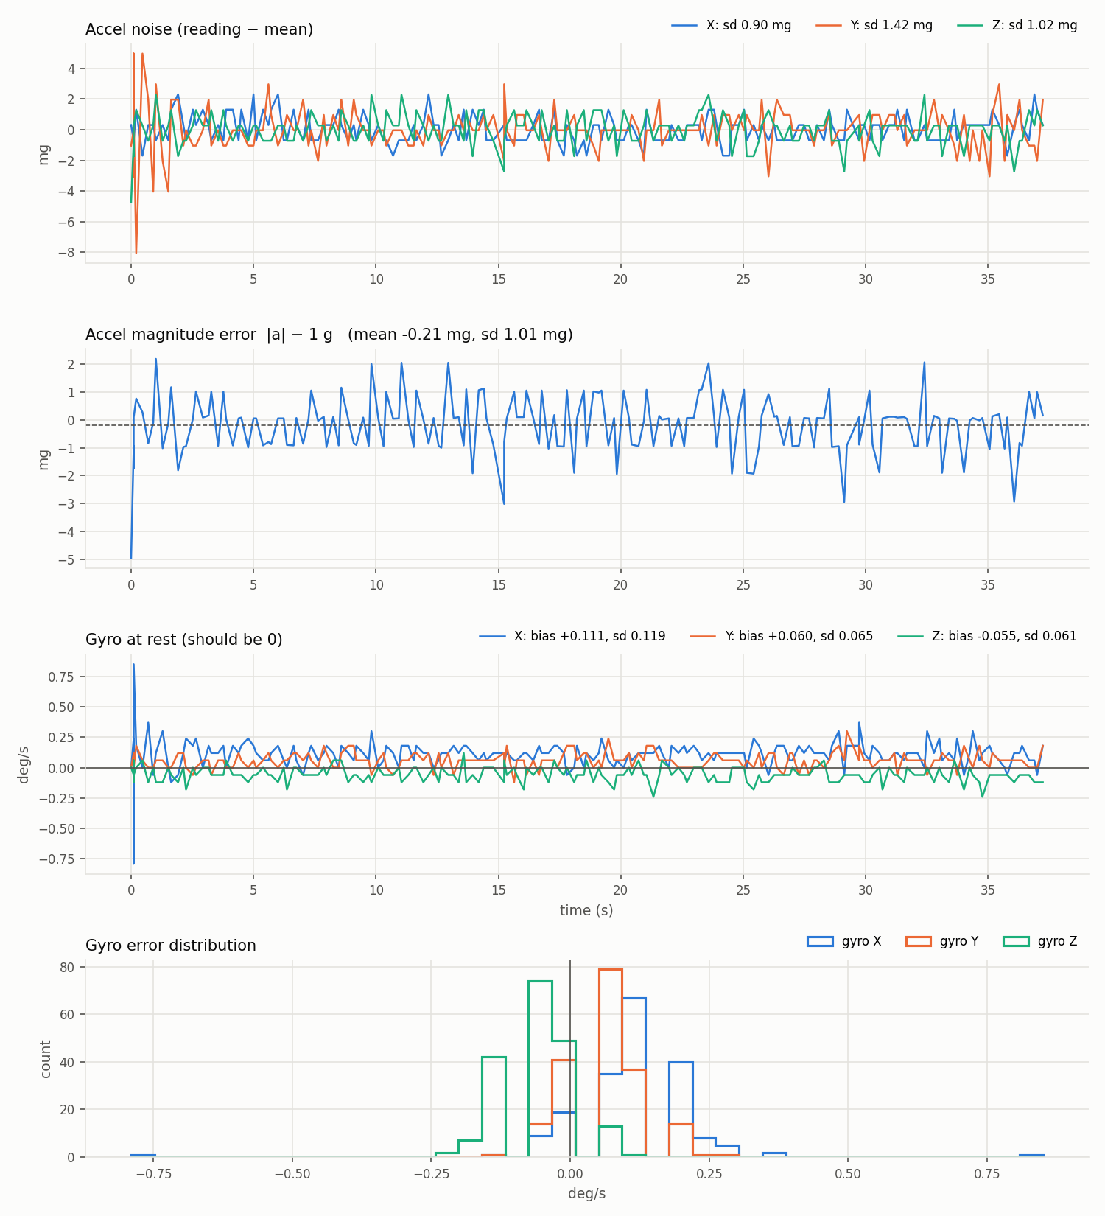
Figure 2. Run 2: accel noise, |a| - 1 g, gyro at rest, gyro distribution.
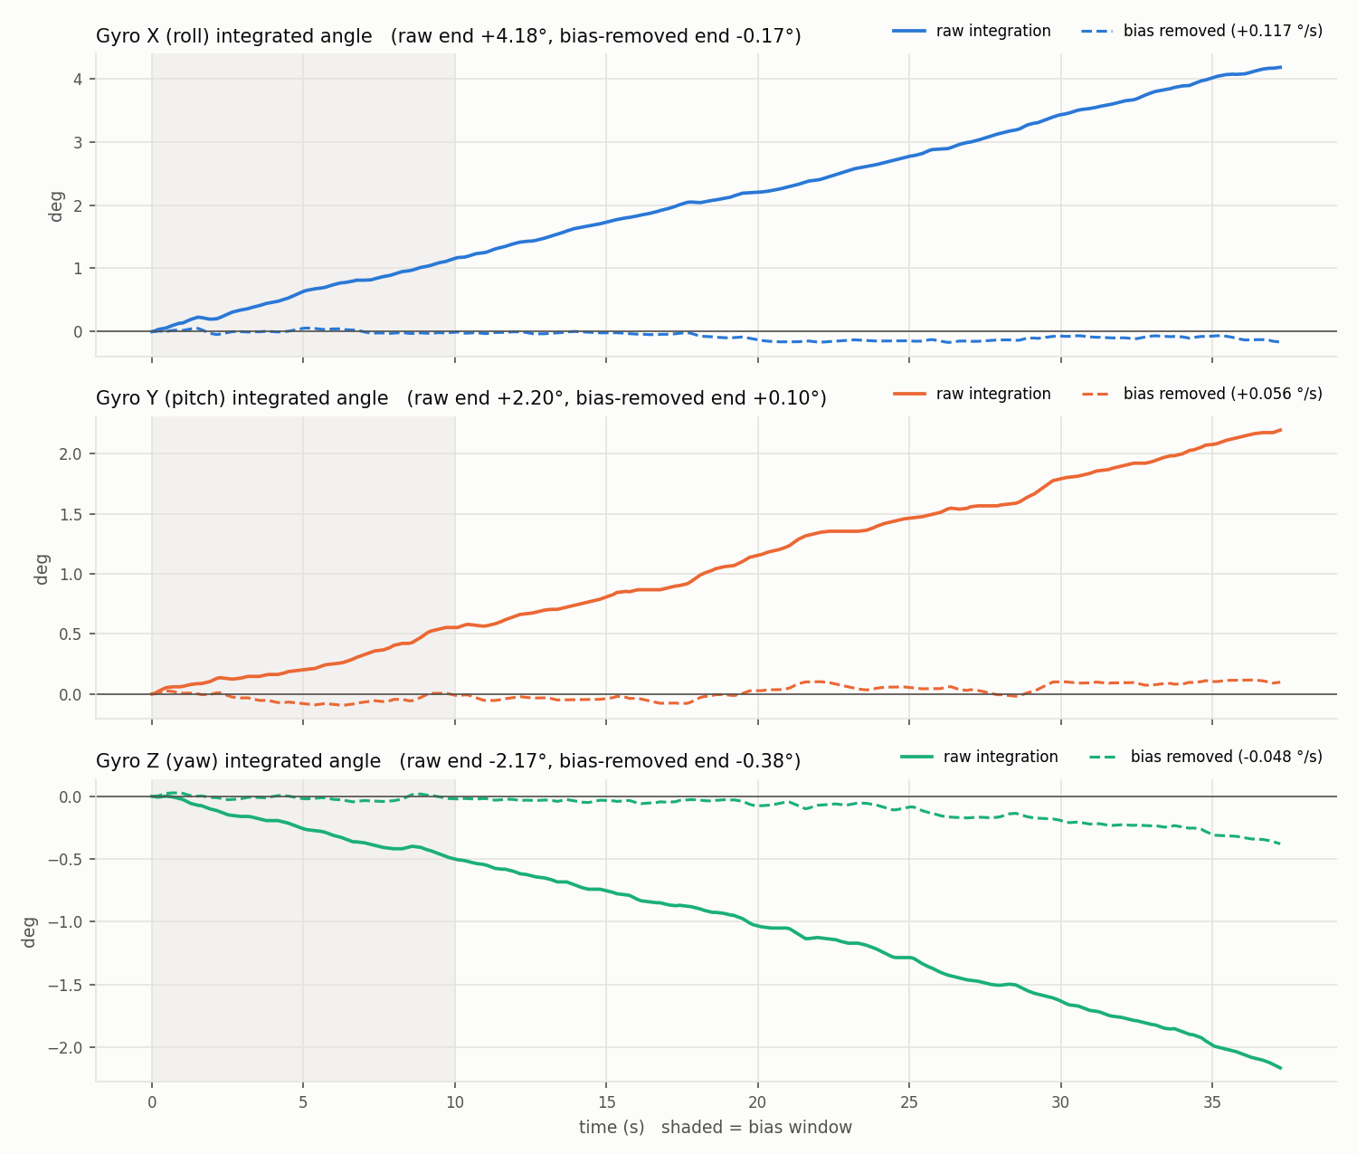
Figure 3. Run 2 integrated gyro angles. Solid = raw, dashed = bias removed (bias from shaded 10 s).

3. IIS2MDC magnetometer

Noise (mag1, still)
Parameter | Datasheet | Measured | Result
RMS noise X | 3 mG typ, 4.6 mG max (Table 3, p.9, Table 10, p.16) | 3.56 mG | Pass
RMS noise Y | 3 mG typ, 4.6 mG max | 3.23 mG | Pass
RMS noise Z | 3 mG typ, 4.6 mG max | 3.11 mG | Pass
|B| noise |  | 3.12 mG
Mean X / Y / Z |  | -120.8 / +212.2 / +62.8 mG | Uncalibrated
Raw heading jitter |  | 0.85 deg sd
Drift (2nd half - 1st half) |  | X +0.12, Y -0.13, Z -1.28 mG
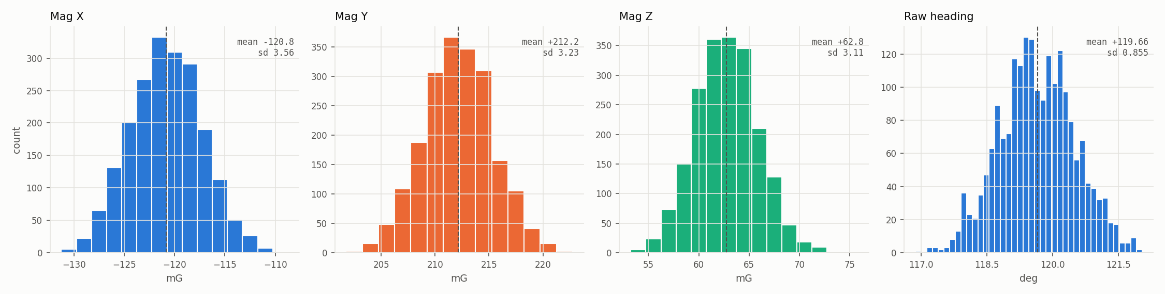
Figure 4. mag1 value histograms: X, Y, Z and raw heading atan2(-Y, X).
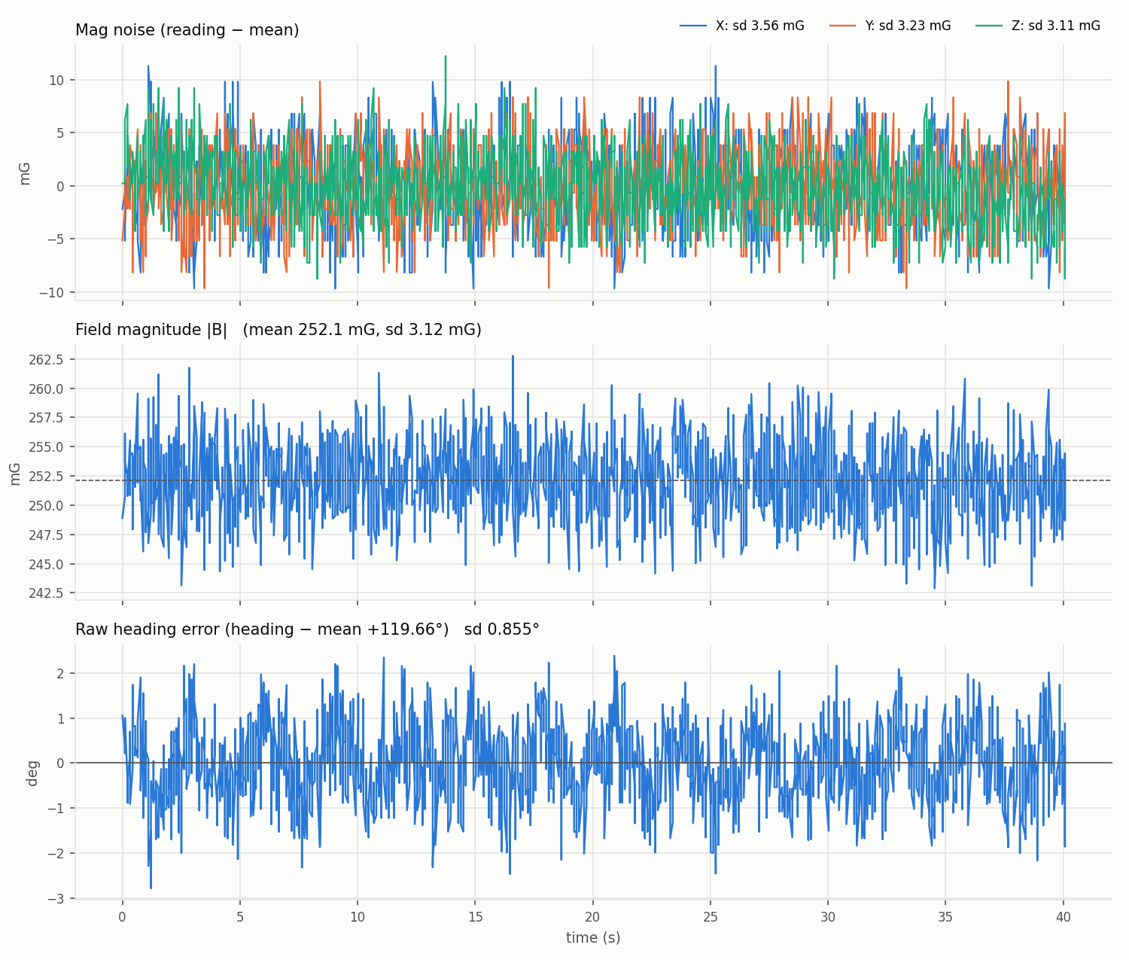
Figure 5. mag1: per-axis noise, |B| and heading jitter over 40 s.

Offset and sensitivity (from multi-orientation data)
Parameter | Datasheet | Ellipsoid fit (proj1) | MotionCal | Note
Offset X | +-60 mG (Table 3, p.9) | -94.4 mG | +82.4 mG | Includes nearby parts
Offset Y | +-60 mG | +68.6 mG | +37.1 mG | Includes nearby parts
Offset Z | +-60 mG | -63.9 mG | +58.8 mG | Includes nearby parts
Sensitivity spread | +-7 % (Table 3, p.9) | radii 476 / 418 / 391 mG (axis ratio 1.22) | invW diag 0.825 / 1.135 / 1.081 | Includes soft iron
Field magnitude |  | 428 mG | 307 mG
|B| spread raw -> calibrated |  | 3.2 % -> 1.6 %
Fit quality |  | 73 % direction coverage | Gaps 12.9 %, Var 4.4 %, Wobble 1.1 %, Fit err 4.4 %
Datasheet offset and sensitivity are for the bare sensor. The fitted values also contain hard and soft iron from the board, Uno, cables and desk, so they are not a direct pass or fail.
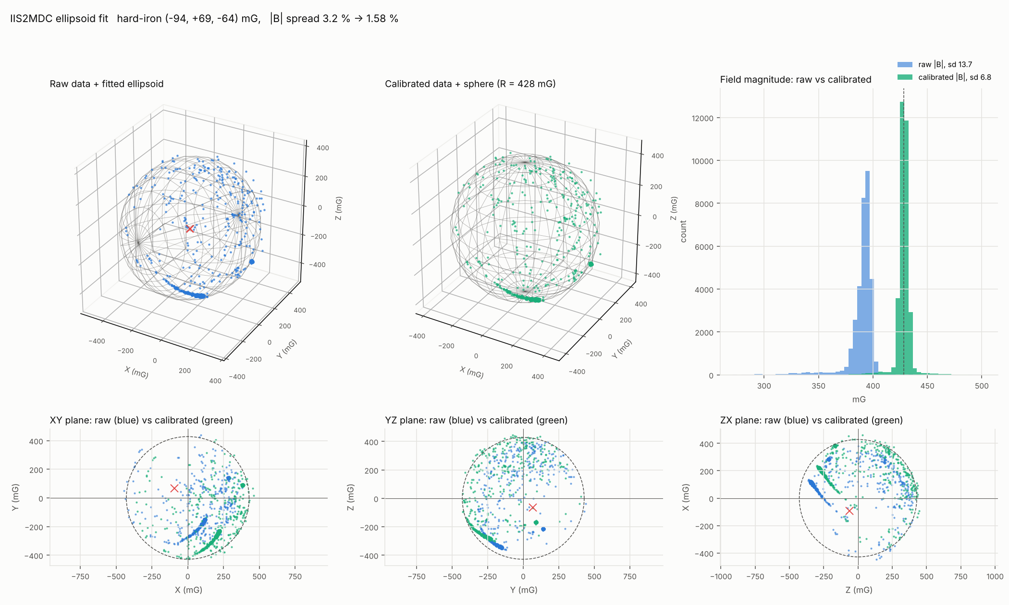
Figure 6. proj1 ellipsoid fit. Raw data and fitted ellipsoid, calibrated data on a sphere, |B| histograms, plane views.
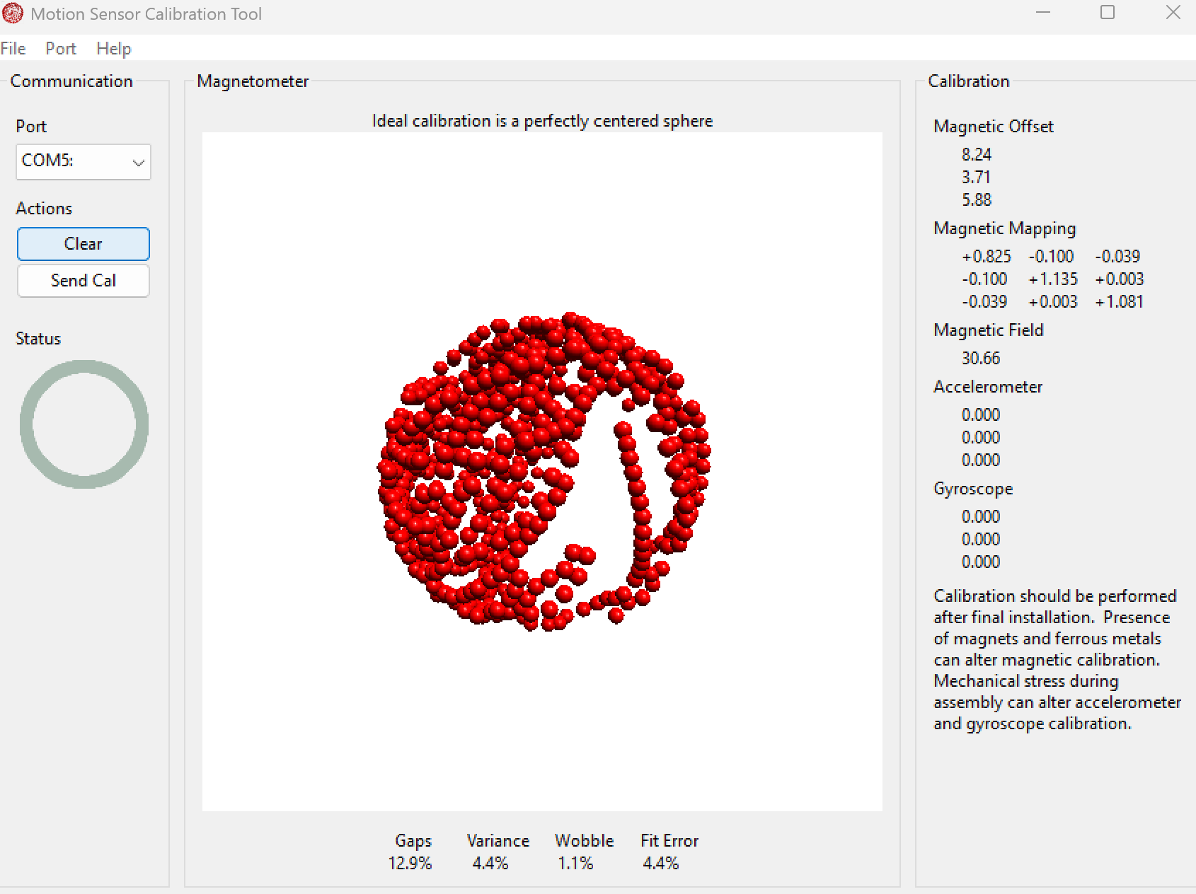
Figure 7. MotionCal result.

Repeatability of the hard-iron fit
Run | Offset X | Offset Y | Offset Z | Field radius | |B| spread raw -> cal
proj1 | -94 mG | +69 mG | -64 mG | 428 mG | 3.2 % -> 1.6 %
ell2 | -56 mG | +82 mG | -4 mG | 430 mG | 8.2 % -> 4.1 %
ell1 | -30 mG | +60 mG | +10 mG | 391 mG | 9.7 % -> 4.4 %
MotionCal | +82 mG | +37 mG | +59 mG | 307 mG

4. Summary
Sensor | Parameter | Datasheet | Measured | Status
BMI270 accel | Zero-g offset | +-20 mg | -0.2 to +1.3 mg | Pass
BMI270 accel | Noise | ~1.0 mg rms | 0.9 to 1.4 mg | Pass
BMI270 gyro | Zero-rate offset | +-0.5 deg/s | -0.06 to +0.11 deg/s | Pass
BMI270 gyro | Noise | ~0.06 deg/s rms | 0.06 to 0.12 deg/s | Y, Z pass. X ~2x
IIS2MDC | RMS noise | 3 typ, 4.6 max mG | 3.11 to 3.56 mG | Pass
IIS2MDC | Offset | +-60 mG | 37 to 94 mG (with surroundings) | Not comparable
IIS2MDC | Sensitivity | +-7 % | axis ratio up to 1.22 (with soft iron) | Not comparable
All | Sensitivity error, cross-axis, temp drift | see tables | Not measured | Open

