Work Update
BMI270 + IIS2MDC sensor board: bring-up, error tests and magnetometer calibration
Shishir | 6 to 7 October 2026

1. Summary
We took the new sensor board from "does it even talk?" to a calibrated magnetometer stream on COM5. The board has a Bosch BMI270 (accelerometer + gyroscope) and an ST IIS2MDC (magnetometer), read by an Arduino Uno over I2C.
- Bus and chips work. Both chips answer on I2C (0x68 and 0x1E) and return the right ID values.
- BMI270 is initialised with the 8 kB Bosch config file. INTERNAL_STATUS reads 0x01 (init OK).
- Accel and gyro are inside the datasheet limits. Gyro bias is about 0.06 to 0.11 deg/s per axis (limit 0.5). Accel |a| error is about 1 mg (limit 20 mg).
- Uncorrected gyro drift is real. Integrating the raw gyro gives up to 6.7 deg per minute of drift. Removing a 10 s bias estimate brings it under 0.4 deg over the run.
- Magnetometer noise is in spec. About 3.1 to 3.6 mG per axis against 3 mG typical and 4.6 mG max.
- Magnetometer calibration is done once, but is not yet trusted. MotionCal gave an offset and soft-iron matrix. It is now applied on the Uno. Our own ellipsoid fits did not agree between sessions, so a clean repeat session is the main open item.
Along the way we wrote 6 Arduino sketches, 12 Python tools, live plot windows and a spreadsheet of datasheet values. Section 11 lists them all.

2. Hardware and setup
The board carries U5 (BMI270, LGA-14) and U8 (IIS2MDC, LGA-12). R1 and R2 are 4.7 k pull-ups on SDA and SCL. All useful signals come out on an 8-pin header J2: VDD, SDA, SCL, BMI270_SDO, IIS2MDC_INT, BMI_INT1, BMI_INT2, GND.
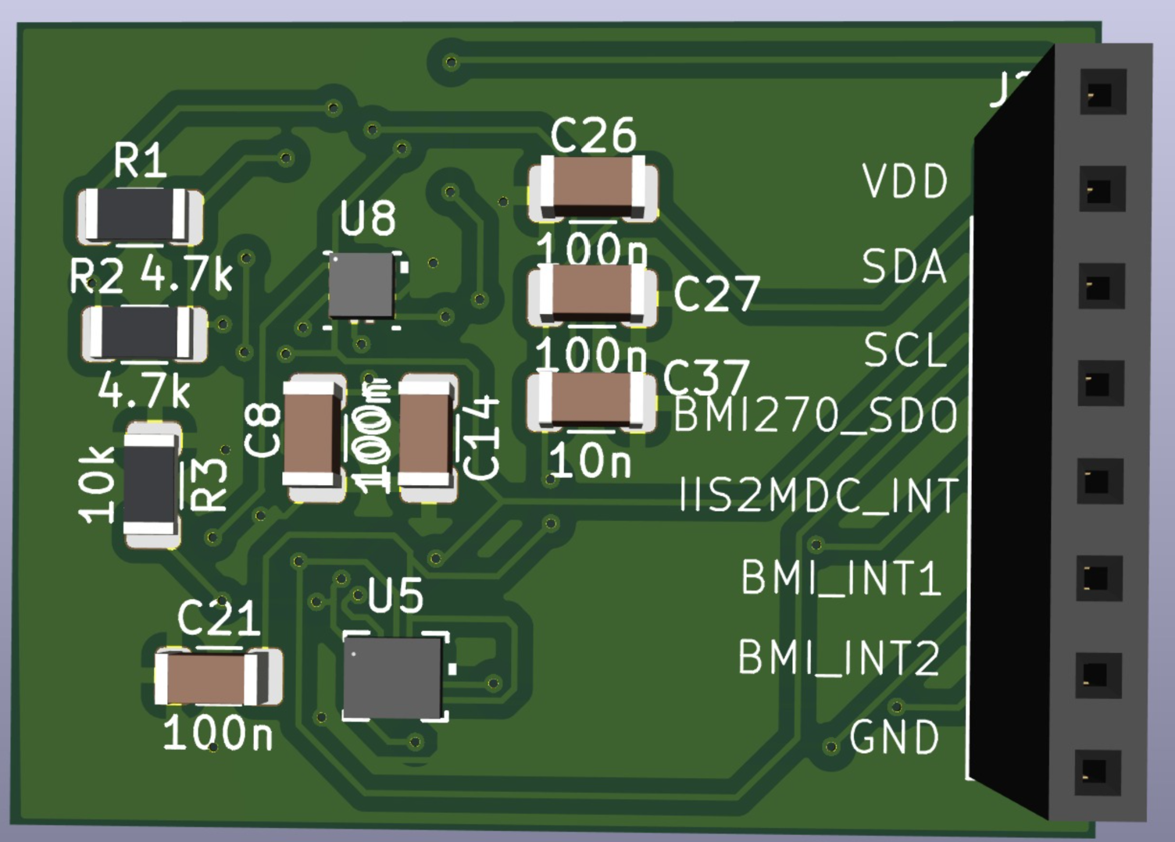
Figure 1. 3D render of the sensor board with the J2 header on the right.
Board pin | Arduino Uno pin | Note
VDD | 3.3V | Both chips are rated 1.71 to 3.6 V. 5 V would damage them.
SDA | A4 | 4.7 k pull-up on the board
SCL | A5 | 4.7 k pull-up on the board
BMI270_SDO | GND | Sets the BMI270 address to 0x68
GND | GND
INT pins | not connected | Not needed yet

One risk to keep in mind. The Uno is a 5 V board. Its internal I2C pull-ups go to 5 V, so the bus idles at about 3.5 V. That is right at the chips' limit. It works on the bench. For flight a level shifter or a 3.3 V controller is safer.
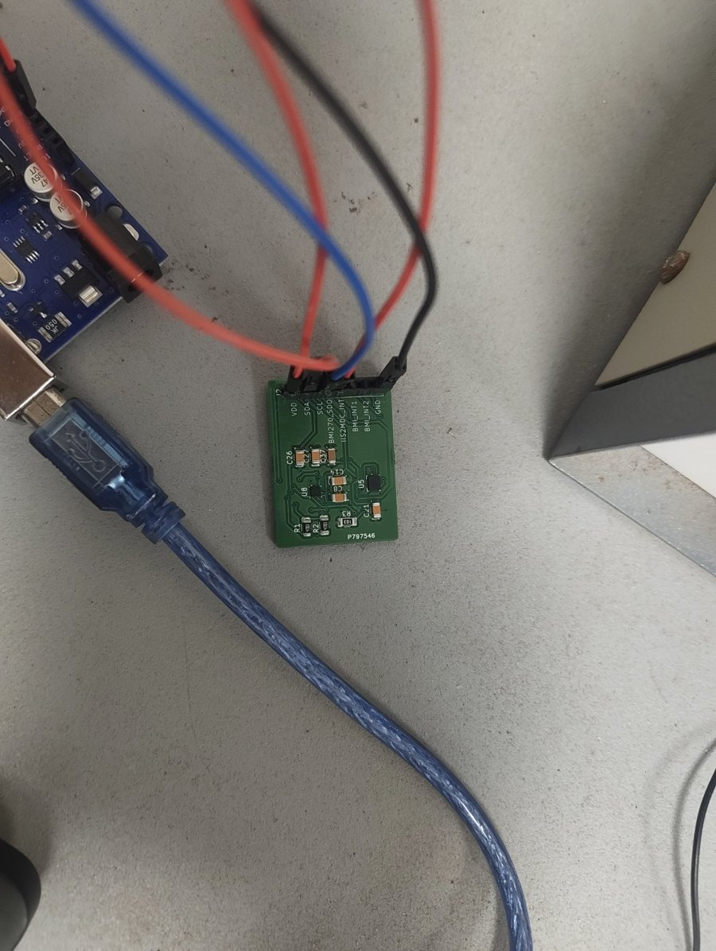
Figure 2. Bench wiring: the board on jumper wires to the Uno.

3. Bus check and chip IDs
The first sketch was a plain I2C scanner. It tries every address from 0 to 127 and prints the ones that send an ACK. It found exactly the two devices we expected, every 2 seconds, with no hangs.
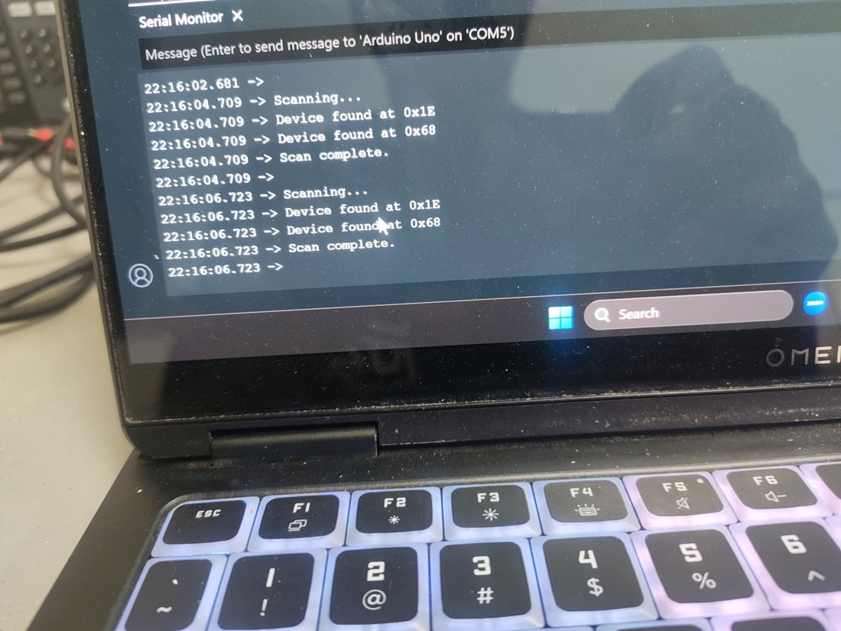
Figure 3. I2C scanner output: 0x1E (IIS2MDC) and 0x68 (BMI270).
An ACK only proves something answers. So a second sketch read each chip's ID register:
Chip | Address | ID register | Expected | Read
BMI270 | 0x68 | CHIP_ID (0x00) | 0x24 | 0x24, OK
IIS2MDC | 0x1E | WHO_AM_I (0x4F) | 0x40 | 0x40, OK

4. BMI270 initialisation
The BMI270 starts in suspend mode and does nothing useful until we upload Bosch's 8192-byte config file (datasheet section 4.4). We took the file unchanged from Bosch's BMI270_SensorAPI on GitHub (BSD-3 licence) and stored it in flash with PROGMEM, since the Uno only has 2 kB of RAM.
The sequence in bmi270_init.ino:
- Soft reset (CMD 0x7E = 0xB6), dummy read, check CHIP_ID = 0x24.
- PWR_CONF (0x7C) = 0x00 to turn off advanced power save, then wait at least 450 us.
- INIT_CTRL (0x59) = 0x00 to prepare the load.
- Write the 8192 bytes to INIT_DATA (0x5E) in 16-byte chunks. The Uno's Wire buffer is only 32 bytes. Before each chunk we set INIT_ADDR_0/1 to the start position in words (bytes / 2), as the datasheet footnote asks.
- INIT_CTRL = 0x01, then poll INTERNAL_STATUS (0x21) until it reads 0x01.
- Performance mode from the datasheet example (p.22): PWR_CTRL = 0x0E, ACC_CONF = 0xA8 (100 Hz), GYR_CONF = 0xE9 (200 Hz), PWR_CONF = 0x02.
Result: INTERNAL_STATUS = 0x01 and sensible readings (about 1 g on the vertical axis, gyro near 0).
Small upload drama. One upload failed with avrdude "not in sync" errors. The bytes it got back were 0x42 0x4D 0x49 0x32 0x37 0x30, which spell "BMI270". The old sketch was busy printing its banner while avrdude waited for the bootloader. Polite of it, but not helpful. A retry with a manual reset fixed it.

5. Accelerometer and gyroscope error tests

5.1 Method
The init sketch prints accel (g) and gyro (deg/s) about 5 times a second. log_serial.py reads COM5, shows a live window and saves a CSV. plot_errors.py then makes the error plots and histograms. With the board still, the ideal readings are |a| = 1 g and gyro = 0 on every axis, so anything else is error.

5.2 Run 1: the board got bumped
Run 1 was 60 s long. Someone (we will not say who) shook the board at about 28 to 32 s and tilted it at 50 s. The plots show this clearly, which is a nice check that the tools work. For numbers we only used the still part from 1 to 27 s.
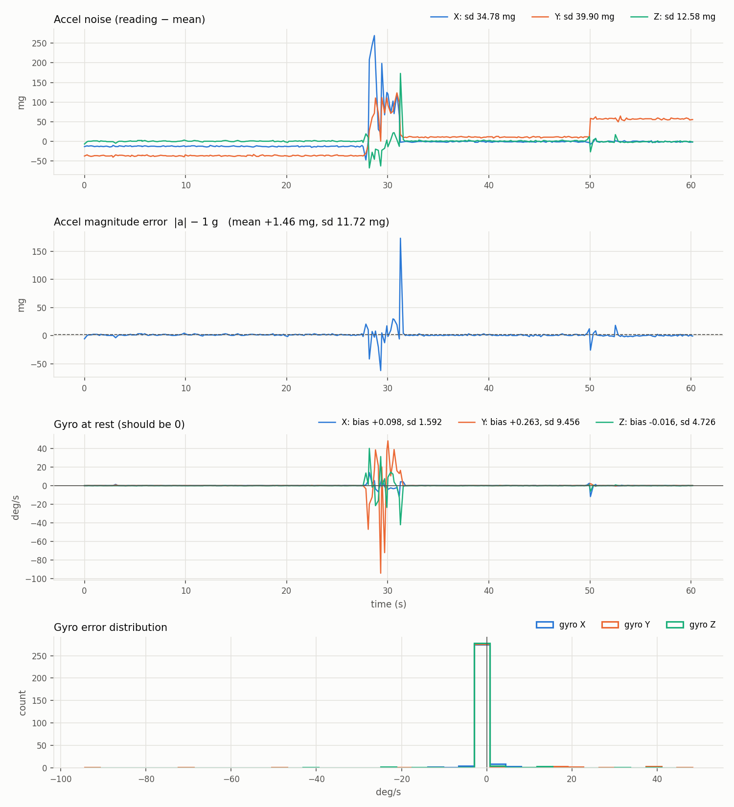
Figure 4. Run 1 error plots. The spikes at 28 to 32 s and the step at 50 s are the board moving, not sensor error.
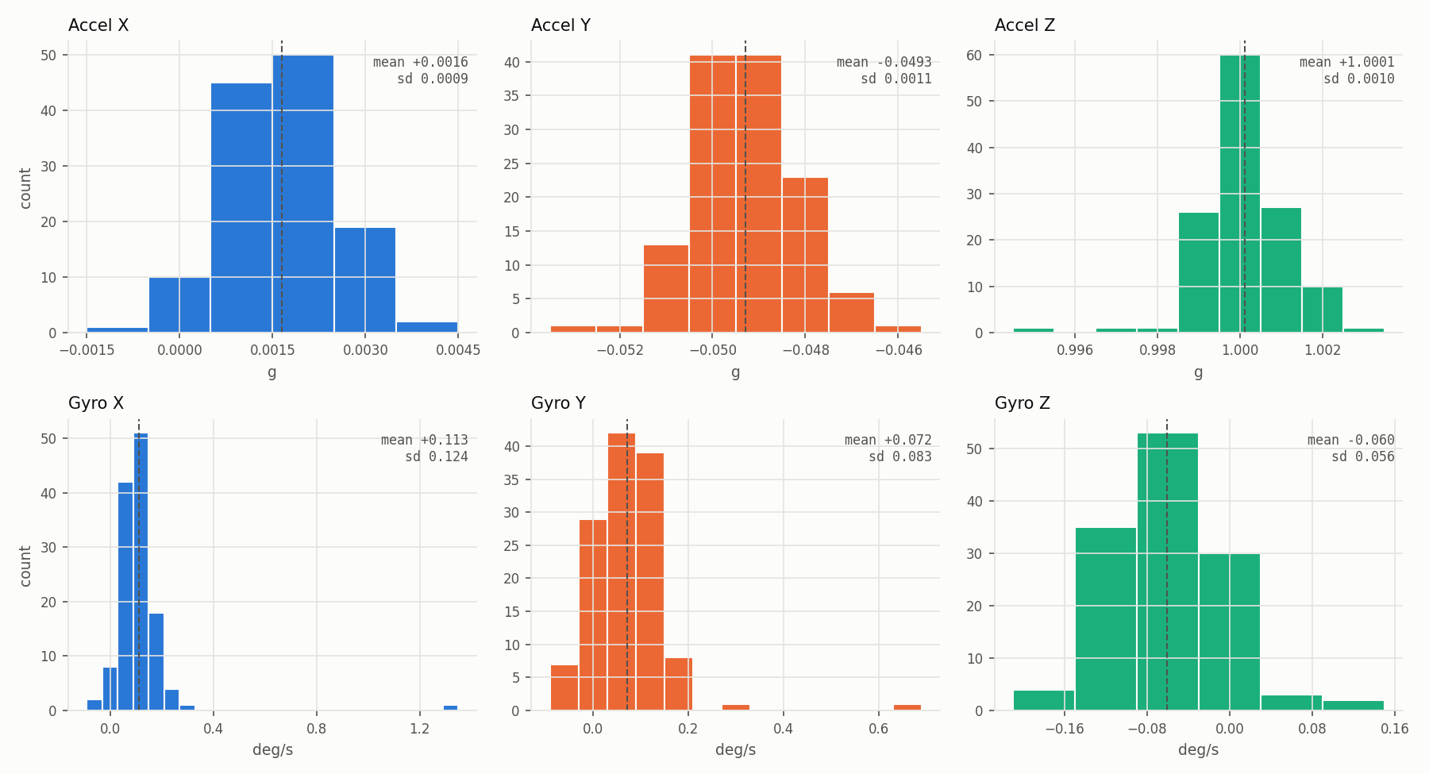
Figure 5. Run 1, still part only (1 to 27 s): value histograms for each axis.

5.3 Run 2: board kept still
Run 2 ran for 37 s (188 samples) with nobody touching the board. Every histogram is a clean single peak.
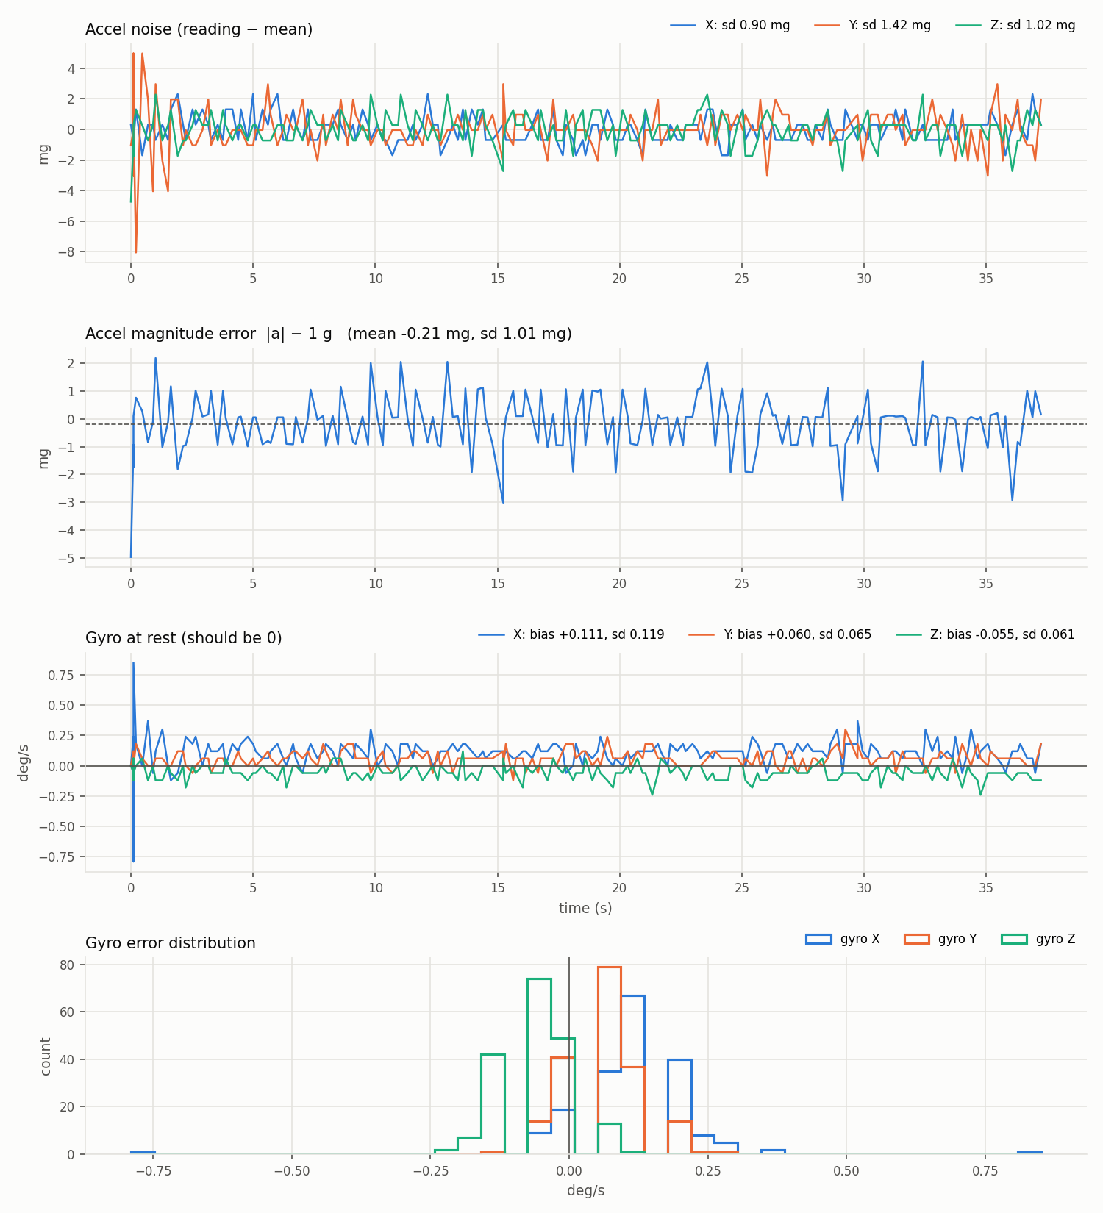
Figure 6. Run 2 error plots: accel noise, |a| - 1 g, gyro at rest and gyro distribution.
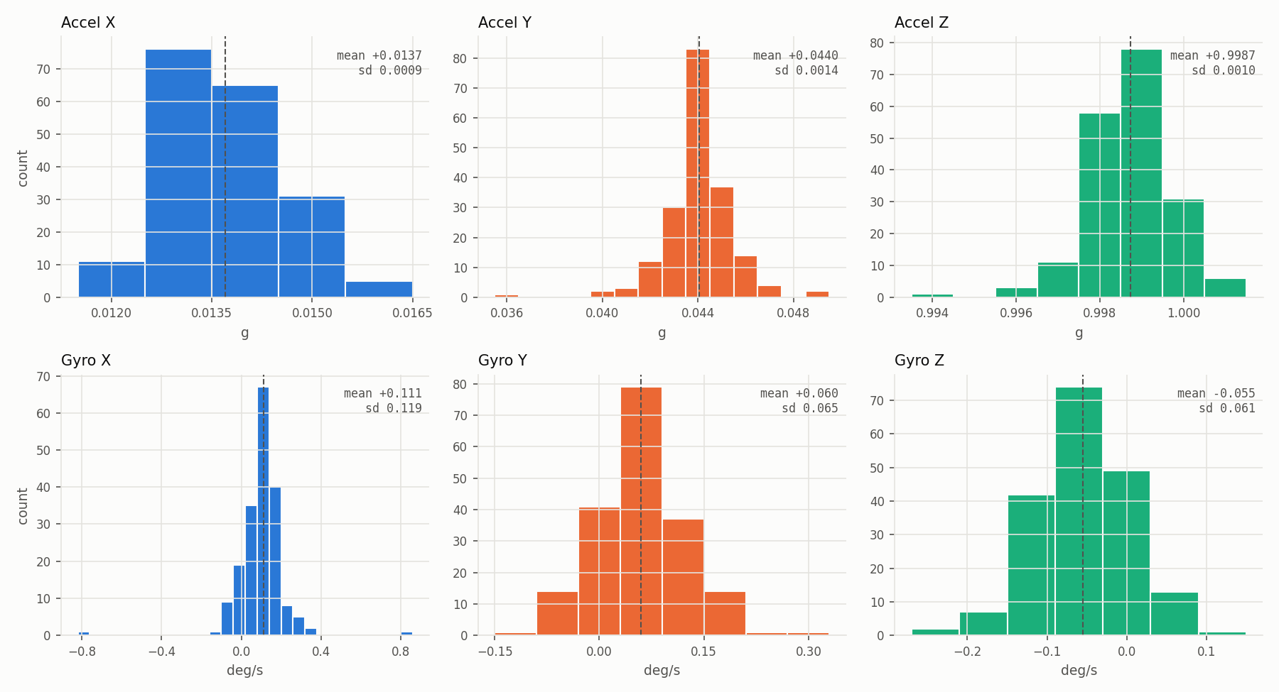
Figure 7. Run 2 value histograms. Dashed line = mean.
Channel | Mean | sd | Unit
|a| - 1 g | -0.2 | 1.0 | mg
Accel X / Y / Z | +0.014 / +0.044 / +0.999 | 0.9 / 1.4 / 1.0 mg | g
Gyro X | +0.111 | 0.119 | deg/s
Gyro Y | +0.060 | 0.065 | deg/s
Gyro Z | -0.055 | 0.061 | deg/s

Accel X and Y are not zero because the board was about 2.5 deg off level. A single pose cannot separate tilt from offset. The accel noise of about 1 mg is the same size as the print step (0.001 g), so the real noise could be a bit lower.

5.4 Comparison with the datasheet
Item | Datasheet | Measured | OK?
Gyro zero-rate offset | within +-0.5 deg/s (Table 3, p.14) | +0.11 / +0.06 / -0.06 deg/s | Yes
Gyro noise | 0.007 deg/s/rtHz, about 0.06 deg/s rms at ~75 Hz bandwidth | 0.06 to 0.12 deg/s | Yes, X is about 2x
Accel zero-g offset | within +-20 mg (Table 2, p.12) | |a| off by ~1 mg | Yes
Accel noise | 0.16 mg/rtHz, about 1 mg rms at ~40 Hz bandwidth | about 1 mg | Yes

The bandwidths used for the expected noise are our estimates, not datasheet numbers. Treat that row as a ballpark.

5.5 Gyro integration: how fast the angle drifts
integrate_angles.py integrates each gyro axis into an angle with the trapezoid rule. It draws two lines per axis. The solid line is the raw integral. The dashed line uses gyro minus bias, where bias is the average of the first 10 s while the board is still:
bias_x = (w_x1 + w_x2 + ... + w_xN) / N (N = samples in the first 10 s)
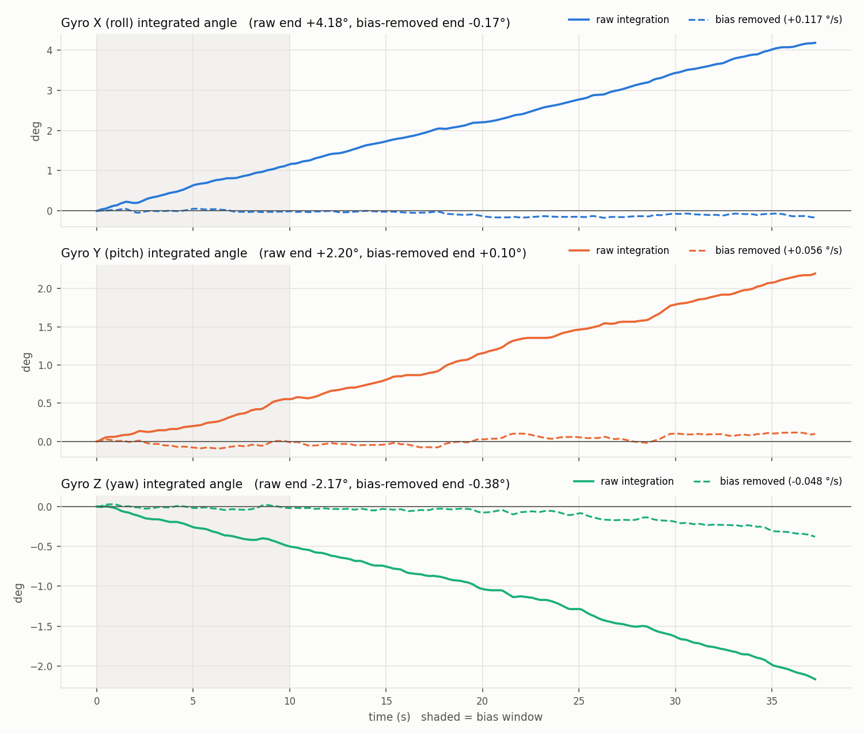
Figure 8. Run 2 integrated angles. Solid = raw, dashed = bias removed. Shaded = bias window.
Axis | Bias (first 10 s) | Raw drift at 37 s | Raw drift rate | Bias-removed at 37 s
X (roll) | +0.117 deg/s | +4.18 deg | 6.7 deg/min | -0.17 deg
Y (pitch) | +0.056 deg/s | +2.20 deg | 3.5 deg/min | +0.10 deg
Z (yaw) | -0.048 deg/s | -2.17 deg | 3.5 deg/min | -0.38 deg

So a bias measured on the pad is worth doing. Without it, the attitude walks off by several degrees a minute. The bias estimate itself is only good to about 0.1 / sqrt(50) = 0.015 deg/s, which is part of why Z still drifts slowly. Run 1's angle plot is in the folder too. At 5 Hz the fast shaking is undersampled, so its angles during motion are rough.

5.6 Accelerometer calibration tool (written, not run yet)
bmi270_acc_cal.ino does a 6-position calibration. You place the board on each face, type c, and it averages 4 s of data. It rejects a pose if the board moved or the SATURATION register (0x4A) flags. Then f fits offset and gain per axis with Gauss-Newton, so slightly tilted poses do not spoil the scale. It was tested on simulated data and recovered offsets to 0.1 mg. It has not been run on the real board yet.

6. Magnetometer bring-up and noise
iis2mdc_read.ino sets the IIS2MDC up as below. Each choice comes from the datasheet register pages.
Register | Value | What it does | Source
CFG_REG_A 0x60 | 0x88 | Temperature compensation on (datasheet says it must be 1), high-resolution, 50 Hz, continuous | Tables 24 to 26, p.30
CFG_REG_B 0x61 | 0x03 | Offset cancellation on, low-pass filter on (bandwidth ODR/4, noise 4.5 -> 3 mG) | Tables 28, 29 p.31, Table 10 p.16
CFG_REG_C 0x62 | 0x10 | BDU on, so the low and high bytes of an axis always come from the same sample | Table 31, p.32

A 40 s still run (mag1.csv, 2014 samples at 50 Hz) gave:
Channel | Mean | sd | Datasheet
Mag X | -120.8 mG | 3.56 mG | noise 3 typ, 4.6 max
Mag Y | +212.2 mG | 3.23 mG | noise 3 typ, 4.6 max
Mag Z | +62.8 mG | 3.11 mG | noise 3 typ, 4.6 max
|B| | 252.1 mG | 3.12 mG | no limit (uncalibrated)
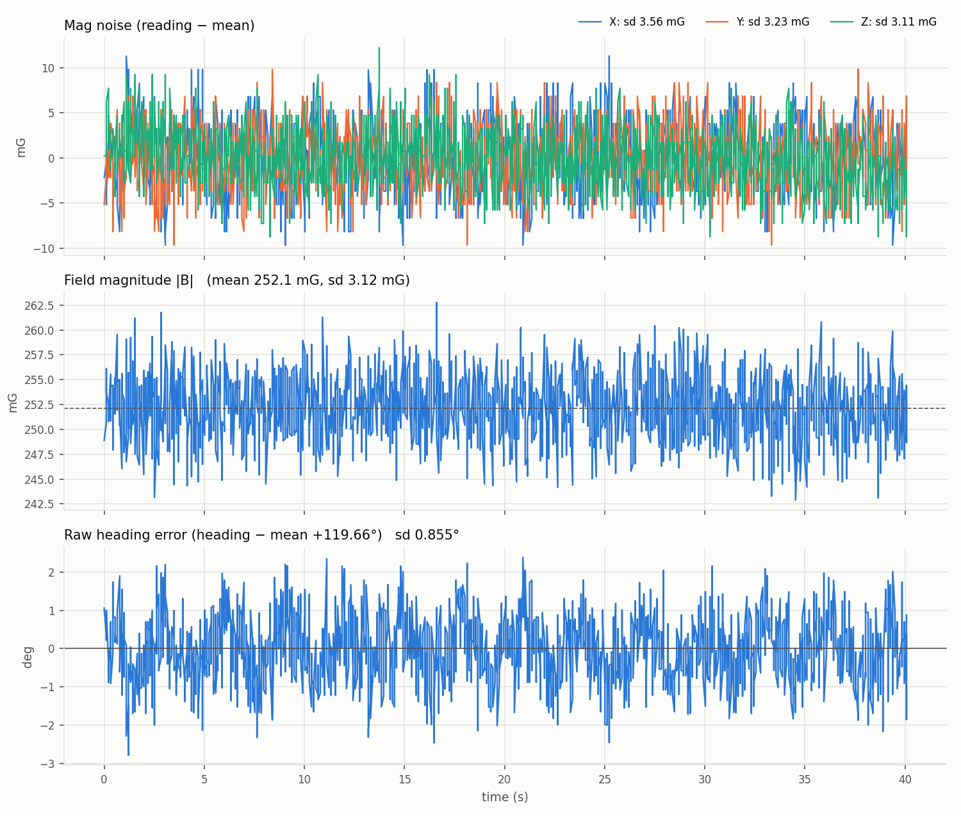
Figure 9. Magnetometer still run: per-axis noise, field magnitude and raw heading jitter.
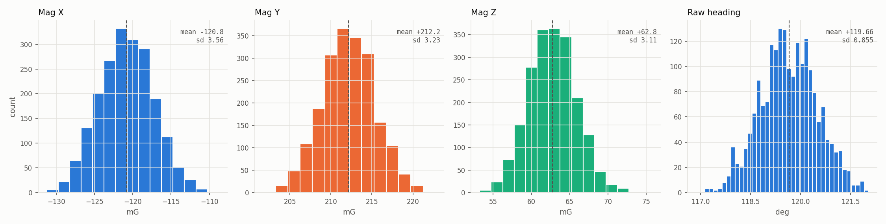
Figure 10. Magnetometer value histograms for X, Y, Z and raw heading.

7. Heading from the magnetometer

7.1 What the axes are
All numbers are along the IIS2MDC's own axes, X, Y and Z. They are fixed to the chip and turn with the board. Datasheet Figure 2 (p.7) shows X and Y in the chip plane, with Y 90 deg clockwise from X when seen from the top, and Z out of the top face. That makes the frame left-handed, which is unusual and easy to get wrong.

7.2 The formula
With the board flat, X and Y only see the horizontal field H, which points at magnetic north. If X points at heading psi (clockwise from north):
X = H * cos(psi) Y = H * cos(psi + 90) = -H * sin(psi)
psi = atan2(-Y, X), wrapped into 0..360 deg
atan2 uses both signs, so it covers the full circle. H cancels out. On day one we used atan2(Y, X), without the minus sign. That gave the mirror angle, so the still heading changed from 119.7 deg to 240.3 deg once fixed. Same data, better formula.
Today's headings are raw. They have no hard-iron correction, no tilt correction and no declination. They are good for checking jitter and drift, not for pointing at true north.
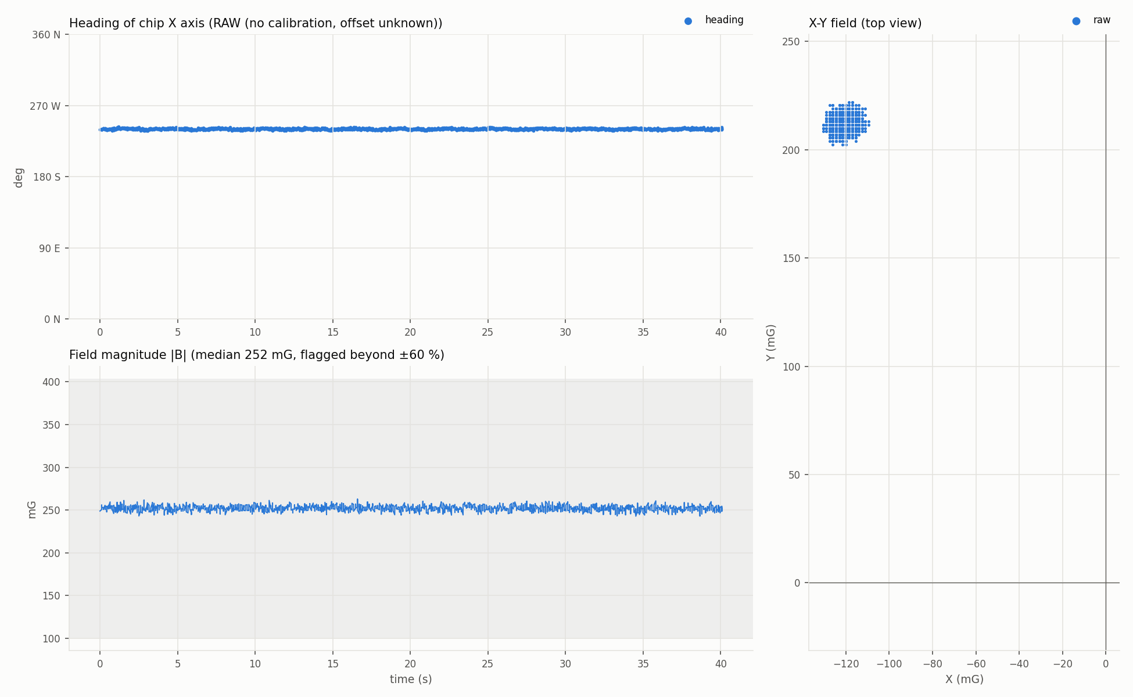
Figure 11. Heading of the chip X axis, still run: 240.3 deg, jitter 0.85 deg sd.
The longer run mag2.csv had a magnet or a phone near the board for long stretches. |B| jumped up to about 23,000 mG against a normal 250 mG. The script flags those samples in red and leaves them out of the averages.
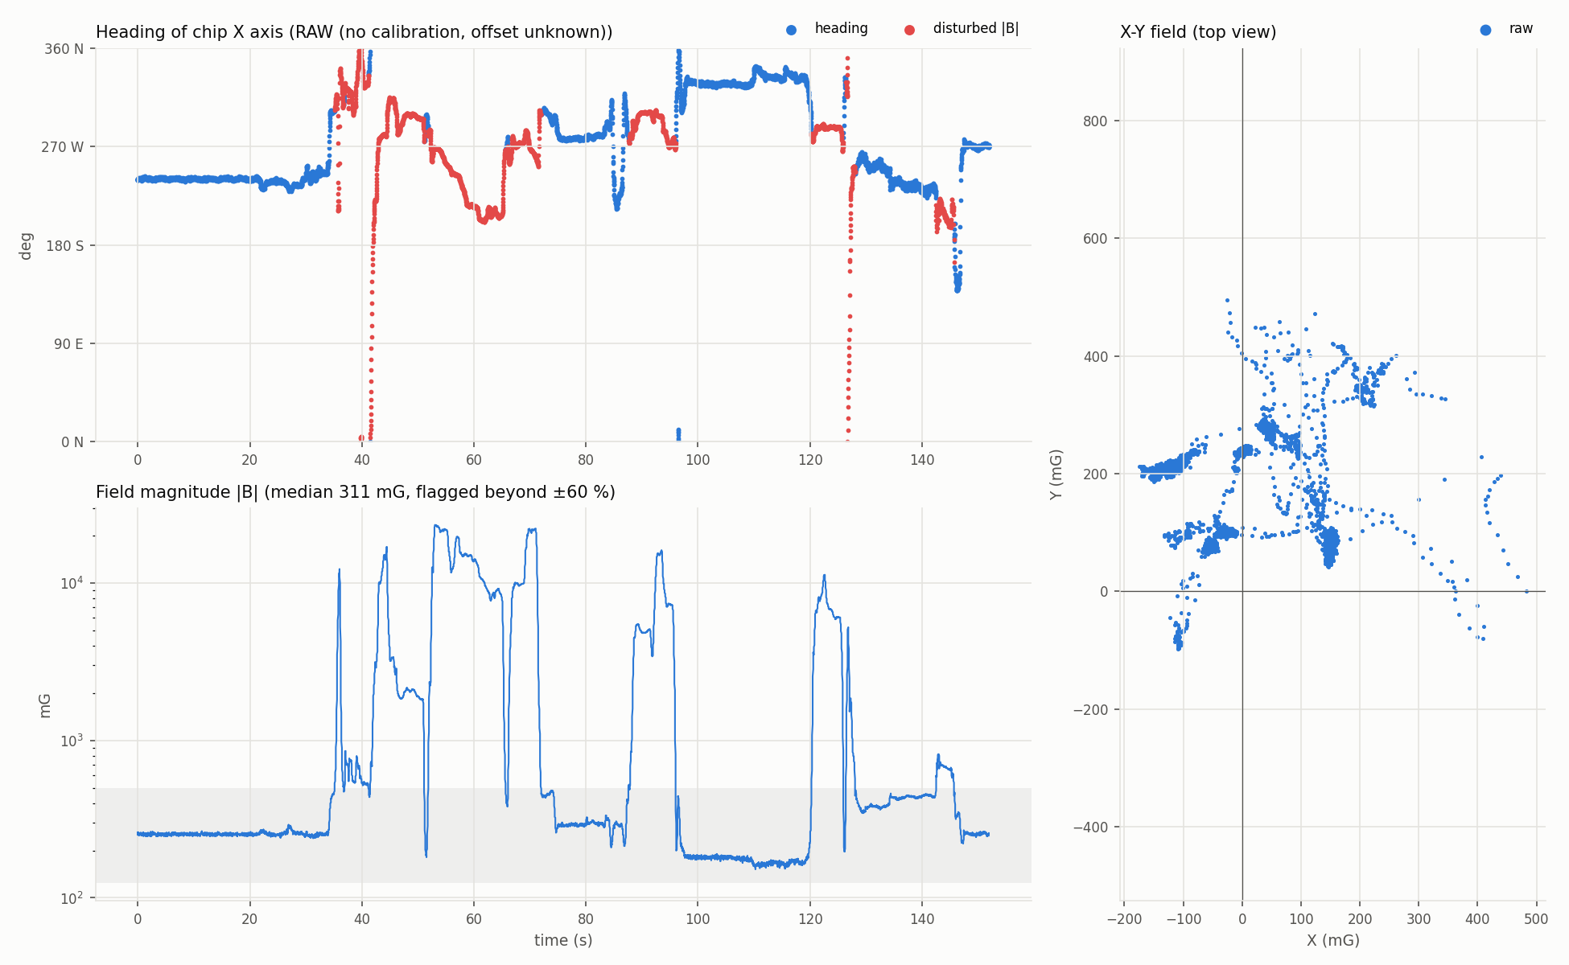
Figure 12. Heading with a magnet nearby. Red = disturbed samples (|B| far from normal). Bottom = |B| on a log scale.

7.3 Live windows
We also built three live windows that read COM5 directly:
- live_heading.py: three panels with the field angle in each plane, atan2(-Y, X), atan2(Z, Y) and atan2(X, Z). Only the first is a compass heading, and only when the board is flat. The other two are plane angles that help see orientation.
- live_projection.py: the field vector projected on the XY, YZ and ZX planes, with a trail and an arrow. Turning the board about one axis traces a circle in the plane at right angles to it.
- live_ellipsoid.py: a rotatable 3D cloud of raw points with an ellipsoid refitted every 2 s.
For three real orientation angles (roll, pitch, yaw) we need both sensors together. Gravity from the accelerometer gives roll and pitch. The magnetometer, rotated back to level, then gives yaw.

8. Ellipsoid fit (our own calibration method)
If we turn the board through every direction, the tips of the field vector should land on a sphere centred at zero. In practice they land on a shifted, stretched ellipsoid. The shift is hard iron (magnetised parts nearby). The stretch is soft iron. mag_ellipsoid.py fits a general 9-term ellipsoid by least squares, rejects outliers, refits, and gives:
calibrated = W * (raw - b) b = hard-iron offset, W = 3x3 soft-iron matrix
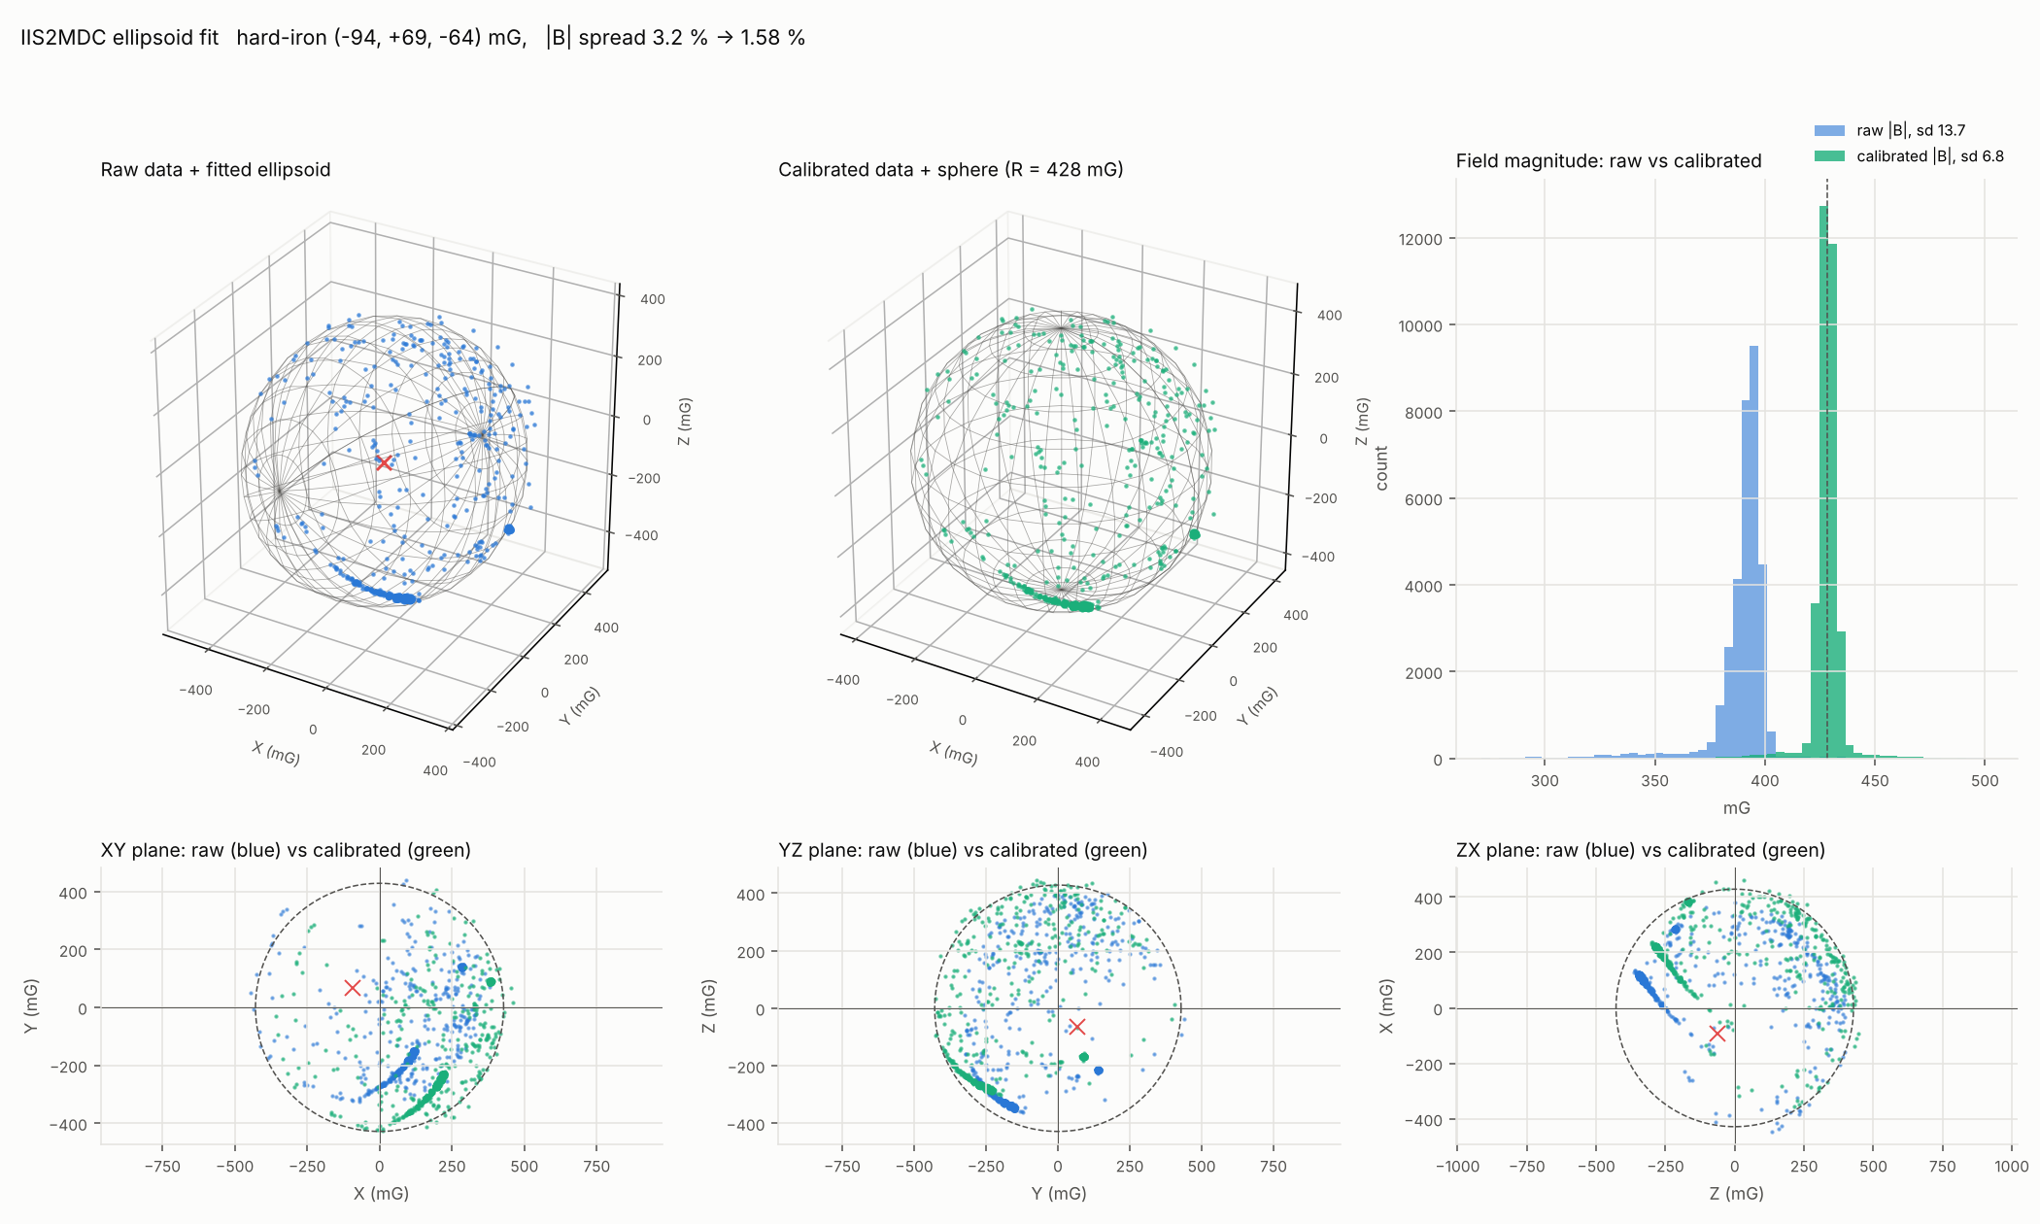
Figure 13. Ellipsoid fit on proj1.csv (33,275 samples). Top: raw data with fitted ellipsoid, calibrated data on a sphere, |B| histograms. Bottom: plane views, raw (blue) and calibrated (green).
On proj1 the fit found a hard-iron offset of (-94, +69, -64) mG and radii of 476, 418 and 391 mG. The |B| spread dropped from 3.2 % to 1.6 %. Direction coverage was 73 %, so the soft-iron part is less certain.
The catch: fits from different sessions disagree.
Run | Hard-iron X | Hard-iron Y | Hard-iron Z | Field radius
proj1 | -94 mG | +69 mG | -64 mG | 428 mG
ell2 | -56 mG | +82 mG | -4 mG | 430 mG
ell1 | -30 mG | +60 mG | +10 mG | 391 mG

A sensor's own offset does not move by 60 mG in an hour. The surroundings did. The most likely causes are the Uno moving relative to the sensor on loose jumper wires (its USB socket and crystal can are steel), and the distance to the laptop and desk changing during the tumble.

9. MotionCal calibration

9.1 Setting it up
We installed PJRC's Motion Sensor Calibration Tool (MotionCal.exe, digital signature checked) and wrote motioncal_stream.ino. It runs both chips and sends one line per sample in the format MotionCal expects. The scaling was checked against MotionCal's source code (imuread.h):
Raw:ax,ay,az,gx,gy,gz,mx,my,mz
Quantity | MotionCal unit | Our conversion
Accel | 8192 counts per g | BMI270 counts x 2 (4096 per g at +-8 g)
Gyro | 16 counts per deg/s | BMI270 counts x 16 / 16.4
Mag | 0.1 uT per count (= 1 mG) | IIS2MDC counts x 1.5

Two bugs showed up and were fixed:
- Nothing on screen. MotionCal's parser only ends a line on a carriage return (byte 13). We sent only a newline. Every line got thrown away. Fixed by sending CR LF.
- Display froze mid-tumble. The Arduino Wire library waits forever if the I2C bus glitches, and moving jumper wires can glitch it. Fixed with Wire.setWireTimeout(3000, true) and a drop back to 100 kHz.

9.2 Result
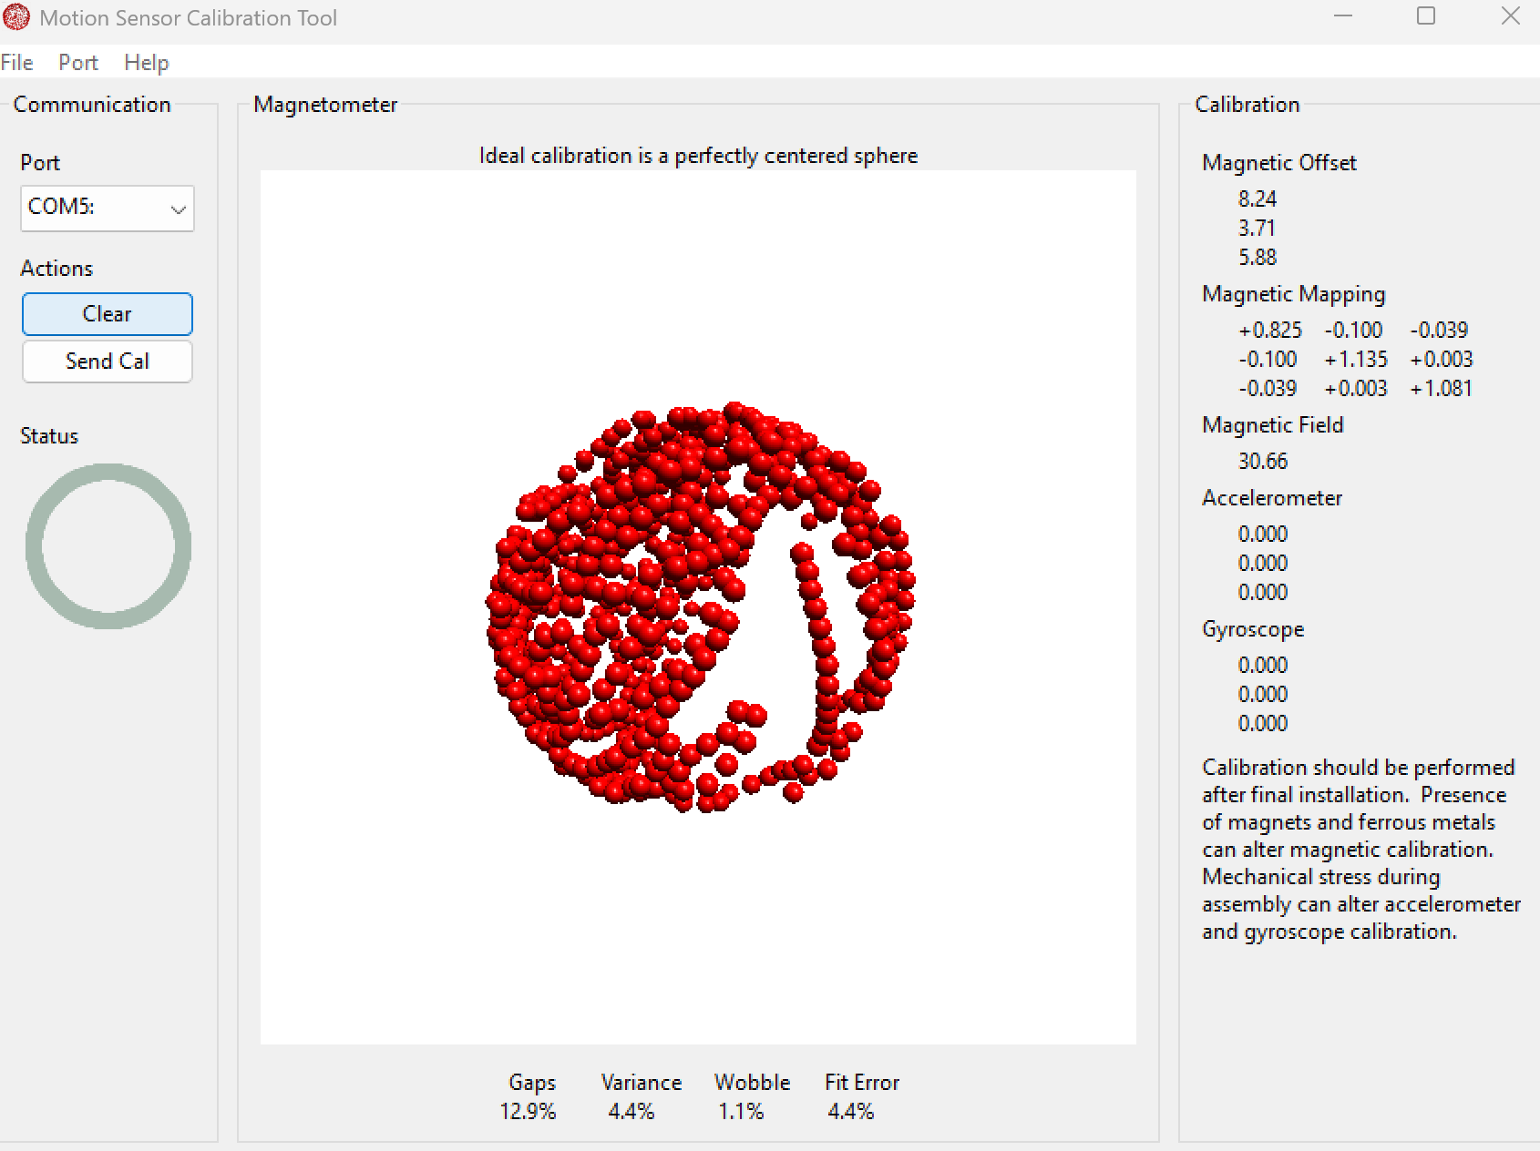
Figure 14. MotionCal after the tumble: Gaps 12.9 %, Variance 4.4 %, Wobble 1.1 %, Fit Error 4.4 %.
Output | Value
Magnetic offset V | 8.24, 3.71, 5.88 uT = 82.4, 37.1, 58.8 mG
Magnetic mapping invW | row 1: +0.825 -0.100 -0.039 / row 2: -0.100 +1.135 +0.003 / row 3: -0.039 +0.003 +1.081
Field strength | 30.66 uT = 306.6 mG
Quality | Gaps 12.9 %, Variance 4.4 %, Wobble 1.1 %, Fit Error 4.4 %

PJRC's rough targets are gaps under 15 %, variance under 4.5 %, wobble under 4 % and fit error under 5 %. Every number passes, but variance and fit error only just.

9.3 Calibration on the Uno
mag_calibrated.ino applies the MotionCal result on the board, with the same formula MotionCal uses (apply_calibration in visualize.c):
calibrated = invW * (raw - V)
It sends two lines per sample on COM5 at about 57 Hz. One is mag mG: x y z for our Python windows. The other is MotionCal's Raw: line with the calibrated magnetometer values. With the board still, calibrated |B| read about 340 mG against MotionCal's 307 mG. That is one orientation only, so it does not prove much either way.

9.4 Check against older logs
We also applied the MotionCal numbers to logs from earlier in the evening. It made them worse. For example ell2 went from 9.2 % |B| spread to 11.6 %. Those logs were from different sessions with a different setup, so this mostly confirms the point from section 8. The surroundings changed between sessions. We need one clean session to judge the calibration properly.
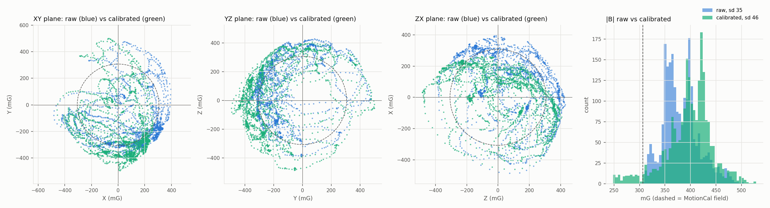
Figure 15. MotionCal calibration applied to an older log (ell2). The calibrated cloud (green) is not a clean circle, so this calibration does not fit that session.

10. Problems met and fixes
Problem | Cause | Fix
avrdude "not in sync", replies spell BMI270 | Old sketch printing while the bootloader was expected | Retry with manual reset
COM5 "device not functioning" / port open hangs | USB-serial link hung, once after sleep and once after a window was force-closed while holding the port | Unplug and replug. Close windows gently from now on.
MotionCal shows no points | Lines ended with LF only, MotionCal needs CR | Send CR LF
MotionCal freezes while tumbling | I2C bus glitch from moving wires, Wire library has no timeout | setWireTimeout and 100 kHz
Heading came out mirrored | Used atan2(Y, X). The chip's frame is left-handed. | atan2(-Y, X) from datasheet Figure 2
Magnetometer runs disagree | Uno and laptop move relative to the sensor | Open: rigid mount and a clean session
Histograms blank on shaken data | Thousands of tiny bins | Bin width now scales with the spread

11. Files produced
Everything is in Downloads\bmi270_init on the laptop.
File | What it is
I2C scanner, id_check.ino | Bus scan and chip ID check
bmi270_init.ino + bmi270_config.h | BMI270 init with config upload, prints accel and gyro
bmi270_acc_cal.ino | 6-position accel calibration (not run yet)
iis2mdc_read\iis2mdc_read.ino | IIS2MDC init and read at 50 Hz
motioncal_stream\ | Both chips, raw stream for MotionCal
mag_calibrated\ | Both chips, MotionCal calibration applied on the Uno
log_serial.py, plot_errors.py | BMI270 live logger, error plots and histograms
integrate_angles.py | Gyro angle integration with bias removal
log_mag.py, plot_mag.py | Magnetometer live logger, error plots and histograms
mag_heading.py | Heading over time, disturbance flag, 2D calibration option
live_heading.py, live_projection.py, live_ellipsoid.py | Live windows: plane angles, projections, 3D ellipsoid
mag_ellipsoid.py | Full ellipsoid fit report and plots
apply_motioncal.py, mag_cal_motioncal.json | Apply MotionCal numbers to a log
imu_common.py | Shared parsing, heading function and plot style
IMU_datasheet_vs_measured.xlsx | Datasheet error values, register settings, measured vs spec
run1/run2, mag1/mag2, head1, proj1, ell1/ell2 .csv and .png | Logged data and plots
tools\MotionCal.exe | PJRC Motion Sensor Calibration Tool

12. Where the datasheet numbers are
Sensor | Values | Location
BMI270 accel | Zero-g offset +-20 mg, drift +-0.25 mg/K, sensitivity error +-0.4 %, noise 0.16 mg/rtHz, cross-axis 1 % | Table 2, p.12 to 13
BMI270 gyro | Zero-rate offset +-0.5 deg/s, drift +-0.015 deg/s/K, sensitivity error +-2 %, noise 0.007 deg/s/rtHz | Table 3, p.14 to 15
BMI270 NVM | Only 14 write cycles, so we never write it | p.11
IIS2MDC | Offset +-60 mG, drift +-0.3 mG/C, 1.5 mG/LSB +-7 %, noise 3 typ / 4.6 max mG | Table 3, p.9
IIS2MDC noise vs filter | 4.5 mG LPF off, 3 mG LPF on | Table 10, p.16
IIS2MDC axes | Direction of X, Y, Z (left-handed) | Figure 2, p.7

13. Next steps (options)
- Clean magnetometer session. Tape the sensor and the Uno together, or mount the sensor where it will fly. Use a long USB cable, stay away from the laptop and steel. Run MotionCal and a logged tumble back to back, then check MotionCal's numbers against that log.
- Check the calibrated stream. With mag_calibrated running, MotionCal (after Clear) should show an offset near 0 and a matrix near identity if the calibration holds.
- Run the 6-position accel calibration with bmi270_acc_cal.ino, in the range we will fly with.
- Gyro bias at power-up on the pad, from a few seconds of still data.
- Roll, pitch and tilt-corrected yaw. Combine both chips in one sketch. First line up the BMI270 and IIS2MDC axes, since the two chips are rotated relative to each other and the IIS2MDC frame is left-handed.
- Find U8's X direction on the PCB from its pin-1 dot, so a heading means a real board direction.
- Print more decimals at a higher rate so noise numbers are not limited by the print step.
- Level shifting or a 3.3 V controller before flight.

