**Task №1. Access settings.**

-- Role for planadmin

**grant** **select** **on** **all** **tables** **in** **schema** public **to** planadmin;

**grant** **select**, **insert**, **update**, **delete** **on** plan_data **to** planadmin;

**grant** **select**, **insert**, **update**, **delete** **on** plan_status **to** planadmin;

**grant** **select**, **insert**, **update**, **delete** **on** country_managers **to** planadmin;

-- Role for planmanagers

**grant** **select** **on** **all** **tables** **in** **schema** public **to** planmanager;

**grant** **select**, **insert**, **update**, **delete** **on** plan_data **to** planmanager;

**grant** **select**, **update** **on** plan_status **to** planmanager;

**grant** **select** **on** country_managers **to** planmanager;

**grant** **select**, **update** **on** v_plan **to** planmanager;

**grant** **select** **on** v_plan_edit **to** planmanager;

-- Create three users

**create** **user** ivan **with** **password** 'ivan123';

**create** **user** sophie **with** **password** 'sophie123';

**create** **user** kirill **with** **password**'kirill123';

-- User roles

**grant** planadmin **to** ivan;

**grant** planmanager **to** sophie, kirill;

-- Adding to the table

**insert** **into** country_managers (username, country)

**values** ('sophie', 'US'), ('sophie', 'CA'),

('kirill', 'FR'), ('kirill', 'GB'), ('kirill', 'DE'), ('kirill', 'AU')

**Task №2. product2 & country 2 materialized views**

**create materialized view product2 as**

**select**

p3.productcategoryid **as** pcid,

p.productid **as** productid,

p3.**name** **as** pcname,

p.**name** **as** pname

**from**

product p

**join** productsubcategory **using**(productsubcategoryid)

**join** productcategory p3 **using**(productcategoryid);

**create** **materialized** **view** country2 **as**

**select**

**distinct** a.countryregioncode

**from**

customeraddress c

**join** address a **using**(addressid)

**where**

c.addresstype = 'Main Office';

-- Granting access

**grant** **select** **on** country2, product2 **to** planadmin;

**grant select on country2, product2 to planmanager;**

**Task №3. Loading data into the company table**

**insert into company (cname, countrycode, city)**

**select**

c2.companyname **as** cname,

a.countryregioncode **as** countrycode,

a.city **as** city

**from**

address a

**join** customeraddress c **using**(addressid)

**join** customer c2 **using**(customerid)

**where**

c.addresstype = 'Main Office';

**Task №4. Company classification**

**select**

cid, salestotal,

**case**

**when** total <= s_a **then** 'A'

**when** total > s_a **and** total <= s_b **then** 'B'

**else** 'C'

**end** **as** cls, "year"

**from**

(**select**

*,

**sum**(salestotal) **over** (**partition** **by** "year"

**order** **by** salestotal **desc**

**rows** **between** **unbounded** **preceding**

**and** **current** **row**) **as** total,

0.8 * **sum**(salestotal) **over**(**partition** **by** "year") **as** s_a,

0.9 * **sum**(salestotal) **over**(**partition** **by** "year") **as** s_b

**from**

(**select**

c2.id **as** cid, **sum**(s.subtotal) **as** salestotal,

**extract**('y' **from** s.orderdate) **as** "year"

**from**

salesorderheader s

**join** customer c **using**(customerid)

**join** company c2 **on** c2.cname = c.companyname

**where**

**extract**('y' **from** s.orderdate) **in** (2012, 2013)

**group** **by**

c2.id, **extract**('y' **from** s.orderdate)

**order** **by**

salestotal **desc**) **as** t1

**order** **by**

**salestotal desc) as t2;**

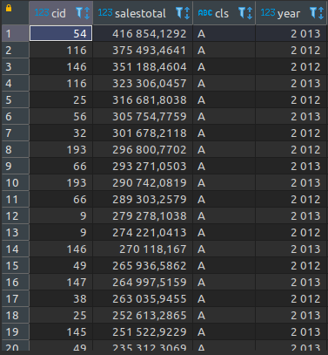

**Task №5. Finding quarterly sales amount by company, and product category**

**insert into company_sales**

**select**

c2.id **as** cid, **sum**(s.linetotal) **as** salesamt, s2."year",

s2.quarter_yr, s2.qr, p.pcid **as** categoryid, ca.cls **as** ccls

**from**

salesorderdetail s

**join** (

**select**

salesorderid, customerid,

**extract**('y' **from** orderdate) **as** "year",

**extract**('qtr' **from** orderdate) **as** quarter_yr,

''|| **extract**('y' **from** orderdate) || '.' ||

**extract**('qtr' **from** orderdate) **as** qr

**from**

salesorderheader

**where**

**extract**('y' **from** orderdate) **in** (2012, 2013)

) s2 **using**(salesorderid)

**join** customer c **using**(customerid)

**join** company c2 **on** c2.cname = c.companyname

**join** product2 p **using**(productid)

**join** company_abc ca **on** ca."year" = s2."year" **and** ca.cid = c2.id

**group** **by**

**s2.qr, c2.id, p.pcid, s2."year", s2.quarter_yr, ca.cls;**

**Task №6. Initial data preparation**

import psycopg2  
  
  
def start_planning(year, quarter, user, pwd):  
 del_plan_data = f"""delete from plan_data  
 where quarterid = '{year}.{quarter}';"""  
 del_plan_status = f"""delete from plan_status  
 where split_part(quarterid, '.', 2)::int = {quarter};"""  
 create_plan_status = f"""insert into plan_status  
 select   
 '{year}.{quarter}'::varchar as quarterid,   
 'R'::varchar as status,   
 current_timestamp as modifieddatetime,   
 '{user}'::varchar as author, countrycode as country  
 from company   
 group by countrycode;"""  
 generate_version_n = f"""insert into plan_data  
 select   
 'N'::varchar as versionid, t1.country,   
 '{year}.{quarter}'::varchar as quarterid,  
 t1.pcid, coalesce(avg(t1.salesamt), 0) as salesamt  
 from  
 (select   
 t.country,t.quarter_yr,t."year", t.pcid,  
 sum(t.salesamt) as salesamt  
 from  
 (select  
 c.countryregioncode as country, cs.quarter_yr, cs.qr,  
 cs."year", p.pcid as pcid, cs.salesamt as salesamt  
 from  
 country2 c  
 join company c2 on c2.countrycode = c.countryregioncode  
 left join company_sales cs on cs.cid = c2.id  
 join product2 p on p.pcid = cs.categoryid   
 where  
 ((cs."year" = {year} - 1) or (cs."year" = {year} - 2))  
 and cs.ccls in ('A', 'B')  
 group by  
 cs.qr, cs."year", cs.quarter_yr, c.countryregioncode,   
 p.pcid, cs.salesamt) as t  
 where   
 t.quarter_yr = {quarter}  
 group by   
 t.country,t.quarter_yr,t."year",t.pcid) as t1  
 group by  
 t1.country, t1.pcid"""  
 copy_data_from_n_to_p = """insert into plan_data   
 select  
 'P'::varchar, country, quarterid, pcid, salesamt  
 from plan_data;"""  
 con = psycopg2.connect(database='2022_plans_Mathew', user=user,  
 password=pwd, host='localhost')  
  
 try:  
 with con:  
 with con.cursor() as cur:  
 cur.execute(del_plan_data)  
 cur.execute(del_plan_status)  
 cur.execute(create_plan_status)  
 cur.execute(generate_version_n)  
 cur.execute(copy_data_from_n_to_p)  
 finally:  
 con.close()  
  
  
start_planning(2014, 1, 'ivan', 'ivan123')

**Plan_status:**

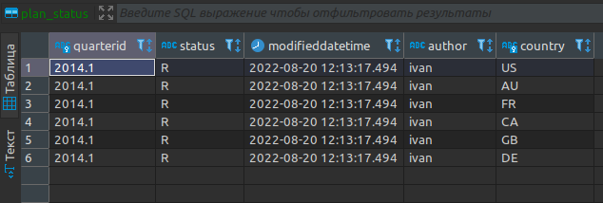

**Plan_data:**

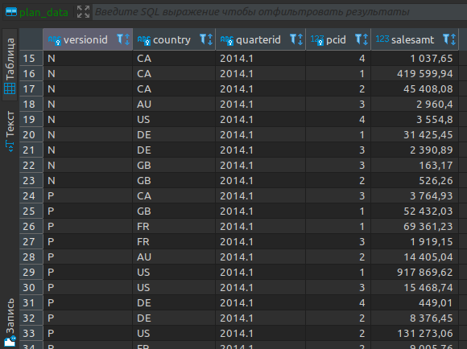

**Changing plan data**

def set_lock(year, quarter, user, pwd): change_from_r_to_l = f"""update plan_status set status = 'L',  modifieddatetime = current_timestamp, author = current_user where split_part(quarterid, '.', 1)::int = {year} and split_part(quarterid, '.', 2)::int = {quarter} and status = 'R' and country in (select country  from country_managers  where username = current_user);""" con = psycopg2.connect(database='2022_plans_Mathew', user=user, password=pwd, host='localhost') try: with con: with con.cursor() as cur: cur.execute(change_from_r_to_l) finally: con.close()set_lock(2014, 1, 'kirill', 'kirill123')set_lock(2014, 1, 'sophie', 'sophie123')

def remove_lock(year, quarter, user, pwd): change_from_r_to_l = f"""update plan_status set status = 'R',  modifieddatetime = current_timestamp, author = current_user where split_part(quarterid, '.', 1)::int = {year} and split_part(quarterid, '.', 2)::int = {quarter} and status = 'L' and country in (select country  from country_managers  where username = current_user);""" con = psycopg2.connect(database='2022_plans_Mathew', user=user, password=pwd, host='localhost') try: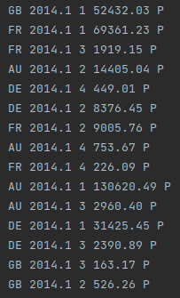 with con: with con.cursor() as cur: cur.execute(change_from_r_to_l) finally: con.close()remove_lock(2014, 1, 'kirill', 'kirill123')remove_lock(2014, 1, 'sophie', 'sophie123')

**Plan data approval**

def accept_plan(year, quarter, user, pwd): del_plan_data_a = f"""delete from plan_data where quarterid = '{year}.{quarter}' and versionid = 'A' and country in (select country from country_managers where username = '{user}');""" copy_data_from_p_to_a = f"""insert into plan_data  select 'A', pd.country, pd.quarterid,  pd.pcid, pd.salesamt from plan_data pd  join plan_status ps on ps.quarterid = pd.quarterid and ps.country = pd.country  join country_managers cm on cm.country = ps.country  where  ps.quarterid = ''|| {year} || '.' || {quarter} and versionid = 'P' and cm.username = '{user}' and ps.status = 'R';""" change_from_r_to_a = f"""update plan_status set status = 'A',  modifieddatetime = current_timestamp, author = current_user where split_part(quarterid, '.', 1)::int = {year} and split_part(quarterid, '.', 2)::int = {quarter} and status = 'R' and country in (select country  from country_managers  where username = current_user);""" con = psycopg2.connect(database='2022_plans_Mathew', user=user, password=pwd, host='localhost') try: with con: with con.cursor() as cur: cur.execute(del_plan_data_a) cur.execute(copy_data_from_p_to_a) cur.execute(change_from_r_to_a) finally: con.close()accept_plan(2014, 1, 'kirill', 'kirill123')accept_plan(2014, 1, 'sophie', 'sophie123')

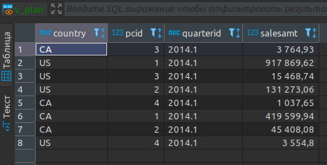

**Data preparation for plan-fact analysis in Q1 2014**

**create** **materialized** **view** mv_plan_fact_2014_q1 **as**

**select**

plan.quarterid **as** "quarter",

plan.country **as** country,

plan.pcid **as** "category name",

**coalesce**(**round**(plan.salesamt - fact.salesamt, 0), 0) **as** "dev.",

**coalesce**(**round**(100 * (plan.salesamt - fact.salesamt) /

plan.salesamt, 0), 0) **as** "dev., %"

**from**

(**select** *

**from** plan_data pd

**where** pd.versionid = 'A') **as** plan

**left** **join** (

**select**

c2.countrycode **as** country,

s2.qr **as** quarterid,

p.pcid **as** pcid,

**sum**(s.linetotal) **as** salesamt

**from**

salesorderdetail s

**join** (

**select**

salesorderid, customerid,

**extract**('y' **from** orderdate) **as** "year",

''|| **extract**('y' **from** orderdate) || '.' ||

**extract**('qtr' **from** orderdate) **as** qr

**from**

salesorderheader

**where**

**extract**('y' **from** orderdate) **in** (2012, 2013)

) s2 **using**(salesorderid)

**join** customer c **using**(customerid)

**join** company c2 **on** c2.cname = c.companyname

**join** product2 p **using**(productid)

**join** company_abc ca **on** ca."year" = s2."year"

**and** ca.cid = c2.id

**where**

ca.cls **in** ('A', 'B')

**and** s2.qr = '2013.1'

**group** **by**

c2.countrycode, s2.qr, p.pcid) **as** fact

**on** plan.country = fact.country **and** plan.pcid = fact.pcid

**order** **by**

country, "category name";

