**DBMS LAB**

**ASSIGNMENT 1**

**NAME SHISHU**

**REG:- 2020CA089**

1. Construct an E-R diagram for a hospital with a set of patients and a set of medical doctors. Associate with each patient a log of the various tests and examinations conducted.

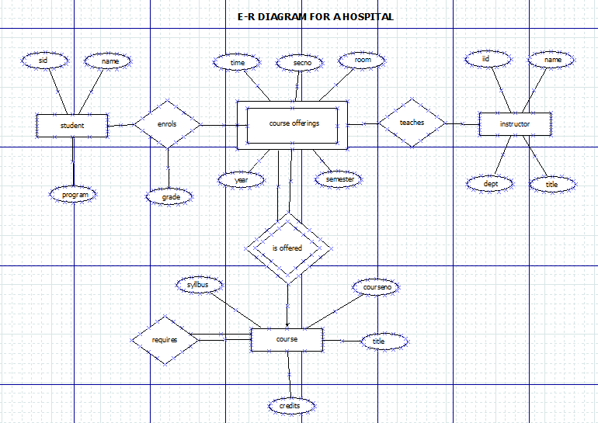

2. A university registrar’s office maintains data about the following entities: a) courses including number, title, credits, syllabus, and prerequisites; b) course offerings, including course number, year, semester, section, instructor(s), timings, and classroom; c) students including student-id, name, and program; and d) Instructors including identification number, name, department, and title. Further, the enrolment of students in courses and grades awarded to students in each course they are enrolled for must be appropriately modelled. Construct an E-R diagram for the registrar’s office. Document all assumptions that you make about the mapping constraints

