**NAME : SHISHU**

**REG 2020CA089**

Assignment 2

DDL & DML Commands (Basics)

1. Exercise 1 (practice on SQL commands)

a. Practice all the following DDL commands

1. Creating a table

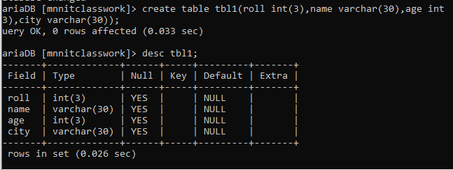

2. Altering a table

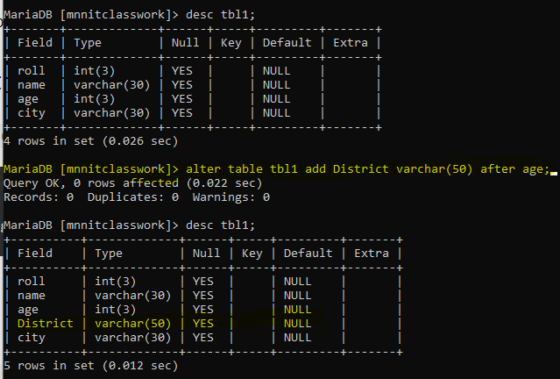

3. Drop a table



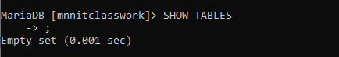

4. Truncating a table

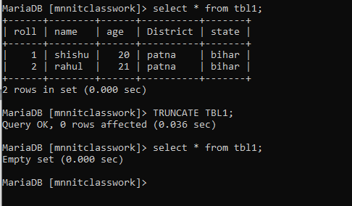

5. Rename

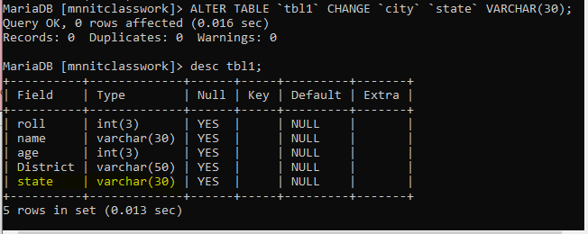

b. Practice all the following DML commands

1. Inserting Rows into table

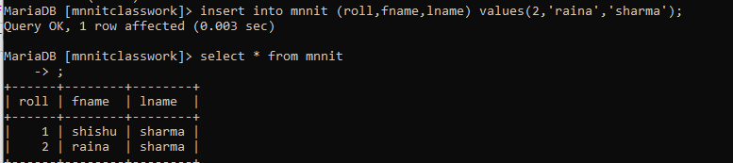

2. Deleting Rows from table

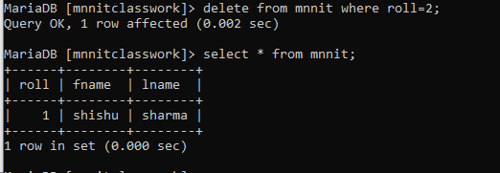

3. Updating data in a table

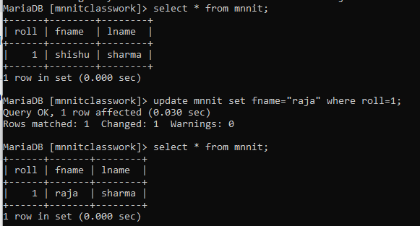

4. Defining constraints

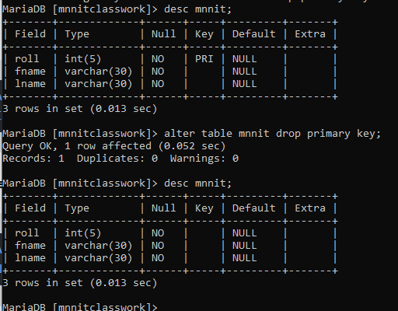

2. Assignment on DDL and DML commands

A. Suppose that a faculty wants to keep records about the students, the desired records should maintain

this information about each student: (Roll No, Full name, CGPA, Age, and Gender)

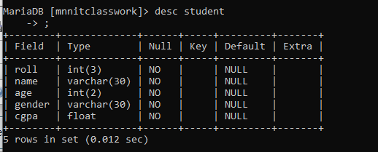

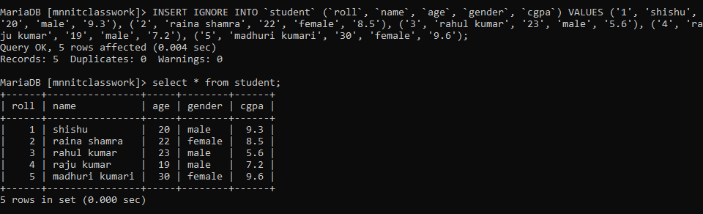

a. Create the appropriate Table.

b. Write SQL Queries to answer the following problems:

- List the names of all female students.

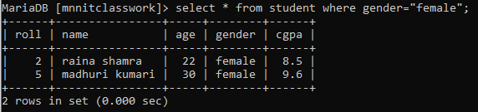

- What is the age of the youngest male student?

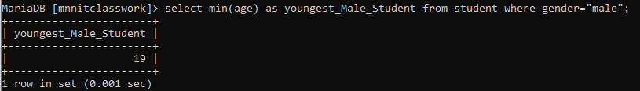

- List the name and the CGPA for all students who got above 6.5 CGPA ordered by

their CGPAs then their names.

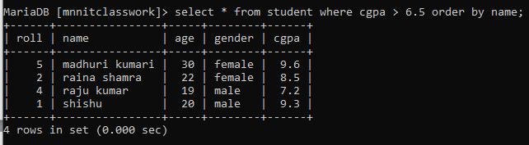

- What is the Topper name?

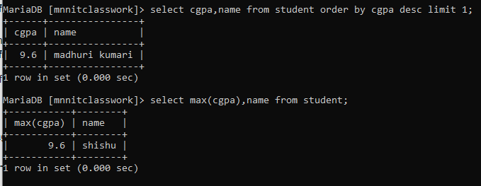

3. A super market manager likes to keep records about all the items in his store these records should hold

the following information about each item (the item identifier item_id, the item name, the item price,

expiration date of the item, quantity in hand)

a. Create the appropriate table.

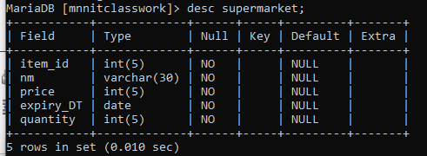

b. Write sql queries to answer the following problems:

- List the names and prices for all items that have a quantity in hand >20.

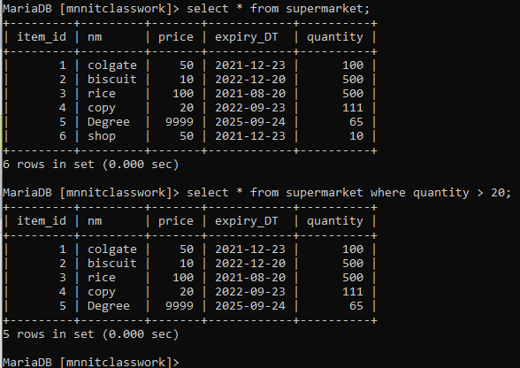

- List the names of expired items.

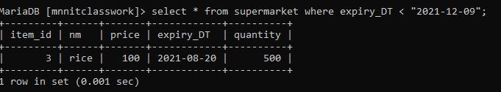

- name the second most expensive item.

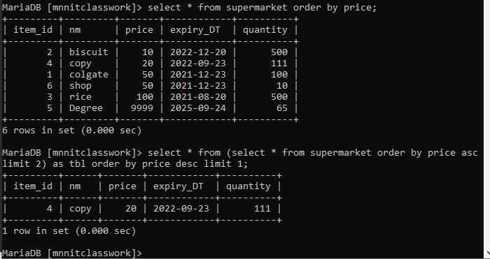

Alter the table structure to make sure that no negative value can be assigned to the price field

