**NAME SHISHU**

**REG 2020CA089**

**Operating System Lab Week 3**

**Question 1.** Keep in mind the utility of fork() and exec() system calls in process creation. Exec is

used to load a process and fork() creates a child process.

• In the xv6 directory, type “make qemu-gdb”, to start qemu along with GNU Debugger.

• Open another terminal window, type “gdb” while in the same xv6 directory. Enter

“source .gdbinit”. Now gdb is connected to the xv6 operating system.

• In the same terminal (gdb), add a breakpoint for exec system call by typing “break exec”.

Then type “continue” to reach the first instance where exec() is called. Typing continue

again takes us to the next point where the exec() is invoked. Type continue the third time,

and in the xv6 OS window run any shell command (ls, cat etc.)

**Explanation of whole process:**

First I executed command make qemu-gdb and after that open another terminal and types gdb

there. In next step, I wrote source .gdbinit, this connected my gdb to xv6 operating system.

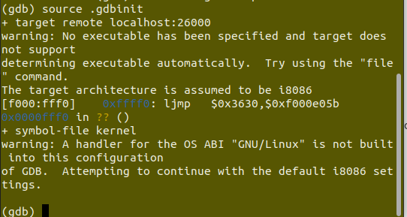

Now, I added breakpoint by typing break exec and then continue. It initiates our operating

system and started first process /init as thread 2.

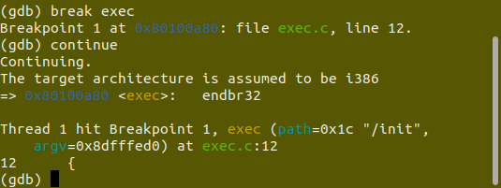

Again after continue, init started a shell process which is the xv6 shell we get when the OS

boots.

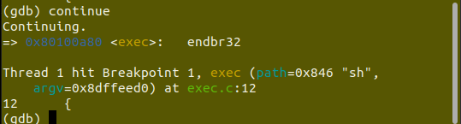

If you continue again, gdb will not return since it is waiting for a command to be started in the shell. Switch to the other window and try typing a command (for example, ls, cat) at which time you will get another break as the shell forks then execs the ls program.

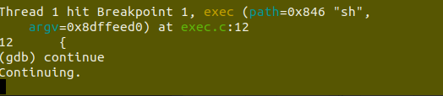

**screenshot of other terminal where I executed ls command**

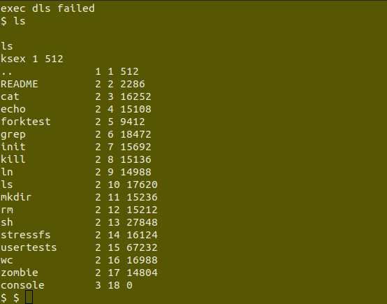

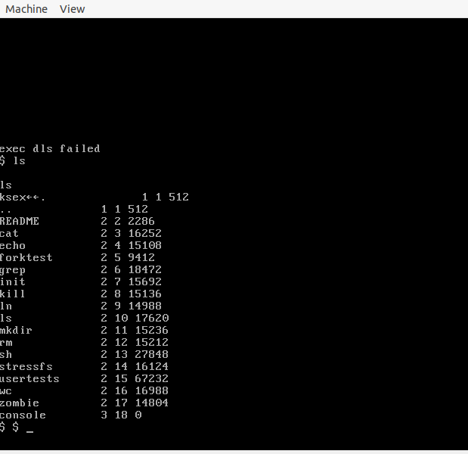

**Question 2.** On xv6 shell, type “ls” command. Your task is to make this command more user

friendly, by finding out what the numbers in the second column of the result represent.

The xv6 source code files are well documented using comments.

Edit the C file for this command, find out what the numbers in the second column represent (hint :

you might want to inspect the #included files) and modify the code appropriately so that it prints a

descriptive string in the second column instead of a number, when “ls” is called.

Note: every time you modify xv6, make has to be called again to implement those changes.

Write a document file whatever changes you have made along with the output screenshot

**Explanation:**

To make second column of ls command more use friendly. I did few changes in ls.c file from line 67 to line 73. Basically, First I find the meaning of status value(1, 2, 3) from stat.h header file. Then I use if-else in ls.c file as you can see in below screenshot from line 67. I changed second format specifier of line 69, 71, 73 with appropriate meaning as I found in stat.h header file.

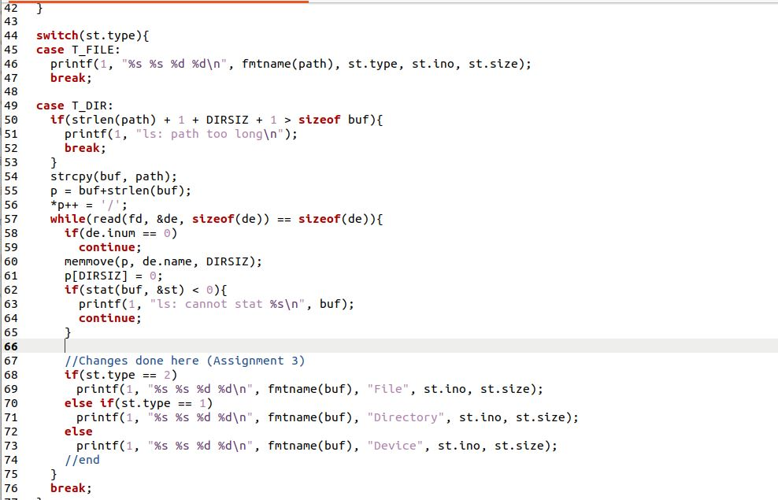

Then after saving ls.c file. I started qemu by make qemu command, and run ls command there.

**Before Changes in ls.c:**

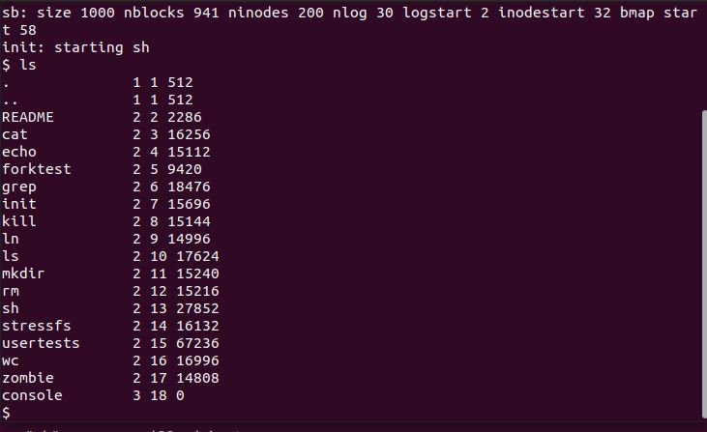

**After Changes in ls.c**

