Motilal Nehru National Institute of Technology Allahabad, Prayagraj
Computer Science & Engineering Department
Analysis of Algorithm Lab
Assignment-5
NAME SHISHU
REG 2020CA089

Q-1: Write a C Program to analyse the complexity of Counting Sort Algorithm. Also plot its graph for all cases.
#include <stdio.h>
#include <stdlib.h>
#include <string.h>
#include <time.h>
#define RANGE 10;

void countsorting(long int arr[], long int n, long int n1)
{
// creating an integer array of size n for sorted array
long int outputArray[n];
// creating an integer array of size n1, initialized by zero
long int freqArray[n1];
memset(freqArray, 0, sizeof(freqArray));
// Using the value of each item in an input array as index,
for (long int i = 0; i < n; i++)
{
freqArray[arr[i]]++;
}
// Calculating starting index for each long integer
long int totalCount = 0;
for (long int i = 0; i < n1; i++)
{
long int oldEleCount = freqArray[i];
freqArray[i] = totalCount;
totalCount += oldEleCount;
}
// Copying to output array, and preserving order of inputs with equal keys
for (long int i = 0; i < n; i++)
{
outputArray[freqArray[arr[i]]] = arr[i];
freqArray[arr[i]]++;
}
// copying output array back to the input array
for (long int i = 0; i < n; i++)
{
arr[i] = outputArray[i];
}

}
int main()
{
FILE *fp;

long int n = 1000;
// variable to store time duration
// of sorting algorithms
double t[10];
fp = fopen("countingSort100000.txt", "w+");
fprintf(fp, "ArraySize ExecutionTime\n");
fclose(fp);

printf("ArraySize ExecutionTime\n");
int it = 0;
// generation n random numbers
// storing them in arrays a;

while (it++ < 5)
{

fp = fopen("countingSort100000.txt", "a+");
long int a[n];
long int mx=0;
for (long int i = 0; i < n; i++)
{
long int no = rand() % n+i;
a[i] = no;
if(mx<a[i])
mx=a[i];
}

long int len=sizeof(a)/sizeof(a[0]);
// using clock_t to store time
clock_t start, end;
// quicksort
start = clock();

countsorting(a,len,mx+1);

end = clock();

t[it] = ((double)(end - start));

// type conversion to long int for plotting
// graph with integer values
fprintf(fp, "%li\t\t%li\n", n, (long int)t[it]);
printf("%li\t\t%li\n", n, (long int)t[it]);
n += 100000;

fclose(fp);
}
return 0;
}

Countsort1000.txt
ArraySize ExecutionTime
1000 0
2000 0
3000 1
4000 1
5000 0
Countsort10000.txt
ArraySize ExecutionTime
1000 0
11000 2
21000 2
31000 2
41000 3
Countsort100000.txt
ArraySize ExecutionTime
1000 0
101000 11

Dataplot.p
set autoscale # scale axes automatically
unset log # remove any log-scaling
unset label # remove any previous labels
set xtic auto # set xtics automatically
set ytic auto # set ytics automatically
set tics font "Helvetica,10"
set title "Calculate Time Comlexity"
set xlabel "Input Size"
set ylabel "Time Taken"
#set key 0.01,100
#set label "Yield Point" at 0.003,260
#set arrow from 0.0028,250 to 0.003,280
set xr [0:108000]
set yr [0.00000:100]
plot "countingSort1000.txt" using 1:2 title 'Best' with linespoints, \
"countingSort10000.txt" using 1:2 title 'Average' with linespoints,\
"countingSort100000.txt" using 1:2 title 'Worst' with linespoints
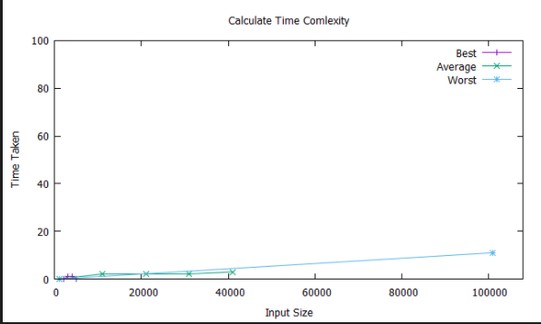

Q-2: Write a C Program to analyse the complexity of Radix Sort Algorithm. Also plot its graph for all cases.
#include<stdio.h>
#include <stdlib.h>
#include <string.h>
#include <time.h>

// A utility function to get maximum value in arr[]
long int getMax(long int arr[], long int n)
{
long int mx = arr[0];
for (long int i = 1; i < n; i++)
if (arr[i] > mx)
mx = arr[i];
return mx;
}

// A function to do counting sort of arr[] according to
// the digit represented by exp.
void countSort(long int arr[], long int n, long int exp)
{
long int output[n]; // output array
long int i, count[10] = { 0 };

// Store count of occurrences in count[]
for (i = 0; i < n; i++)
count[(arr[i] / exp) % 10]++;

// Change count[i] so that count[i] now contains actual
// position of this digit in output[]
for (i = 1; i < 10; i++)
count[i] += count[i - 1];

// Build the output array
for (i = n - 1; i >= 0; i--) {
output[count[(arr[i] / exp) % 10] - 1] = arr[i];
count[(arr[i] / exp) % 10]--;
}

// Copy the output array to arr[], so that arr[] now
// contains sorted numbers according to current digit
for (i = 0; i < n; i++)
arr[i] = output[i];
}

// The main function to that sorts arr[] of size n using
// Radix Sort
void radixsort(long int arr[], long int n)
{
// Find the maximum number to know number of digits
long int m = getMax(arr, n);

// Do counting sort for every digit. Note that instead
// of passing digit number, exp is passed. exp is 10^i
// where i is current digit number
for (long int exp = 1; m / exp > 0; exp *= 10)
countSort(arr, n, exp);
}

int main()
{
FILE *fp;

long int n = 100000;
// variable to store time duration
// of sorting algorithms
double t[10];
fp = fopen("radixsort100000.txt", "w+");
fprintf(fp, "ArraySize ExecutionTime\n");
fclose(fp);

printf("ArraySize ExecutionTime\n");
int it = 0;
// generation n random numbers
// storing them in arrays a;

while (it++ < 5)
{

fp = fopen("radixsort100000.txt", "a+");
long int a[n];

for (long int i = 0; i < n; i++)
{
long int no = rand() % n+i;
a[i] = no;

}

// using clock_t to store time
clock_t start, end;
// quicksort
start = clock();

radixsort(a, n);

end = clock();

t[it] = ((double)(end - start));

// type conversion to long int for plotting
// graph with integer values
fprintf(fp, "%li\t\t%li\n", n, (long int)t[it]);
printf("%li\t\t%li\n", n, (long int)t[it]);
n += 20000;

fclose(fp);
}
return 0;
}

Radixsort1000.txt
ArraySize ExecutionTime
1000 0
2000 1
3000 1
4000 1
5000 1
Radixsort10000.txt
ArraySize ExecutionTime
10000 5
11000 4
12000 3
13000 3
14000 2
Radixsort100000.txt
ArraySize ExecutionTime
100000 53
120000 50
140000 61
160000 54
180000 47
Dataplot.p
set autoscale # scale axes automatically
unset log # remove any log-scaling
unset label # remove any previous labels
set xtic auto # set xtics automatically
set ytic auto # set ytics automatically
set tics font "Helvetica,10"
set title "Calculate Time Comlexity"
set xlabel "Input Size"
set ylabel "Time Taken"
#set key 0.01,100
#set label "Yield Point" at 0.003,260
#set arrow from 0.0028,250 to 0.003,280
set xr [0:180000]
set yr [0.00000:100]
plot "radixsort1000.txt" using 1:2 title 'Best' with linespoints, \
"radixsort10000.txt" using 1:2 title 'Average' with linespoints,\
"radixsort100000.txt" using 1:2 title 'Worst' with linespoints
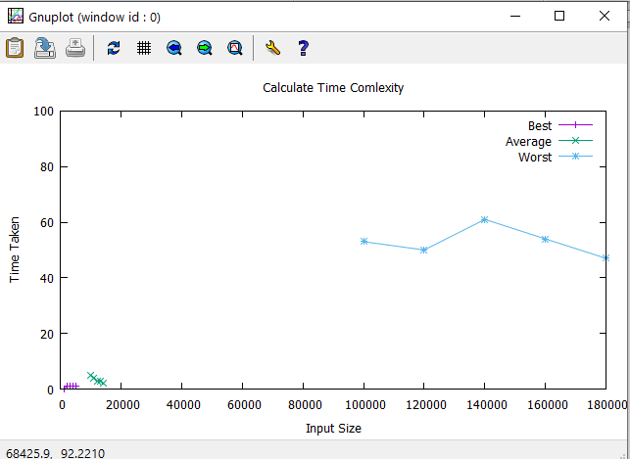

Q-3: Write a C Program to analyse the complexity of Bucket Sort Algorithm. Also plot its graph for all cases.
#include <stdio.h>
#include <stdlib.h>
#include <string.h>
#include <time.h>
#include <stdio.h>
long int getMax(long int a[], long int n) // function to get maximum element from the given array
{
long int max = a[0];
for (long int i = 1; i < n; i++)
if (a[i] > max)
max = a[i];
return max;
}
void bucket(long int a[], long int n) // function to implement bucket sort
{
long int max = getMax(a, n); //max is the maximum element of array
long int bucket[max], i;
for (long int i = 0; i <= max; i++)
{
bucket[i] = 0;
}
for (long int i = 0; i < n; i++)
{
bucket[a[i]]++;
}
for (long int i = 0, j = 0; i <= max; i++)
{
while (bucket[i] > 0)
{
a[j++] = i;
bucket[i]--;
}
}
}

int main()
{
FILE *fp;

long int n = 100000;
// variable to store time duration
// of sorting algorithms
double t[10];
fp = fopen("bucketsort100000.txt", "w+");
fprintf(fp, "ArraySize ExecutionTime\n");
fclose(fp);

printf("ArraySize ExecutionTime\n");
int it = 0;
// generation n random numbers
// storing them in arrays a;

while (it++ < 5)
{

fp = fopen("bucketsort100000.txt", "a+");
long int a[n];

for (long int i = 0; i < n; i++)
{
long int no = rand() % n + i;
a[i] = no;
}

// using clock_t to store time
clock_t start, end;
// quicksort
start = clock();

bucket(a, n);

end = clock();

t[it] = ((double)(end - start));

// type conversion to long int for plotting
// graph with integer values
fprintf(fp, "%li\t\t%li\n", n, (long int)t[it]);
printf("%li\t\t%li\n", n, (long int)t[it]);
n += 20000;

fclose(fp);
}
return 0;
}

Bucketsort1000.txt
ArraySize ExecutionTime
1000 0
3000 0
5000 1
7000 0
9000 1
Bucketsort10000.txt
ArraySize ExecutionTime
10000 1
30000 6
50000 2
70000 4
90000 4
Bucketsort100000.txt
ArraySize ExecutionTime
100000 17
120000 10
140000 10
160000 11
180000 13
Dataplot.p
set autoscale # scale axes automatically
unset log # remove any log-scaling
unset label # remove any previous labels
set xtic auto # set xtics automatically
set ytic auto # set ytics automatically
set tics font "Helvetica,10"
set title "Calculate Time Comlexity"
set xlabel "Input Size"
set ylabel "Time Taken"
#set key 0.01,100
#set label "Yield Point" at 0.003,260
#set arrow from 0.0028,250 to 0.003,280
set xr [0:180000]
set yr [0.00000:100]
plot "bucketsort1000.txt" using 1:2 title 'Best' with linespoints, \
"bucketsort10000.txt" using 1:2 title 'Average' with linespoints,\
"bucketsort100000.txt" using 1:2 title 'Worst' with linespoints
