Assignment – 1

Multimedia lab

*Name: Aman Pachouri*

*Reg no: 2020CA005*

// A C++ Program to play tic-tac-toe

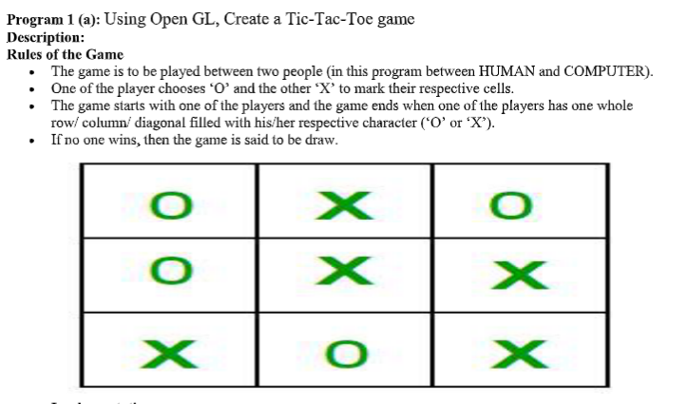

#include<bits/stdc++.h>

using namespace std;

#define COMPUTER 1

#define HUMAN 2

#define SIDE 3 // Length of the board

// Computer will move with 'O'

// and human with 'X'

#define COMPUTERMOVE 'O'

#define HUMANMOVE 'X'

// A function to show the current board status

void showBoard(char board[][SIDE])

{

printf("\n\n");

printf("\t\t\t %c | %c | %c \n", board[0][0],

board[0][1], board[0][2]);

printf("\t\t\t--------------\n");

printf("\t\t\t %c | %c | %c \n", board[1][0],

board[1][1], board[1][2]);

printf("\t\t\t--------------\n");

printf("\t\t\t %c | %c | %c \n\n", board[2][0],

board[2][1], board[2][2]);

return;

}

// A function to show the instructions

void showInstructions()

{

printf("\t\t\t Tic-Tac-Toe\n\n");

printf("Choose a cell numbered from 1 to 9 as below"

" and play\n\n");

printf("\t\t\t 1 | 2 | 3 \n");

printf("\t\t\t--------------\n");

printf("\t\t\t 4 | 5 | 6 \n");

printf("\t\t\t--------------\n");

printf("\t\t\t 7 | 8 | 9 \n\n");

printf("-\t-\t-\t-\t-\t-\t-\t-\t-\t-\n\n");

return;

}

// A function to initialise the game

void initialise(char board[][SIDE], int moves[])

{

// Initiate the random number generator so that

// the same configuration doesn't arises

srand(time(NULL));

// Initially the board is empty

for (int i=0; i<SIDE; i++)

{

for (int j=0; j<SIDE; j++)

board[i][j] = ' ';

}

// Fill the moves with numbers

for (int i=0; i<SIDE*SIDE; i++)

moves[i] = i;

// randomise the moves

random_shuffle(moves, moves + SIDE*SIDE);

return;

}

// A function to declare the winner of the game

void declareWinner(int whoseTurn)

{

if (whoseTurn == COMPUTER)

printf("COMPUTER has won\n");

else

printf("HUMAN has won\n");

return;

}

// A function that returns true if any of the row

// is crossed with the same player's move

bool rowCrossed(char board[][SIDE])

{

for (int i=0; i<SIDE; i++)

{

if (board[i][0] == board[i][1] &&

board[i][1] == board[i][2] &&

board[i][0] != ' ')

return (true);

}

return(false);

}

// A function that returns true if any of the column

// is crossed with the same player's move

bool columnCrossed(char board[][SIDE])

{

for (int i=0; i<SIDE; i++)

{

if (board[0][i] == board[1][i] &&

board[1][i] == board[2][i] &&

board[0][i] != ' ')

return (true);

}

return(false);

}

// A function that returns true if any of the diagonal

// is crossed with the same player's move

bool diagonalCrossed(char board[][SIDE])

{

if (board[0][0] == board[1][1] &&

board[1][1] == board[2][2] &&

board[0][0] != ' ')

return(true);

if (board[0][2] == board[1][1] &&

board[1][1] == board[2][0] &&

board[0][2] != ' ')

return(true);

return(false);

}

// A function that returns true if the game is over

// else it returns a false

bool gameOver(char board[][SIDE])

{

return(rowCrossed(board) || columnCrossed(board)

|| diagonalCrossed(board) );

}

// A function to play Tic-Tac-Toe

void playTicTacToe(int whoseTurn)

{

// A 3*3 Tic-Tac-Toe board for playing

char board[SIDE][SIDE];

int moves[SIDE*SIDE];

// Initialise the game

initialise(board, moves);

// Show the instructions before playing

showInstructions();

int moveIndex = 0, x, y;

// Keep playing till the game is over or it is a draw

while (gameOver(board) == false &&

moveIndex != SIDE*SIDE)

{

if (whoseTurn == COMPUTER)

{

st: x = moves[moveIndex] / SIDE;

y = moves[moveIndex] % SIDE;

if(board[x][y] == 'X' || board[x][y] == 'O')

goto st;

board[x][y] = COMPUTERMOVE;

printf("COMPUTER has put a %c in cell %d\n",

COMPUTERMOVE, moves[moveIndex]+1);

showBoard(board);

moveIndex ++;

whoseTurn = HUMAN;

}

else if (whoseTurn == HUMAN)

{

cin >> x;

cin >> y;

board[x][y] = HUMANMOVE;

printf ("HUMAN has put a %c in cell %d\n",

HUMANMOVE, moves[moveIndex]+1);

showBoard(board);

moveIndex ++;

whoseTurn = COMPUTER;

}

}

// If the game has drawn

if (gameOver(board) == false &&

moveIndex == SIDE * SIDE)

printf("It's a draw\n");

else

{

// Toggling the user to declare the actual

// winner

if (whoseTurn == COMPUTER)

whoseTurn = HUMAN;

else if (whoseTurn == HUMAN)

whoseTurn = COMPUTER;

// Declare the winner

declareWinner(whoseTurn);

}

return;

}

// Driver program

int main()

{

// Let us play the game with COMPUTER starting first

playTicTacToe(COMPUTER);

return (0);

}

**OUTPUT:**

