NAME SHISHU

REG 2020CA089

**Motilal Nehru National Institute of Technology, Allahabad**

**(Department of Computer Science & Engineering)**

**(MCA- 3rd Sem)**

**Assignment-9**

**Lab Name: Design Analysis & Algorithms**

Write a C program to implement Prim's algorithm to find Minimum Spanning Tree.

Suppose the graph that given solution below

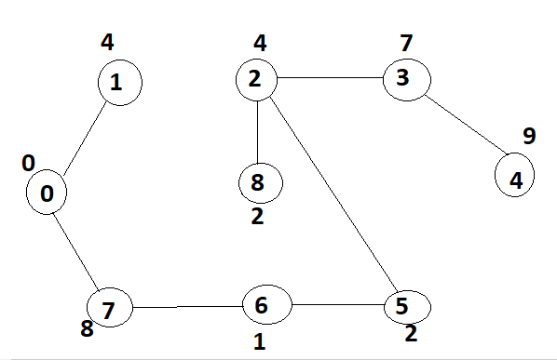

#include <limits.h>

#include <stdbool.h>

#include <stdio.h>

// Number of vertices in the graph

#define V 5

// A utility function to find the vertex with

// minimum key value, from the set of vertices

// not yet included in MST

int minKey(int key[], bool mstSet[])

{

    // Initialize min value

    int min = INT_MAX, min_index;

    for (int v = 0; v < V; v++)

        if (mstSet[v] == false && key[v] < min)

            min = key[v], min_index = v;

    return min_index;

}

// constructed MST stored in parent[]

int printMST(int parent[], int graph[V][V])

{

    printf("Edge \tWeight\n");

    for (int i = 1; i < V; i++)

        printf("%d - %d \t%d \n", parent[i], i, graph[i][parent[i]]);

}

// Function to construct and print MST for

// a graph represented using adjacency

// matrix representation

void primMST(int graph[V][V])

{

    // Array to store constructed MST

    int parent[V];

    // Key values used to pick minimum weight edge in cut

    int key[V];

    // To represent set of vertices included in MST

    bool mstSet[V];

    // Initialize all keys as INFINITE

    for (int i = 0; i < V; i++)

        key[i] = INT_MAX, mstSet[i] = false;

    // Always include first 1st vertex in MST.

    // Make key 0 so that this vertex is picked as first vertex.

    key[0] = 0;

    parent[0] = -1; // First node is always root of MST

    // The MST will have V vertices

    for (int count = 0; count < V - 1; count++) {

        // Pick the minimum key vertex from the

        // set of vertices not yet included in MST

        int u = minKey(key, mstSet);

        // Add the picked vertex to the MST Set

        mstSet[u] = true;

        for (int v = 0; v < V; v++)

            // Update the key only if graph[u][v] is smaller than key[v]

            if (graph[u][v] && mstSet[v] == false && graph[u][v] < key[v])

                parent[v] = u, key[v] = graph[u][v];

    }

    // print the constructed MST

    printMST(parent, graph);

}

// driver program to test above function

int main()

{

    int graph[V][V] = { { 0, 2, 0, 6, 0 },

                        { 2, 0, 3, 8, 5 },

                        { 0, 3, 0, 0, 7 },

                        { 6, 8, 0, 0, 9 },

                        { 0, 5, 7, 9, 0 } };

    // Print the solution

    primMST(graph);

    return 0;

}

Output

