**Assignment – No 2**

**DBMS LAB**

**Name : SHISHU**

**Registration No. 2020CA089**

**Q1: Consider a database used to record the marks that students get in different exams of different course offerings.**

**a )Construct an E-R diagram that models exams as entities, and uses a ternary relationship, for the above database.**

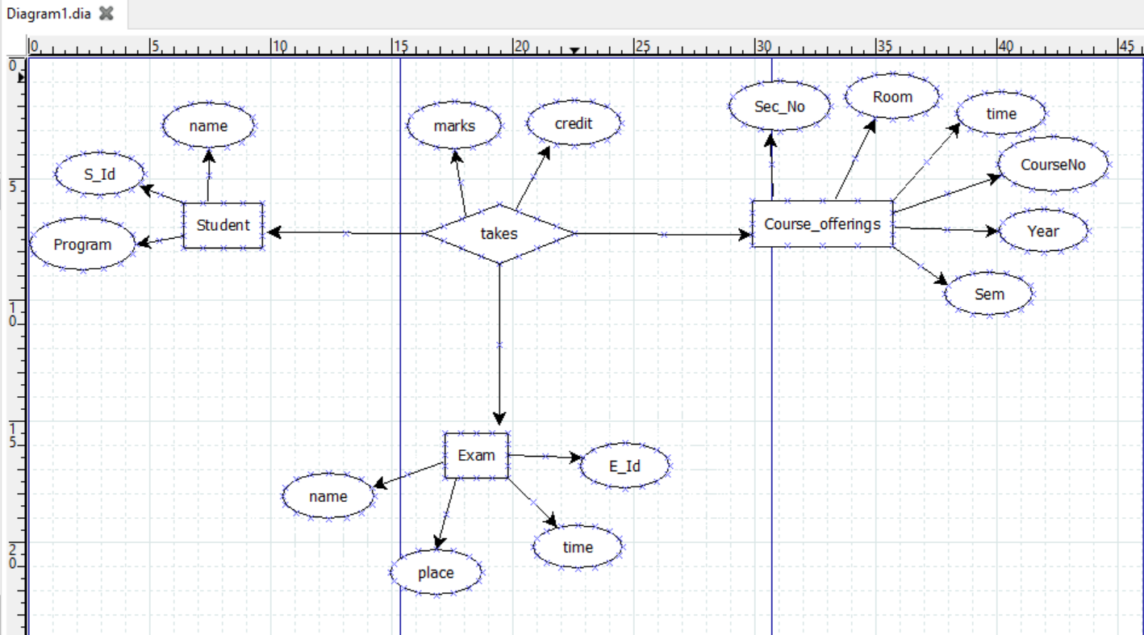

**b ) Construct an alternative E-R diagram that uses only a binary relationship between students and course-offerings. Make sure that only one relationship exists between a particular student and course-offering pair, yet you can represent the marks that a student gets in different exams of a course offering.**

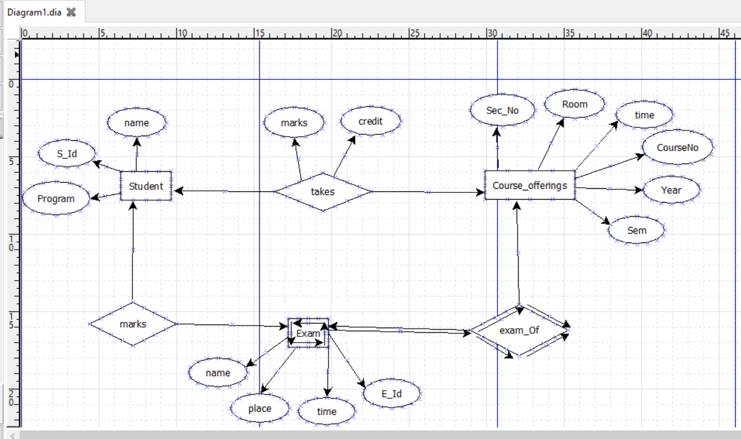

**Q2: A database is to be set up to record details of experts on different subjects. The database will be used to contact experts to be called as witnesses in court cases. The following information needs to be recorded.**

**For each expert, their witness identitynumber, name, affiliation (e.g. XYZUniversity”), and email address.**

**For each field of expertise, the name of the field (e.g., “DNA forensics”).**

**For each expert, all the fields of expertise that they are expert in.**

**Draw an ER diagram that expresses the requirements for the database. Make sure that you capture all the constraints on the data mentioned above**

