**MNNIT ALLAHABAD**

**DBMS**

|  |  |
| --- | --- |
| **SUBMITTED BY :**  **NAME : SHISHU**  **ROLL/REG ID : 2020CA089**  **SUBMIT DATE : 17/12/2021** | **SUBMITTED TO :**  **TEACHER _______________**  **DEPPT : COMPUTER SCIENCE**  **DEADLINE: 17/12/2021** |

# Q 1. Considering the given relations, operate the following queries:

CREATE TABLE stud_member ( Roll_No INT(5) NOT NULL ,

F_Name VARCHAR(20) NOT NULL , M_Name VARCHAR(20) NOT NULL , S_Name VARCHAR(20) NOT NULL , Dept_ID INT(3) NOT NULL ,

Semester INT(3) NOT NULL , Contact_No INT(20) NOT NULL , Gender VARCHAR(3) NOT NULL , PRIMARY KEY (Roll_No)

);

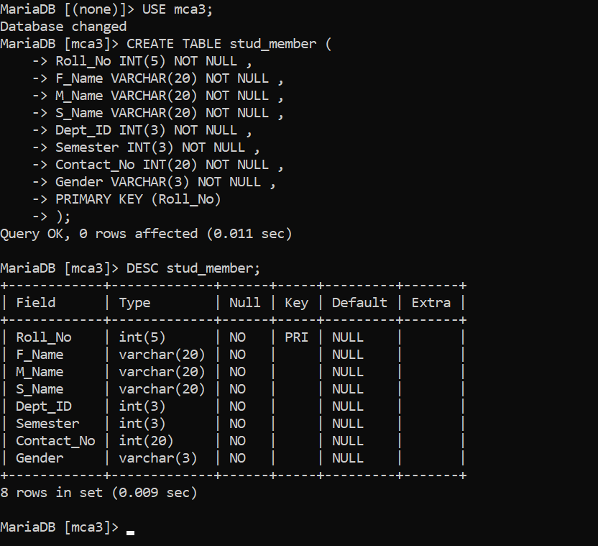

INSERT INTO stud_member

(Roll_No, F_Name, M_Name, S_Name, Dept_ID, Semester, Contact_No, Gender) VALUES (1 , 'Ankur' , 'Samir' , 'Kahar' ,1 ,1 ,272121 , 'M' ),

(2 , 'Dhaval' , 'Dhiren' , 'Joshi' ,1 ,1 ,232122 , 'M' ),

(3 , 'Ankita' , 'Biren', 'Shah', 1, 1, 112121, 'F'),

(10,'Komal', 'Maheskumar', 'Pandey', 2, 3, 123123, 'F'),

(13, 'Amit', 'Jitenkumar', 'Mehta', 3, 3, 453667, 'M'),

(23,'Jinal', 'Ashish', 'Gandhi', 2, 1, 323232, 'M'),

(22,'Ganesh', 'Asha', 'Patel', 2, 3, 124244, 'M'),

(4, 'Shweta', 'Mihir', 'Patel', 3, 1, 646342, 'F'),

(7, 'Pooja', 'Mayank', 'Desai', 3, 3, 328656, 'F'),

(8, 'Komal', 'Krishnaraj', 'Bhatia', 2, 3, 257422, 'F'),

(43, 'Kiran', 'Viraj', 'Shah', 1, 1, 754124, 'F') ;

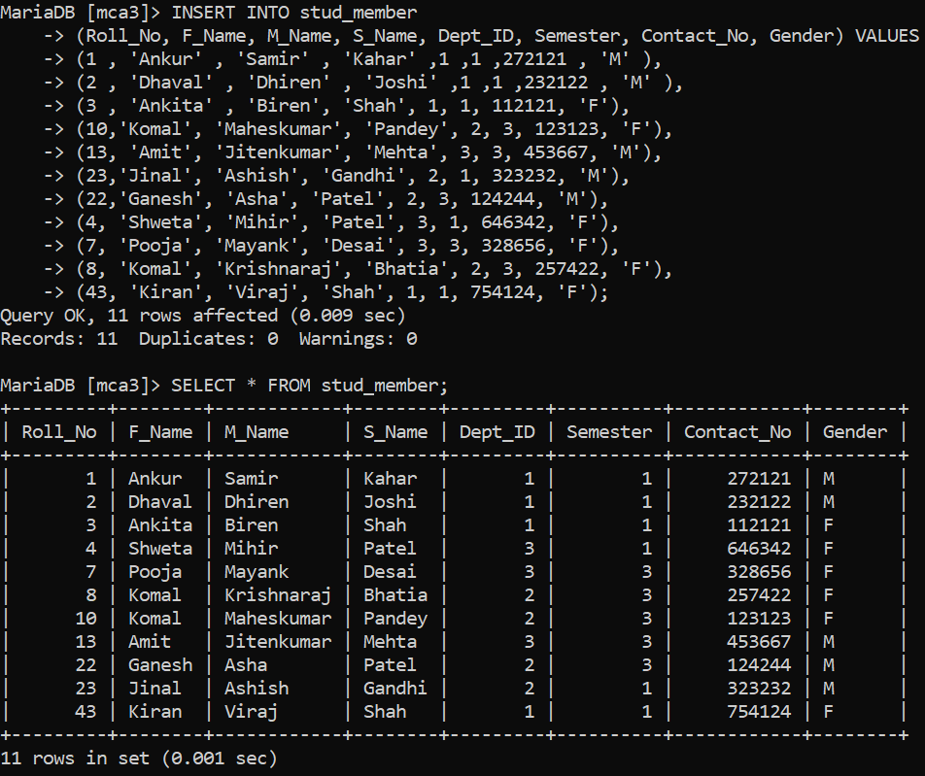

CREATE TABLE department ( Dept_ID INT(3 ) NOT NULL ,

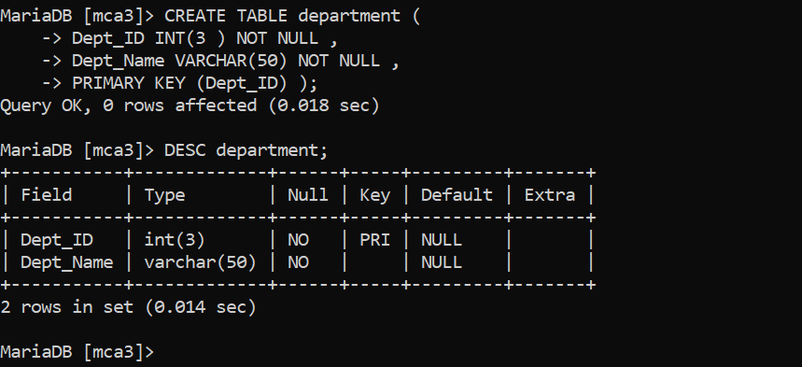Dept_Name VARCHAR(50) NOT NULL , PRIMARY KEY (Dept_ID) );

INSERT INTO department (Dept_ID, Dept_Name) VALUES (1, 'Information Technology'),

(2, 'Electrical'),

(3, 'Civil'),

(4, 'Mechanical'),

(5, 'Chemical');

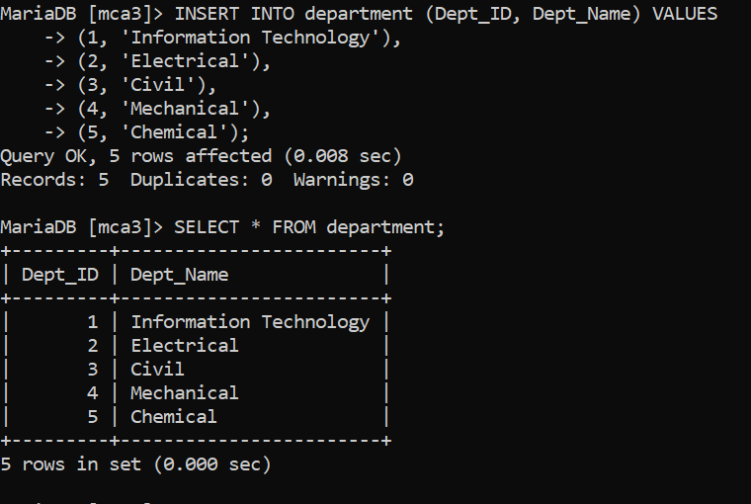

ALTER TABLE stud_member

ADD FOREIGN KEY (Dept_ID) REFERENCES department(Dept_ID) ;

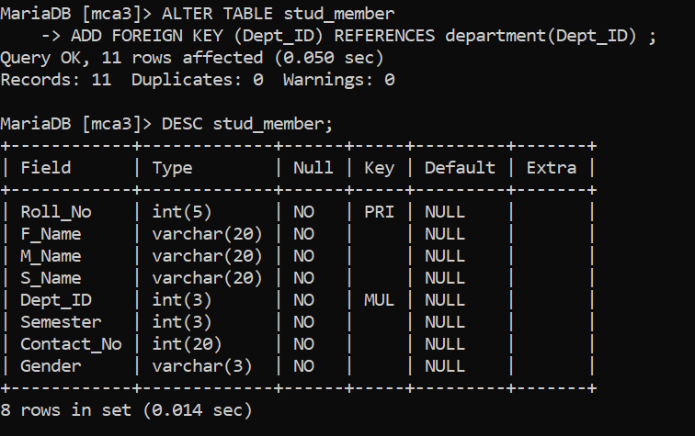

1. **Display the names and contact number of all student member** SELECT CONCAT(F_Name ,' ', M_Name ,' ',S_Name) AS Name, Contact_No FROM stud_member;

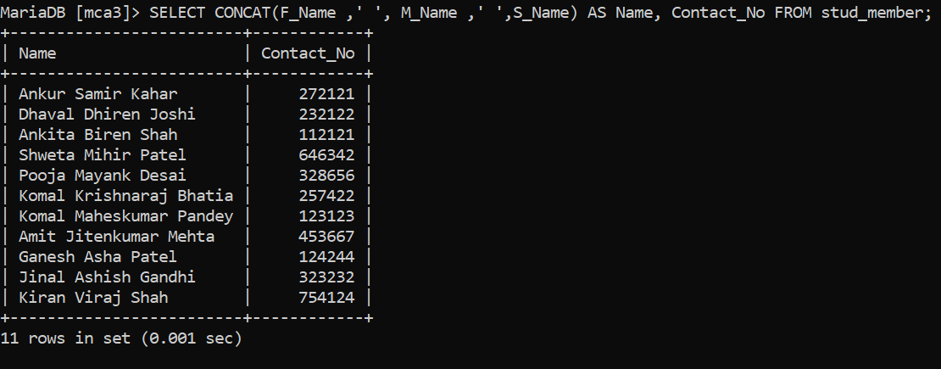

# Give the names and roll numbers of all students of information technology who are the members

SELECT Roll_No, F_Name FROM STUD_MEMBER S, DEPARTMENT D

WHERE S.Dept_ID=D.Dept_ID and D.Dept_Name="Information Technology";

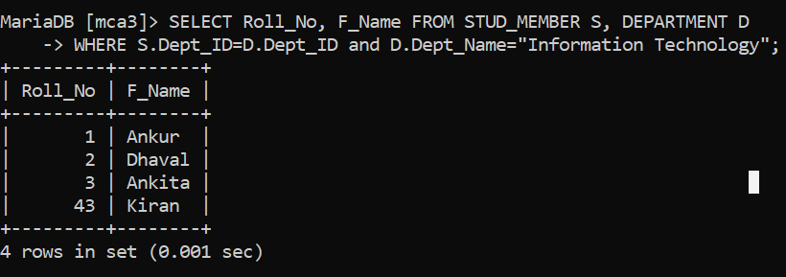

# Display the names of department whose students are members

SELECT DISTINCT Dept_Name FROM department D, stud_member S WHERE D.Dept_ID=S.Dept_ID;

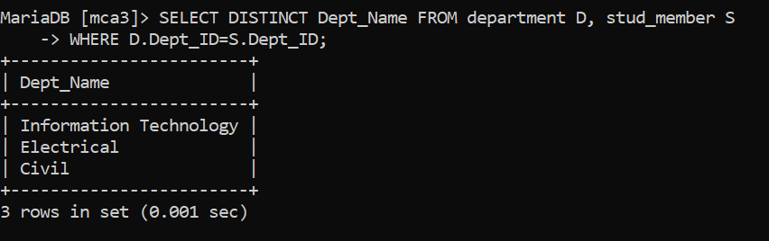

# Display the names of departments for which no student are the members

SELECT Dept_Name FROM department WHERE DEPT_Name NOT IN (

SELECT DISTINCT Dept_Name FROM department D, stud_member S WHERE S.Dept_ID=D.Dept_ID);

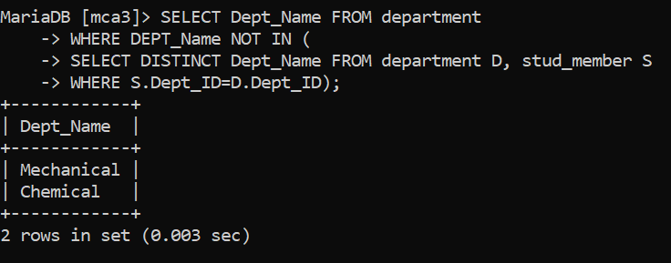

# Display the names of all departments

SELECT Dept_Name FROM department ;

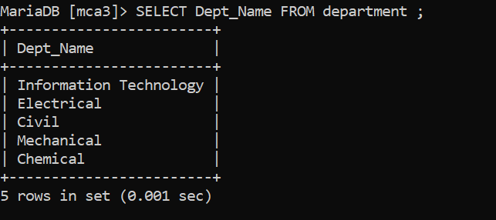

# Find the names of students of electrical department who are the members

SELECT F_Name FROM stud_member S, department D WHERE S.Dept_ID=D.Dept_ID AND D.Dept_Name="Electrical" ;

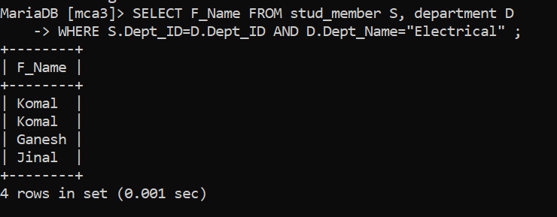

# Display the information of students members whose names begin with the letter A

SELECT * FROM stud_member WHERE F_Name LIKE "A%";

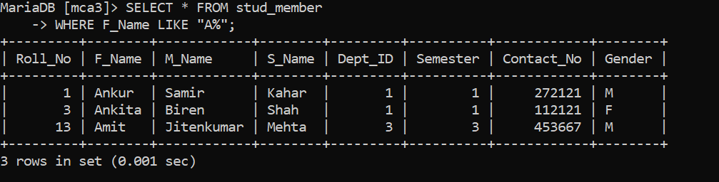

# Display all the details of male members only

SELECT * FROM stud_member WHERE Gender="M";

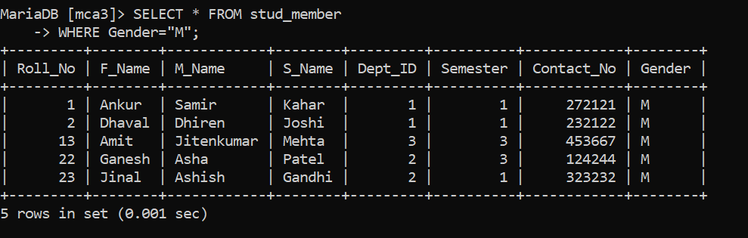

# Display the data of student members who are currently in semester 3

SELECT * FROM stud_member WHERE Semester=3;

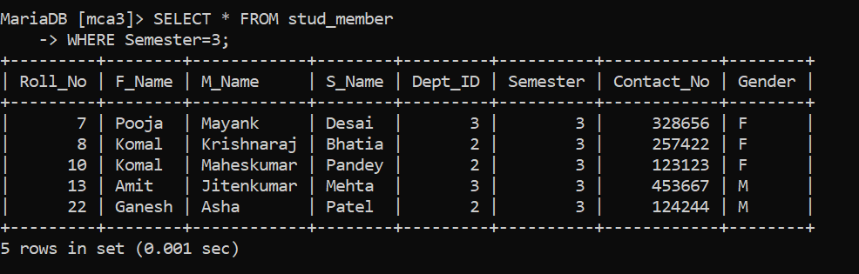

# Display the data of student female member in alphabetic order

SELECT * FROM stud_member

WHERE Gender="F" ORDER BY F_Name;

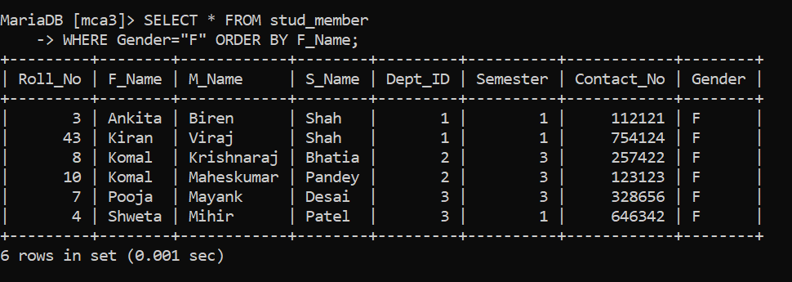

# Q2. Consider the following relations and operate the given queries.

CREATE TABLE sales ( OrderID INT(10) NOT NULL ,

OrderDate DATE NOT NULL , OrderPrice INT(100) NOT NULL , OrderQuantity INT(20) NOT NULL ,

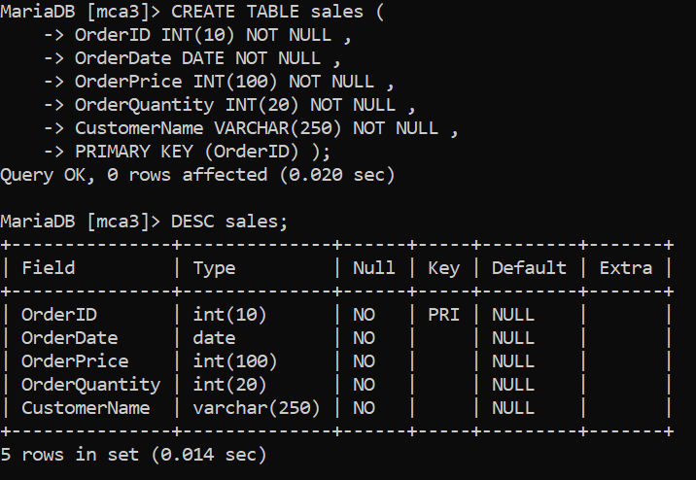CustomerName VARCHAR(250) NOT NULL , PRIMARY KEY (OrderID) );

INSERT INTO sales

(OrderID, OrderDate, OrderPrice, OrderQuantity, CustomerName) VALUES (1, '2005-12-22', 160, 2, 'Smith'),

(2, '2005-08-10', 190, 2, 'Johnson'),

(3, '2005-07-13', 500, 5, 'Baldwin'),

(4, '2005-07-15', 420,2, 'Smith'),

(5, '2005-12-22', 1000, 4, 'Wood'),

(6,'2005-10-02', 820, 4, 'Smith'),

(7, '2005-11-03', 2000, 2, 'Baldwin'),

(8, '2002-12-22', 1000, 4, 'Wood'),

(9, '2004-12-29', 5000, 4, 'Smith') ;

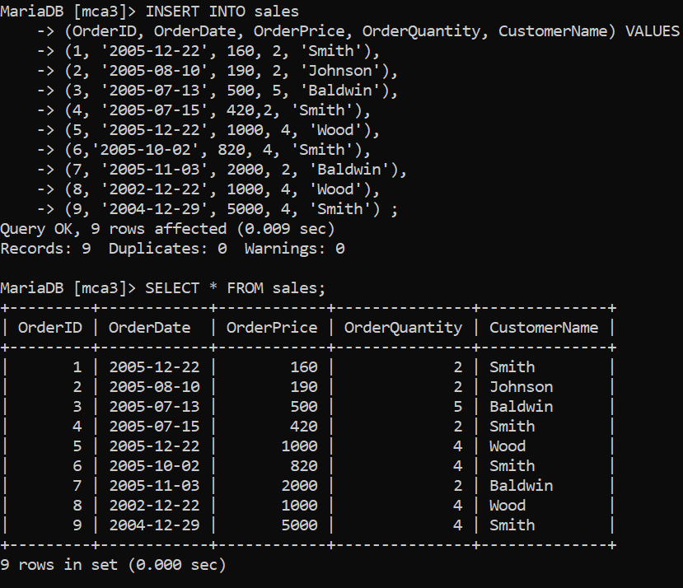

CREATE TABLE products (

Product_id VARCHAR(10) NOT NULL, OrderId INT(10) NOT NULL,

Manufacture_Date DATE NOT NULL, Raw_Material VARCHAR (20) NOT NULL,

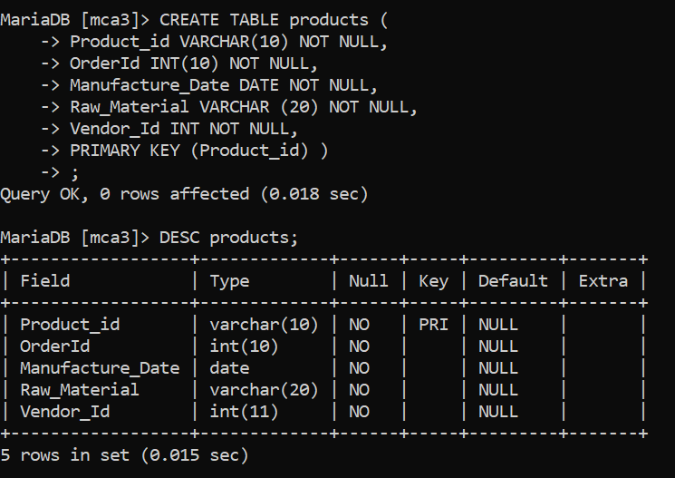Vendor_Id INT NOT NULL, PRIMARY KEY (Product_id) ) ;

INSERT INTO products

(Product_id, OrderId, Manufacture_Date, Raw_Material, Vendor_Id) VALUES ('AZ145', 2, '2005-12-23', 'Steel' ,1),

('CS784', 4, '2005-11-28', 'Plastic' ,2),

('AZ147', 6, '2002-8-15', 'Steel' ,3),

('FD344', 3, '2005-11-3', 'Milk' ,1),

('GR233', 3, '2005-11-30', 'Pulses' ,2),

('FD123', 2, '2005-10-3', 'Milk' ,2),

('CS783', 1, '2004-11-3', 'Plastic' ,2),

('CS435', 5, '2001-11-4', 'Steel' ,1),

('GR567', 6, '2005-9-3', 'Pulses' ,2),

('FD267', 5, '2002-12-3', 'Bread' ,4),

('FD333', 9, '2005-12-12', 'Milk' ,1);

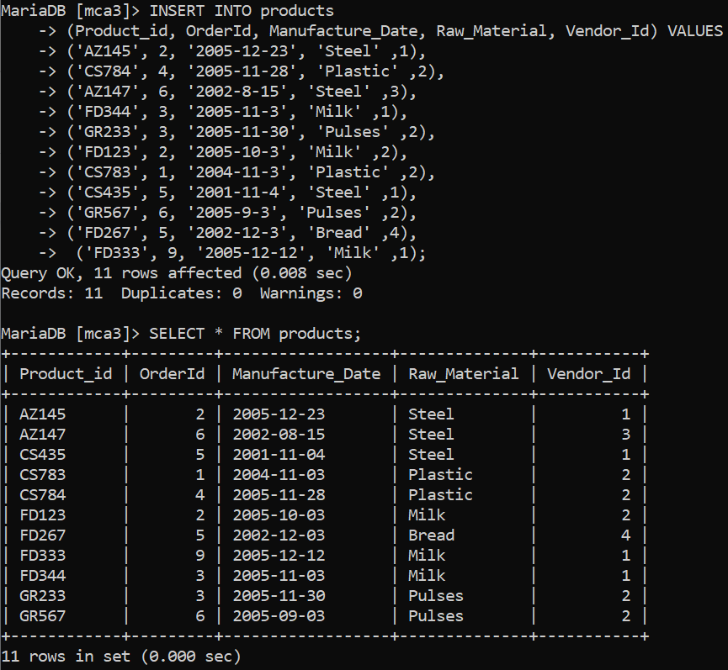

CREATE TABLE vendor_info ( Vendor_id INT(5) NOT NULL,

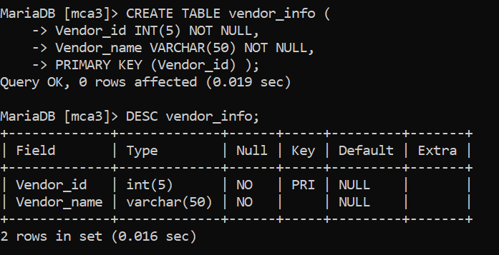Vendor_name VARCHAR(50) NOT NULL, PRIMARY KEY (Vendor_id) );

INSERT INTO vendor_info (Vendor_id, Vendor_name) VALUES (1, 'Smith'),

(2, 'Wills'),

(3, 'Johnson'),

(4, 'Roger');

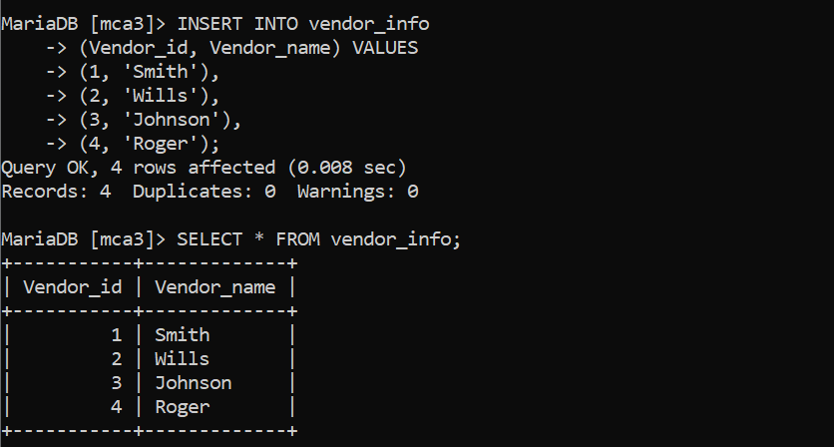

CREATE TABLE vendors(

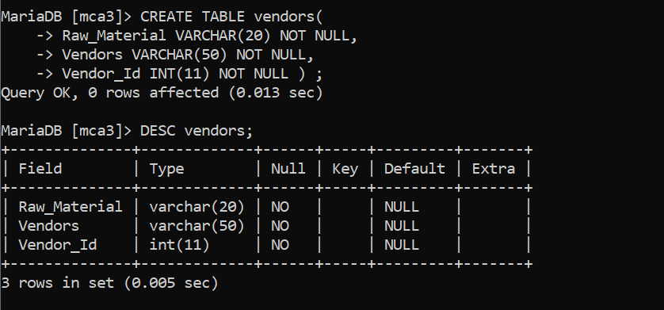Raw_Material VARCHAR(20) NOT NULL, Vendors VARCHAR(50) NOT NULL, Vendor_Id INT(11) NOT NULL ) ;

INSERT INTO vendors

(Raw_material, Vendors, Vendor_id) VALUES ('Steel', 'Smith', 1),

('Plastic', 'Wills', 2),

('Steel', 'Johnson', 3),

('Milk', 'Smith', 1),

('Pulses', 'Wills', 2),

('Bread', 'Rogers', 4),

('Bread', 'Wills', 2),

('Milk', 'Wills', 2);

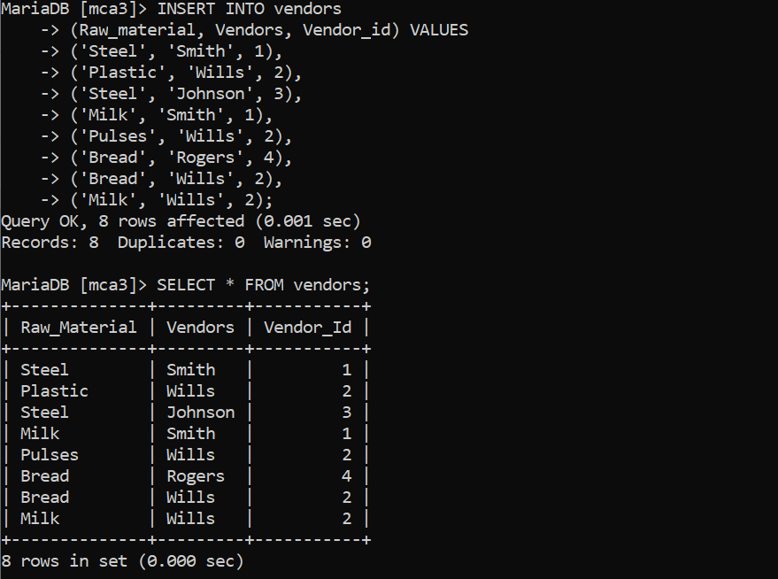

# Display product information which are ordered in the same year of its manufacturing year.

select p.* from products p, sales s

where year(p.Manufacture_date) = year(s.OrderDate) and p.OrderId = s.OrderId ;

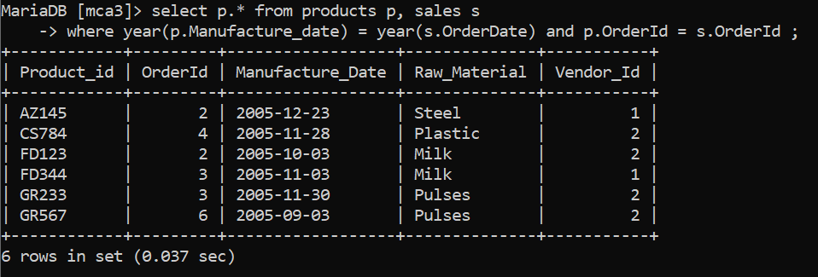

# Display product information which are ordered in the same year of its manufacturing year where vendor is “smith‟.

SELECT p.* FROM products p, sales s

WHERE year(p.Manufacture_date) = year(s.OrderDate) AND p.OrderId = s.OrderId AND

p.Vendor_Id = (SELECT Vendor_id FROM vendor_info WHERE Vendor_name = 'Smith');

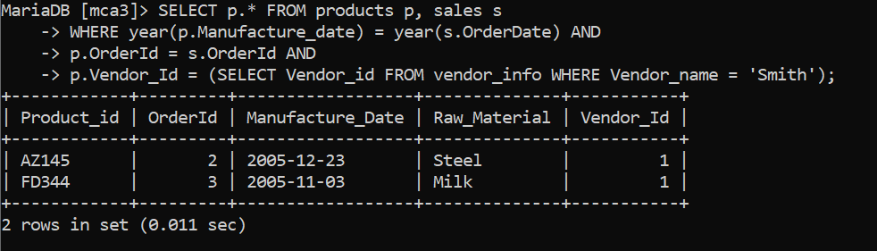

# Display total no. of orders placed in each year.

SELECT sum(OrderQuantity) AS sum, year(OrderDate) FROM sales GROUP BY year(OrderDate);

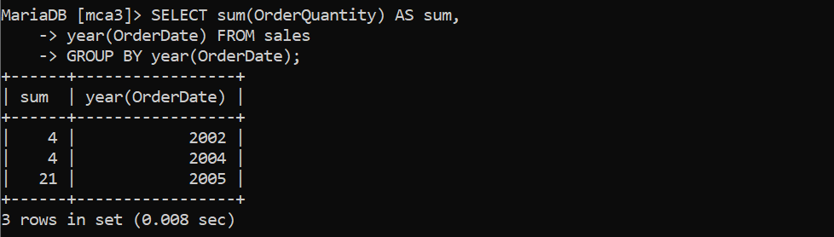

# Display total no. of orders placed in each year by vendor Wills.

SELECT count(*), year(a.OrderDate) FROM sales a, products b

WHERE a.OrderID = b.OrderID AND

b.Vendor_Id=(SELECT Vendor_id FROM vendor_info WHERE Vendor_name = 'Wills') GROUP BY year(a.OrderDate);

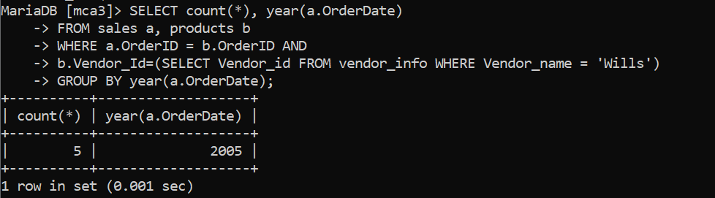

# Display the name of all those persons who are vendors and customers both.

SELECT DISTINCT CustomerName AS Person FROM Sales S, Vendor_info V WHERE V.Vendor_name=S.CustomerName;

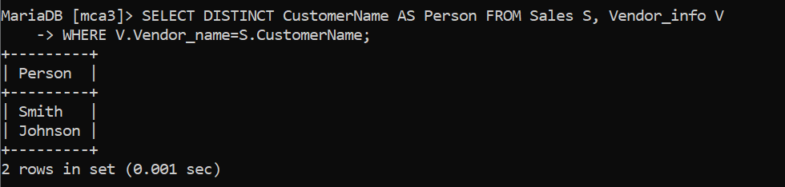

# Display total no. of food items ordered every year.

SELECT year(OrderDate) AS year, sum(OrderQuantity) AS Food_Quantity FROM sales GROUP BY year(OrderDate);

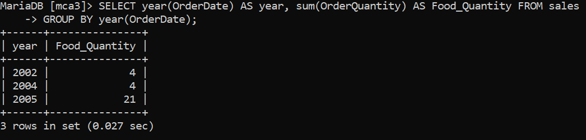

1. **Display total no. of food items ordered every year made from Bread.** SELECT year(OrderDate) AS year, sum(OrderQuantity) AS Food_Quantity FROM sales WHERE OrderId IN (SELECT OrderId FROM products WHERE Raw_Material = 'Bread') GROUP BY year(OrderDate);

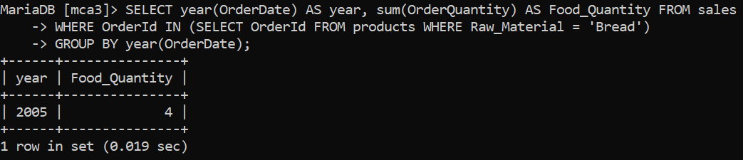

# Display list of product_id whose vendor and customer is different.

SELECT a.Product_id from products a, vendor_info b, sales c where c.OrderID=a.OrderId AND

a.Vendor_Id=b.vendor_id AND b.vendor_name != c.CustomerName;

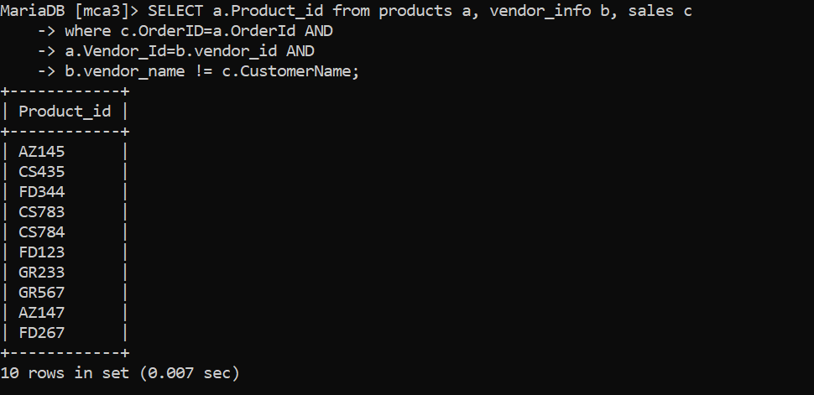

# Display all those customers who are ordering products of milk by smith.

SELECT a.CustomerName from sales a, products b, vendor_info c WHERE a.OrderID = b.OrderId AND

b.Vendor_Id = c.Vendor_id AND c.Vendor_name = 'Smith' AND b.Raw_Material = 'Milk';

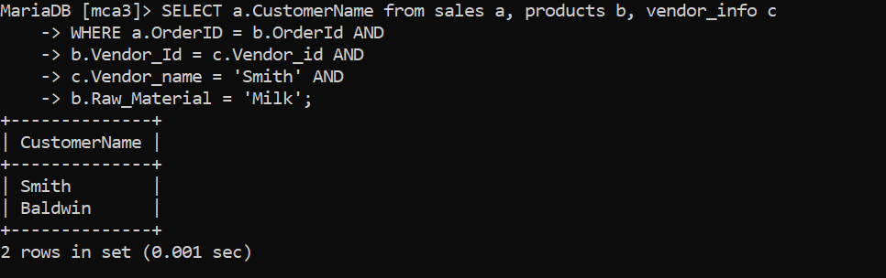

# Display total no. of orders by each vendor every year.

SELECT sum(c.OrderQuantity) AS Total_Orders, b.Vendor_name, year(c.OrderDate) AS Year From products a, vendor_info b, sales c

WHERE c.OrderID=a.OrderId AND a.Vendor_Id = b.Vendor_id

GROUP BY Vendor_name, year(OrderDate);

