**MNNIT ALLAHABAD**

**DBMS**

|  |  |
| --- | --- |
| **SUBMITTED BY :**  **NAME : SHISHU**  **ROLL/REG ID : 2020CA089**  **SUBMIT DATE : 24/12/2021** | **SUBMITTED TO :**  **TEACHER _______________**  **DEPPT : COMPUTER SCIENCE**  **DEADLINE: 24/12/2021** |

**Q.1.** A database is being constructed for storing sales information system. A product can be described with a unique product number, product name, selling price, manufacturer name. The product can sale to a particular client and each client have it own unique client number, client name, client addresses, city, pin code, state and total balance to be required to paid. Each client order is to buy product from the salesman. In the order, it has unique sales order number, sales order date,client number, salesman number (unique), billed whole payment by the party or not and its delivery date. The salesman have the name, addresses, city, pin code, state, salary of the sales man, delivery date, total quantity ordered, product rate.

The schema for the above is as below:-

**Product**(product_id,product_name,manufacturer_name,product_rate,sell_price, product_description)

CREATE TABLE product (p_id int primary key, product_name varchar(20), manufacturer_name varchar(20), product_rate double(5,2), sell_price double(5,2), prod_desc varchar(20))

**Client**(client_id, client_name, address, city, pin, state, balance_due)

CREATE TABLE client (client_id int primary key, client_name varchar(20), address varchar(25), city varchar(20), pin varchar(7), state varchar(20), balance_due double(5,2))

**Salesman**(salesman_id, salesman_name, address, city, pin, state, salary)

CREATE TABLE salesman (salesman_id int primary key, salesman_name varchar(20), address varchar(25), city varchar(20), pin varchar(7), state varchar(20), salary double(7,2))

**Sales_order_details**(sales_order_no, sales_order_date, client_id,salesman_id, bill_payby_party, delivery_date, product_rate, total_quantity_order, cancel_date)

CREATE TABLE sales_order_details (sales_order_no int primary key, sales_order_date date, client_id int references client(client_id), salesman_id int references salesman(salesman_id), bill_payby_party varchar(5), delivery_date date, product_rate double(5,2), total_quantity_order int, cancel_date date);

*Write the SQL queries for the following with respect to database created:–*

1. Retrieve the list of names and the cities of all the clients.

SELECT client_name, city FROM client

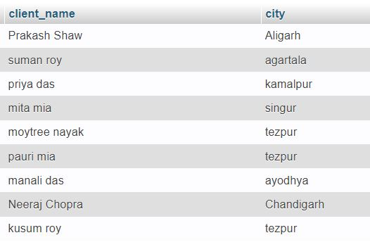

1. List the various products available.

select * from product

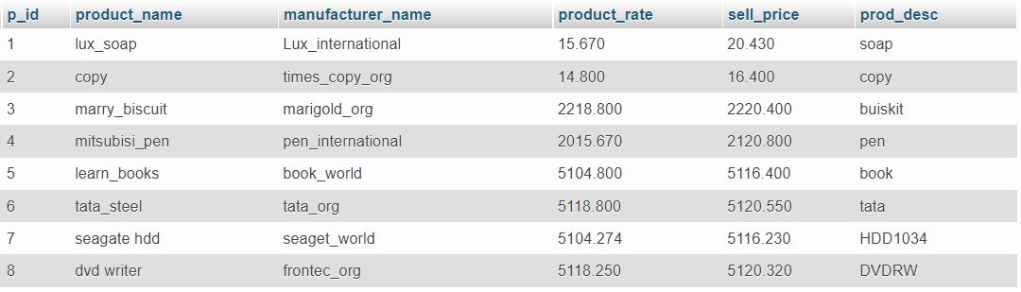

1. Find the names of all clients having ‘a’ as the second letter in their names.

SELECT client_name FROM client WHERE client_name like '_a%'

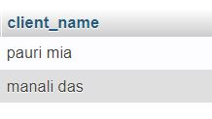

1. List all the clients who are located in Allahabad.

SELECT * FROM client WHERE city='allahabad'

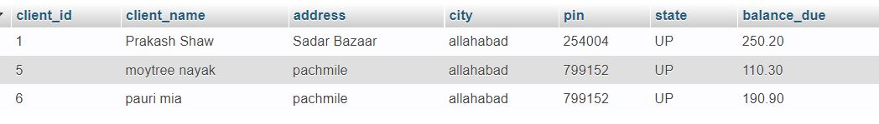

1. Find the products whose selling price is greater than 2000 and less than or equal to 5000

SELECT * FROM product WHERE sell_price>2000 AND (sell_price<5000 OR sell_price=5000)



1. Add a new column NEW_PRICE into the produc table.

ALTER TABLE product add new_price double(7,2)

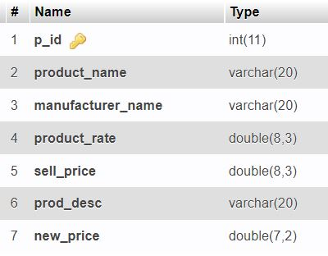

1. Rename the column P_rate of Sales_Order_Details to new_P_rate.

ALTER table sales_order_details RENAME column product_rate TO new_product_rate;

1. List the products in sorted order of their description**.**

SELECT * FROM `product` ORDER BY prod_desc

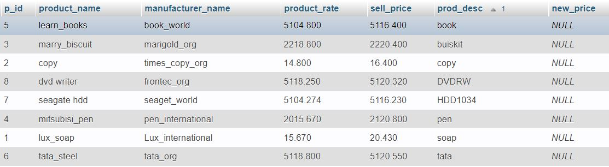

1. Display the order number and date on which the clients placed their order.

SELECT sales_order_no, sales_order_date FROM Sales_Order_Details

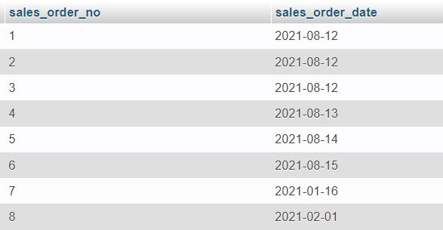

1. Delete all the records having delivery date before 25th August, 2021.

DELETE FROM sales_order_details WHERE delivery_date < '2021-08-25'

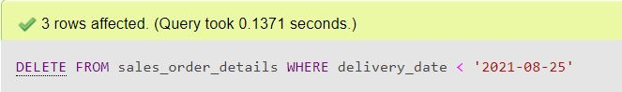

1. Change the delivery date of order number **8** to 16-08-21

UPDATE sales_order_details SET delivery_date = '2021-08-16' WHERE sales_order_no ='8'

1. Change the bal_due of client_no **3** to 1200

UPDATE client SET balance_due = '1200' WHERE client_id = '3'

1. Find the product with description as ‘HDD1034’ and ‘DVDRW’

SELECT * FROM product where prod_desc='HDD1034' OR prod_desc='DVDRW'



1. List the names, city and state of the clients not in the state of ‘ASSAM’

SELECT client_name,city,state FROM client WHERE NOT state ='assam'

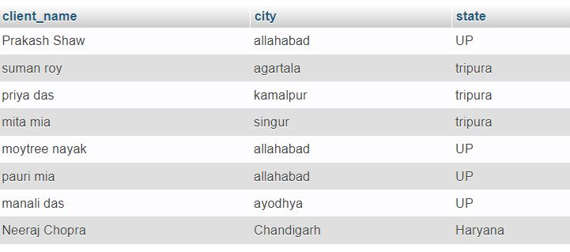

1. List of all orders that were cancelled in the month of March.

Select * from sales_order_details where cancel_date LIKE '%-03-%'

