Operating Systems Lab Week 7 Assignment Name: SHISHU Reg No: 2020CA089

Question 2. XV6 Process Priority Scheduling: In the previous question, we have learned how to change the priority of a process. In this question, we will implement a very simple priority scheduling policy. We simply choose a runnable process with the highest priority to run. (In practice, multilevel queues are often used to put processes into groups with similar priorities.) As we have done in the previous question, we assume that a process has a value between 0 and 20, the smaller the value, the higher the priority. The default value is 10. The program nice that we implemented in the previous question is used to change the priority of a process.

1. **Give high priority to a newly loaded process by adding a priority statement in exec.c**

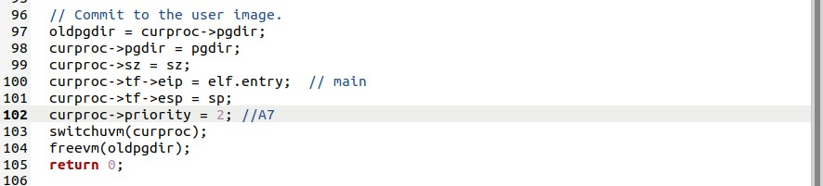

1. **Modify foo.c so that the parent waits for the children and adjust the loop for your convenience**

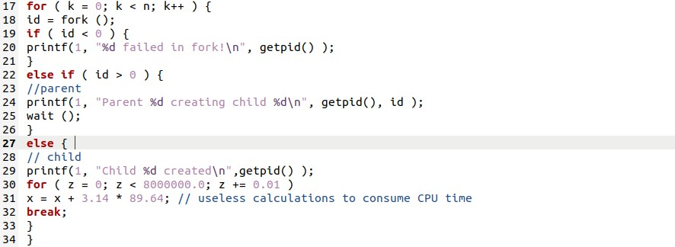

1. **Observe the default round-robin (RR) scheduling**

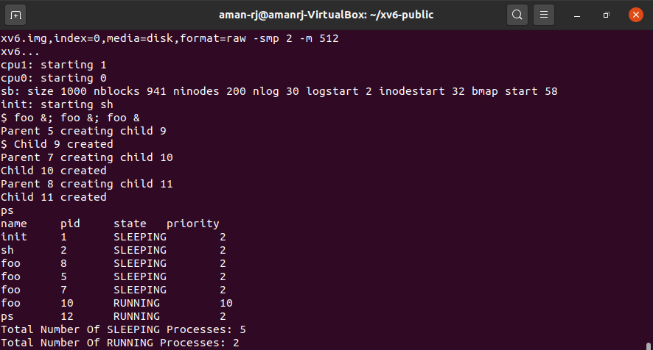

1. **Implement Priority Scheduling**

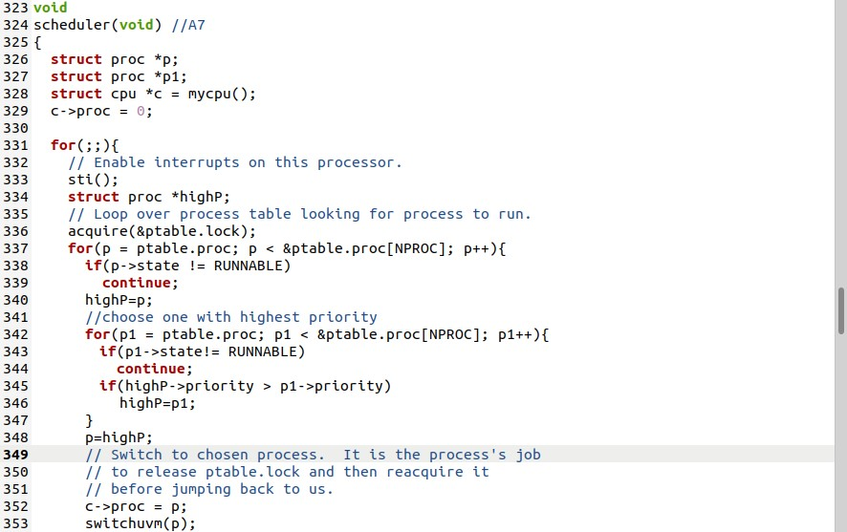

1. **Observe Priority Scheduling**

