**Web Programming Assignment -11**

**Name: Shishu**

**Reg. No.: 2020CA037**

Q1. A simple calculator web application that takes two numbers and an operator (+, /,*and %) from an HTML page and returns the result page with the operation performed on the operands.

**index.html**

<html>

<head>

<title>Simple Calculator</title>

</head>

<body>

<h2 align = "center"> Simple Calculator </h2>

<form method = "post" action = "Q1.php" >

<table align="center">

<tr>

<td>Enter First Number : </td>

<td><input type="text" name="fnum"></input> </td>

</tr>

<tr>

<td>Enter Second Number : </td>

<td><input type="text" name="snum"></input> </td>

</tr>

<tr>

<td colspan=2>&nbsp;&nbsp;&nbsp;&nbsp;&nbsp;&nbsp;&nbsp;

<input type="submit" name="op" value="+"></input> &nbsp;&nbsp;&nbsp;&nbsp;&nbsp;

<input type="submit" name="op" value="-"></input> &nbsp;&nbsp;&nbsp;&nbsp;&nbsp;

<input type="submit" name="op" value="*"></input> &nbsp;&nbsp;&nbsp;&nbsp;&nbsp;

<input type="submit" name="op" value="/"></input> &nbsp;&nbsp;&nbsp;&nbsp;&nbsp;

<input type="submit" name="op" value="%"></input> </td>

</tr>

</table>

</form>

</body>

</html>

**Q1. PHP**

**CODE:**

<?php

$num1=$_POST["fnum"];

$num2=$_POST["snum"];

$op=$_POST["op"];

if($num1=="" or $num2=="")

{

echo "Please enter two numbers...";

}

else

{

echo "First Number is : ".$num1."<br/>";

echo "Second Number is : ".$num2."<br/>";

echo "Operator is : ".$op."<br/>";

if($op=="+")

{

$res=$num1+$num2;

echo "Additon is : ".$res;

}

if($op=="-")

{

$res=$num1-$num2;

echo "Subtraction is : ".$res;

}

if($op=="*")

{

$res=$num1*$num2;

echo "Multiplication is : ".$res;

}

if($op=="/")

{

$res=$num1/$num2;

echo "Division is : ".$res;

}

if($op=="%")

{

$res=$num1%$num2;

echo "Modulus is : ".$res;

}

}?>

**Output**

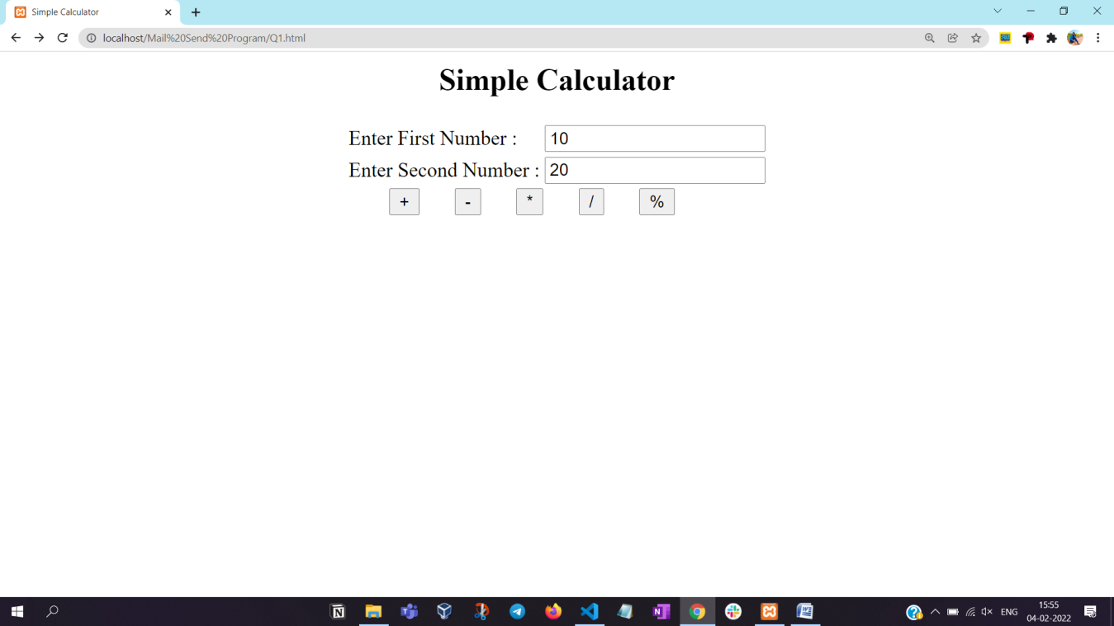

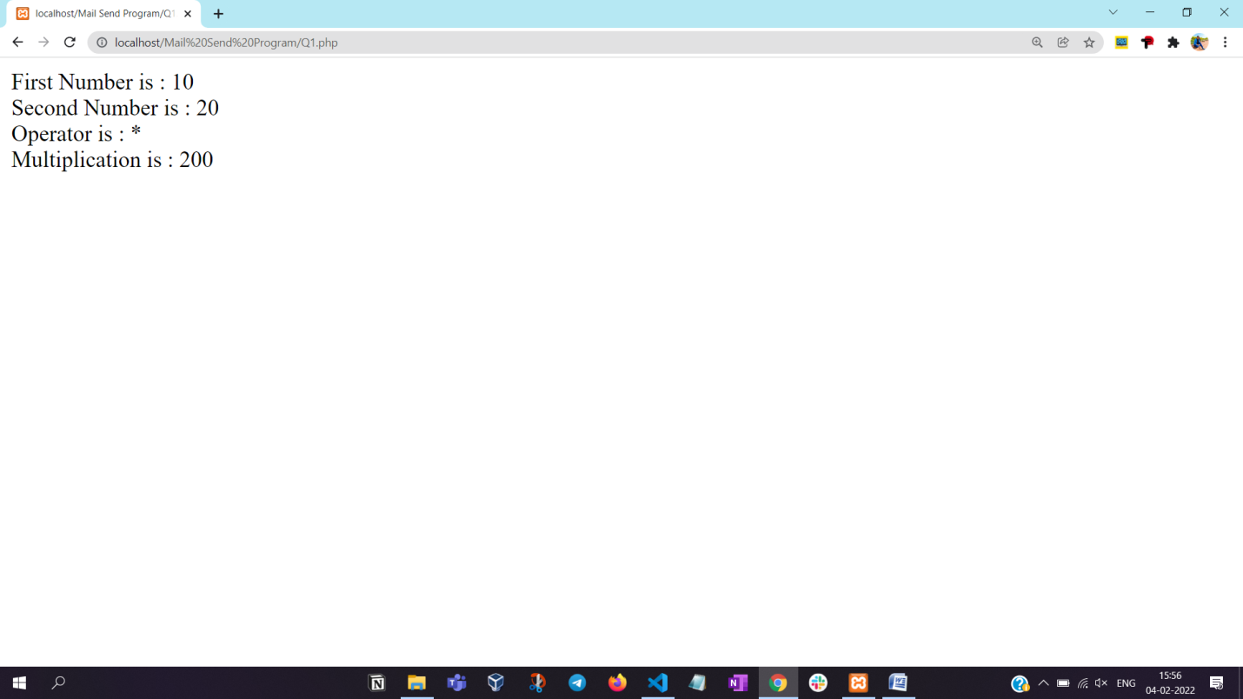

**Q2. Write PHP program how to send mail using PHP.**

1. **Locate php.ini file. (C:\xampp\php\php.ini)**
2. **Make the following 4 changes in php.ini file.**

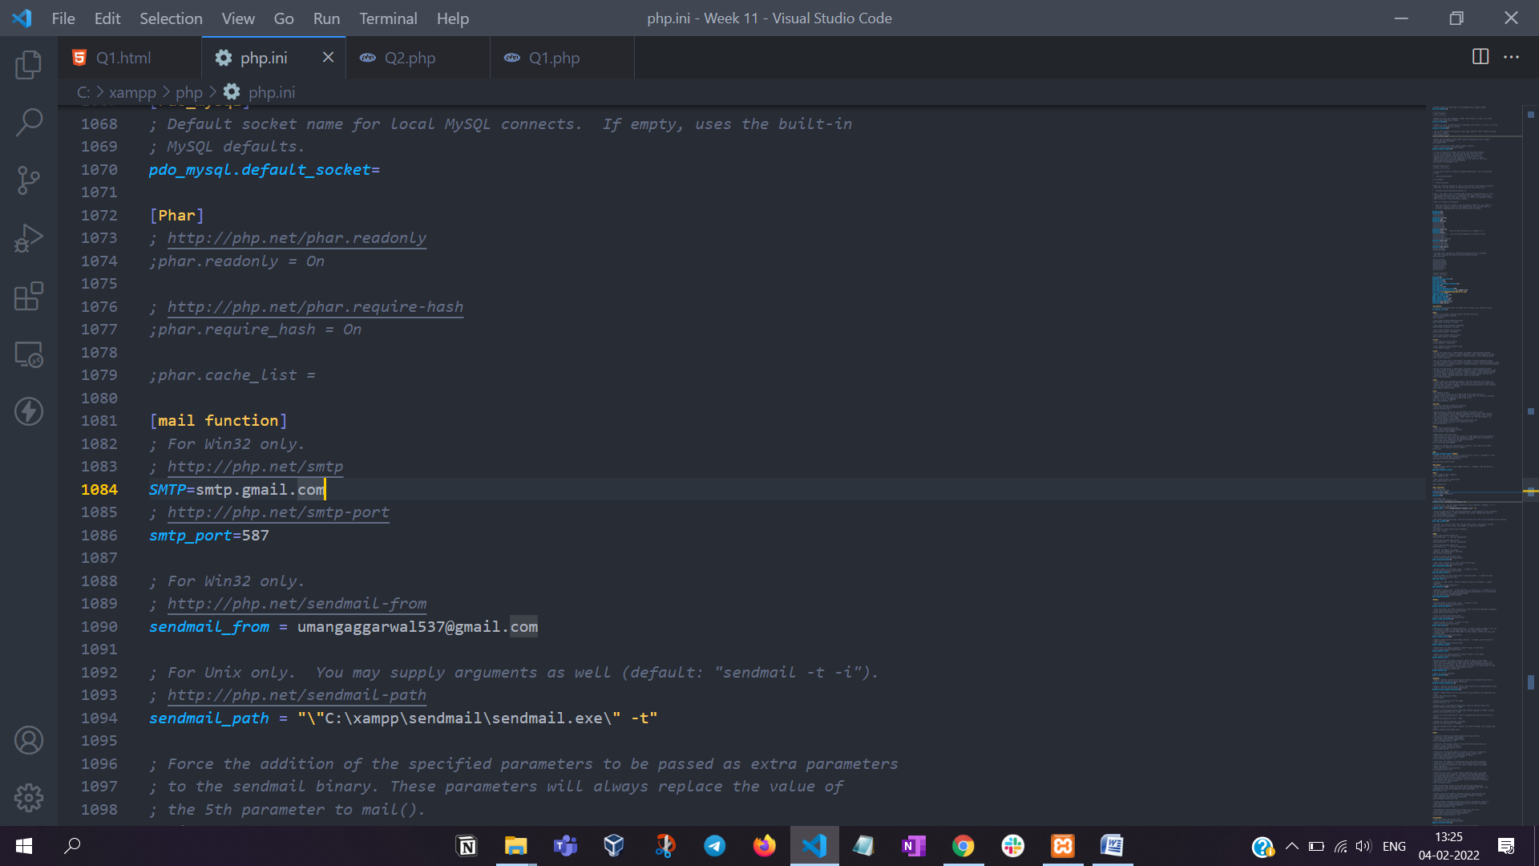

1. Locate sendmail.ini file. (C:\xampp\sendmail\sendmail.ini)
2. Update smtp_server, smtp_port, debug_logfile, auth_username, and auth_password.

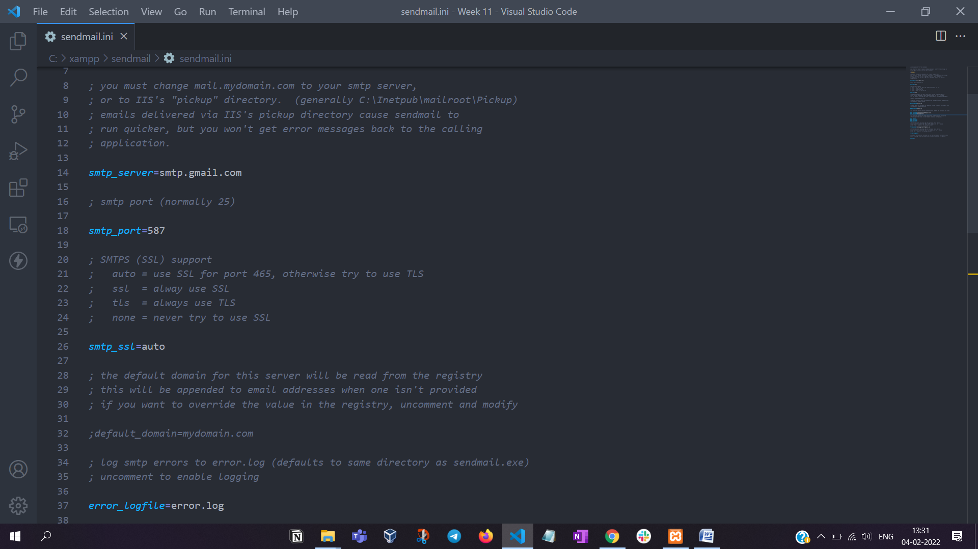

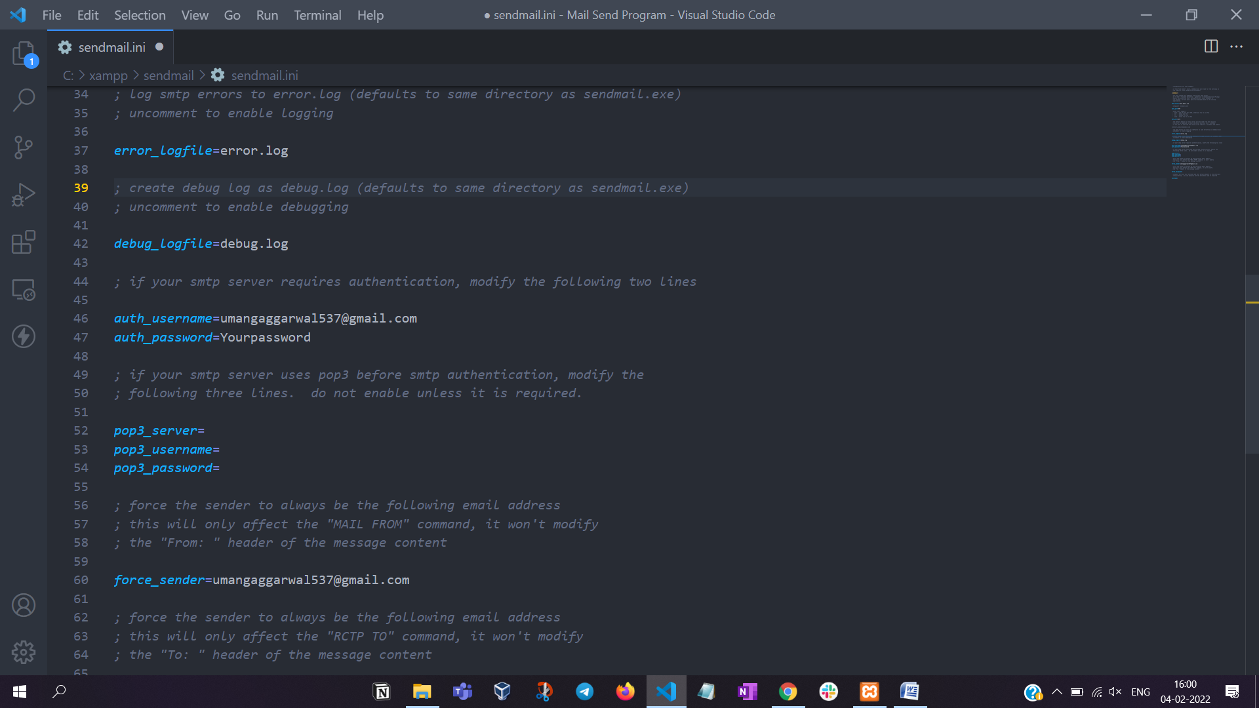

**sendmail.php**

<?php

$to_email = "alpha123@gmail.com";

$subject = "PHP Email Testing";

$body = "This email is sent via PHP.";

$headers = "From: alpha123@gmail.com";

if(mail($to_email, $subject, $body, $headers))

echo "Email Sent Successfully to $to_email !!";

else

echo "Some error occurred! Email Sending Failed!";

?>