# Assignment – 13

# Name: Shishu Registration No.:2020CA089

**Course: (CS33204) Web Tech lab(MCA)**

1. **Write PHP program to upload registration form into database.**

**Code:**

## Insert.php:

<!DOCTYPE html>

<html>

<head>

<title>Insert Page data to database</title>

</head>

<body>

<center>

<?php

// servername => localhost

// username => root

// password => empty

// database name => staff

$conn = mysqli_connect("localhost", "root", "", "db3");

// Check connection if($conn === false){

die("ERROR: Could not connect. "

. mysqli_connect_error());

}

// Taking all 5 values from the form data(input)

$first_name = $_REQUEST['first_name'];

$last_name = $_REQUEST['last_name'];

$gender = $_REQUEST['gender'];

$address = $_REQUEST['address'];

$email = $_REQUEST['email'];

// Performing insert query execution

// here our table name is college

$sql = "INSERT INTO college VALUES ('$first_name', '$last_name','$gender','$address','$email')";

if(mysqli_query($conn, $sql)){

echo "<h3>data stored in a database successfully. </h3>";

echo nl2br("\n$first_name\n $last_name\n "

. "$gender\n $address\n $email");

}

else{

}

echo "ERROR: Hush! Sorry $sql. "

. mysqli_error($conn);

// Close connection mysqli_close($conn);

?>

</center>

</body>

</html>

**Index.php:**

<!DOCTYPE html>

<html lang="en">

<head>

<title>GFG- Store Data</title>

</head>

<body>

<center>

<h1>Storing Form data in Database</h1>

<form action="insert.php" method="post">

<p>

<label for="firstName">First Name:</label>

<input type="text" name="first_name" id="firstName">

</p>

<p>

</p>

<p>

</p>

<p>

</p>

<p>

</p>

<label for="lastName">Last Name:</label>

<input type="text" name="last_name" id="lastName">

<label for="Gender">Gender:</label>

<input type="text" name="gender" id="Gender">

<label for="Address">Address:</label>

<input type="text" name="address" id="Address">

<label for="emailAddress">Email Address:</label>

<input type="text" name="email" id="emailAddress">

<input type="submit" value="Submit">

</form>

</center>

</body>

</html>

**Output:**

' • • ' @ @, Iocelhost/.j0.* 8/index.php



Let's check in our database

*phpMyAdmin "*

Storing Form data in Database

First Name: a



Address: | Peddapalakaluru Road

Email Address: a a 1 8 ,

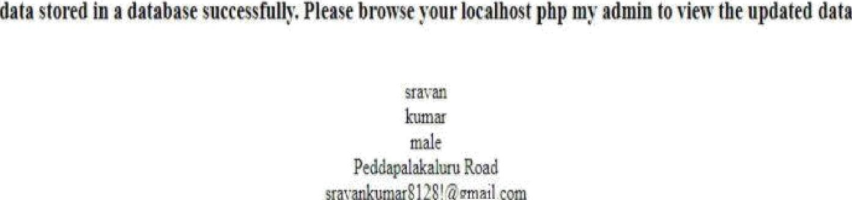





Recent Favorités

Browse 4_ Structure, **SQL** ”a Search ¿• Insert: Expon , Impon ’ e . Privileges Or

'Gurrent selection does not contain a unique.column. Grid edit, checkbox, Edit, Copy and Delete features are not available g

,.-@ New

'+-. , db1



, ñb3

QA New

:— , e

m

master



bbLbCT IRON OllBge’

@ I?rofilin' g,[:: Edit,'i?Iine' ]'|- Edit ].'| Explain 'S:QL ]:[.'Creat'e.. PHI? .Code. ]'[ Réfresh:]-

'F It'er rows-'- Search Ihis lab e

--}'j produ.ct_rriaster

+;.: , .salesman master T—/ ' saIes_orde r

+:--j•'t': sales order details

+- student_detaif

.+.—:. , information schema

+-: : performance. schema

., : phpmyadmin



.+-. : Yes

;:First npme „Last na'mg . Gender Address Em il

Sravan Kumar male Peddapalakaluru Road [sravankumar8128!@gmaiI.com](mailto:sravankumar8128!@gmaiI.com)

F'lt'er:rows.' Search lhis lab e 

Query results operations

@ Print §•é Cdpy to clipboard Export @ D.isplay cfiart A Create view

# Write PHP program to display the registration form from the database.

**Code:**

<?php

$servername = "localhost";

$username = "root";

$password = "";

$dbname = "db3";

// Create connection

$conn = new mysqli($servername, $username, $password, $dbname);

// Check connection

if ($conn->connect_error) {

die("Connection failed: " . $conn->connect_error);

}

$sql = "SELECT first_name, last_name, Gender, Address, Email FROM college";

$result = $conn->query($sql);

if ($result->num_rows > 0) {

// output data of each row

while($row = $result->fetch_assoc()) {

echo "<br> - Name: ". $row["first_name"]. " " . $row["last_name"]

."<br> - Gender: ". $row["Gender"]. "<br> - Address: ". $row["Address"]."<br>

- Email: ". $row["Email"]. "<br>";

}

} else {

echo "0 results";

}

$conn->close();

?>

</body>

</html>

**Output:**



1. **Write PHP program to update the registration form present in database.**

**Code:**

**Update.php**

<?php

include_once 'database.php';

$sql = "UPDATE users SET first_name = 'Navin',lastname = 'Kumar',Gender =

‘male’, Address ='Araria Bihar',Email = 'abc@gmail.com' WHERE id=1 ";

$query = mysqli_query($conn,$sql); if(!$query)

{

echo "Query does not work.".mysqli_error($conn);die;

}

else

{

echo "Data successfully updated";

}

?>

## Database.php

<?php

$servername='localhost';

$username='root';

$password='';

$dbname = "db3";

$con=mysqli_connect($servername,$username,$password,"$dbname"); if(!$conn){

die('Could not Connect My Sql:' .mysql_error());

}

?>

# Output:

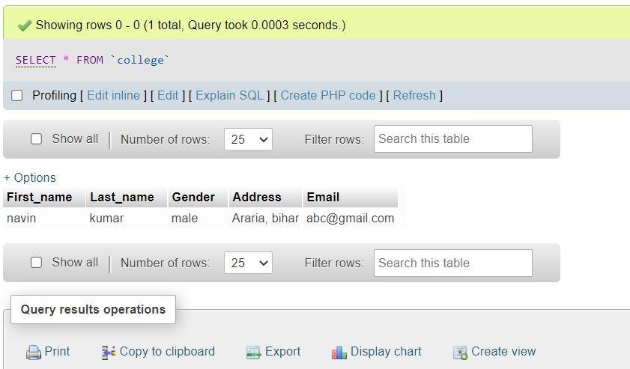

1. **Write PHP program to delete the registration form from database.**

**Code:**

**Delete.php:**

<?php

include_once 'database.php';

$sql = "DELETE FROM users WHERE userid='" . $_GET["userid"] . "'"; if (mysqli_query($conn, $sql)) {

echo "Record deleted successfully";

} else {

echo "Error deleting record: " . mysqli_error($conn);

}

mysqli_close($conn);

?>

## Database.php

<?php

$servername='localhost';

$username='root';

$password='';

$dbname = "db3";

$con=mysqli_connect($servername,$username,$password,"$dbname"); if(!$conn){

die('Could not Connect My Sql:' .mysql_error());

}

?>

**Output:**

