**WEB TECHNOLOGY LAB**

**(Assignment-4)**

**Name:-**Shishu

**Reg.No:-**2020CA089

**Q1:Design a Registration form of MNNIT with HTML and CSS.**

**HTML Code:-**

<!DOCTYPE html>

<html lang="en-us">

<head>

<meta charset="UTF-8">

<title>Register</title>

<link rel="stylesheet" href="form.css">

</head>

<body>

<h1>Student Registaration Form</h1>

<div class="container">

<div class="row">

<div class="col-10">

<label for="fname">First Name:</label>

</div>

<div class="col-90">

<input type="text" id="fname" name="firstname" placeholder="Enter your first name">

</div>

</div>

<div class="row">

<div class="col-10">

<label for="lname">Last Name:</label>

</div>

<div class="col-90">

<input type="text" id="lname" name="lastname" placeholder="Enter your last name">

</div>

</div>

<div class="row">

<div class="col-10">

<label for="email">Email:</label>

</div>

<div class="col-90">

<input type="email" id="email" name="email" placeholder="it should contain @,.">

</div>

</div>

<div class="row">

<div class="col-10">

<label for="mobile">Mobile:</label>

</div>

<div class="col-90">

<input type="tel" id="mobile" name="mobile" placeholder="only 10 digits are allowed">

</div>

</div>

<div class="row">

<div class="col-10">

<label for="gender" required>Gender:</label>

</div>

<div class="col-90">

<input type="radio" id="male" name="gender" value="male"/>Male

<input type="radio" id="female" name="gender" value="female"/>Female

</div>

</div>

<div class="row">

<div class="col-10">

<label for="dob">Date Of Birth:</label>

</div>

<div class="col-90">

<input type="Date" id="dob" name="dob">

</div>

</div>

<div class="row">

<div class="col-10">

<label for="address">Address:</label>

</div>

<div class="col-90">

<textarea name="address" id="address" cols="30" rows="10"></textarea>

</div>

</div>

<div class="row">

<div class="col-10">

<label for="city">City:</label>

</div>

<div class="col-90">

<input type="text" id="city" name="city" maxlength="10">

</div>

</div>

<div class="row">

<div class="col-10">

<label for="pincode">Area PIN:</label>

</div>

<div class="col-90">

<input type="number" id="pin" name="pin" maxlength="6">

</div>

</div>

<div class="row">

<div class="col-10">

<label for="state">State:</label>

</div>

<div class="col-90">

<input type="text" id="state" name="state">

</div>

</div>

<div class="row">

<div class="col-10">

<label for="qualification" required >Qualification:</label>

</div>

<div class="col-90">

<select name="qualification" id="qualification">

<option value=" ">Select Qualification:</option>

<option value="Graduation">Graduation</option>

<option value="BTech.">BTech.</option>

<option value="MTech.">MTech.</option>

<option value="MCA">MCA</option>

<option value="BCA">BCA</option>

</select>

</div>

</div>

<div class="row">

<div class="col-10">

<label for="specialization">Specialization:</label>

</div>

<div class="col-90">

<input type="checkbox" class="specialization" id="cs" name="specialization[]" value="Computer Science">Computer Science<br/>

<input type="checkbox" class="specialization" id="it" name="specialization[]" value="Information Technology">Information Technology<br/>

<input type="checkbox" class="specialization" id="ca" name="specialization[]" value="Computer Architecture">Computer Architecture<br/>

<input type="checkbox" class="specialization" id="tc" name="specialization[]" value="Tele Communication">Tele Communication<br/>

</div>

</div>

<div class="row">

<div class="col-10">

<label for="password">Password:</label>

</div>

<div class="col-90">

<input type="password" id="password" name="password" maxlength="8">

</div>

</div>

<div class="row">

<div class="col-10">

<label for="password">Confirm Password:</label>

</div>

<div class="col-90">

<input type="password" id="password" name="password" maxlength="8">

</div>

</div>

<div class="row">

<input type="submit" value="Register">

</div>

</div>

</body>

</html>

**CSS Code:-**

*{

box-sizing: border-box;

}

input[type=text], input[type=email], input[type=number], input[type=select], input[type=date],input[type=select],input[type=password], input[type=tel]

{

width: 45%;

padding: 12px;

border: 1px solid rgb(168, 166, 166);

border-radius: 4px;

resize: vertical;

}

textarea{

width:45%;

padding: 12px;

border: 1px solid rgb(168, 166, 166);

border-radius: 4px;

resize: vertical;

}

input[type=radio],input[type=checkbox]{

width: 1%;

padding-left: 0%;

border: 1px solid rgb(168, 166, 166);

border-radius: 4px;

resize: vertical;

}

h1{

font-family: Arial;

font-style: normal;

font-weight: bold;

color: brown;

text-align: center;

text-decoration: underline;

}

label{

padding: 12px 12px 12px 0;

display: inline-block;

}

input[type=submit] {

background-color: #4CAF50;

color: white;

padding: 12px 20px;

border: none;

border-radius: 4px;

cursor: pointer;

float:center;

}

input[type=submit]:hover {

background-color: #32a336;

}

.container{

border-radius: 5px;

background-color:#f2f2f2;

padding: 20px;

}

.col-10{

float: left;

width:10%;

margin-top: 6px;

}

.col-90{

float: left;

width: 90%;

margin-top: 6px;

}

.row:after{

content: "";

display: table;

clear: both;

}

**Output:-**

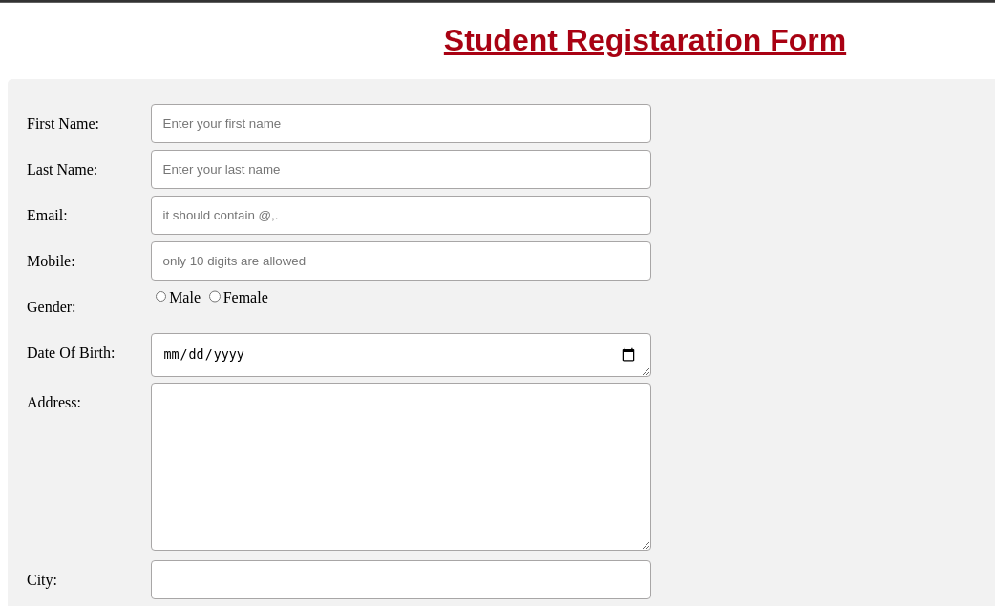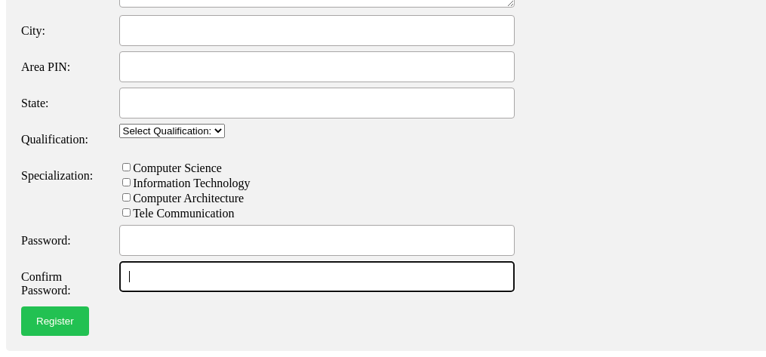

**Q2:-Design a home page of MNNIT with HTML and CSS.**

**HTML Code:-**

<!DOCTYPE html>

<html lang="en">

<head>

<meta charset="UTF-8">

<meta http-equiv="X-UA-Compatible" content="IE=edge">

<meta name="viewport" content="width=device-width, initial-scale=1.0">

<link rel="stylesheet" href="HomePage.css">

<title>MNNIT</title>

</head>

<body>

<header>

<!-- header section start -->

<div class="outer">

<!-- college logo -->

<div class="innerImg">

<a class="mediaLogo" href="/">

<img id="logo" src="logonew1.png" alt="MNNIT Allahabad">

</a>

</div>

<!-- college ends -->

<!-- college name and navbar starts -->

<div class="navele">

<div id="clgName">

<img id="name" src="name33.png" alt="">

</div>

<!-- nabar -->

<div class="navMain">

<ul>

<li class="navItems" id="home" >

<a class="navButton" href="#">Home</a>

</li>

<li class="navItems">

<a class="navButton" href="#">Institute</a>

</li>

<li class="navItems">

<a class="navButton" href="#">Academic</a>

</li>

<li class="navItems">

<a class="navButton" href="#">Department</a>

</li>

<li class="navItems">

<a class="navButton" href="#">Facilities</a>

</li>

<li class="navItems">

<a class="navButton" href="#">Contact</a>

</li>

</ul>

</div>

</div>

<!-- college name and navbar ends -->

<div id="search">

<input type="text" placeholder="Search...">

</div>

</div>

<!-- header section ends -->

</header>

<!-- Main area start 2 section divide-->

<section class="parent">

<section class="child1">

<img src="corona.jpg" alt="">

</section>

<section class="child2">

<p id="heading">ANNOUNCEMENTS</p>

<p class="ann_cont">Institutions' Innovation Council, MNNIT Allahabad awarded Four [4] Star Ranking by MIC

and AICTE...

<p class="ann_cont">Compassionate Appointment Notice...</p>

<p class="ann_cont">B.Tech. Admissions (Session 2021-22) through CSAB 2021... </p>

<p class="ann_cont">*Global Alumni Convention to be held on March 11 to 13, 2022*... </p>

<div id="view">

<a href="#">View all</a>

</div>

</section>

</section>

<!-- Main area ends-->

<!-- another nav starts -->

<section class="parent">

<section class="child">

<a href='#'>

<button>

Admission

</button>

</a>

<a href='#'>

<button>

Web Mail

</button>

</a>

<a href='#'>

<button>

Dean R&C

</button>

</a>

<a href='#'>

<button>

Academic Portal

</button>

</a>

<a href='#'>

<button>

Dean(SW)

</button>

</a>

<a href='#'>

<button>

Moodle

</button>

</a>

<div class="sec_nav">

<a href='#'>

<button class="GFG">

Donate

</button>

</a>

<a href='#'>

<button class="GFG">

AMRIT APP

</button>

</a>

<a href='#'>

<button class="GFG">

ARIIA

</button>

</a>

<a href='#'>

<button class="GFG">

MoUs

</button>

</a>

</div>

</section>

</section>

<section>

</section>

<!-- another nav starts -->

</body>

</html>

**CSS Code:-**

.outer{

display: flex;

justify-content: center;

flex-direction: row;

border-bottom: 2px solid rgb(122, 109, 109);

margin-bottom:none;

}

#logo{

height: 110px;

width: 200px;

padding-bottom: 0px;

}

.innerImg{

padding-top: 5px;

padding-bottom: 0px;

/* border: 1px solid black; */

}

#home{

background-color: aqua;

border-radius: 12%;

}

#name{

padding-top: 0px;

width: 500px;

}

#search{

padding-top: 20px;

padding-left: 10px;

}

#clgName{

padding-left: 30px;

padding-right: 30px;

}

li{

display:inline;

}

.navItems{

font-size:large;

/* border: 1px solid black; */

padding-left: 20px;

padding-right: 20px;

padding-top: 10px;

padding-bottom: 10px;

}

.navMain{

position: absolute;

padding-left: 40px;

}

.navButton{

color: black;

text-decoration: none;

}

.navItems:hover{

background-color: aqua;

border-radius: 12%;

}

#main{

padding-left: 100px;

padding-right: 100px;

height: 300px;

width: auto;

border: 1px solid black;

background-color: aqua;

}

.parent{

padding-top: 20px;

display: flex;

padding-left: 150px;

padding-right: 150px;

}

.child1 img{

height: 300px;

width: 600px;

}

.child2{

padding-top:none;

padding-left: 20px;

height: 300px;

width: 400px;

text-align: justify;

}

.child2 #heading{

font-size:x-large;

border-bottom: 2px solid black;

border-width:thin;

}

.ann_cont{

padding-bottom: 10px;

}

.child2 div{

position: absolute;

justify-content: right;

}

.child a{

text-decoration: none;

}

button{

margin-right: 30px;

padding-left: 20px;

padding-right: 20px;

padding-top: 15px;

padding-bottom: 15px;

font-size: large;

background-color: #5ED8F5;

border-radius: 12px;

}

.child div{

padding-top: 10px;

}

button:hover{

cursor: pointer;

}

#search input{

padding-left: 10px;

padding-right: 10px;

padding-top: 5px;

padding-bottom: 5px;

border-radius: 15px;

}

**Output:-**

