Student Academic Record System Project

Group 30

Group Leader: HUANG Liming_12839828

Group mate: WANG_Zifeng_12819320

Sum_Chin_Ho_12433460

Wong_Ki_Tung_13276160

Test Plan

Develop Group: 30

Client Group: 29

Test Plan

**Appendix**

1. **Validation Test(~5 different Tests)**
   1. Set Up Page Function Test
   2. Login Page Function Test
   3. Different Type Account Scope Test
   4. Modify Function Test
   5. Sorting Function Test
   6. Searching Function Test
2. **Defect Test(~5 different Tests)**
   1. Set Up Page Function Defect Test
   2. Login Page Function Defect Test
   3. Modify Function Defect Test
   4. Sorting Function Defect Test
   5. Searching Function Defect Test
3. **Development Test**
   1. Unit Test
   2. Component Test
   3. System Test
4. **User Test**

Appendix

Student:

|  |  |  |  |  |
| --- | --- | --- | --- | --- |
| Name | Student ID (User ID) | Date of Birth | HKID | Class |
| Tommy | s7635 | 2001/01/20 | E1357 | 1 |
| Amy | s5367 | 2002/06/17 | B2468 | 1 |
| Bill | s3742 | 2001/03/08 | K9815 | 1 |
| Katty | S1309 | 2002/11/30 | C1357 | 2 |
| Candy | S5382 | 2001/02/16 | C2779 | 2 |

Teacher:

|  |  |  |
| --- | --- | --- |
| Name | Teacher ID (User ID) | HKID |
| Teacher1 | t7635 | A1357 |
| Teacher2 | t5367 | C2468 |
| Teacher3 | t3742 | D1369 |

# Validation Test

* 1. Set up Page Function Test

Teacher Account:

1. Enter corresponding HKID as verification.

e.g., Teacher1’s HKID: A1357 (From the appendix)

1. Enter the password twice to initialize teacher account password: check whether the password entered twice are consistent, if not there will showing an error prompt window.

Student Account:

1. Enter corresponding HKID as verification.

e.g., Tommy’s HKID: “E1357” (From the appendix)

1. Enter the password twice to initialize teacher account password: Check whether the password entered twice are consistent) , if not there will showing an error prompt window.
   1. Login Page Function Test

Teacher Account:

1. Enter corresponding Teacher ID as User ID

e.g., Teacher 1’s Teacher ID (User ID): “t7635” (From the appendix)

1. Enter the password which is initialized at “Set Up” page. (If user forget password or change the password, user need to enter the last password they changed.)
2. After login the main page will illustrate what type of account, e.g., “The current account type: Teacher”.

Student Account:

1. Enter corresponding Student ID as User ID

e.g., Tommy’s Student ID (User ID): “s7635” (From the appendix)

1. Enter the password which is initialized at “Set Up” page. (If user forget password or change the password, user need to enter the last password they changed.)
2. After login the main page will illustrate what type of account, e.g., “The current account type: Student”.
   1. Different Type Account Scope Test

Teacher Account:

* 1. All classes (e.g., Class 1, Class 2)
  2. All student information in the class (e.g., student’s student ID, Date of Birth, HKID).
  3. Student’s test information (e.g., Test name, date, score)

Student Account:

* 1. Only can access their personal information.
  2. Class where they are.
  3. Only can access their personal test information (e.g., Test name, score, date) which is created by teacher.
  4. Modify Function Test

Admin Account:

1. When the administrator selects a class in the system, there is an “ADD” button at the bottom of the student list of that class page.
2. Click the “ADD” button a new line will be illustrated at the page, then teacher can enter a new student information on that line to create a new student on that class.
3. There is a “View” button displayed on the right of each row of student list which can access or modify the student’s test information (e.g., add/delete a test).

Teacher Account:

1. When the teacher selects a class in the system, there is a “View” button in each line of student list of that class page.
2. Click the “View” button teacher can access or modify the student’s test information (e.g., add/delete a test).

Students do not have any permission to modify any student information and test information including their own.

* 1. Sorting Function Test

Teacher Account:

1. When the teacher selects a class in the system, a list of students will be displayed on the page. The teacher can click one of the label tag (e.g., Name, sID, DoB, HKID) at the head of the list to sort it (only one type of tag can be selected for ascending or descending sorting at a time.)



Student Account:

1. For the student account , they can click one of the label tag (e.g., Test Name, Score, Date) at the head of the list to sort it (only one type of tag can be selected for ascending or descending sorting at a time.)

* 1. Searching Function Test

Teacher Account:

can search student information, student test information on the system via search box by any keywords.

Student Account:

Only can search they own test information on the system via search box by any keywords.

# Defect Test

* 1. Set up Page Function Defect Test

Teacher Account:

1. Enter corresponding HKID with different character type situation:

Correct Teacher1’ s HKID: A1357

* Lowercase letter: a1357
* Special characters:

Space with in HKID: A1 35 7

characters “*@!#” with in HKID: A1@357

* Missing input characters: A157

1. Enter corresponding password with different type situation:

* Enter different password.
* Enter space in password.
* Enter password with all number.
* Enter password with all character.

Student Account:

* 1. Enter corresponding HKID with different character type situation:

Correct Teacher1’ s HKID: E1357

* Lowercase letter: e1357
* Special characters:

Space with in HKID: E1 35 7

characters “*@!#” with in HKID: E1@357

* Missing input characters: E157
  1. Enter corresponding password with different type situation:
* Enter different password.
* Enter space in password.
* Enter password with all number.
* Enter password with all character.
  1. Login Page Function Defect Page

Teacher Account

1. Enter corresponding Teacher ID as User ID with different character type situation:

* Uppercase/Lowercase Letter
* Special characters: e.g., *@!#
* Missing input characters

1. Enter corresponding password with different type situation:

* Enter different password.
* Enter space in password.
* Enter password with all number.
* Enter password with all character.

Student Account

1. Enter corresponding Student ID as User ID with different character type situation:

* Uppercase/Lowercase Letter
* Special characters: e.g., *@!#
* Missing input characters

1. Enter corresponding password with different type situation:

* Enter different password.
* Enter space in password.
* Enter password with all number.
* Enter password with all character.

* 1. Different Type Account Scope Defect Test

Teacher Account:

* 1. Check whether teacher account can access all classes. (e.g., Class 1, Class 2)
  2. Check whether teacher account can access all student information in the class (e.g., student's student ID, Date of Birth, HKID).
  3. Check whether teacher account can access all student’s test information (e.g., Test name, date, score)

Student Account:

1. Check whether student account can only access their personal information (e.g., student's student ID, Date of Birth, HKID).
2. Check whether student account can only access the class where they are.
3. Check whether student account can only access their personal test information (e.g., Test name, date, score).
   1. Modify Function Defect Test

Admin Account:

1. Check when the administrator click “ADD” button at the bottom of the student list of that class page whether it will add new line for create a new student in the class with corresponding information.
2. There is a “View” button displayed on the right of each row of student list. Check when admin click the “View” button and they can access or modify the student’s test information (e.g., add/delete a test).

Teacher Account:

1. Check whether the test information of one of the students in the class can be accessed when the teacher clicks the view button.
2. Check when the teacher clicks the “View” button, teacher can access or modify the student’s test information (e.g., add/delete a test).

Student Account:

Check student should not be able to modify any of their own information and test information.

* 1. Soring Function Defect Test

Administrator & Teacher Account:

When the admin and teacher selects a class in the system, a list of students will be displayed on the page. The admin and teacher can click one of the label tags (e.g., Name, sID, DoB, HKID) at the head of the list to sort it (only one type of tag can be selected for ascending or descending sorting at a time.)

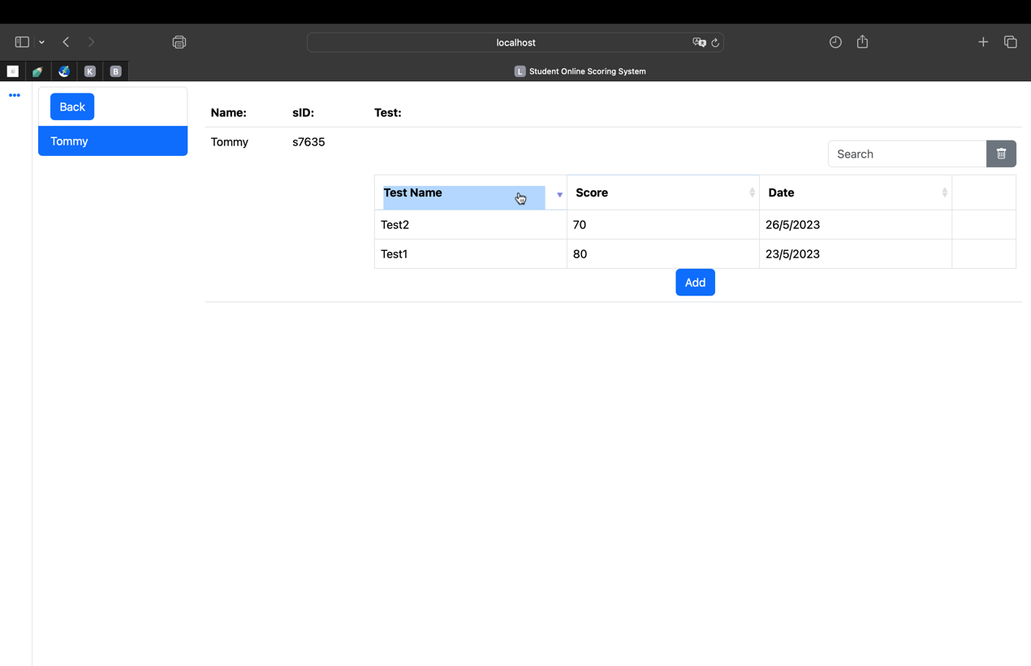

Student Account:

Check whether it is success when students click one of the label tag (e.g., Test

Name, Score, Date) at the head of the list to sort it (only one type of tag can be selected for ascending or descending sorting at a time.)



* 1. Searching Function Defect Test

Administrator & Teacher & student Account:

1. Check whether search results will be displayed when correct keyword information is entered.
2. When entering incorrect keyword information whether it will have any prompt windows or corresponding exception handler.

# Development Test

* 1. Unit Test

Login Unit Test：

* Whether the login page could recognize different account type and log-into corresponding account type home page (e.g., student account, teacher account, admin account)

Forget Password Unit Test:

* Users use their HKID as verification in reset password page to set up new password, check whether it is changing the password successfully in corresponding account. (e.g., Student’s account, Teacher’s account, Admin’s account)

Change Password Unit Test:

* Users use their HKID as verification in reset password page to set up new password, check whether it is changing the password successfully in corresponding account. (e.g., Student’s account, Teacher’s account, Admin’s account)

Home Password Unit Test:

* Users use their HKID as verification in reset password page to set up new password, check whether it is changing the password successfully in corresponding account. (e.g., Student’s account, Teacher’s account, Admin’s account)
  1. Component Test

Login Page Component Test:

1. Set up Page:

Test this function interface ware correct illustrate at corresponding page position and the first-time user could use it to initialize their account’s password.

1. Login Page

Test this function interface ware correct illustrate at corresponding page position and user could use it to log into the system successfully.

Forget Password/Change Password Component Test:

* Test the function it has any prompt windows to notice user their account password has been reset successfully.

“ADD” Component Test:

Teacher account:

* + Add student’s Test information(e.g., Test Name, Test Score, Test Date)

Admin account:

* + Add corresponding classes for teacher who are teaching in some classes in current semester.
  + Add student information(e.g., Student Name, Student Date of Birth, Student’s HKID, Student’s Student ID) in corresponding classes.
  + Add student’s test information(e.g., Test Name, Test Score, Test Date)

Searcher Component Test:

* Test it could correctly illustrate result by using key words to search.

Sorting Component Test:

* Test the corresponding content could be ascending or descending illustrate on the table.
  1. System Test
* HTML:

Test whether the system web page runnable on browser and illustrate correct account type and corresponding content.

* Node.js:

Test whether Node.js can render corresponding content on the system in response to user operations.

* MongoDB:

Test whether it is able to menage and classify corresponding user information, include account type, user password, student’s information, student’s test score, e.g. .

# User Test

* 1. Student:

In the student account, only the student's course class in the current semester and the personal information in the current class are displayed. The personal information and course classes of other students cannot be viewed. When entering the corresponding course class, you can only view the test results of the student's current course.

* 1. Teacher:

In the teacher account, teachers can only view relevant courses taught in the current semester and cannot see other teachers' courses. In the corresponding course, the teacher can see all student information in the current course, as well as the test scores of all students. The teacher can only modify and add student test scores but cannot modify or add student information.

* 1. Admin:

In the administrator account, the administrator has the highest authority and can add relevant courses to the corresponding teacher account, as well as the number of students in the corresponding class, student information, and student test scores.