

Smart Irrigation System using AVR Microcontroller
(Group-IV)

Team Members Name:
Shital Kumar Singh(12301324)
Dibya Krishna Kar(12306155)
Nilesh Yadav(12306938)
Alffrin Regi(12315587)

Submitted to:
Dr. Neha Ahuja(UID-33604)

1. Introduction:
The Smart Irrigation System is an automated solution developed to optimize water usage in agricultural fields by continuously monitoring soil moisture levels and controlling irrigation accordingly. In traditional irrigation methods, water is supplied manually or at fixed intervals, which often leads to overwatering or underwatering. This system eliminates such inefficiencies by using real-time data to make intelligent decisions.
The system is built around an AVR microcontroller (ATmega32), which acts as the brain of the system. It receives input from the soil moisture sensor, processes the data, and determines whether irrigation is required. The integration of sensors and control units allows the system to operate autonomously without constant human intervention. This not only improves efficiency but also ensures precise water distribution.
These components help users easily understand the condition of the soil and the operation of the pump. Overall, the Smart Irrigation System demonstrates how embedded systems can be effectively used to support modern and sustainable agricultural practices.

2. Objective:
The primary objective of this project is to develop an automated irrigation system that can intelligently control water supply based on soil moisture conditions. By doing so, the system aims to eliminate the need for manual monitoring and reduce dependency on human intervention in agricultural irrigation processes.
Another important objective is to ensure efficient utilization of water resources. Water scarcity is a major concern in many regions, and this system helps address the issue by supplying water only when necessary. This not only conserves water but also prevents problems like soil erosion and nutrient loss caused by excessive irrigation.
Furthermore, the project aims to enhance crop productivity and promote sustainable farming practices. By maintaining optimal moisture levels in the soil, plants receive the right amount of water required for healthy growth. The system also serves as a foundation for future advancements, such as integrating IoT and smart farming technologies.

3. Components Used:
AVR Microcontroller (ATmega32):-
Acts as the main control unit of the system, processing sensor data and controlling the operation of the relay and pump.
Soil Moisture Sensor:-
Measures the moisture content in the soil and provides an analog signal to the microcontroller for analysis.
Relay Module:-
Works as an electrically operated switch that allows the microcontroller to control the high-power water pump safely.
DC Water Pump:-
Supplies water to the plants when activated, based on the soil moisture condition.
Power Supply:-
Provides the required voltage to operate the microcontroller and other components in the system.
Connecting Wires & Breadboard:-
Used to establish electrical connections between components and for easy circuit prototyping.

4. Working Principle:
The Smart Irrigation System operates on the principle of real-time monitoring and automatic control of soil moisture to ensure efficient water usage. The system uses a soil moisture sensor that is placed in the soil to continuously detect the amount of water present. This sensor works by measuring the electrical conductivity or resistance of the soil, which varies depending on the moisture content. The sensor generates an analog voltage signal proportional to the moisture level, which is then sent to the AVR microcontroller (ATmega32) for further processing.
The microcontroller plays a central role in the system by converting the analog signal received from the sensor into a digital value using its built-in Analog-to-Digital Converter (ADC). Once the data is converted, the microcontroller compares the measured moisture level with a predefined threshold value stored in its program. This threshold represents the minimum moisture level required for proper plant growth. If the detected moisture level falls below this threshold, the system interprets the condition as dry soil and initiates the irrigation process automatically.
When the soil is detected as dry, the microcontroller sends a control signal to the relay module. The relay acts as a switch that allows the low-power microcontroller to control the high-power DC water pump. Once the relay is activated, the water pump turns ON and begins supplying water to the soil. During this process, As the water is supplied, the soil moisture level gradually increases. The sensor continuously monitors these changes and keeps sending updated data to the microcontroller. When the moisture level reaches or exceeds the predefined threshold, the microcontroller recognizes that the soil has received sufficient water. It then sends a signal to deactivate the relay, which results in turning OFF the water pump. This automatic stopping mechanism prevents overwatering, which can harm plant roots and lead to water wastage.
The entire process runs in a continuous loop, ensuring that the soil moisture is maintained within an optimal range at all times. This automation reduces the need for manual intervention and ensures that plants receive water only when required. By integrating sensing, processing, and actuation, the system achieves efficient irrigation management. Overall, the working principle demonstrates how embedded systems and sensors can be combined to create a smart, reliable, and sustainable irrigation solution.
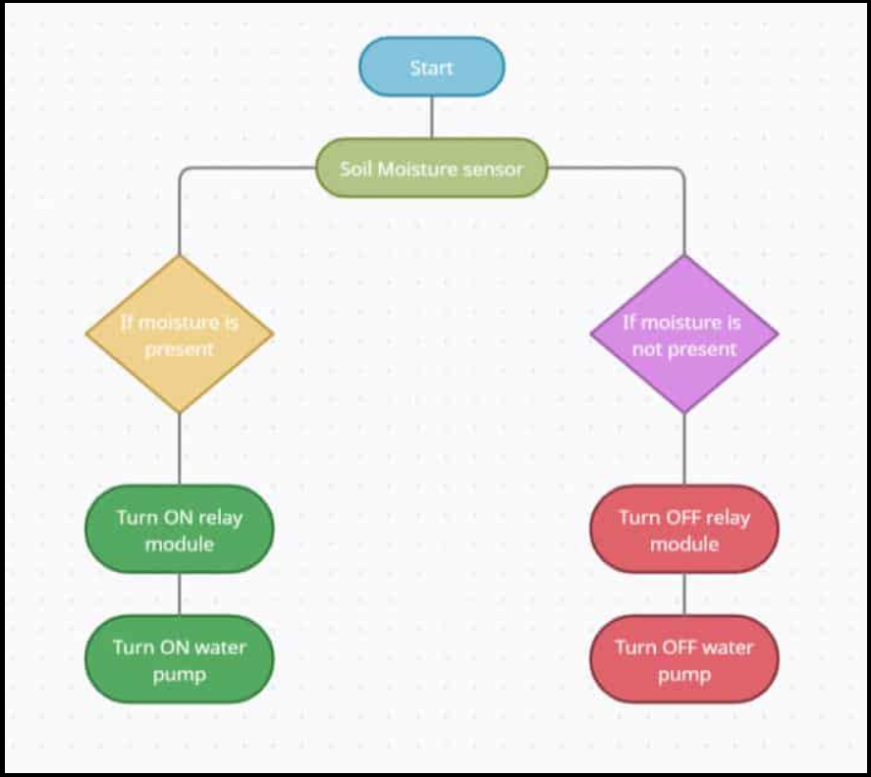
5. Block Diagram:
Description:
The block diagram consists of:
- Sensor → Microcontroller → Relay → Pump

6. Circuit Diagram:
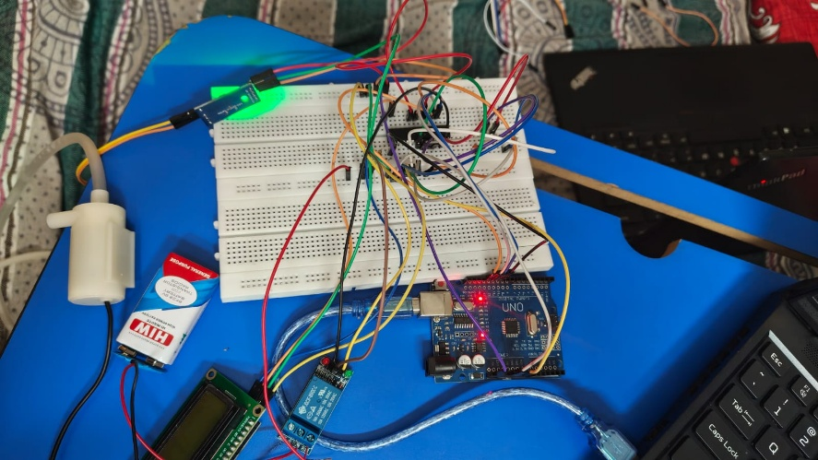

Description:
Shows connections between:
- ATmega32
- Sensor input (ADC pin)
- Relay driver circuit

7. Advantages:
- One of the primary advantages of the Smart Irrigation System is its ability to conserve water by supplying irrigation only when necessary. Unlike traditional irrigation methods that operate on fixed schedules, this system continuously monitors soil moisture levels and responds in real time. This prevents unnecessary water usage and makes the system highly efficient, especially in regions facing water scarcity.
- Another important advantage is the significant reduction in manual effort. The system operates automatically without requiring constant human supervision. Farmers or users do not need to check soil conditions repeatedly or manually switch the pump ON and OFF, as the microcontroller handles all operations. This automation saves time, reduces labour costs, and improves overall convenience.
- Additionally, the system is cost-effective and easy to implement using commonly available components. It ensures better plant health by maintaining optimal moisture levels and prevents problems such as overwatering or underwatering. Due to its simplicity and efficiency, the system is suitable for both small-scale gardens and large agricultural fields.

8. Applications:
- The Smart Irrigation System is widely used in agricultural fields where efficient water management is essential. It helps farmers automate irrigation processes by supplying water based on actual soil conditions rather than fixed schedules. This results in improved crop productivity, reduced water wastage, and better resource management.
- In addition to large-scale farming, the system is highly useful for home gardens and small plantations. Individuals can use this system to maintain their plants without needing to water them manually every day. It is particularly beneficial for people with busy schedules, as it ensures plants receive proper care even in their absence.
- Furthermore, the system can be applied in greenhouses and advanced smart farming environments. In such controlled environments, maintaining precise soil moisture levels is critical for plant growth. The system provides a reliable and automated solution, making it suitable for modern agricultural practices and research applications.
9. Future Scope:
- The Smart Irrigation System can be further improved by integrating Internet of Things (IoT) technology. With IoT connectivity, users can monitor soil conditions and control the irrigation system remotely through mobile applications or web platforms. This enhances user convenience and allows real-time decision-making from anywhere.
- Another enhancement includes adding multiple environmental sensors such as temperature, humidity, and rainfall sensors. By combining data from these sensors, the system can make more accurate and intelligent decisions regarding irrigation. This multi-parameter approach improves system efficiency and ensures better crop management.
- Moreover, the system can be upgraded to use renewable energy sources like solar power, making it more sustainable and suitable for rural or remote areas. Advanced technologies such as artificial intelligence and machine learning can also be incorporated to predict irrigation needs and automate scheduling, making the system smarter and more adaptive.

10. Conclusion
The Smart Irrigation System using an AVR microcontroller provides an effective and reliable solution for automated water management in agriculture. By continuously monitoring soil moisture levels and controlling irrigation accordingly, the system ensures efficient use of water and minimizes wastage.
The integration of sensors, microcontroller, and output devices demonstrates the practical application of embedded systems in real-world scenarios. This system not only simplifies irrigation processes but also enhances plant growth by maintaining optimal soil conditions at all times.
In conclusion, the project highlights the importance of automation in modern agriculture and its contribution to sustainable farming practices. With further technological advancements and enhancements, the system has the potential to become an essential component of future smart agriculture solutions.

