Student Record and Academic
Management System
Computational Thinking and Basic Programming – Unit 1

Completed Assignment Report
Console-based Python prototype with analysis, design, implementation, and testing

Submission item | Included
Problem statement | Section 1
Functional and non-functional requirements | Section 2
Algorithms and pseudocode | Sections 3 and 5
Flowchart collection | Section 4
Python source code | Section 6 and Appendix A
Testing and debugging report | Section 7
README and GitHub notes | Sections 8 and 9
Learning reflection | Section 10

1. Problem Statement
Educational institutions need accurate student academic records so that staff can quickly review a learner's identity, department, semester, subject marks, attendance, average marks, and grade. When records are maintained only in separate notebooks or spreadsheets, searching is slow and manual calculations can create mistakes.
The proposed Student Record and Academic Management System is a small console-based prototype. It stores records during the program session, allows a user to add and display students, searches by roll number or name, and calculates an average and grade from subject marks.

Objective and scope
- Apply problem decomposition, algorithms, flowcharts, pseudocode, coding, and testing.
- Use a simple menu-driven Python application rather than a database or graphical interface.
- Demonstrate variables, data types, input/output, conditions, loops, lists, dictionaries, and functions.
- Keep the prototype in memory; records are not saved after the program exits.

2. Requirement Analysis

2.1 Functional requirements
ID | Requirement | Acceptance condition
FR1 | Add student information | A valid record is stored with a unique roll number.
FR2 | Display student records | All stored records appear in a formatted table.
FR3 | Search student details | A roll number or part of a name returns matching records.
FR4 | Calculate average marks | The average of the three subject marks is shown to two decimals.
FR5 | Display grades | A grade is assigned using the documented boundary rules.
FR6 | Validate input | Invalid numbers, blank fields, duplicates, and bad menu choices are handled.
FR7 | Exit application | The user can end the menu loop with a goodbye message.

2.2 Non-functional requirements
Quality | Requirement
Simplicity | The interface uses a numbered console menu and clear prompts.
Ease of use | Messages explain errors and the next expected input.
Accuracy | Marks and attendance stay between 0 and 100; averages use all subjects.
Reliability | Invalid input does not crash the application.
Maintainability | Each major operation is implemented in a separate function.
Portability | The program uses standard Python and has no external runtime dependency.

2.3 Data design and assumptions
Field | Type | Rule
roll_number | String | Required and unique; comparison is case-insensitive.
name | String | Required; blank names are rejected.
department | String | Required; blank departments are rejected.
semester | Integer | Must be from 1 to 8.
marks | Dictionary | Python, Mathematics, and Database; each mark is 0–100.
attendance | Integer | Percentage from 0–100.
average | Float | Sum of subject marks divided by number of subjects.
grade | String | Calculated from average using the grade table below.

Grade rules
Average | Grade
90–100 | A+
80–89.99 | A
70–79.99 | B
60–69.99 | C
50–59.99 | D
Below 50 | F

3. Algorithm Design

3.1 Add student record
- Start.
- Read roll number and check whether it already exists.
- If it exists, display an error and stop this operation.
- Read name, department, and semester.
- Read marks for Python, Mathematics, and Database.
- Read attendance percentage.
- Calculate average and grade.
- Create a student record and add it to the student list.
- Display a success message and stop.

3.2 Display student records
- Start.
- Check whether the student list is empty.
- If empty, display 'No student records available'.
- Otherwise print the table headings.
- For each record, print roll number, name, department, semester, average, grade, and attendance.
- Stop.

3.3 Search student
- Start.
- Read a search keyword.
- For each student, compare the keyword with roll number and name.
- Store records where the keyword is found.
- If no records match, display an error message.
- Otherwise display every matching record.
- Stop.

3.4 Average and grade calculation
- Start.
- Read three subject marks from a student record.
- Add the marks and divide by three.
- Compare the average with the grade boundaries from highest to lowest.
- Return the matching grade.
- Stop.

3.5 Menu and exit
- Start the program with an empty student list.
- Display the menu and read a choice.
- Call the function matching choices 1–4.
- If the choice is 5, display a goodbye message and end the loop.
- For any other choice, display an invalid-choice message.
- Repeat until the user chooses Exit.

4. Flowchart Collection
The diagrams below translate the algorithms into visual sequences. The implementation uses the same decisions and outcomes.
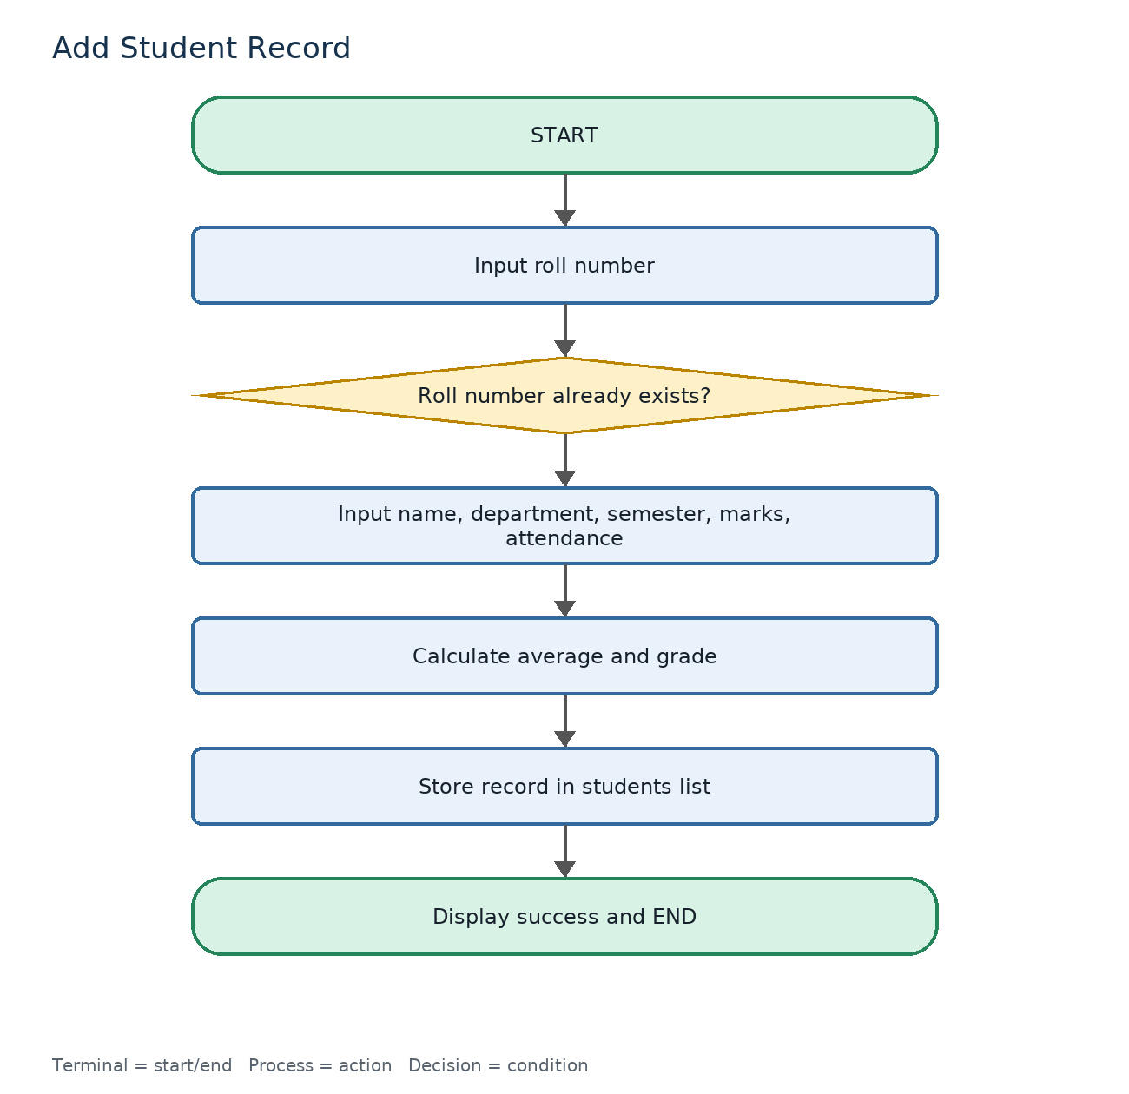
Figure 1: Add student flowchart
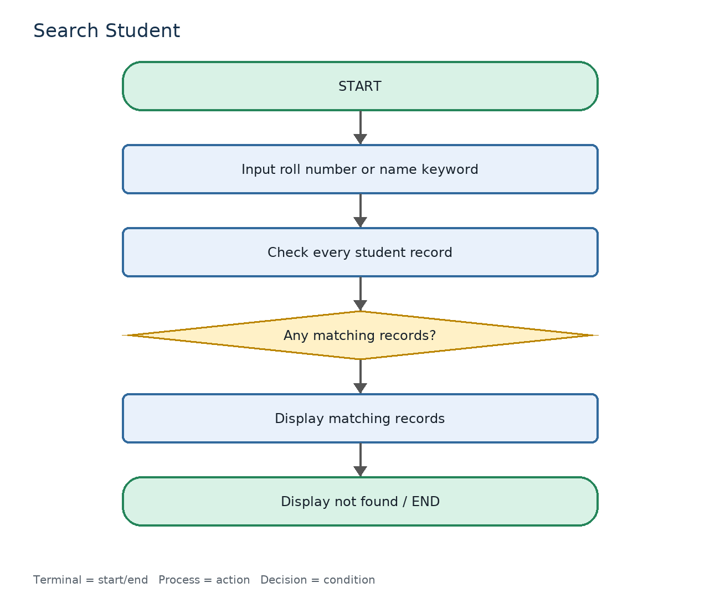
Figure 2: Search student flowchart
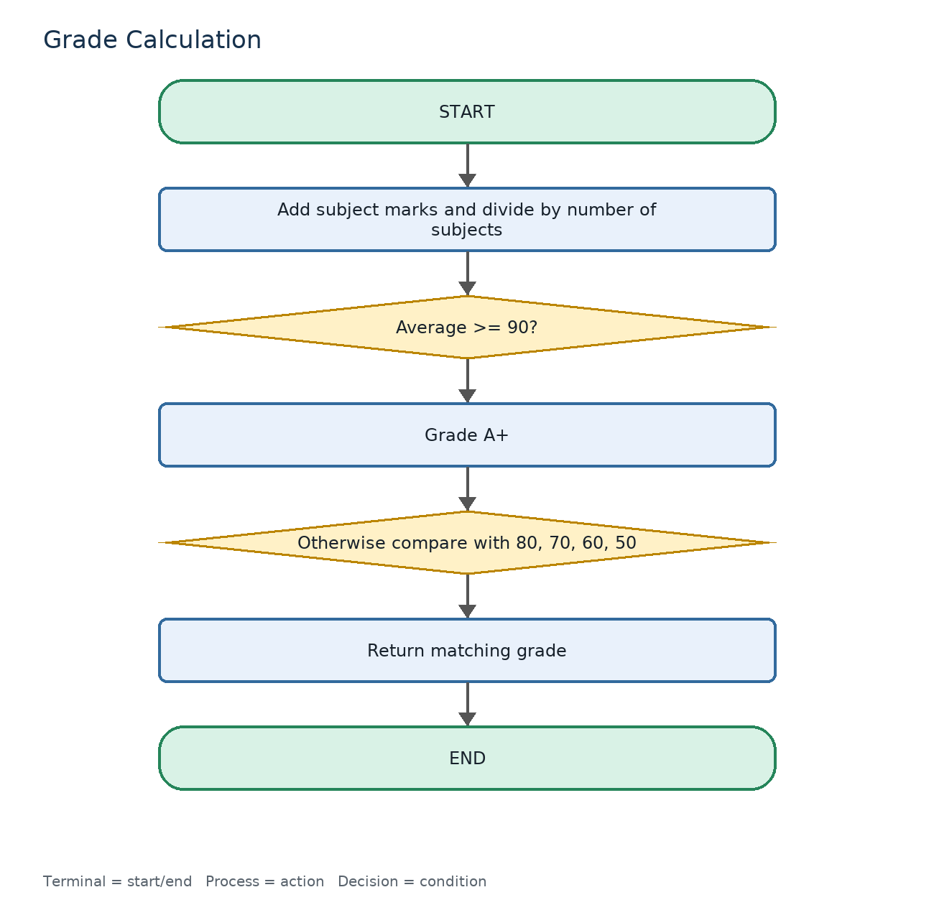
Figure 3: Grade calculation flowchart
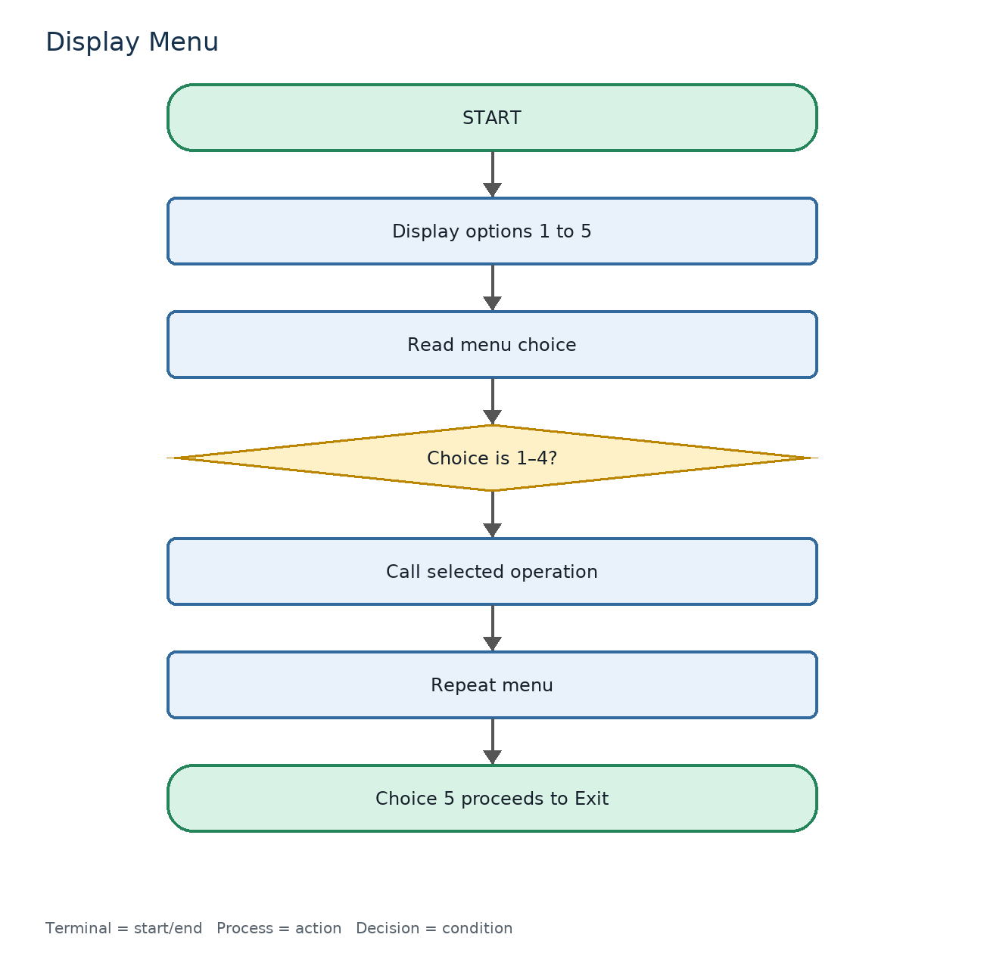
Figure 4: Display menu flowchart
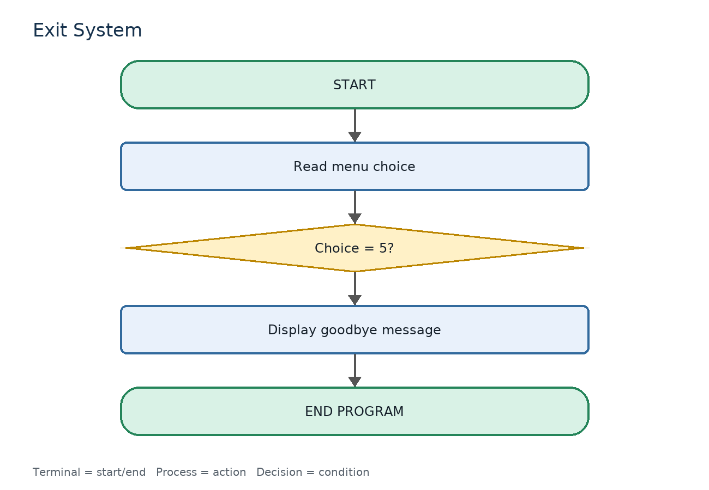
Figure 5: Exit system flowchart

5. Pseudocode
BEGIN StudentRecordSystem
students <- empty list

REPEAT
DISPLAY menu
READ choice

IF choice = 1 THEN AddStudent
ELSE IF choice = 2 THEN DisplayStudents
ELSE IF choice = 3 THEN SearchStudent
ELSE IF choice = 4 THEN ShowAverageAndGrade
ELSE IF choice = 5 THEN
DISPLAY goodbye message
EXIT LOOP
ELSE
DISPLAY invalid choice
END IF
UNTIL choice = 5
END StudentRecordSystem

FUNCTION AddStudent
READ roll_number
IF roll_number already exists THEN
DISPLAY duplicate error
RETURN
END IF
READ name, department, semester
FOR each subject in [Python, Mathematics, Database]
READ mark between 0 and 100
END FOR
READ attendance between 0 and 100
average <- sum(marks) / number of subjects
grade <- CalculateGrade(average)
ADD complete record to students
DISPLAY success message
END FUNCTION

FUNCTION CalculateGrade(average)
IF average >= 90 RETURN "A+"
ELSE IF average >= 80 RETURN "A"
ELSE IF average >= 70 RETURN "B"
ELSE IF average >= 60 RETURN "C"
ELSE IF average >= 50 RETURN "D"
ELSE RETURN "F"
END FUNCTION

FUNCTION SearchStudent
READ keyword
matches <- records whose roll number or name contains keyword
IF matches is empty DISPLAY not found message
ELSE DISPLAY every matching record
END FUNCTION

6. Python Programming Implementation
The implementation is stored in student_record_system.py. It uses a list of dictionaries so that the data structure remains understandable at Unit 1 level. Input helper functions repeat prompts until valid values are entered.

6.1 Key implementation decisions
- A list named students stores all records for the current session.
- Each record is a dictionary containing identity, academic, attendance, average, and grade data.
- The SUBJECTS tuple keeps subject processing consistent and avoids repeated code.
- calculate_average and calculate_grade are separate functions so the logic can be tested independently.
- No record is written to a file or database because persistence is outside the Unit 1 scope.

6.2 Source code
"""
Student Record and Academic Management System
Computational Thinking and Basic Programming - Unit 1

Console-based prototype using lists, dictionaries, functions, loops,
conditional statements, and input validation.
"""

SUBJECTS = ("Python", "Mathematics", "Database")
students = []

def calculate_average(marks):
"""Return the average of a dictionary of subject marks."""
if not marks:
return 0.0
return sum(marks.values()) / len(marks)

def calculate_grade(average):
"""Return a grade based on the average mark."""
if average >= 90:
return "A+"
if average >= 80:
return "A"
if average >= 70:
return "B"
if average >= 60:
return "C"
if average >= 50:
return "D"
return "F"

def find_student(roll_number):
"""Find and return a student dictionary by roll number."""
for student in students:
if student["roll_number"].lower() == roll_number.lower():
return student
return None

def read_integer(prompt, minimum=None, maximum=None):
"""Read an integer and keep asking until it meets the given limits."""
while True:
try:
value = int(input(prompt).strip())
if minimum is not None and value < minimum:
print(f"Please enter a value from {minimum} onwards.")
continue
if maximum is not None and value > maximum:
print(f"Please enter a value up to {maximum}.")
continue
return value
except ValueError:
print("Invalid input. Please enter a whole number.")

def read_non_empty(prompt):
"""Read text that cannot be blank."""
while True:
value = input(prompt).strip()
if value:
return value
print("This field cannot be blank.")

def add_student():
"""Read and add one student record."""
print("\n--- Add Student Record ---")
roll_number = read_non_empty("Enter roll number: ")

if find_student(roll_number) is not None:
print("Error: a student with this roll number already exists.")
return

name = read_non_empty("Enter student name: ")
department = read_non_empty("Enter department: ")
semester = read_integer("Enter semester (1-8): ", 1, 8)

marks = {}
for subject in SUBJECTS:
marks[subject] = read_integer(
f"Enter marks for {subject} (0-100): ", 0, 100
)

attendance = read_integer("Enter attendance percentage (0-100): ", 0, 100)
average = calculate_average(marks)

student = {
"roll_number": roll_number,
"name": name,
"department": department,
"semester": semester,
"marks": marks,
"attendance": attendance,
"average": average,
"grade": calculate_grade(average),
}
students.append(student)
print(f"Student record for {name} added successfully.")

def display_student(student):
"""Print one student's complete academic record."""
print(f"\nRoll Number : {student['roll_number']}")
print(f"Name : {student['name']}")
print(f"Department : {student['department']}")
print(f"Semester : {student['semester']}")
print(f"Attendance : {student['attendance']}%")
print("Subject Marks:")
for subject, mark in student["marks"].items():
print(f" {subject:<12}: {mark}")
print(f"Average : {student['average']:.2f}")
print(f"Grade : {student['grade']}")

def display_students(records=None):
"""Display all records, or the records supplied by a search."""
records = students if records is None else records
print("\n--- Student Records ---")
if not records:
print("No student records available.")
return

header = (
f"{'Roll No.':<12}{'Name':<22}{'Department':<18}"
f"{'Sem':<6}{'Average':<10}{'Grade':<7}{'Attendance':<12}"
)
print(header)
print("-" * len(header))
for student in records:
print(
f"{student['roll_number']:<12}{student['name'][:20]:<22}"
f"{student['department'][:16]:<18}{student['semester']:<6}"
f"{student['average']:<10.2f}{student['grade']:<7}"
f"{str(student['attendance']) + '%':<12}"
)

def search_student():
"""Search by roll number or a part of the student's name."""
print("\n--- Search Student ---")
keyword = read_non_empty("Enter roll number or student name: ").lower()
results = [
student
for student in students
if keyword in student["roll_number"].lower()
or keyword in student["name"].lower()
]

if not results:
print("No matching student found.")
return

for student in results:
display_student(student)

def show_average_and_grade():
"""Display the calculated average and grade for one student."""
print("\n--- Average and Grade ---")
roll_number = read_non_empty("Enter roll number: ")
student = find_student(roll_number)
if student is None:
print("Error: student record not found.")
return
print(
f"{student['name']} has an average of "
f"{student['average']:.2f} and grade {student['grade']}."
)

def display_menu():
"""Display the main menu."""
print("\n===== STUDENT RECORD AND ACADEMIC MANAGEMENT SYSTEM =====")
print("1. Add student record")
print("2. Display all student records")
print("3. Search student")
print("4. Calculate average and display grade")
print("5. Exit")

def main():
"""Run the menu-driven application."""
while True:
display_menu()
choice = input("Enter your choice (1-5): ").strip()

if choice == "1":
add_student()
elif choice == "2":
display_students()
elif choice == "3":
search_student()
elif choice == "4":
show_average_and_grade()
elif choice == "5":
print("Thank you for using the Student Record System. Goodbye!")
break
else:
print("Invalid choice. Please enter a number from 1 to 5.")

if __name__ == "__main__":
main()

7. Testing and Debugging Report
Testing covered normal use, invalid input, duplicate data, boundary values, search behavior, calculation logic, and clean exit. The automated unit test file contains four checks; the manual cases below cover the complete menu flow.
# | Test case and input | Expected result | Result
1 | Add ST101 with marks 85, 78, 92 and attendance 90 | Record added; average 85.00; grade A | Pass
2 | Add another ST101 | Duplicate roll number rejected | Pass
3 | Enter text instead of semester | Prompt repeats; no crash | Pass
4 | Enter mark -1 | Prompt rejects value below 0 | Pass
5 | Enter mark 101 | Prompt rejects value above 100 | Pass
6 | Enter attendance 100 | Boundary value accepted | Pass
7 | Display all records | Formatted record table appears | Pass
8 | Search for Asha | ST101 complete record appears | Pass
9 | Search for Chemistry | No matching student message | Pass
10 | Average 90 | Grade is A+ | Pass
11 | Average 49.99 | Grade is F | Pass
12 | Menu choice 9 | Invalid choice message appears | Pass
13 | Choose 5 | Goodbye message; loop terminates | Pass

7.1 Automated test result
test_average_calculation (test_student_record_system.StudentRecordSystemTests.test_average_calculation) ... ok
test_find_student_is_case_insensitive (test_student_record_system.StudentRecordSystemTests.test_find_student_is_case_insensitive) ... ok
test_grade_boundaries (test_student_record_system.StudentRecordSystemTests.test_grade_boundaries) ... ok
test_zero_marks_produce_fail_grade (test_student_record_system.StudentRecordSystemTests.test_zero_marks_produce_fail_grade) ... ok

----------------------------------------------------------------------
Ran 4 tests in 0.000s

OK

7.2 Sample console evidence
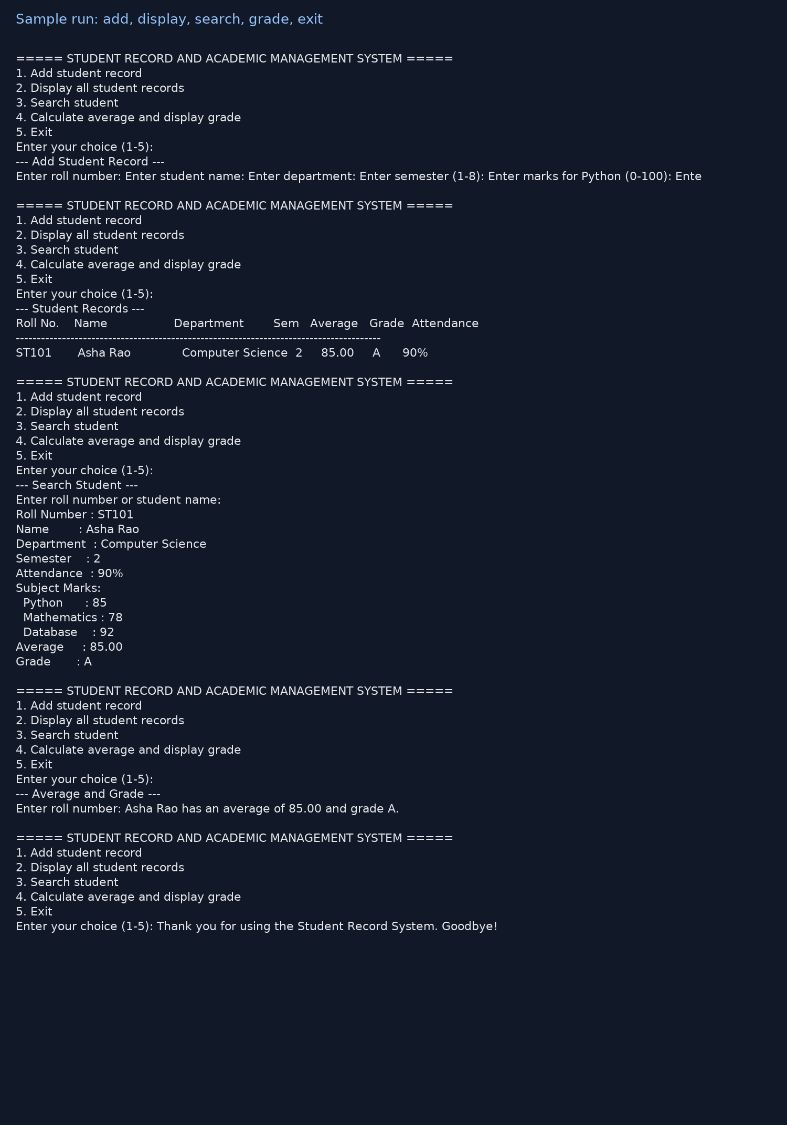
Figure 6: Sample run showing record entry, display/search, grade calculation, and exit.

7.3 Errors identified and corrected
- A duplicate roll number could create two records; corrected by checking find_student before append.
- Non-numeric and out-of-range values could stop the program; corrected with read_integer validation and a loop.
- Average and grade could become inconsistent if calculated in different places; corrected by calculating them when the record is created.
- Search was made case-insensitive so users do not need exact capitalization.

8. Project Folder Structure
Student_Record_Academic_Management_System/
├── student_record_system.py
├── tests/
│ └── test_student_record_system.py
├── docs/
│ ├── flowcharts/
│ │ ├── add_student.png
│ │ ├── search_student.png
│ │ ├── grade_calculation.png
│ │ ├── display_menu.png
│ │ └── exit_system.png
│ ├── sample_console_output.png
│ └── sample_console_output.txt
├── README.md
├── .gitignore
└── assignment_report.docx

9. GitHub Repository Plan
The included README provides the commands required to upload the folder to GitHub. A repository URL is intentionally not invented here because it must be created under the student's own GitHub account.
git init
git add .
git commit -m "Initial Student Record System Unit 1 submission"
git branch -M main
git remote add origin <your-github-repository-url>
git push -u origin main
Suggested repository name: student-record-academic-management-system

10. Learning Reflection
This assignment showed that a program should be planned before it is coded. The problem was divided into smaller operations: adding, displaying, searching, calculating, and exiting. Writing algorithms and pseudocode first made the menu flow and decision points easier to understand.
I learned how lists and dictionaries can represent structured student data, how loops can keep asking for valid input, and how conditional statements can assign grades. Testing boundary values such as 0, 50, 90, and 100 was important because a program can appear to work for normal input while still failing at its limits.
The current prototype is intentionally limited: data is stored only while the program runs, there is no login, and there is no database. A future unit could add file/database storage, update and delete operations, reports, and a graphical or web interface.

Appendix A – Submission Checklist
Deliverable | Status
Problem Statement Report | Completed
Requirement Analysis | Completed
Functional and Non-Functional Requirements | Completed
Algorithm Design | Completed
Flowchart Collection | Completed
Pseudocode Document | Completed
Basic Python Program | Completed
Menu-Driven Student Record Prototype | Completed
Testing Report | Completed
README / GitHub upload instructions | Completed
Project Documentation | Completed
Unit Reflection Report | Completed

