**Market Regime Detection using Unsupervised Learning**

Name: Shital Niras

Project: Task@RozReturns

**Objective :**

To segment the market into distinct behavioral regimes based on real-time order book and volume data, capturing dimensions of:

* Trending vs Mean-Reverting
* Volatile vs Stable
* Liquid vs Illiquid

**Methodology :**

#### 1. Data Source

Used trade and order book data across several days for BNBFDUSD from .txt files containing fields like:

* Time, Price, Quantity, IsMarketMaker, NumTrades

#### 2. Feature Engineering

We derived both standard and custom features to represent market dynamics:

* Order Book Features:  
  + Bid/Ask Spread
  + Order Book Imbalance
  + Microprice
  + Cumulative Depth (bid and ask)
* Volatility & Price Action:  
  + Rolling Log Returns
  + Price Volatility (std over 10s, 30s)
* Volume Features:  
  + Volume Imbalance (Buy vs Sell)
  + VWAP Shift (Volume Weighted Avg Price delta over 10s)
  + Cumulative Trade Volume
* Derived Features:  
  + Depth Slope (quantity decay)
  + Trade Wipe Level (levels cleared by aggressive trades)

#### 3. Normalization

All features were normalized using z-score scaling to bring them to comparable scales. Optionally, PCA was used to visualize feature space variance.

#### 4. Clustering (Regime Detection)

Used KMeans clustering after elbow-method showed 3–4 optimal clusters. Evaluated clustering using:

* Silhouette Score
* Davies-Bouldin Index

### **📊 Regime Interpretation**

Each cluster was mapped to a qualitative regime label based on feature statistics:

| Regime | Volatilit y | VWAP Shift | Volume Imbalance | Quantity | Label |
| --- | --- | --- | --- | --- | --- |
| 0 | Low | Low | Low | Low | Mean-Reverting & Stable & Illiquid |
| 1 | High | High | Positive | Moderate | Trending & Volatile & Moderately Liquid |
| 2 | Medium | Low | Negative | Low | Mean-Reverting & Mildly Volatile & Illiquid |
| 3 | High | Very High | Mixed | High | Trending & Volatile & Highly Liquid |

**Visualizations :**

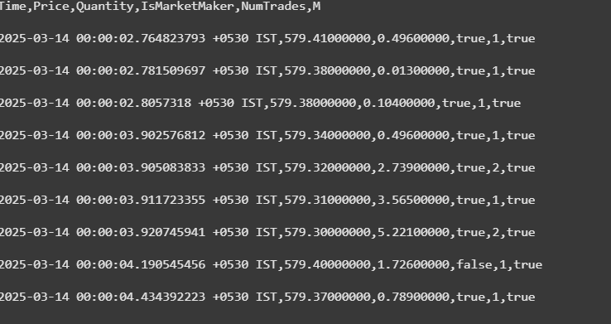

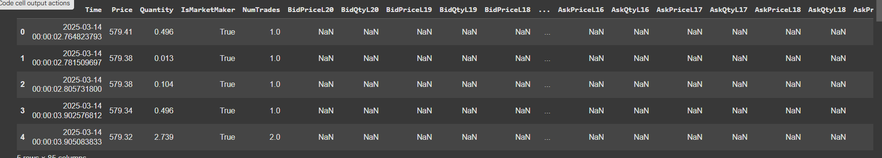

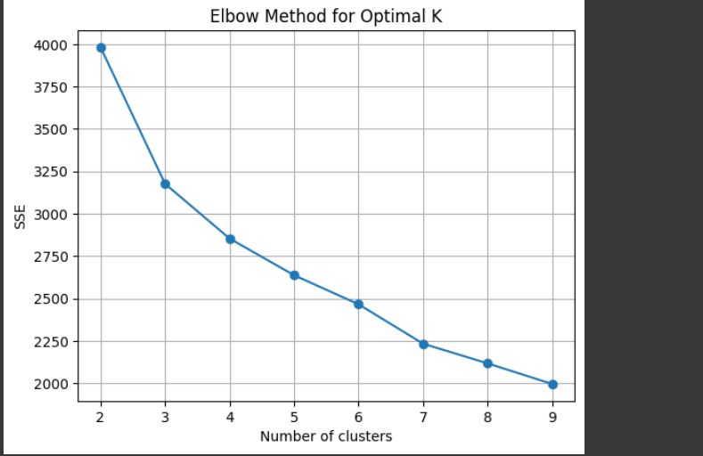

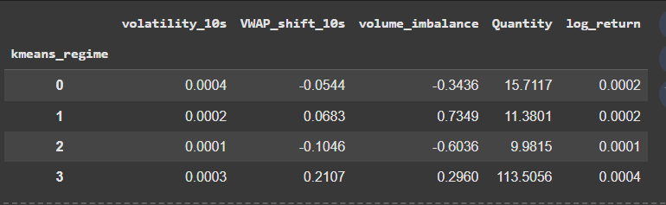

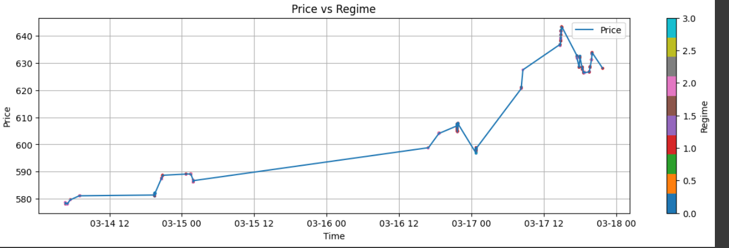

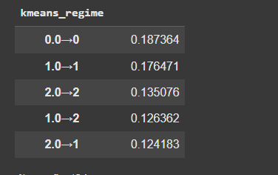

### **🔍 Insights**

* Trending regimes tend to show higher VWAP shifts and volatility.
* Liquid regimes are associated with higher trade quantities and smoother transitions.
* Regime shifts often occur after periods of abnormal volume or sharp microprice changes — can potentially act as signals for risk/momentum strategies.