create database Product;

use product;

-- 1. create a table product - product_id , product_name , product_price

CREATE TABLE product (product_id INT PRIMARY KEY AUTO_INCREMENT, product_name VARCHAR(255) NOT NULL, product_price int NOT NULL);

-- 3 create table customer - customer-id , customer_name, country, age, aadharcard_no

CREATE TABLE customer (customer_id INT PRIMARY KEY AUTO_INCREMENT, customer_name VARCHAR(255) NOT NULL,

country VARCHAR(255) NOT NULL, age INT NOT NULL, aadharcard_no VARCHAR(255) Unique NOT NULL);

-- 2. create table sales - sales_id, customer_id , product_id, quantity

CREATE TABLE sales (sales_id INT PRIMARY KEY AUTO_INCREMENT,customer_id INT NOT NULL,product_id INT NOT NULL,

quantity INT NOT NULL, FOREIGN KEY (customer_id) REFERENCES customer(customer_id),

FOREIGN KEY (product_id) REFERENCES product(product_id));

INSERT INTO product (product_name, product_price)

VALUES ('Rice', 500),('Wheat flour', 350),('Salt', 200),('Sugar', 450),

('Milk', 250),('Bread', 100),('Chocolate', 200),('Apple',100);

INSERT INTO customer (customer_name, country, age, aadharcard_no)

VALUES

('Aarav', 'Australia', 25, '1234-5678-9012'),

('Aarushi', 'Canada', 28, '2345-6789-0123'),

('Advait', 'Germany', 30, '3456-7890-1234'),

('Akshay', 'Sri Lanka', 22, '4567-8901-2345'),

('Ananya', 'Australia', 33, '5678-9012-3456'),

('Ankit', 'Mexico', 27, '6789-0123-4567'),

('Anjali', 'Japan', 35, '7890-1234-5678'),

('Arnav', 'Australia', 20, '8901-2345-6789'),

('Aryan', 'South Africa', 24, '9012-3456-7890'),

('Divya', 'Sri Lanka', 31, '0143-4567-8901'),

('Harsh', 'Japan', 26, '2365-6789-0123'),

('Ishaan', 'South Korea', 29, '3446-7890-1234'),

('Jasmin', 'Sri Lanka', 32, '4557-8901-2345'),

('Karan', 'Australia', 21, '5668-9012-3456'),

('Kavya', 'Japan', 23, '6779-0123-4567'),

('Neha', 'Sri Lanka', 27, '7880-1234-5678'),

('Pranav', 'Australia', 30, '8991-2345-6789'),

('Rahul', 'Japan', 25, '9002-3456-7890'),

('Riya', 'Sri Lanka', 28, '0223-4567-8901'),

('Vikram', 'Nepal', 33, '2555-6789-0123');

INSERT INTO sales (customer_id, product_id, quantity)

VALUES (1, 1, 2), (2, 2, 1), (3, 3, 3), (4, 4, 1), (5, 5, 2), (6, 1, 1), (7, 2, 2), (8, 7, 3), (9, 6, 1),

(10, 5, 2), (11, 1, 3), (12, 2, 2), (13, 3, 1), (14, 4, 2), (15, 7, 3), (16, 6, 1), (17, 2, 1), (18, 3, 2),

(19, 4, 1), (20, 5, 2);

-- 4. show the product with maximum price

SELECT * FROM product WHERE product_price = (SELECT MAX(product_price) FROM product);

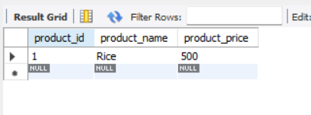

-- 5. show the sales with minimum quantity

SELECT * FROM sales WHERE quantity = (SELECT MIN(quantity) from sales );

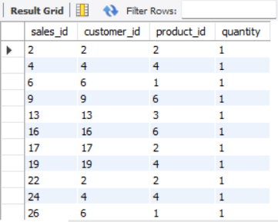

-- 6. show all product whose name start with 'A'

SELECT * FROM product WHERE product_name LIKE 'A%';

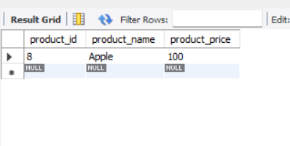

-- 7. show all customers who are from "Australia"

SELECT * FROM customer WHERE country = 'Australia';

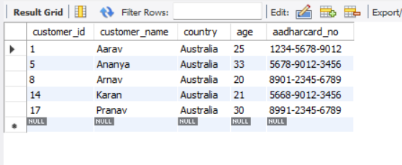

-- 8. show all the customers from japan and have age greater than 30

SELECT * FROM customer WHERE country = 'Japan' AND age > 30;

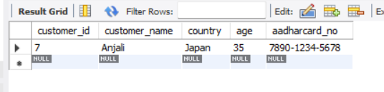

-- 9. show all the product with price range 200 to 500 rupees

SELECT * FROM product WHERE product_price BETWEEN 200 AND 500;

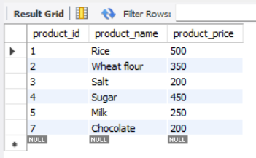

-- 10. show all the sales product where you will list the price and also the amount paid per sales

SELECT s.sales_id, p.product_name, p.product_price, s.quantity, s.quantity * p.product_price AS amount_paid

FROM sales as s INNER JOIN product as p ON s.product_id = p.product_id;

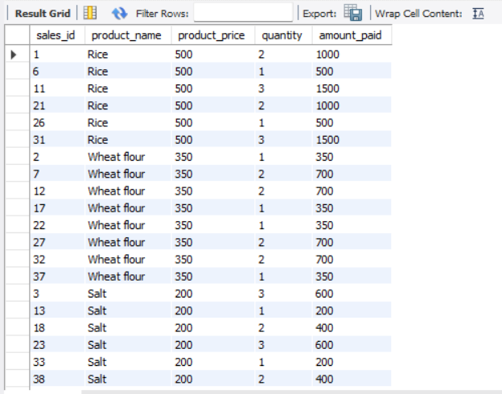

-- 11. show all the product are having price less than 200 or have the name starting with S

SELECT * FROM product WHERE product_price < 200 OR product_name LIKE 'S%';

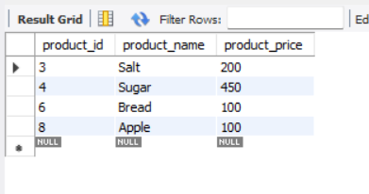

-- 12. change the name of customer 402 to shakti

-- UPDATE customer SET customer_name = 'Shakti' WHERE customer_id = 402;

-- since I used auto increment I will change the name of cutomer 2

UPDATE customer SET customer_name = 'Shakti' WHERE customer_id = 2;

-- 13. list down all the sales id, product id, product name and quantity

SELECT s.sales_id, s.product_id, p.product_name, s.quantity

FROM sales as s INNER JOIN product AS p ON s.product_id = p.product_id;

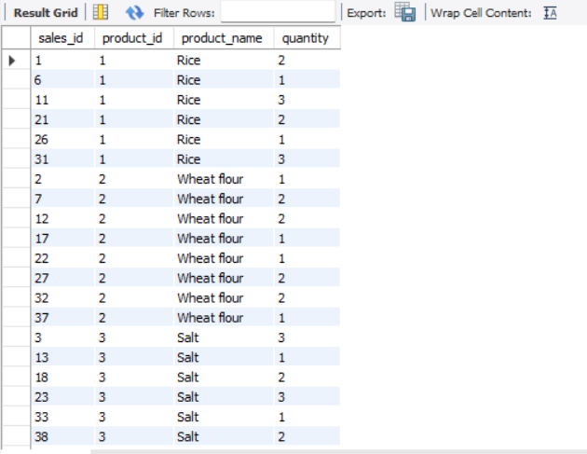

-- 14. search for all customers from "UK" , "Japan" and "Sri Lanka"

SELECT * FROM customer WHERE country IN ('UK', 'Japan', 'Sri Lanka');

