**Future Intern as Data Analysis**

**Task 1**

**Task: Clean a dataset by removing missing values and outliers**

**Solution:**

**Step:**

**1.Import packages and display train dataset and test dataset**

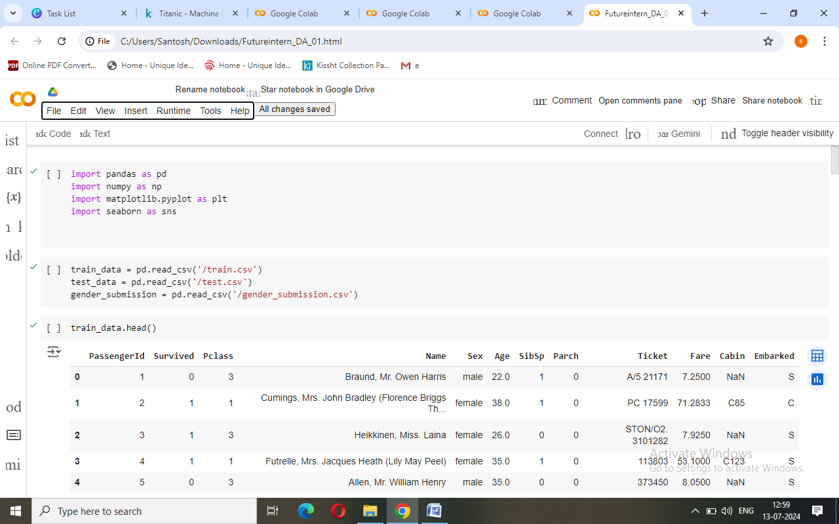

**2. Display data types**

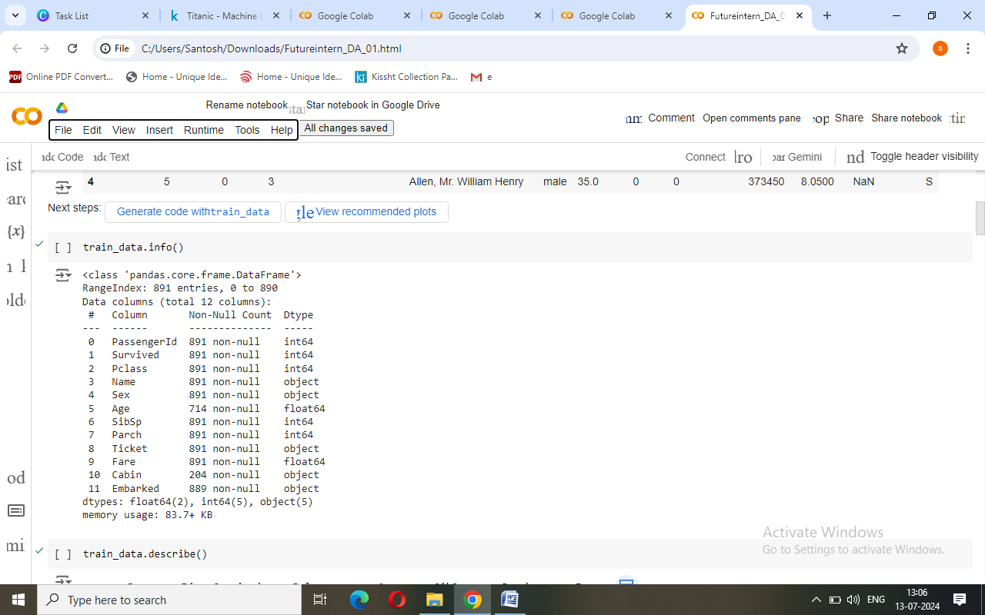

**3. Get Summary Statistics for numerical column**

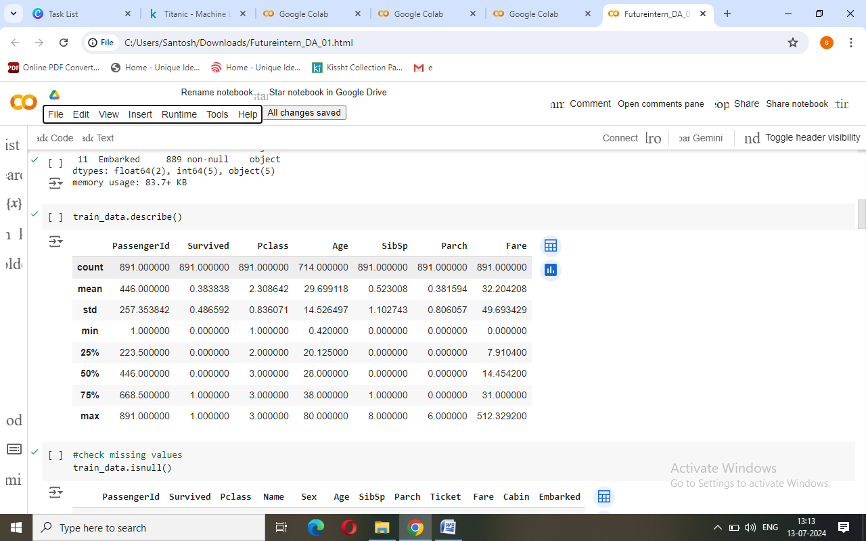

**4. Get the missing values in train dataset**

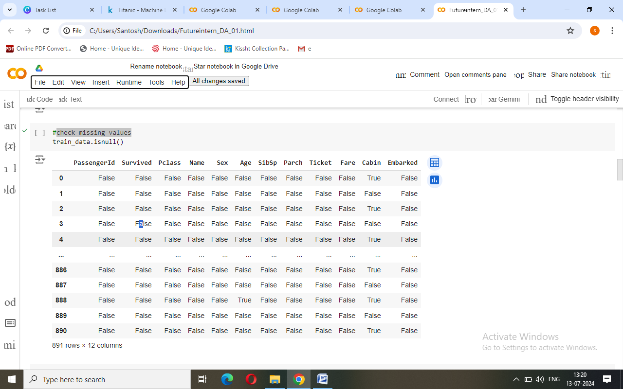

**5. Get missing values from train dataset in each column**

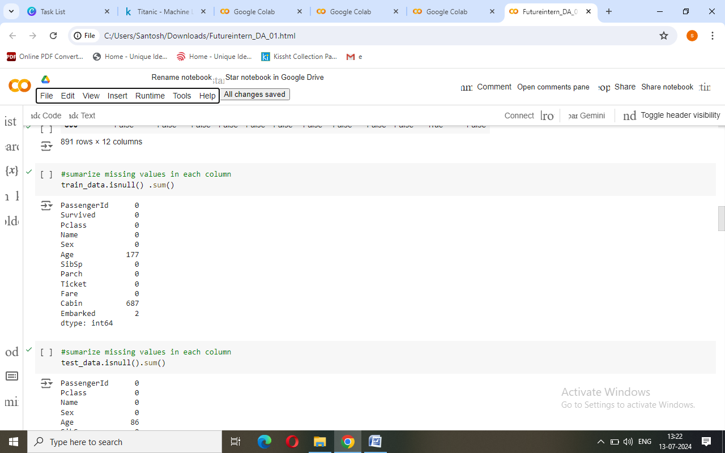

**6. Get missing values from test dataset in each column**

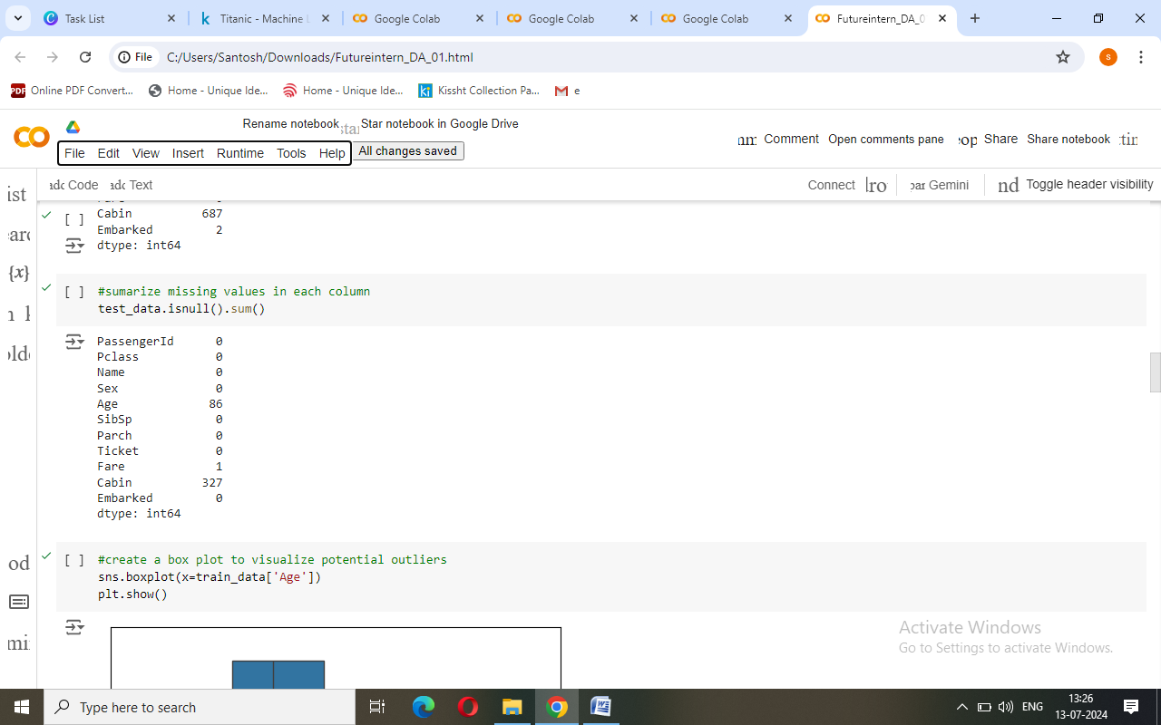

**7. Create a box plot to visualize potential outliers for train dataset(Age)**

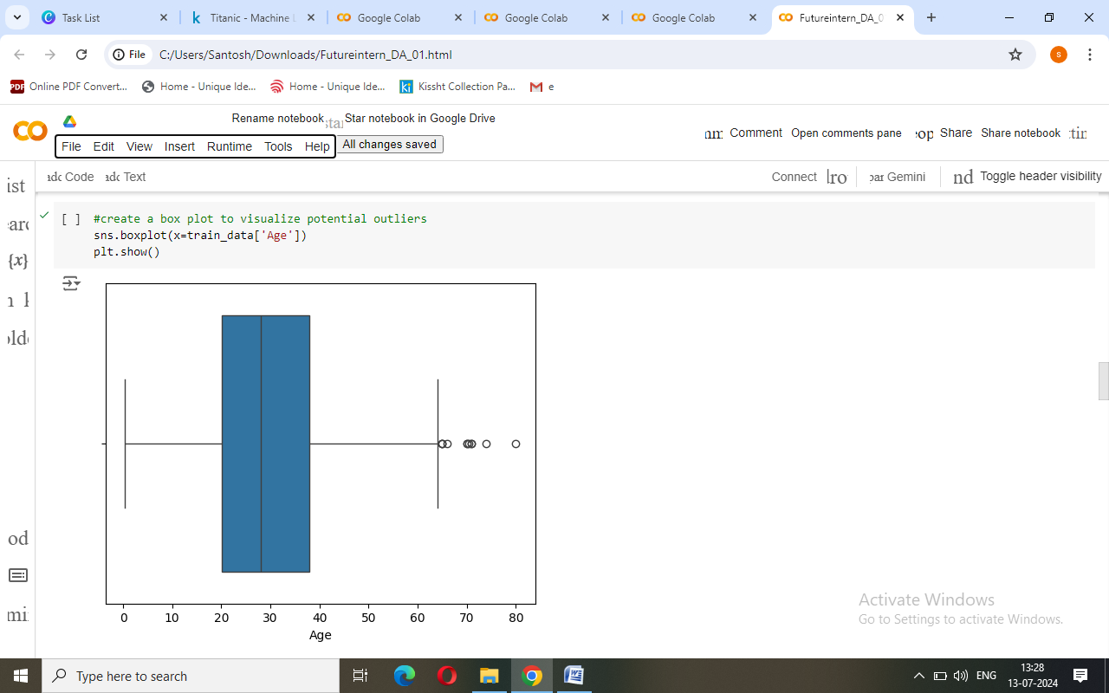

**8. Create a box plot to visualize potential outliers for test dataset (Age)**

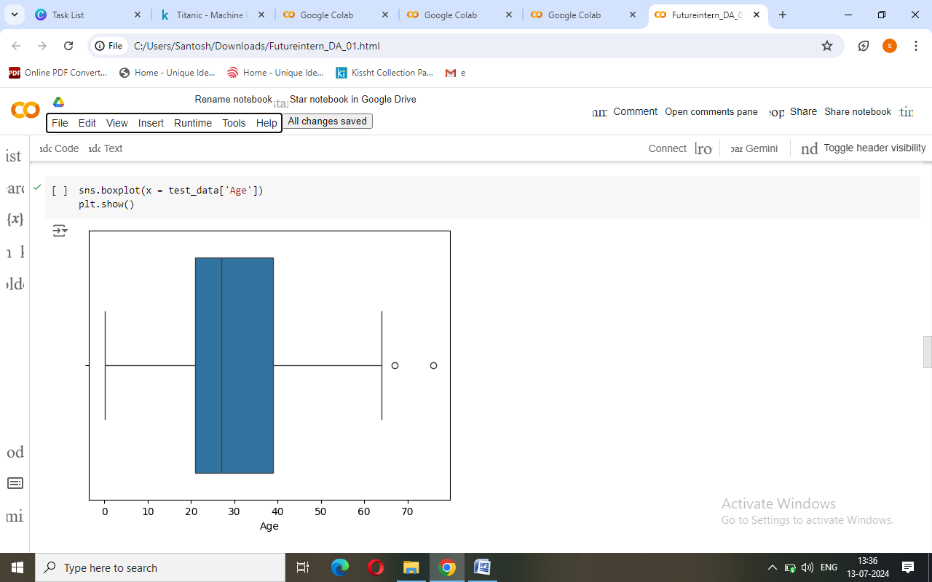

**9. Create a box plot to visualize potential outliers for train dataset (Fare)**

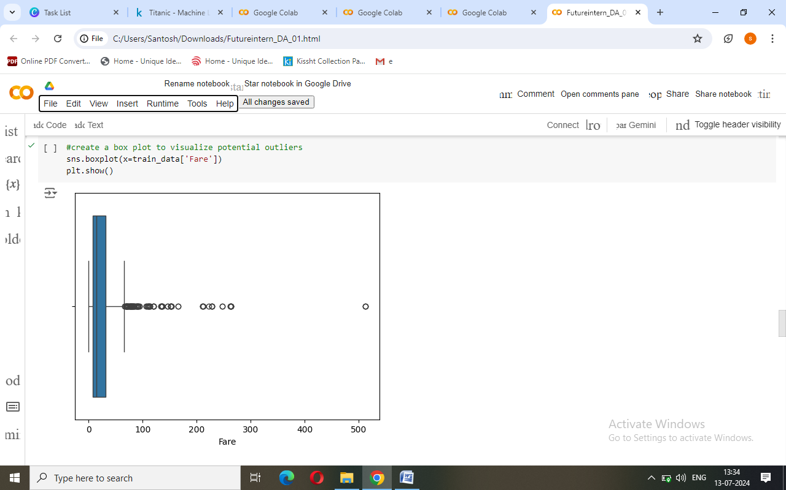

**10. Create a box plot to visualize potential outliers for test dataset(Fare)**

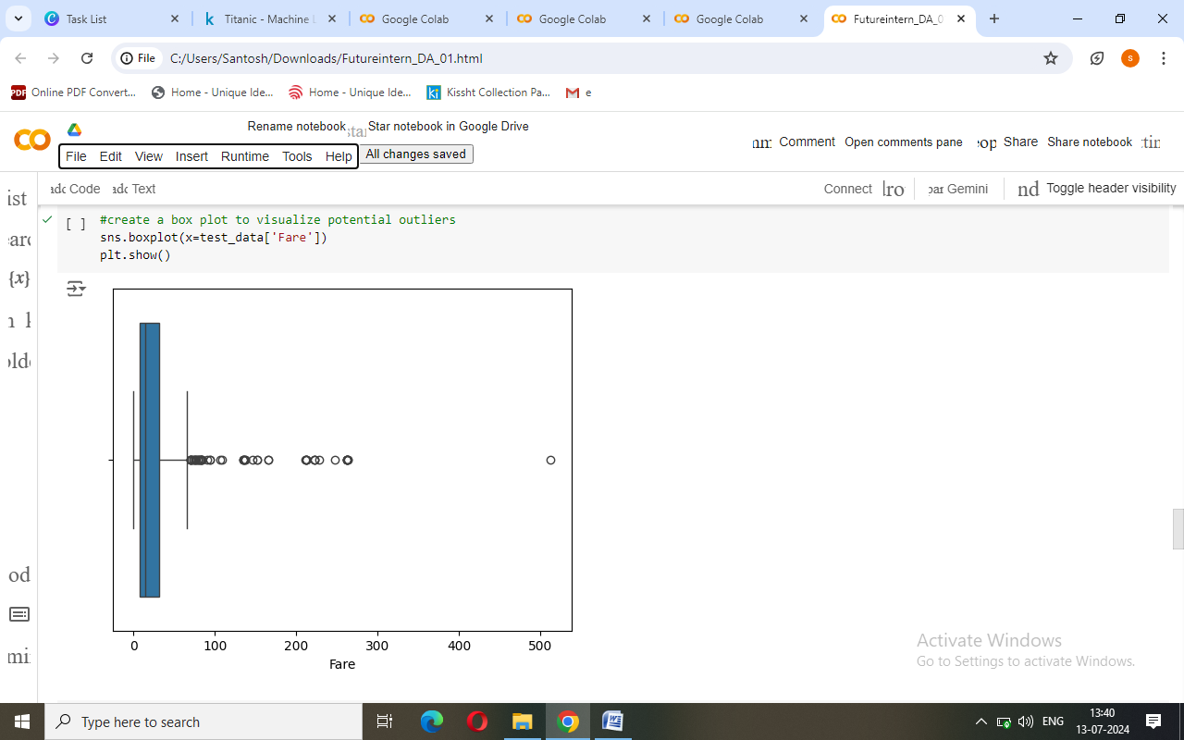

**11. Replace the missing values with mean of the column**

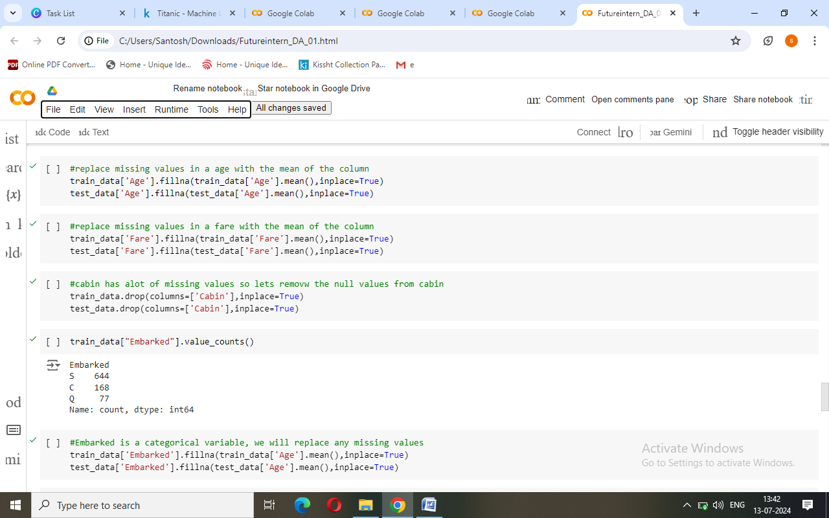

**12. outlier**

