**Future Intern as Data Analysis**

**Task 2**

**Task: Calculate summary statistics (Mean, Mode ,Median And Standard Deviation for a dataset**

**Solution:**

**Step:**

**1. Import packages and display train dataset and test dataset**

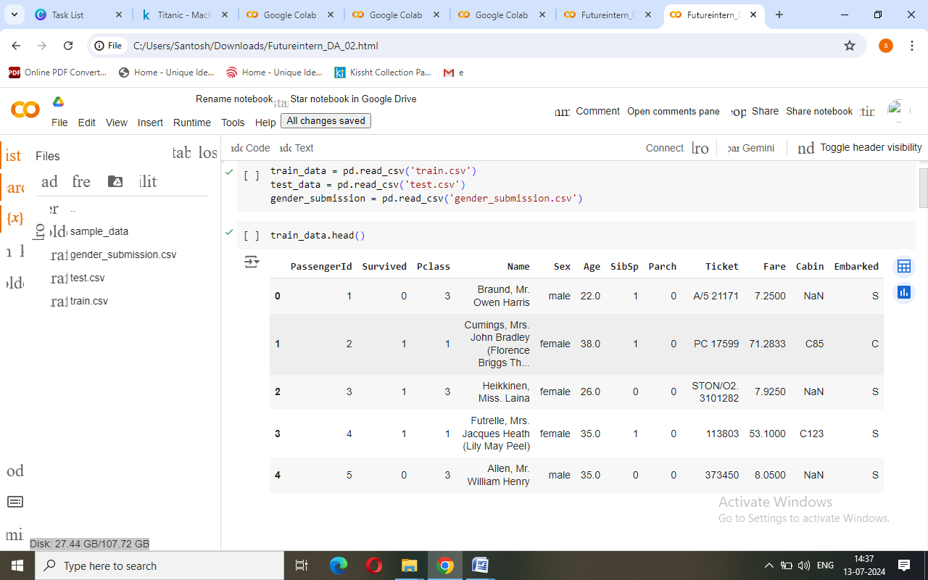

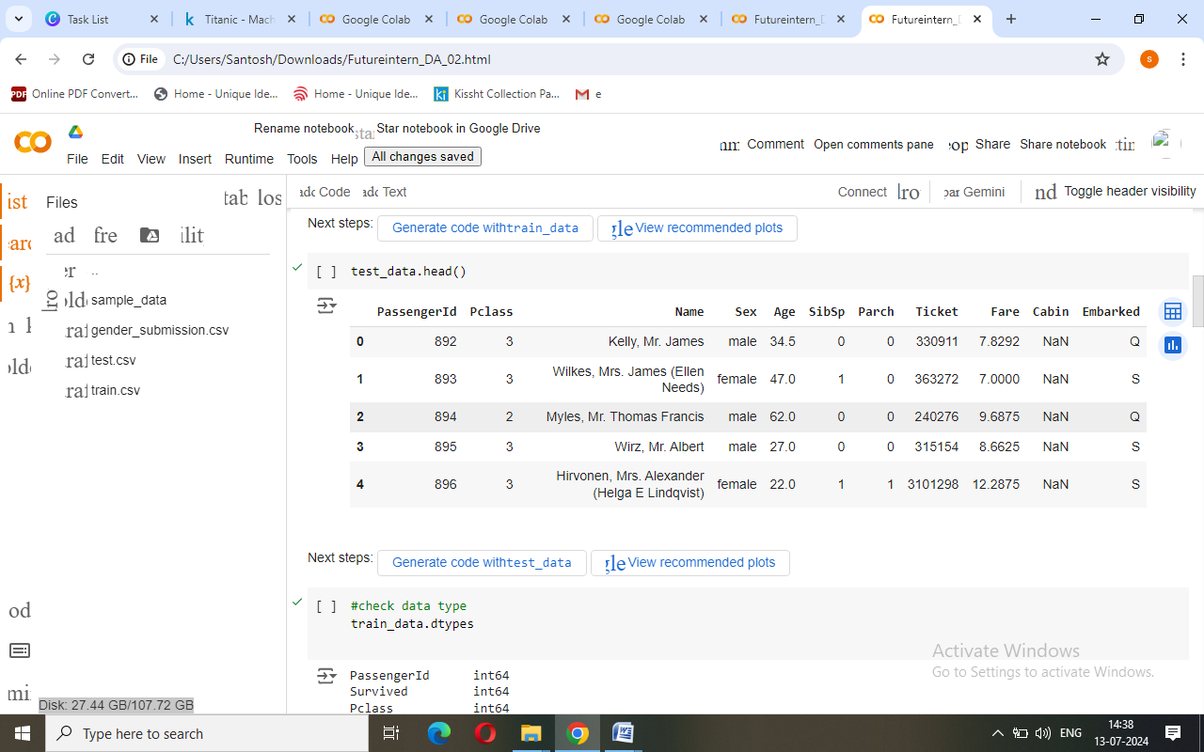

**2. Check data type of train dataset and test dataset**

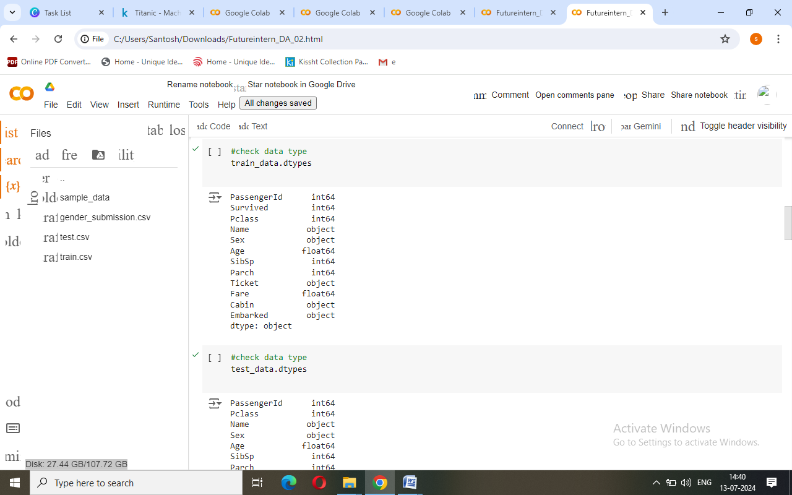

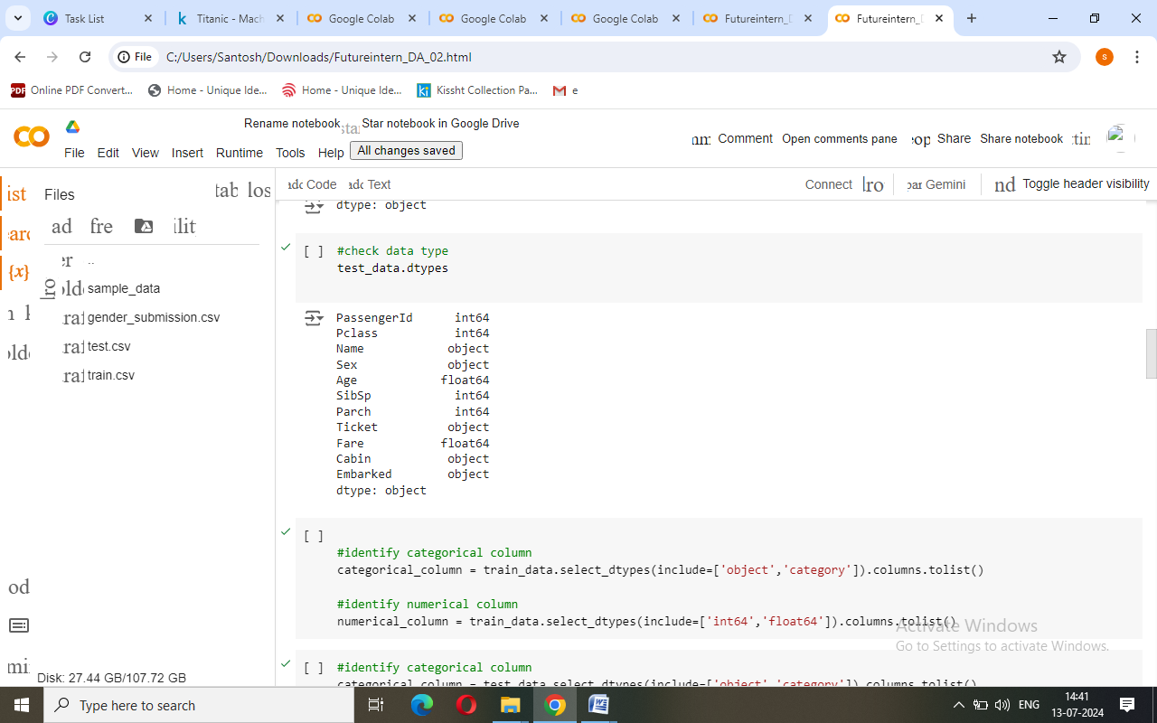

**3. Identify categorical and numerical columns**

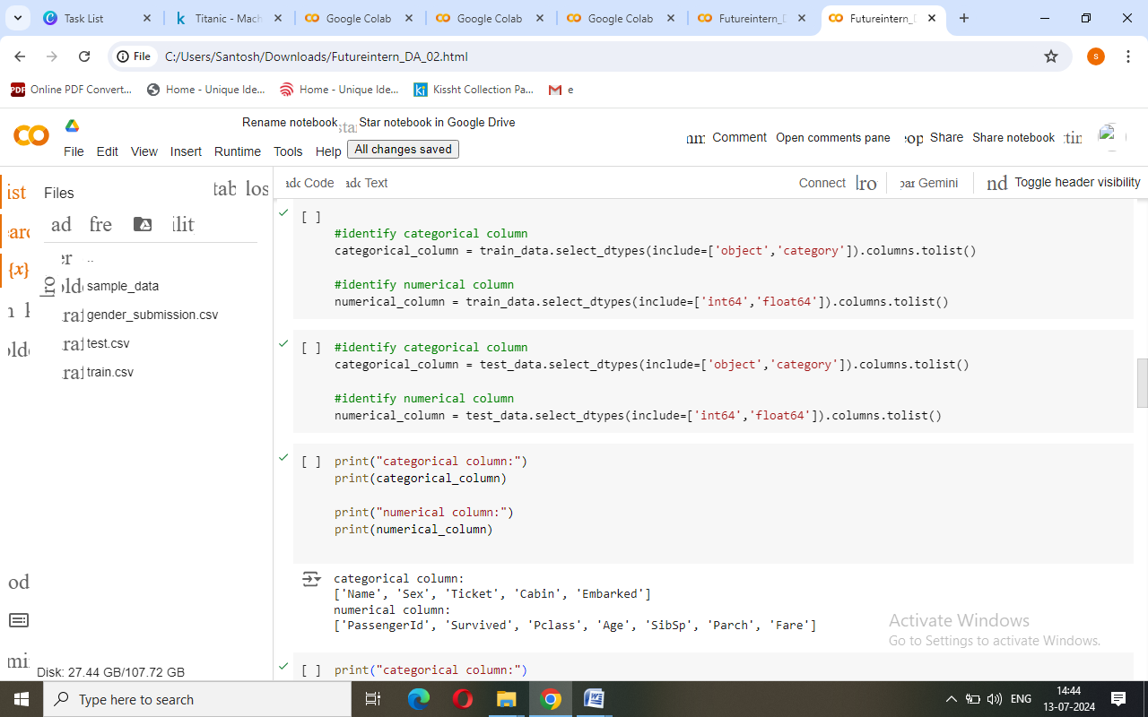

**4. Select columns where we perform staticstics**

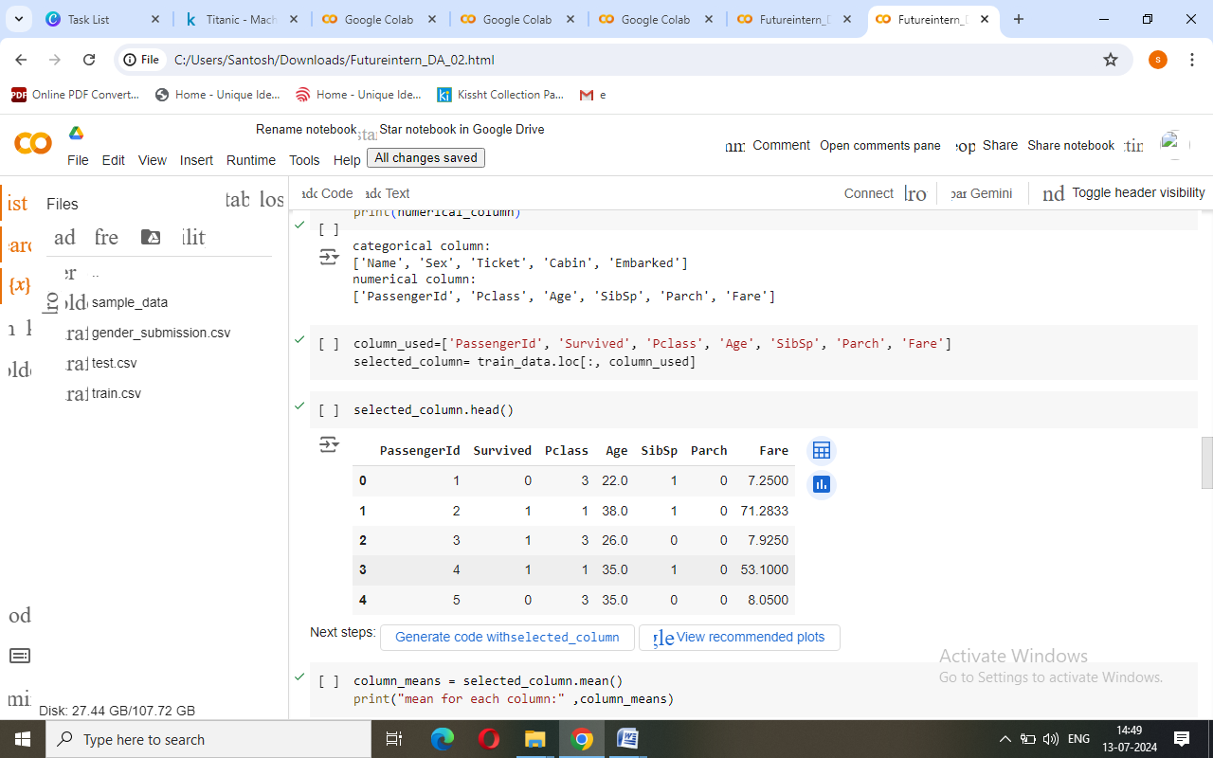

**5. Check Mean for each column**

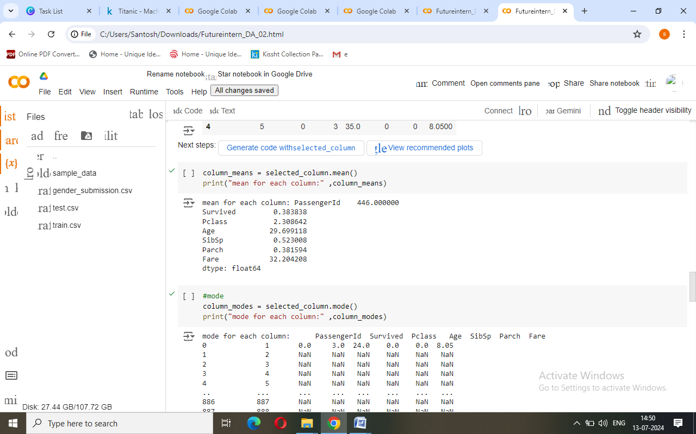

**6. Check Mode for each column**

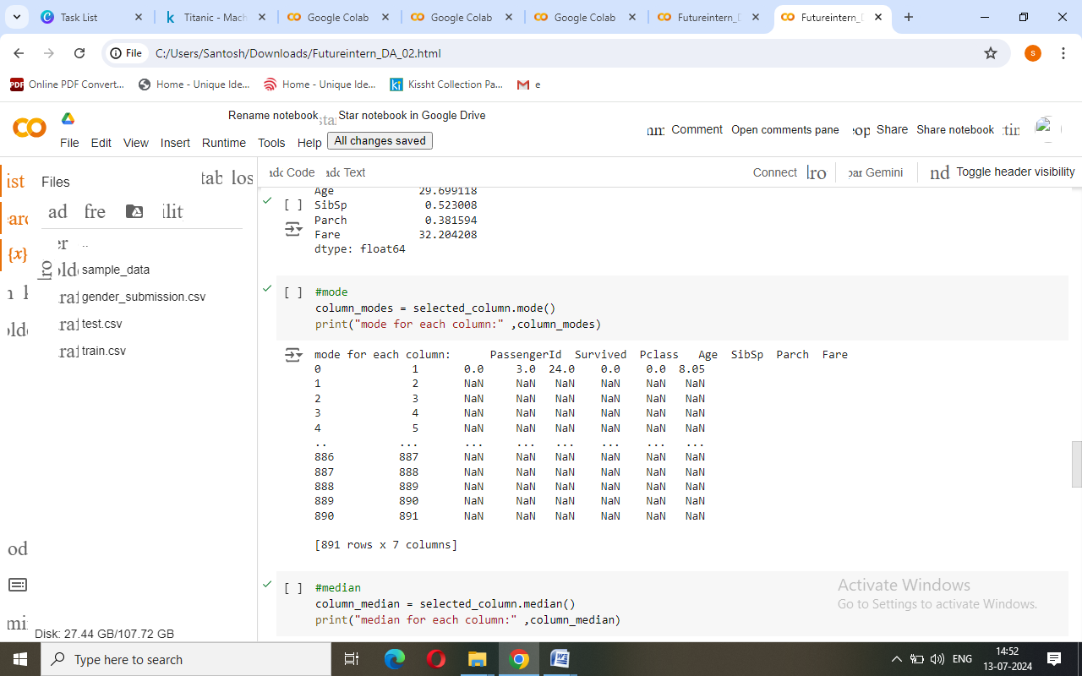

**7. Check Median for each column**

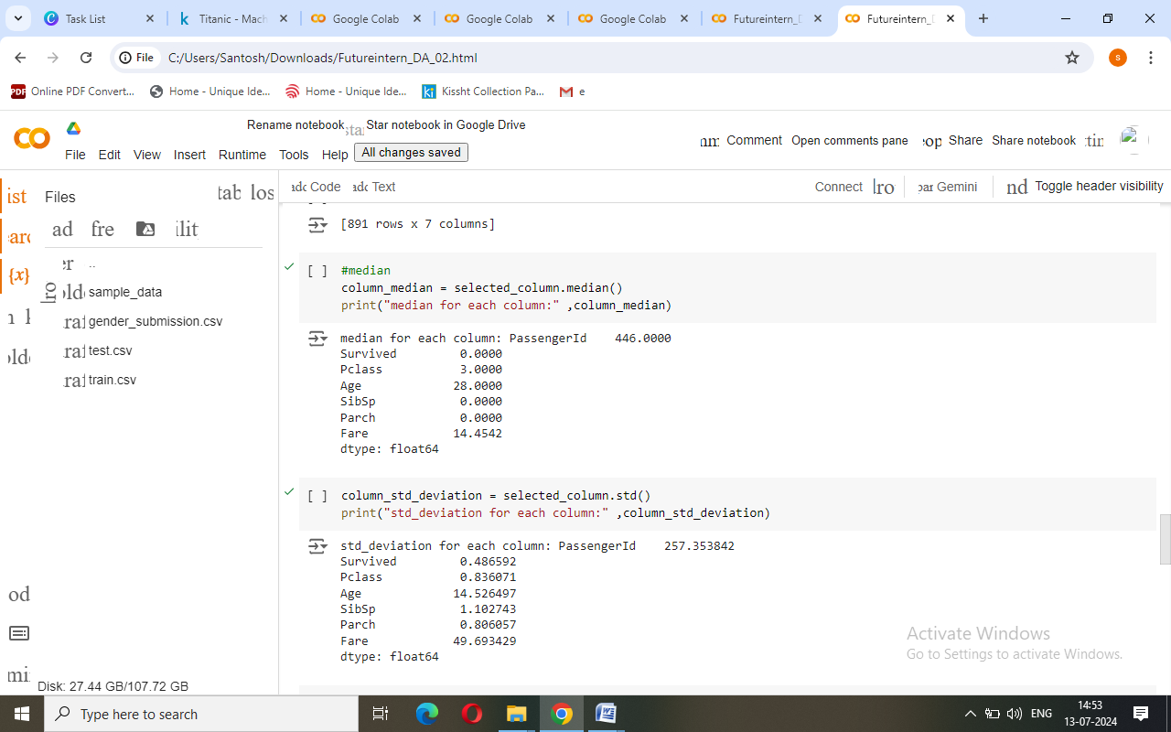

**8. Check Mean for each column**

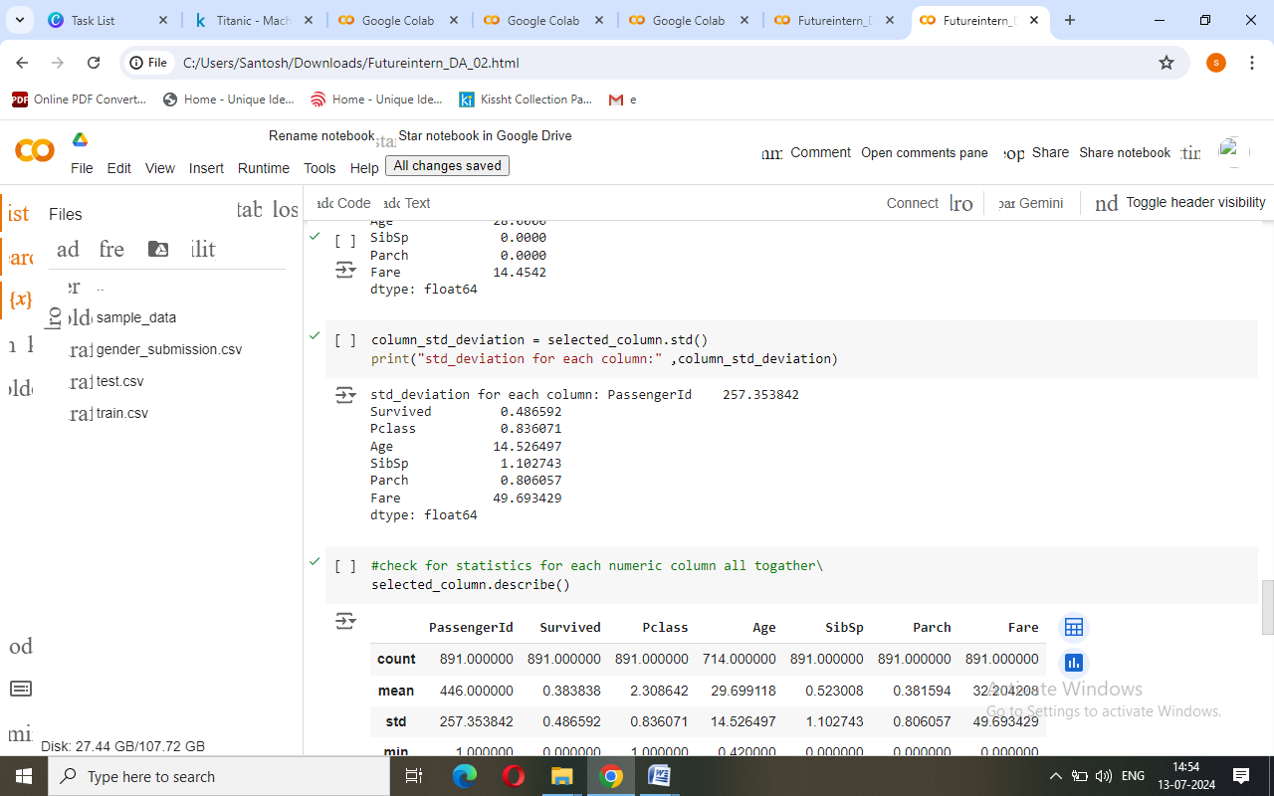

**9. Check the statistics for each numeric column**

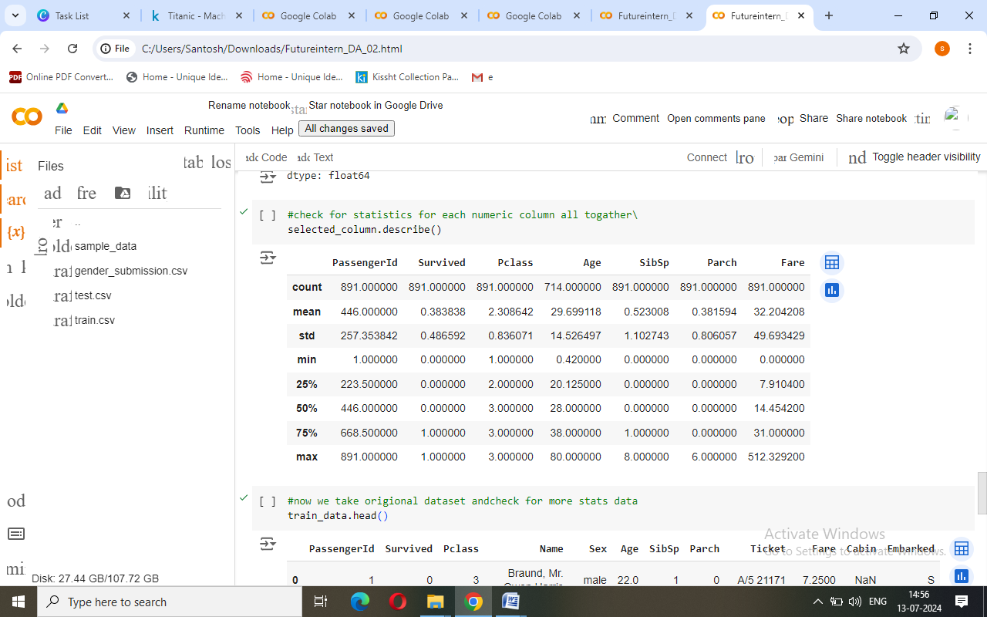

**10. Check stats data**

