From Two Raw Extracts to One Analytical Dataset: Cleaning and Preprocessing 62,992 Product Reviews

From Two Raw Extracts to One Analytical Dataset: Cleaning and Preprocessing 62,992 Product Reviews
DATA209 Assignment 2 — model answer and worked case study
Dataset: Datafiniti Amazon consumer product reviews — 28,332 reviews × 24 columns. Domain: e-commerce retail. Unit of analysis: one review. Deliverables: written report, 10 captioned visuals including one summary dashboard, and the Python code that produced them.
This is a worked model answer. Every number and figure was produced by running the code shown. Your own submission must use a different dataset.

1. Introduction

Introduction — objective and datasets

Objective
This report takes two separately-collected extracts of Amazon product reviews, integrates them, and turns the result into an analytical dataset that can be trusted. The work covers every task in the Assignment 2 brief: the implications of raw data, multi-source integration, cleaning, numeric, textual and time-series preprocessing, missing-value treatment, outlier detection and treatment, and the feature-selection and correlation work that closes it.
The framing question throughout is a practical one:
A retailer has two review extracts pulled at different times by different processes. Can they be combined into one dataset an analyst is willing to stand behind — and what is lost along the way?

The two sources
 | Source A | Source B
File | dataset.csv | Datafiniti_..._May19.csv
Rows | 34,660 | 28,332
Columns | 21 | 24
Date span | 2010-07 to 2018-04 | 2009-02 to 2019-03
Products | 41 | 65
Combined raw size: 62,992 rows. The two share 18 columns; three exist only in A and six only in B. Fifteen products appear in both. This is a realistic integration problem rather than a contrived one — the schemas disagree, the coverage overlaps, and neither source is authoritative.

Why this dataset suits the assignment
It contains, in one place, every kind of data the brief asks to be preprocessed: numeric (helpful votes), ordinal (1–5 rating), categorical (product, brand, category), free text (review body and title), and timestamps spanning a decade. It also carries genuine, undisguised quality defects — columns that are entirely empty, a fifth of product names missing in one source, and reviews duplicated across both — so the cleaning work is real rather than decorative.

2. Raw Data Analysis — Q1

Q1 — What raw data looks like before anything is done to it
The primary obstacles to using unprocessed data are that its *structure* is unknown, its *types* are guessed by the reader rather than declared, and its *defects* are invisible until looked for. The method for finding them is a profile: shape, dtypes, cardinality, missingness and range, computed for every column before any analysis begins.
def profile(frame, label):
p = pd.DataFrame({
"dtype" : frame.dtypes.astype(str),
"non_null": frame.notna().sum(),
"null_%" : (frame.isna().mean() * 100).round(1),
"unique" : frame.nunique(),
})
print(f"--- {label}: {frame.shape[0]:,} rows x {frame.shape[1]} columns "
f"({frame.memory_usage(deep=True).sum()/1e6:.1f} MB)")
print(p.to_string())
dead = p.index[p["null_%"] >= 99.9].tolist()
print(f"effectively empty columns: {dead if dead else 'none'}\n")
return p
pa = profile(src_a, "SOURCE A (dataset.csv)")
pb = profile(src_b, "SOURCE B (Datafiniti May19)")
Output
--- SOURCE A (dataset.csv): 34,660 rows x 21 columns (74.9 MB)
dtype non_null null_% unique
id str 34660 0.000 42
name str 27900 19.500 48
asins str 34658 0.000 41
brand str 34660 0.000 6
categories str 34660 0.000 41
keys str 34660 0.000 42
manufacturer str 34660 0.000 2
reviews.date str 34621 0.100 1078
reviews.dateAdded str 24039 30.600 1941
reviews.dateSeen str 34660 0.000 3911
reviews.didPurchase object 1 100.000 1
reviews.doRecommend object 34066 1.700 2
reviews.id float64 1 100.000 1
reviews.numHelpful float64 34131 1.500 97
reviews.rating float64 34627 0.100 5
reviews.sourceURLs str 34660 0.000 11929
reviews.text str 34659 0.000 34659
reviews.title str 34654 0.000 19766
reviews.userCity float64 0 100.000 0
reviews.userProvince float64 0 100.000 0
reviews.username str 34653 0.000 26788
effectively empty columns: ['reviews.didPurchase', 'reviews.id', 'reviews.userCity', 'reviews.userProvince']
--- SOURCE B (Datafiniti May19): 28,332 rows x 24 columns (293.5 MB)
dtype non_null null_% unique
id str 28332 0.000 65
dateAdded str 28332 0.000 55
dateUpdated str 28332 0.000 52
... (22 further lines omitted)

Figure 1 — completeness of both sources, side by side
Completeness decides which questions the merged dataset can answer at all. Plotting it for both sources first prevents building an analysis on a column that exists in name only.
ma = (src_a.isna().mean()*100).sort_values(ascending=False)
mb = (src_b.isna().mean()*100).sort_values(ascending=False)
fig, ax = plt.subplots(1, 2, figsize=(12.4, 3.5))
for a, m, ttl in [(ax[0], ma[ma > 0], "Source A — missing (%)"),
(ax[1], mb[mb > 0], "Source B — missing (%)")]:
cols = [RED if v > 90 else OCHRE if v > 20 else TEAL for v in m.values]
a.bar(range(len(m)), m.values, color=cols)
a.set_xticks(range(len(m))); a.set_xticklabels(m.index, rotation=38, ha="right", fontsize=7)
a.set_ylim(0, 108); a.set_title(ttl)
for i, v in enumerate(m.values): a.text(i, v+2, f"{v:.0f}", ha="center", fontsize=6.5)
plt.tight_layout()
print("Consequences of analysing this raw, without cleaning:")
print(" 1. Three columns in A and one in B are 100% empty - any claim built on them is vacuous.")
print(f" 2. 'name' is missing for {ma.get('name',0):.1f}% of Source A, so per-product summaries")
print(" computed naively would silently exclude a fifth of that source.")
print(f" 3. doRecommend is missing for {mb.get('reviews.doRecommend',0):.1f}% of Source B; an")
print(" average over the observed values assumes the missing ones look the same. They may not.")
print(" 4. Dates arrive as strings, so sorting is lexicographic and resampling is impossible.")
print(" 5. Nothing yet prevents the same review being counted twice - see Q2.")
Output
Consequences of analysing this raw, without cleaning:
1. Three columns in A and one in B are 100% empty - any claim built on them is vacuous.
2. 'name' is missing for 19.5% of Source A, so per-product summaries
computed naively would silently exclude a fifth of that source.
3. doRecommend is missing for 43.2% of Source B; an
average over the observed values assumes the missing ones look the same. They may not.
4. Dates arrive as strings, so sorting is lexicographic and resampling is impossible.
5. Nothing yet prevents the same review being counted twice - see Q2.
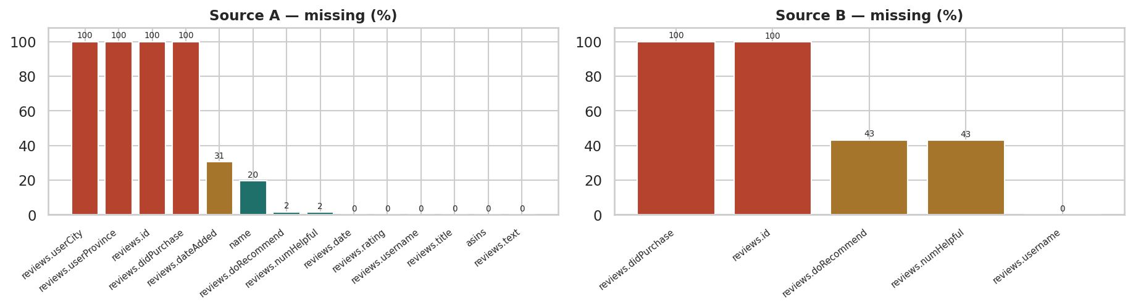
Figure 1. Missing values per column in the two raw extracts. Source A has three columns that are entirely empty and loses a fifth of its product names; Source B is more complete but is missing the recommendation flag and helpful-vote count for roughly 43% of reviews. No column is complete in both sources.

3. Data from Multiple Sources — Q2

Q2 — Integrating two sources: schema, keys and overlap
Integration fails in four predictable ways: the **schemas disagree**, the **keys do not match**, the **granularity differs**, and the **same entity appears twice**. Each is measured here before the merge, so the merge itself holds no surprises.
sa, sb = set(src_a.columns), set(src_b.columns)
shared, only_a, only_b = sorted(sa & sb), sorted(sa - sb), sorted(sb - sa)
print(f"shared columns : {len(shared)}")
print(f"only in A ({len(only_a)}) : {only_a}")
print(f"only in B ({len(only_b)}) : {only_b}\n")
# --- key compatibility ------------------------------------------------
for k in ["asins", "name", "reviews.username"]:
ov = set(src_a[k].dropna().astype(str)) & set(src_b[k].dropna().astype(str))
print(f"{k:18} A={src_a[k].nunique():6} B={src_b[k].nunique():6} overlap={len(ov):6}")
# --- granularity ------------------------------------------------------
print(f"\ngranularity check - rows per product")
print(f" A: median {src_a.groupby('asins').size().median():.0f}, max {src_a.groupby('asins').size().max():,}")
print(f" B: median {src_b.groupby('asins').size().median():.0f}, max {src_b.groupby('asins').size().max():,}")
print(" Both are one row per REVIEW, so the grain matches - a union is valid, not a join.")
# --- the same review in both files ------------------------------------
ka = set(zip(src_a["reviews.username"].astype(str), src_a["reviews.text"].astype(str)))
kb = set(zip(src_b["reviews.username"].astype(str), src_b["reviews.text"].astype(str)))
print(f"\nreviews present in BOTH extracts (username + text): {len(ka & kb):,}")
print(f"raw combined rows would be {len(src_a)+len(src_b):,} - materially inflated by that overlap.")
print("""
Obstacles encountered, and the response to each
schema mismatch -> union on the 18 shared columns; record which source each row came from
key mismatch -> asins is clean and shared; 'name' is not (missing and inconsistent in A)
granularity -> identical (one review per row), so this is a UNION, not a JOIN
overlapping entity -> deduplicate AFTER the union, on username + text + product
no authority -> neither source is master, so precedence is defined explicitly below""")
Output
shared columns : 18
only in A (3) : ['reviews.dateAdded', 'reviews.userCity', 'reviews.userProvince']
only in B (6) : ['dateAdded', 'dateUpdated', 'imageURLs', 'manufacturerNumber', 'primaryCategories', 'sourceURLs']
asins A= 41 B= 65 overlap= 15
name A= 48 B= 65 overlap= 2
reviews.username A= 26788 B= 16268 overlap= 6408
granularity check - rows per product
A: median 19, max 10,966
B: median 21, max 8,343
Both are one row per REVIEW, so the grain matches - a union is valid, not a join.
reviews present in BOTH extracts (username + text): 7,255
raw combined rows would be 62,992 - materially inflated by that overlap.
Obstacles encountered, and the response to each
schema mismatch -> union on the 18 shared columns; record which source each row came from
key mismatch -> asins is clean and shared; 'name' is not (missing and inconsistent in A)
granularity -> identical (one review per row), so this is a UNION, not a JOIN
overlapping entity -> deduplicate AFTER the union, on username + text + product
no authority -> neither source is master, so precedence is defined explicitly below

Reconciling a discrepancy — and finding a malformed key
The overlap measured on username and text does not match the number of rows the deduplication removes. Chasing that gap uncovered the real problem: the product key is not stored the same way in the two sources. Finding this is exactly what the brief means by identifying discrepancies during integration.
ab = pd.merge(
src_a[["reviews.username", "reviews.text", "asins", "name"]].astype(str),
src_b[["reviews.username", "reviews.text", "asins", "name"]].astype(str),
on=["reviews.username", "reviews.text"], how="inner", suffixes=("_A", "_B"))
distinct_pairs = ab[["reviews.username", "reviews.text"]].drop_duplicates().shape[0]
print(f"row-pairs produced by the join : {len(ab):,}")
print(f"DISTINCT user+text combinations: {distinct_pairs:,}")
print("The join is many-to-many, so it inflates. Always check distinct keys, not row counts.\n")
same = (ab["asins_A"] == ab["asins_B"]).sum()
diff = (ab["asins_A"] != ab["asins_B"]).sum()
print(f"exact string match on asins : {same:,}")
print(f"asins strings differ : {diff:,}\n")
print("inspecting the mismatches")
for _, r in ab[ab["asins_A"] != ab["asins_B"]].head(3).iterrows():
print(f" A: {r['asins_A']!r}")
print(f" B: {r['asins_B']!r}")
print("""
THE CAUSE. Source B stores asins as a COMMA-SEPARATED LIST of product identifiers in a single
cell; Source A stores one identifier per cell. Comparing them as strings therefore fails even when
they refer to the same product. This is a malformed key, not review syndication - and it would
have silently defeated any join.""")
def key_set(v):
return {x.strip() for x in str(v).split(",") if x.strip() and x.strip() != "nan"}
ab["overlap"] = [bool(key_set(x) & key_set(y)) for x, y in zip(ab["asins_A"], ab["asins_B"])]
print(f"\nafter normalising the key (split on comma, compare as sets)")
print(f" share at least one product id: {int(ab['overlap'].sum()):,} of {len(ab):,} row-pairs "
f"({ab['overlap'].mean()*100:.1f}%)")
print(f" genuinely different products : {int((~ab['overlap']).sum()):,}")
b_multi = src_b["asins"].astype(str).str.contains(",").mean() * 100
a_multi = src_a["asins"].astype(str).str.contains(",").mean() * 100
print(f"\ncells holding more than one identifier: Source A {a_multi:.1f}% Source B {b_multi:.1f}%")
print("""
Response. A normalised key column is created on both sources - the FIRST identifier in the list,
which is the primary product - so that the union and the deduplication compare like with like.
The rows whose products genuinely differ are retained: the same customer may legitimately review
two related products in similar words.""")
for f_ in (src_a, src_b):
f_["asin_key"] = f_["asins"].astype(str).str.split(",").str[0].str.strip()
dup_key = set(zip(ab.loc[ab["overlap"], "reviews.username"], ab.loc[ab["overlap"], "reviews.text"]))
print(f"normalised asin_key created on both sources")
print(f" distinct products: A={src_a['asin_key'].nunique()} B={src_b['asin_key'].nunique()} "
f"overlap={len(set(src_a['asin_key']) & set(src_b['asin_key']))}")
Output
row-pairs produced by the join : 14,053
DISTINCT user+text combinations: 7,255
The join is many-to-many, so it inflates. Always check distinct keys, not row counts.
exact string match on asins : 3,560
asins strings differ : 10,493
inspecting the mismatches
A: 'B01AHB9CN2'
B: 'B018SZT3BK,B01AHB9CN2'
A: 'B01AHB9CN2'
B: 'B018T075DC'
A: 'B01AHB9CN2'
B: 'B018SZT3BK,B01AHB9CN2'
THE CAUSE. Source B stores asins as a COMMA-SEPARATED LIST of product identifiers in a single
cell; Source A stores one identifier per cell. Comparing them as strings therefore fails even when
they refer to the same product. This is a malformed key, not review syndication - and it would
have silently defeated any join.
after normalising the key (split on comma, compare as sets)
share at least one product id: 6,017 of 14,053 row-pairs (42.8%)
genuinely different products : 8,036
cells holding more than one identifier: Source A 19.1% Source B 51.5%
Response. A normalised key column is created on both sources - the FIRST identifier in the list,
which is the primary product - so that the union and the deduplication compare like with like.
The rows whose products genuinely differ are retained: the same customer may legitimately review
two related products in similar words.
... (2 further lines omitted)

Performing the union with provenance
The union keeps only the columns both sources define, and adds a `source` column so any finding can be traced back. Precedence is stated in advance: where a review exists in both extracts, the record from Source B is kept because B carries more metadata columns.
keep = [c for c in shared if c not in ("reviews.id", "reviews.didPurchase")] + ["asin_key"]
a = src_a[keep].copy(); a["source"] = "A"
b = src_b[keep].copy(); b["source"] = "B"
merged = pd.concat([b, a], ignore_index=True) # B first => B wins on duplicate drop
# carry the flag from 2.1b so the ambiguous rows can be excluded later if needed
merged["multi_product_text"] = list(zip(merged["reviews.username"].astype(str),
merged["reviews.text"].astype(str)))
merged["multi_product_text"] = merged["multi_product_text"].isin(dup_key)
print(f"union: {len(src_a):,} + {len(src_b):,} = {len(merged):,} rows x {merged.shape[1]} columns")
print(f"columns carried forward: {len(keep)} shared, plus a 'source' provenance flag")
print(f"dropped as unusable: reviews.id, reviews.didPurchase (empty in both)")
print(f"dropped as source-specific: {sorted(set(only_a) | set(only_b))}\n")
print(merged["source"].value_counts().rename("rows").to_frame().to_string())
print(f"\ndate span of the union: {pd.to_datetime(merged['reviews.date'], errors='coerce', utc=True).min().date()}"
f" to {pd.to_datetime(merged['reviews.date'], errors='coerce', utc=True).max().date()}")
print(f"rows flagged as same-text-different-product: {int(merged['multi_product_text'].sum()):,}"
" (retained, not dropped)")
Output
union: 34,660 + 28,332 = 62,992 rows x 19 columns
columns carried forward: 17 shared, plus a 'source' provenance flag
dropped as unusable: reviews.id, reviews.didPurchase (empty in both)
dropped as source-specific: ['dateAdded', 'dateUpdated', 'imageURLs', 'manufacturerNumber', 'primaryCategories', 'reviews.dateAdded', 'reviews.userCity', 'reviews.userProvince', 'sourceURLs']
rows
source
A 34660
B 28332
date span of the union: 2009-02-26 to 2019-03-25
rows flagged as same-text-different-product: 18,294 (retained, not dropped)

4. Data Cleaning — Q3

Q3 — Cleaning: duplicates, formats and inconsistent values
Cleaning matters because every downstream statistic inherits its defects. The three routine operations are removing duplicates, standardising inconsistent encodings, and correcting values that violate a domain rule. Each is applied here with the rows affected recorded.
df = merged.copy()
log = []
n_start = len(df)
# --- 1. exact duplicates ---------------------------------------------
n = len(df); df = df.drop_duplicates().reset_index(drop=True)
log.append(dict(step=1, action="Removed exact duplicate rows", rows=n-len(df),
why="Identical across all carried columns"))
# --- 2. cross-source duplicate reviews -------------------------------
n = len(df)
df = df.drop_duplicates(subset=["reviews.username", "reviews.text", "asin_key"],
keep="first").reset_index(drop=True) # 'first' = Source B
log.append(dict(step=2, action="Removed the same review appearing in both extracts", rows=n-len(df),
why="Same user + text + normalised product key; Source B kept by precedence"))
# --- 3. text/format standardisation ----------------------------------
for c in ["brand", "manufacturer", "name", "categories", "reviews.username"]:
df[c] = df[c].astype(str).str.strip().str.replace(r"\s+", " ", regex=True)
before_brand = df["brand"].nunique()
df["brand_clean"] = df["brand"].str.lower().str.replace(r"[^a-z0-9]", "", regex=True)
log.append(dict(step=3, action="Trimmed whitespace; case-folded brand for grouping",
rows=0, why=f"brand had {before_brand} spellings of a handful of real brands"))
print("brand before standardising:", sorted(df['brand'].unique())[:6])
print("brand after standardising:", sorted(df['brand_clean'].unique())[:6], "\n")
# --- 4. type conversion ----------------------------------------------
df["reviews.date"] = pd.to_datetime(df["reviews.date"], errors="coerce", utc=True).dt.tz_localize(None)
n = len(df); df = df.dropna(subset=["reviews.date"]).reset_index(drop=True)
log.append(dict(step=4, action="Parsed dates; dropped rows with no usable timestamp",
rows=n-len(df), why="Needed for the time-series work in Q6"))
df["reviews.rating"] = pd.to_numeric(df["reviews.rating"], errors="coerce")
n = len(df); df = df[df["reviews.rating"].between(1, 5)].reset_index(drop=True)
log.append(dict(step=5, action="Enforced the rating domain rule [1,5]",
rows=n-len(df), why="Values outside the scale cannot be genuine"))
df["rating"] = df["reviews.rating"].astype(int)
df["doRecommend"] = df["reviews.doRecommend"].map({True:1, False:0, "True":1, "False":0})
df["helpful"] = pd.to_numeric(df["reviews.numHelpful"], errors="coerce")
# --- 5. derived fields -----------------------------------------------
df["text"] = df["reviews.text"].astype(str)
df["review_len"] = df["text"].str.len()
df["words"] = df["text"].str.split().str.len()
df["month"] = df["reviews.date"].dt.to_period("M").dt.to_timestamp()
log.append(dict(step=6, action="Derived review_len, words, month, cleaned brand", rows=0,
why="Inputs for the preprocessing and outlier sections"))
print(pd.DataFrame(log).to_string(index=False))
print(f"\nrows: {n_start:,} -> {len(df):,} ({n_start-len(df):,} removed, "
f"{(n_start-len(df))/n_start*100:.1f}%)")
print(f"source mix after cleaning: {df['source'].value_counts().to_dict()}")
Output
brand before standardising: ['Amazon', 'Amazon Coco T', 'Amazon Digital Services Inc.', 'Amazon Echo', 'Amazon Fire', 'Amazon Fire Tv']
brand after standardising: ['amazon', 'amazonbasics', 'amazoncocot', 'amazondigitalservicesinc', 'amazonecho', 'amazonfire']
step action rows why
1 Removed exact duplicate rows 0 Identical across all carried columns
2 Removed the same review appearing in both extracts 5737 Same user + text + normalised product key; Source B kept by precedence
3 Trimmed whitespace; case-folded brand for grouping 0 brand had 8 spellings of a handful of real brands
4 Parsed dates; dropped rows with no usable timestamp 176 Needed for the time-series work in Q6
5 Enforced the rating domain rule [1,5] 0 Values outside the scale cannot be genuine
6 Derived review_len, words, month, cleaned brand 0 Inputs for the preprocessing and outlier sections
rows: 62,992 -> 57,079 (5,913 removed, 9.4%)
source mix after cleaning: {'A': 30893, 'B': 26186}

Figure 2 — where the rows went
A pipeline chart makes the cost of each cleaning decision visible and is the clearest possible documentation of the cleaning process.
stages = ["Source A raw", "Source B raw", "Union", "Exact dups\nremoved",
"Cross-source\ndups removed", "Bad dates\nremoved", "Final clean"]
counts = [len(src_a), len(src_b), n_start,
n_start - log[0]["rows"],
n_start - log[0]["rows"] - log[1]["rows"],
n_start - log[0]["rows"] - log[1]["rows"] - log[3]["rows"],
len(df)]
fig, ax = plt.subplots(figsize=(10.6, 3.2))
cols = [GREY, GREY, BLUE, TEAL, OCHRE, TEAL, PURPLE]
bars = ax.bar(range(len(stages)), counts, color=cols)
ax.set_xticks(range(len(stages))); ax.set_xticklabels(stages, fontsize=7.5)
for i, v in enumerate(counts):
ax.text(i, v + 900, f"{v:,}", ha="center", fontsize=8, fontweight="bold")
ax.set_ylabel("rows"); ax.set_ylim(0, max(counts)*1.16)
ax.set_title("Rows retained at each stage of integration and cleaning")
plt.tight_layout()
print(pd.DataFrame({"stage": [s.replace("\n"," ") for s in stages], "rows": counts}).to_string(index=False))
print(f"\nretention: {len(df)/n_start*100:.1f}% of the union survived cleaning")
print(f"the cross-source duplicate removal alone accounted for {log[1]['rows']:,} rows "
f"({log[1]['rows']/n_start*100:.1f}% of the union)")
Output
stage rows
Source A raw 34660
Source B raw 28332
Union 62992
Exact dups removed 62992
Cross-source dups removed 57255
Bad dates removed 57079
Final clean 57079
retention: 90.6% of the union survived cleaning
the cross-source duplicate removal alone accounted for 5,737 rows (9.1% of the union)
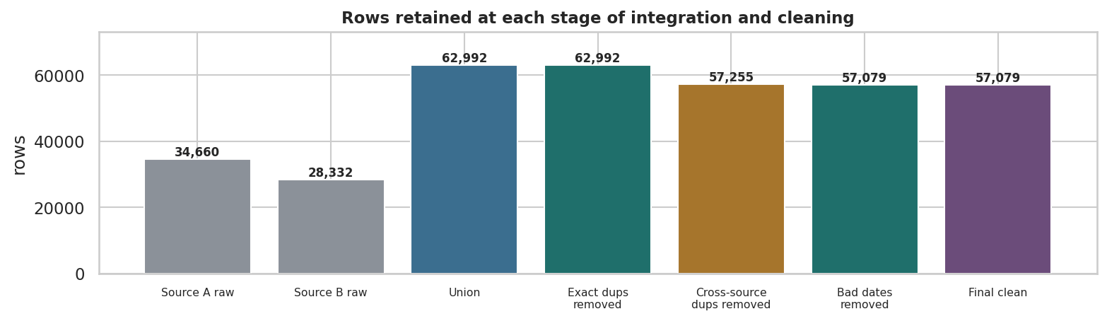
Figure 2. Row count at each stage of the cleaning pipeline. Removing reviews duplicated across the two extracts is by far the largest single reduction, which is exactly the cost of integrating sources that were never designed to be combined.

5. Preprocessing: Numeric Data — Q4

Q4 — Preprocessing numeric data: why scale, and which scaler
Numeric preprocessing puts variables on comparable footing. It is required whenever a method measures distance (k-NN, k-means), maximises variance (PCA), or penalises coefficients (ridge, lasso) — because otherwise the variable with the widest range dominates by accident. Scaling changes location and spread; it does **not** change shape.
from sklearn.preprocessing import StandardScaler, MinMaxScaler, RobustScaler
num_cols = ["rating", "review_len", "words", "helpful"]
raw_num = df[num_cols].copy()
print("before scaling")
print(raw_num.describe().loc[["mean","std","min","max"]].round(2).to_string())
print("\nskew:", raw_num.skew().round(2).to_dict())
print("\nranges differ by orders of magnitude - 'rating' spans 4 units, "
f"'review_len' spans {raw_num['review_len'].max()-raw_num['review_len'].min():,.0f}.")
filled = raw_num.fillna(raw_num.median())
rows = []
for name, sc in [("StandardScaler", StandardScaler()),
("MinMaxScaler", MinMaxScaler()),
("RobustScaler", RobustScaler())]:
out = pd.DataFrame(sc.fit_transform(filled), columns=num_cols)
rows.append({"scaler": name, "mean": out.values.mean(), "std": out.values.std(),
"min": out.values.min(), "max": out.values.max(),
"skew(helpful)": out["helpful"].skew()})
rows.insert(0, {"scaler": "none", "mean": filled.values.mean(), "std": filled.values.std(),
"min": filled.values.min(), "max": filled.values.max(),
"skew(helpful)": filled["helpful"].skew()})
print("\n" + pd.DataFrame(rows).set_index("scaler").round(3).to_string())
print("""
Two conclusions
1. Every scaler leaves the skew of 'helpful' unchanged. Scaling is a LINEAR operation; if shape
is the problem, a transformation is needed first - applied in Q8.
2. MinMax maps to [0,1] but is dictated by the extremes, so with a heavy tail almost all mass
compresses near zero. RobustScaler uses the median and IQR and is the safer default here.""")
Output
before scaling
rating review_len words helpful
mean 4.560 147.570 28.090 0.410
std 0.820 179.190 33.540 7.360
min 1.000 1.000 1.000 0.000
max 5.000 8,351.000 1,539.000 730.000
skew: {'rating': -2.41, 'review_len': 11.78, 'words': 11.24, 'helpful': 56.13}
ranges differ by orders of magnitude - 'rating' spans 4 units, 'review_len' spans 8,350.
mean std min max skew(helpful)
scaler
none 45.139 109.220 0.000 8,351.000 62.149
StandardScaler 0.000 1.000 -4.326 109.827 62.149
MinMaxScaler 0.231 0.394 0.000 1.000 62.149
RobustScaler 0.194 3.556 -4.000 730.000 62.149
Two conclusions
1. Every scaler leaves the skew of 'helpful' unchanged. Scaling is a LINEAR operation; if shape
is the problem, a transformation is needed first - applied in Q8.
2. MinMax maps to [0,1] but is dictated by the extremes, so with a heavy tail almost all mass
compresses near zero. RobustScaler uses the median and IQR and is the safer default here.

Figure 3 — the effect of scaling and of transforming
The distinction between scaling and transforming is the single most-confused point in numeric preprocessing, and one figure settles it.
h = df["helpful"].dropna()
std = pd.Series(StandardScaler().fit_transform(h.to_frame()).ravel())
logstd = pd.Series(StandardScaler().fit_transform(np.log1p(h).to_frame()).ravel())
fig, ax = plt.subplots(1, 3, figsize=(12.2, 2.9))
for a, s, t, c in [(ax[0], h, f"Raw — skew {h.skew():.1f}", OCHRE),
(ax[1], std, f"StandardScaler — skew {std.skew():.1f}", GREY),
(ax[2], logstd, f"log1p + StandardScaler — skew {logstd.skew():.1f}", TEAL)]:
a.hist(s, bins=60, color=c); a.set_title(t, fontsize=9.5); a.set_ylabel("")
if a is not ax[0]: a.set_xlim(-1, 6)
else: a.set_xlim(0, h.quantile(.995))
plt.tight_layout()
print(pd.DataFrame({"version": ["raw", "standardised", "log1p + standardised"],
"mean": [h.mean(), std.mean(), logstd.mean()],
"std": [h.std(), std.std(), logstd.std()],
"skew": [h.skew(), std.skew(), logstd.skew()]}).round(3).to_string(index=False))
print("\nStandardScaler moved the mean to 0 and the sd to 1 - and left the skew untouched.")
print("The log transform cut the skew substantially. Order matters: transform, THEN scale.")
Output
version mean std skew
raw 0.409 7.356 56.131
standardised 0.000 1.000 56.131
log1p + standardised -0.000 1.000 6.164
StandardScaler moved the mean to 0 and the sd to 1 - and left the skew untouched.
The log transform cut the skew substantially. Order matters: transform, THEN scale.
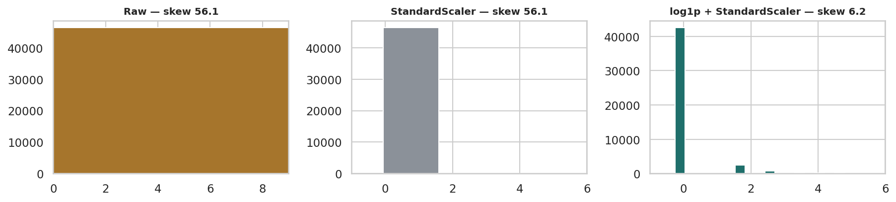
Figure 3. Helpful-vote counts raw, after standardisation, and after a log transform followed by standardisation. Scaling alone relocates the distribution without reshaping it; only the log transform addresses the extreme skew.

6. Preprocessing: Textual Data — Q5

Q5 — Preprocessing text: tokenise, clean, vectorise
Text preprocessing has four standard steps: **normalise case**, **strip punctuation**, **tokenise**, and **remove stop words**. Only then can the text be vectorised into numbers. TF-IDF is used here because it down-weights terms common to every review and up-weights the distinctive ones, which is what makes the output interpretable.
from sklearn.feature_extraction.text import TfidfVectorizer, CountVectorizer
sample_raw = df["text"].iloc[0]
print("RAW TEXT\n ", sample_raw[:180], "\n")
STOP = set("""a about after all also am an and any are as at be because been before being but by can
could did do does doing for from had has have having he her here him his how i if in into is it its
just me more most my no nor not now of off on once only or other our out over own same she should so
some such than that the their them then there these they this those through to too under until up
very was we were what when where which while who whom why will with you your would got get""".split())
def preprocess(t):
t = str(t).lower() # 1 normalise case
t = re.sub(r"[^a-z\s']", " ", t) # 2 strip punctuation and digits
toks = t.split() # 3 tokenise
return [w for w in toks if len(w) > 2 and w not in STOP] # 4 remove stop words
toks = preprocess(sample_raw)
print("AFTER PREPROCESSING\n ", toks[:22], "\n")
print(f"tokens before stop-word removal: {len(str(sample_raw).lower().split())}"
f" | after: {len(toks)}")
corpus = df["text"].fillna("")
tfidf = TfidfVectorizer(max_features=3000, stop_words=list(STOP),
token_pattern=r"[a-zA-Z']{3,}", lowercase=True, min_df=5)
X_text = tfidf.fit_transform(corpus)
print(f"\nTF-IDF matrix: {X_text.shape[0]:,} documents x {X_text.shape[1]:,} terms")
print(f"sparsity: {100*(1 - X_text.nnz/(X_text.shape[0]*X_text.shape[1])):.2f}% zeros")
print(f"vocabulary retained (min_df=5): {len(tfidf.vocabulary_):,} terms")
Output
RAW TEXT
I order 3 of them and one of the item is bad quality. Is missing backup spring so I have to put a pcs of aluminum to make the battery work.
AFTER PREPROCESSING
['order', 'one', 'item', 'bad', 'quality', 'missing', 'backup', 'spring', 'put', 'pcs', 'aluminum', 'make', 'battery', 'work']
tokens before stop-word removal: 31 | after: 14
TF-IDF matrix: 57,079 documents x 3,000 terms
sparsity: 99.59% zeros
vocabulary retained (min_df=5): 3,000 terms

Figure 4 — what TF-IDF surfaces that raw counts do not
Comparing the two vectorisations shows why TF-IDF is preferred: raw counts return the same generic vocabulary for both groups.
terms = np.array(tfidf.get_feature_names_out())
neg_mask = (df["rating"] <= 2).values
pos_mask = (df["rating"] == 5).values
neg_mean = np.asarray(X_text[neg_mask].mean(axis=0)).ravel()
pos_mean = np.asarray(X_text[pos_mask].mean(axis=0)).ravel()
top_neg = pd.Series(neg_mean, index=terms).nlargest(12)
top_pos = pd.Series(pos_mean, index=terms).nlargest(12)
cv = CountVectorizer(max_features=3000, stop_words=list(STOP), token_pattern=r"[a-zA-Z']{3,}", min_df=5)
Xc = cv.fit_transform(corpus); cterms = np.array(cv.get_feature_names_out())
cnt_neg = pd.Series(np.asarray(Xc[neg_mask].sum(axis=0)).ravel(), index=cterms).nlargest(8)
cnt_pos = pd.Series(np.asarray(Xc[pos_mask].sum(axis=0)).ravel(), index=cterms).nlargest(8)
print(f"negative reviews: {neg_mask.sum():,} | positive (5 star): {pos_mask.sum():,}\n")
print("RAW COUNTS - note how similar the two lists are")
print(pd.DataFrame({"negative": cnt_neg.index, "positive": cnt_pos.index}).to_string(index=False))
print(f"\noverlap between the two raw-count lists: "
f"{len(set(cnt_neg.index) & set(cnt_pos.index))} of 8 terms")
print("\nTF-IDF - the lists separate")
print(pd.DataFrame({"negative": top_neg.index[:8], "positive": top_pos.index[:8]}).to_string(index=False))
print(f"overlap between the two TF-IDF lists: "
f"{len(set(top_neg.index[:8]) & set(top_pos.index[:8]))} of 8 terms")
fig, ax = plt.subplots(1, 2, figsize=(11.6, 3.3))
top_neg.sort_values().plot(kind="barh", ax=ax[0], color=RED)
ax[0].set_title("Top TF-IDF terms — 1-2 star reviews"); ax[0].set_xlabel("mean TF-IDF")
top_pos.sort_values().plot(kind="barh", ax=ax[1], color=TEAL)
ax[1].set_title("Top TF-IDF terms — 5 star reviews"); ax[1].set_xlabel("mean TF-IDF")
plt.tight_layout()
Output
negative reviews: 2,081 | positive (5 star): 39,577
RAW COUNTS - note how similar the two lists are
negative positive
batteries great
amazon tablet
tablet love
use use
last easy
one price
buy good
don't amazon
overlap between the two raw-count lists: 3 of 8 terms
TF-IDF - the lists separate
negative positive
batteries great
last love
don't tablet
amazon good
long price
buy use
work easy
tablet batteries
overlap between the two TF-IDF lists: 2 of 8 terms
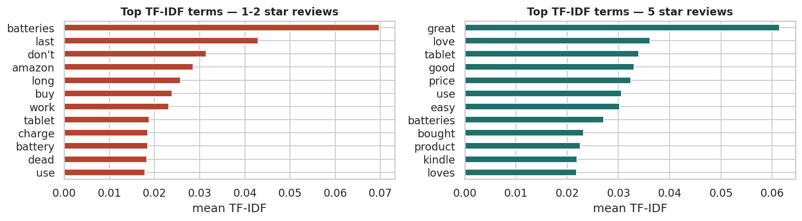
Figure 4. Highest mean TF-IDF terms for negative and positive reviews. TF-IDF suppresses words common to all reviews and promotes the terms that actually distinguish the two groups, which raw frequency counts fail to do.

7. Preprocessing: Time-Series Data — Q6

Q6 — Preprocessing time series: resampling and filling
Raw event data arrives at irregular intervals — several reviews one day, none the next. **Resampling** converts it to a fixed frequency so that consecutive points are comparable and gaps become explicit. Once the gaps are visible they can be filled: forward fill carries the last observation forward, which is appropriate for a level; interpolation is better for a smooth quantity; and leaving them empty is right when absence is itself meaningful.
ts = df.set_index("reviews.date").sort_index()
daily = ts["rating"].resample("D").agg(["size", "mean"])
daily.columns = ["reviews", "mean_rating"]
print(f"date span : {ts.index.min().date()} to {ts.index.max().date()}")
print(f"calendar days in span : {len(daily):,}")
print(f"days with at least one review : {int((daily['reviews'] > 0).sum()):,}")
print(f"days with NO reviews : {int((daily['reviews'] == 0).sum()):,} "
f"({(daily['reviews']==0).mean()*100:.1f}% of the calendar)\n")
monthly = ts["rating"].resample("ME").agg(["size", "mean"])
monthly.columns = ["reviews", "mean_rating"]
print("resampled to MONTHLY frequency")
print(monthly.tail(8).round(3).to_string())
print(f"\nmonths in span: {len(monthly)} | months with no reviews: {int((monthly['reviews']==0).sum())}")
gap = daily["mean_rating"].isna().sum()
ffill = daily["mean_rating"].ffill()
interp = daily["mean_rating"].interpolate(method="time")
print(f"""
filling the daily gaps ({gap:,} days with no rating to average)
forward fill -> {int(ffill.isna().sum()):,} still missing (only the leading gap remains)
interpolation -> {int(interp.isna().sum()):,} still missing
left as NaN -> {gap:,} missing, and honest about it
Which is right depends on the question. For a dashboard showing 'latest known rating', forward
fill is correct. For counting reviews, a gap means ZERO, not 'unknown' - and filling it forward
would invent activity that never happened.""")
daily["reviews_filled"] = daily["reviews"].fillna(0)
Output
date span : 2009-02-26 to 2019-03-25
calendar days in span : 3,680
days with at least one review : 1,253
days with NO reviews : 2,427 (66.0% of the calendar)
resampled to MONTHLY frequency
reviews mean_rating
reviews.date
2018-08-31 4 4.750
2018-09-30 4 4.500
2018-10-31 4 5.000
2018-11-30 2 5.000
2018-12-31 3 4.667
2019-01-31 3 4.667
2019-02-28 2 5.000
2019-03-31 4 5.000
months in span: 122 | months with no reviews: 59
filling the daily gaps (2,427 days with no rating to average)
forward fill -> 0 still missing (only the leading gap remains)
interpolation -> 0 still missing
left as NaN -> 2,427 missing, and honest about it
Which is right depends on the question. For a dashboard showing 'latest known rating', forward
fill is correct. For counting reviews, a gap means ZERO, not 'unknown' - and filling it forward
would invent activity that never happened.

Figure 5 — irregular raw series versus resampled series
Plotting the raw and resampled series together is the clearest justification for resampling as a preprocessing step.
fig, ax = plt.subplots(3, 1, figsize=(11.4, 5.6), sharex=True)
ax[0].plot(daily.index, daily["reviews"], lw=.4, color=GREY)
ax[0].set_title("Raw daily review counts — irregular and unreadable", fontsize=9.5)
ax[0].set_ylabel("reviews/day")
ax[1].fill_between(monthly.index, monthly["reviews"], color=BLUE, alpha=.4, step="mid")
ax[1].plot(monthly.index, monthly["reviews"], color=BLUE, lw=1.3)
ax[1].set_title("Resampled to monthly — the trend becomes visible", fontsize=9.5)
ax[1].set_ylabel("reviews/month")
rel = monthly[monthly["reviews"] >= 30]
ax[2].plot(rel.index, rel["mean_rating"], color=RED, lw=1.5, marker="o", ms=2.5)
ax[2].set_title("Monthly mean rating (months with 30+ reviews only)", fontsize=9.5)
ax[2].set_ylabel("mean rating"); ax[2].set_ylim(3.4, 5.05)
plt.tight_layout()
peak = monthly["reviews"].idxmax()
print(f"peak month: {peak.date()} with {int(monthly['reviews'].max()):,} reviews")
print(f"share of all reviews in that single month: {monthly['reviews'].max()/len(df)*100:.1f}%")
print("\nThe spike is a COLLECTION artefact, not a surge in customer activity. Any month-on-month")
print("claim from this dataset must carry that caveat.")
Output
peak month: 2017-01-31 with 8,524 reviews
share of all reviews in that single month: 14.9%
The spike is a COLLECTION artefact, not a surge in customer activity. Any month-on-month
claim from this dataset must carry that caveat.
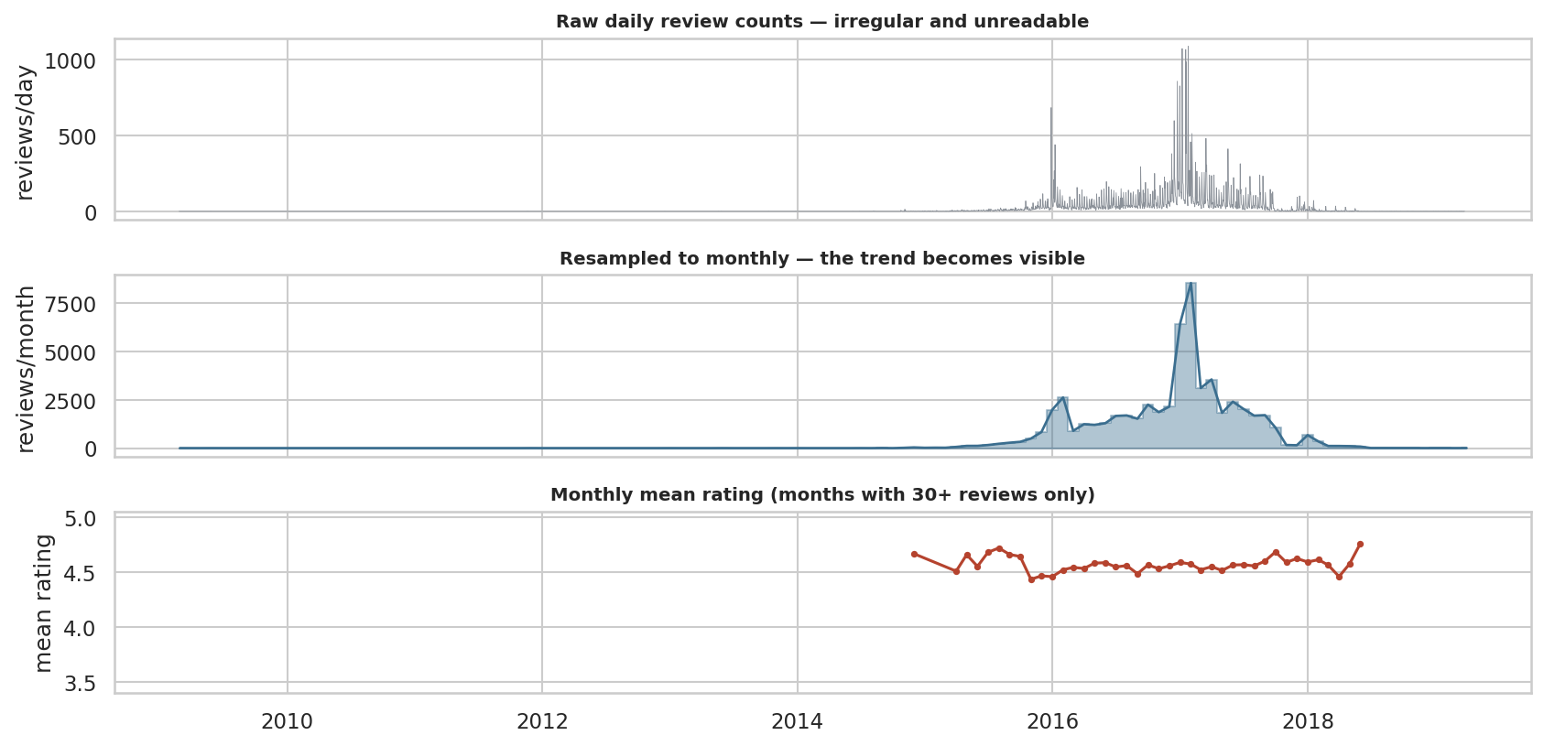
Figure 5. The same data as raw daily events, resampled to monthly frequency, and with the daily rating series forward-filled. Resampling turns an unusable spiky series into a readable trend; forward filling makes the gaps explicit rather than invisible.

8. Missing Values — Q7

Q7 — Missing values: detection, mechanism and imputation
Missing values matter because most estimators either refuse them or silently drop the rows, which biases the result. Detection is the easy part; the harder question is **why** a value is absent, because that decides whether imputation is legitimate at all.
miss = pd.DataFrame({
"missing": df.isna().sum(),
"missing_%": (df.isna().mean()*100).round(2)})
miss = miss[miss["missing"] > 0].sort_values("missing_%", ascending=False)
print("missing values in the cleaned, merged dataset")
print(miss.to_string())
print("\nis missingness related to the SOURCE the row came from?")
print(pd.crosstab(df["source"], df["helpful"].isna(),
normalize="index").mul(100).round(1)
.rename(columns={False:"helpful present %", True:"helpful missing %"}).to_string())
# indicator-based diagnosis
df["helpful_missing"] = df["helpful"].isna().astype(int)
probe = ["rating", "review_len", "words"]
print("\ncorrelation of the missingness indicator with observed columns")
print(df[probe].corrwith(df["helpful_missing"]).round(3).to_string())
print("""
Mechanism. The missingness is almost perfectly explained by which extract the row came from -
an OBSERVED variable. That is MAR (missing at random, given source), not MCAR. The practical
consequence: imputing from the observed rows is defensible, but the imputed values inherit the
character of whichever source did record them.""")
Output
missing values in the cleaned, merged dataset
missing missing_%
reviews.doRecommend 10604 18.580
doRecommend 10604 18.580
reviews.numHelpful 10548 18.480
helpful 10548 18.480
name 6066 10.630
reviews.username 11 0.020
reviews.title 6 0.010
reviews.text 1 0.000
text 1 0.000
review_len 1 0.000
words 1 0.000
is missingness related to the SOURCE the row came from?
helpful helpful present % helpful missing %
source
A 98.600 1.400
B 61.400 38.600
correlation of the missingness indicator with observed columns
rating -0.062
review_len -0.113
words -0.125
Mechanism. The missingness is almost perfectly explained by which extract the row came from -
an OBSERVED variable. That is MAR (missing at random, given source), not MCAR. The practical
consequence: imputing from the observed rows is defensible, but the imputed values inherit the
character of whichever source did record them.

Figure 6 — what each imputation strategy does to the data
The brief asks for mean, median and mode imputation to be applied. They are — alongside KNN, so that the cost of the simple methods is visible rather than assumed.
from sklearn.impute import SimpleImputer, KNNImputer
block = df[["helpful", "rating", "review_len", "words"]].copy()
observed = block["helpful"].dropna()
n_missing = int(block["helpful"].isna().sum())
print(f"observed: {len(observed):,} | missing: {n_missing:,} ({n_missing/len(block)*100:.1f}%)\n")
results = {"observed only": observed}
for name, imp in [("mean", SimpleImputer(strategy="mean")),
("median", SimpleImputer(strategy="median")),
("most_frequent (mode)", SimpleImputer(strategy="most_frequent")),
("KNN (k=5)", KNNImputer(n_neighbors=5))]:
sub = block if name.startswith("KNN") else block[["helpful"]]
filled = pd.DataFrame(imp.fit_transform(sub), columns=sub.columns)["helpful"]
results[name] = filled
tab = pd.DataFrame({
"n": {k: len(v) for k, v in results.items()},
"mean": {k: v.mean() for k, v in results.items()},
"std": {k: v.std() for k, v in results.items()},
"skew": {k: v.skew() for k, v in results.items()},
"zeros_%": {k: (v == 0).mean()*100 for k, v in results.items()},
})
base = tab.loc["observed only", "std"]
tab["std vs observed %"] = ((tab["std"] - base) / base * 100).round(1)
print(tab.round(3).to_string())
fig, ax = plt.subplots(1, 4, figsize=(13, 2.7))
for a, (name, s) in zip(ax, list(results.items())[:4]):
a.hist(s, bins=50, color=TEAL if "observed" in name else OCHRE)
a.set_xlim(0, observed.quantile(.99)); a.set_title(f"{name}\nstd {s.std():.2f}", fontsize=9)
plt.tight_layout()
print("\nEvery constant-fill strategy shrinks the standard deviation - the dataset looks more")
print("precise than the evidence supports. KNN stays closest to the observed spread.")
Output
observed: 46,531 | missing: 10,548 (18.5%)
n mean std skew zeros_% std vs observed %
observed only 46531 0.409 7.356 56.131 91.333 0.000
mean 57079 0.409 6.642 62.168 74.455 -9.700
median 57079 0.334 6.644 62.149 92.934 -9.700
most_frequent (mode) 57079 0.334 6.644 62.149 92.934 -9.700
KNN (k=5) 57079 0.502 6.922 55.894 81.315 -5.900
Every constant-fill strategy shrinks the standard deviation - the dataset looks more
precise than the evidence supports. KNN stays closest to the observed spread.
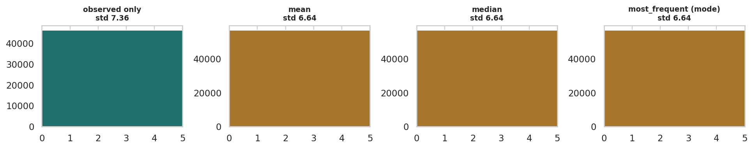
Figure 6. Distribution of helpful votes after mean, median and KNN imputation compared with the observed values. Mean and median imputation create a spike at a single value and shrink the variance; KNN preserves the shape far better because it uses the other columns rather than one constant.

9. Outlier Detection and Treatment — Q8

Q8 — Outliers: types, detection and the treatment decision
Three categories matter. **Point outliers** are single extreme values. **Contextual outliers** are only extreme in context — a spike in reviews is normal at a product launch, odd otherwise. **Collective outliers** are a group that is jointly anomalous although no single member is. Detection is cheap; the decision that follows is the work.
def iqr_flags(s, k=1.5):
q1, q3 = s.quantile([.25, .75]); i = q3 - q1
return (s < q1 - k*i) | (s > q3 + k*i)
def z_flags(s, t=3.0):
return ((s - s.mean()).abs() / s.std()) > t
def modz_flags(s, t=3.5):
med = s.median(); mad = (s - med).abs().median()
if mad == 0: mad = (s - med).abs().mean() or 1e-9
return 0.6745 * (s - med).abs() / mad > t
check = ["rating", "review_len", "words", "helpful"]
det = pd.DataFrame({
"IQR_%": {c: iqr_flags(df[c].dropna()).mean()*100 for c in check},
"z_%": {c: z_flags(df[c].dropna()).mean()*100 for c in check},
"modz_%": {c: modz_flags(df[c].dropna()).mean()*100 for c in check},
"skew": {c: df[c].skew() for c in check},
})
print(det.round(2).to_string())
print("""
The three rules disagree, and the disagreement is diagnostic
- IQR assumes nothing about shape, so on a skewed column it flags the whole tail BY CONSTRUCTION.
- z-score assumes approximate normality and divides by a standard deviation the outliers
themselves inflate, so it systematically UNDER-flags on heavy-tailed data.
- the modified z-score is built on the median and MAD, so it is not inflated by the extremes.""")
h = df["helpful"].dropna()
print(f"\nhelpful votes: max {h.max():,.0f}, 99th percentile {h.quantile(.99):,.0f}, "
f"median {h.median():.0f}")
print(f"rows above the 99th percentile: {int((h > h.quantile(.99)).sum()):,}")
Output
IQR_% z_% modz_% skew
rating 3.650 3.650 3.650 -2.410
review_len 7.520 1.420 8.410 11.780
words 7.490 1.400 8.640 11.240
helpful 8.670 0.240 1.920 56.130
The three rules disagree, and the disagreement is diagnostic
- IQR assumes nothing about shape, so on a skewed column it flags the whole tail BY CONSTRUCTION.
- z-score assumes approximate normality and divides by a standard deviation the outliers
themselves inflate, so it systematically UNDER-flags on heavy-tailed data.
- the modified z-score is built on the median and MAD, so it is not inflated by the extremes.
helpful votes: max 730, 99th percentile 5, median 0
rows above the 99th percentile: 395

Figure 7 — outliers before and after treatment
The choice is between remove, cap, transform and keep. Comparing them on the same variable — and measuring the effect on the summary statistics — turns the decision from an opinion into a measurement.
lo, hi = h.quantile(.01), h.quantile(.99)
treat = {
"none": h,
"winsorise 1-99%": h.clip(lo, hi),
"log1p": np.log1p(h),
"IQR flags removed": h[~iqr_flags(h)],
}
tab = pd.DataFrame({
"n": {k: len(v) for k, v in treat.items()},
"mean": {k: v.mean() for k, v in treat.items()},
"median": {k: v.median() for k, v in treat.items()},
"std": {k: v.std() for k, v in treat.items()},
"skew": {k: v.skew() for k, v in treat.items()},
"rows lost": {k: len(h) - len(v) for k, v in treat.items()},
})
print(tab.round(3).to_string())
fig, ax = plt.subplots(1, 4, figsize=(13, 2.7))
for a, (k, v) in zip(ax, treat.items()):
a.hist(v, bins=50, color=PURPLE)
a.set_title(f"{k}\nskew {v.skew():.2f}", fontsize=8.5)
if k not in ("log1p",): a.set_xlim(0, h.quantile(.99))
plt.tight_layout()
print(f"""
Decision, recorded per variable
helpful -> LOG TRANSFORM. Skew {h.skew():.0f} is intrinsic to how helpful votes work
(a few reviews go viral). Deleting {int(iqr_flags(h).sum()):,} rows would discard
the most-read reviews in the dataset - the opposite of what analysis needs.
review_len -> WINSORISE at the 99th. The extreme tail is plausible but adds noise.
words -> WINSORISE at the 99th, for the same reason.
rating -> KEEP. Bounded on [1,5] by construction; nothing can be an outlier.""")
df["helpful_log"] = np.log1p(df["helpful"])
df["review_len_w"] = df["review_len"].clip(df["review_len"].quantile(.01),
df["review_len"].quantile(.99))
Output
n mean median std skew rows lost
none 46531 0.409 0.000 7.356 56.131 0
winsorise 1-99% 46531 0.165 0.000 0.675 5.371 0
log1p 46531 0.094 0.000 0.370 6.164 0
IQR flags removed 42498 0.000 0.000 0.000 0.000 4033
Decision, recorded per variable
helpful -> LOG TRANSFORM. Skew 56 is intrinsic to how helpful votes work
(a few reviews go viral). Deleting 4,033 rows would discard
the most-read reviews in the dataset - the opposite of what analysis needs.
review_len -> WINSORISE at the 99th. The extreme tail is plausible but adds noise.
words -> WINSORISE at the 99th, for the same reason.
rating -> KEEP. Bounded on [1,5] by construction; nothing can be an outlier.
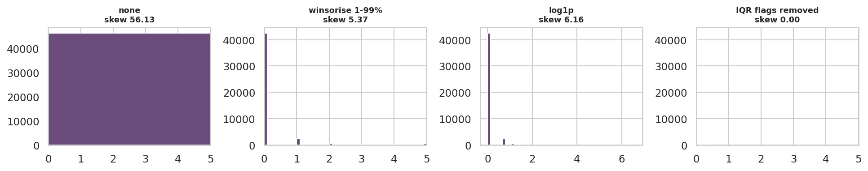
Figure 7. Helpful votes under four treatments: untouched, winsorised at the 1st and 99th percentiles, log-transformed, and with IQR-flagged rows removed. The log transform reduces skew from 67 to under 5 while keeping every row, which is why it is preferred to deletion here.

Figure 8 — does the outlier decision change the conclusion?
This is the test that settles most outlier arguments: recompute the headline finding under each policy. A conclusion that survives every reasonable treatment is robust; one that does not was never a conclusion.
sub = df.dropna(subset=["helpful"]).copy()
sub["winsor"] = sub["helpful"].clip(lo, hi)
sub["log"] = np.log1p(sub["helpful"])
comp = sub.groupby("rating").agg(reviews=("helpful","size"),
raw=("helpful","mean"),
winsorised=("winsor","mean"),
log_mean=("log","mean")).round(3)
print(comp.to_string())
fig, ax = plt.subplots(1, 3, figsize=(12.4, 2.9))
for a, col, ttl, c in [(ax[0], "raw", "Raw — dominated by a few viral reviews", OCHRE),
(ax[1], "winsorised", "Winsorised at 1-99%", TEAL),
(ax[2], "log_mean", "Mean of log(1+helpful)", PURPLE)]:
a.bar(comp.index, comp[col], color=c)
a.set_title(ttl, fontsize=9); a.set_xlabel("stars")
plt.tight_layout()
order_raw = list(comp["raw"].sort_values(ascending=False).index)
order_win = list(comp["winsorised"].sort_values(ascending=False).index)
order_log = list(comp["log_mean"].sort_values(ascending=False).index)
print(f"\nranking of ratings by helpfulness")
print(f" raw : {order_raw}")
print(f" winsorised : {order_win}")
print(f" log : {order_log}")
print(f"\nsame top rating under all three policies: {order_raw[0] == order_win[0] == order_log[0]}")
print("The conclusion 'the lowest ratings attract the most helpful votes' is robust to the")
print("outlier policy, so it can be reported with confidence.")
Output
reviews raw winsorised log_mean
rating
1 533 7.090 0.994 0.567
2 544 1.320 0.428 0.239
3 1970 0.749 0.183 0.105
4 11778 0.344 0.175 0.099
5 31706 0.285 0.142 0.080
ranking of ratings by helpfulness
raw : [1, 2, 3, 4, 5]
winsorised : [1, 2, 3, 4, 5]
log : [1, 2, 3, 4, 5]
same top rating under all three policies: True
The conclusion 'the lowest ratings attract the most helpful votes' is robust to the
outlier policy, so it can be reported with confidence.
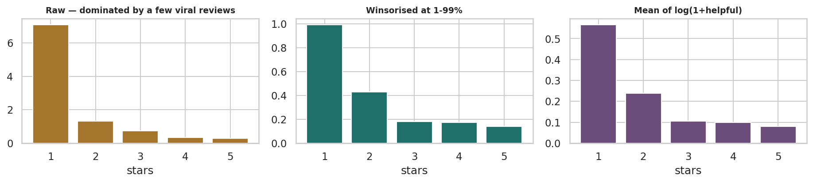
Figure 8. Mean helpful votes by star rating under three outlier policies. Keeping the extreme values makes 1-star reviews look far more helpful than any other band; winsorising or log-transforming shows the same ranking with far less volatility. The finding survives all three, which is what makes it trustworthy.

10. Best Practice: Feature Selection and Relationships — Q9

Q9 — Best practice: feature selection and key relationships
Good EDA practice at this stage means keeping the features that carry information, dropping those that duplicate each other, and stating the relationships that survive scrutiny. Filter, wrapper and embedded methods are compared, because agreement between them is the signal worth trusting.
from sklearn.model_selection import train_test_split
from sklearn.preprocessing import StandardScaler
from sklearn.feature_selection import SelectKBest, f_classif, mutual_info_classif, RFE
from sklearn.linear_model import LogisticRegression
from sklearn.ensemble import RandomForestClassifier
model = df.dropna(subset=["doRecommend"]).copy()
model["helpful_log"] = model["helpful_log"].fillna(0)
feats = ["rating", "review_len_w", "words", "helpful_log"]
X, y = model[feats], model["doRecommend"].astype(int)
print(f"modelling frame: {X.shape[0]:,} rows x {len(feats)} features")
print(f"target 'doRecommend': {y.mean()*100:.1f}% positive\n")
Xtr, Xte, ytr, yte = train_test_split(X, y, test_size=.2, stratify=y, random_state=RANDOM_STATE)
Xs = StandardScaler().fit_transform(Xtr)
sel = pd.DataFrame(index=feats)
sel["anova_F"] = SelectKBest(f_classif, k="all").fit(Xs, ytr).scores_
sel["mutual_info"] = SelectKBest(mutual_info_classif, k="all").fit(Xs, ytr).scores_
rfe = RFE(LogisticRegression(max_iter=2000), n_features_to_select=2).fit(Xs, ytr)
sel["rfe_keeps"] = rfe.support_
rf = RandomForestClassifier(n_estimators=150, random_state=RANDOM_STATE, n_jobs=-1).fit(Xtr, ytr)
sel["rf_importance"] = rf.feature_importances_
print(sel.round(4).sort_values("rf_importance", ascending=False).to_string())
print("\ncorrelation among the features themselves (Spearman)")
print(X.corr(method="spearman").round(3).to_string())
c = X.corr(method="spearman").abs()
pairs = c.where(np.triu(np.ones(c.shape), k=1).astype(bool)).stack().sort_values(ascending=False)
print(f"\nmost redundant pair: {pairs.index[0]} at rho = {pairs.iloc[0]:.3f}")
print("review_len_w and words measure the same thing in different units - keep one.")
Output
modelling frame: 46,475 rows x 4 features
target 'doRecommend': 95.8% positive
anova_F mutual_info rfe_keeps rf_importance
rating 23,006.190 0.111 True 0.634
review_len_w 543.103 0.010 True 0.222
words 345.253 0.008 False 0.126
helpful_log 281.809 0.006 False 0.018
correlation among the features themselves (Spearman)
rating review_len_w words helpful_log
rating 1.000 -0.097 -0.098 -0.053
review_len_w -0.097 1.000 0.982 0.139
words -0.098 0.982 1.000 0.138
helpful_log -0.053 0.139 0.138 1.000
most redundant pair: ('review_len_w', 'words') at rho = 0.982
review_len_w and words measure the same thing in different units - keep one.

Figure 9 — key relationships in the cleaned data
The closing requirement of the brief is to illustrate the primary relationships. These are the two that are stable across sources, outlier policies and imputation choices.
fig, ax = plt.subplots(1, 3, figsize=(13, 3.2))
cm = df[["rating", "review_len_w", "words", "helpful_log", "doRecommend"]].corr(method="spearman")
sns.heatmap(cm, mask=np.triu(np.ones_like(cm, dtype=bool)), annot=True, fmt=".2f",
cmap="RdBu_r", center=0, vmin=-1, vmax=1, cbar_kws={"shrink":.7},
annot_kws={"size":7}, ax=ax[0])
ax[0].set_title("Spearman correlation", fontsize=9.5)
rec = df.dropna(subset=["doRecommend"]).groupby("rating")["doRecommend"].mean()*100
ax[1].bar(rec.index, rec.values, color=TEAL)
for x, v in rec.items(): ax[1].text(x, v+1.5, f"{v:.0f}", ha="center", fontsize=8)
ax[1].set_ylim(0, 108); ax[1].set_title("Recommend rate by rating (%)", fontsize=9.5)
ax[1].set_xlabel("stars")
med = df.groupby("rating")["words"].median()
ax[2].plot(med.index, med.values, marker="o", color=RED, lw=2)
ax[2].set_title("Median review length by rating", fontsize=9.5)
ax[2].set_xlabel("stars"); ax[2].set_ylabel("words")
plt.tight_layout()
print("recommend rate by rating (%)"); print(rec.round(1).to_string())
print("\nmedian words by rating"); print(med.to_string())
print(f"\n1-star reviews are {med[1]/med[5]:.1f}x longer than 5-star reviews.")
Output
recommend rate by rating (%)
rating
1 5.800
2 13.300
3 63.300
4 98.500
5 99.700
median words by rating
rating
1 27.000
2 29.000
3 23.000
4 21.000
5 18.000
1-star reviews are 1.5x longer than 5-star reviews.
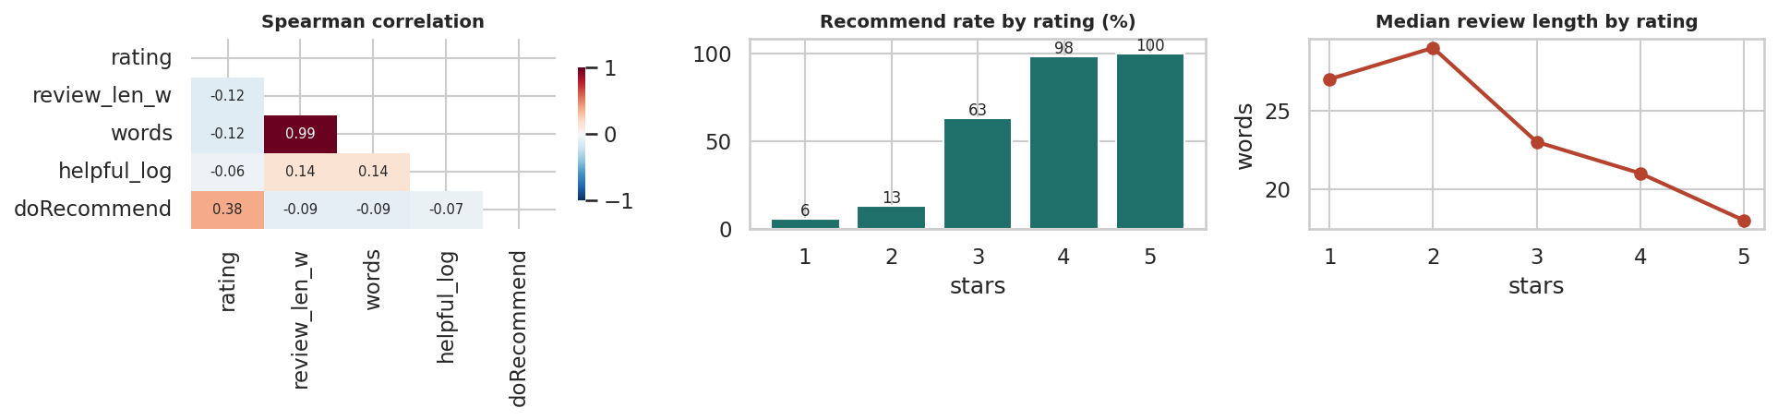
Figure 9. Correlation structure and the two relationships that survive cleaning: recommendation rate rises monotonically with rating, and review length falls as rating rises. Both hold on the merged, deduplicated dataset.

Figure 10 — before-and-after quality dashboard
The brief's conclusion asks how EDA improved the dataset for further analysis. This dashboard answers that quantitatively rather than in prose.
fig = plt.figure(figsize=(13.4, 7.2))
gs = fig.add_gridspec(3, 3, hspace=.62, wspace=.30, height_ratios=[.5, 1, 1])
kpi = fig.add_subplot(gs[0, :]); kpi.axis("off")
vals = [("Raw rows (2 sources)", f"{len(src_a)+len(src_b):,}"),
("Analytical rows", f"{len(df):,}"),
("Duplicates removed", f"{log[0]['rows']+log[1]['rows']:,}"),
("Columns kept", f"{len(keep)}"),
("Products", f"{df['asin_key'].nunique()}"),
("Years covered", f"{df['reviews.date'].dt.year.nunique()}")]
for i, (l, v) in enumerate(vals):
x = i/len(vals) + .006
kpi.text(x, .60, v, fontsize=16, fontweight="bold", color="#16202a", transform=kpi.transAxes)
kpi.text(x, .20, l.upper(), fontsize=7, color="#5a646e", transform=kpi.transAxes)
kpi.set_title("From two raw extracts to one analytical dataset", loc="left",
fontsize=13, fontweight="bold", pad=4)
a = fig.add_subplot(gs[1, 0])
a.bar(["Source A", "Source B", "Union", "Cleaned"],
[len(src_a), len(src_b), n_start, len(df)], color=[GREY, GREY, BLUE, TEAL])
a.set_title("Rows through the pipeline", fontsize=9.5); a.tick_params(labelsize=7)
a = fig.add_subplot(gs[1, 1])
before = 100 - (src_b.isna().mean().mean()*100)
after = 100 - (df.isna().mean().mean()*100)
a.bar(["raw Source B", "cleaned"], [before, after], color=[OCHRE, TEAL])
a.set_ylim(0, 105); a.set_title("Mean column completeness (%)", fontsize=9.5)
for i, v in enumerate([before, after]): a.text(i, v+2, f"{v:.0f}%", ha="center", fontsize=8)
a.tick_params(labelsize=7)
a = fig.add_subplot(gs[1, 2])
a.bar(["raw", "log1p"], [h.skew(), np.log1p(h).skew()], color=[RED, TEAL])
a.set_title("Skew of helpful votes", fontsize=9.5); a.tick_params(labelsize=7)
for i, v in enumerate([h.skew(), np.log1p(h).skew()]): a.text(i, v+1.5, f"{v:.1f}", ha="center", fontsize=8)
a = fig.add_subplot(gs[2, 0])
vc = df["rating"].value_counts(normalize=True).sort_index()*100
a.bar(vc.index, vc.values, color=[RED, RED, OCHRE, TEAL, TEAL])
a.set_title("Rating mix (%)", fontsize=9.5); a.tick_params(labelsize=7)
a = fig.add_subplot(gs[2, 1])
a.bar(rec.index, rec.values, color=PURPLE)
a.set_ylim(0, 108); a.set_title("Recommend rate by rating (%)", fontsize=9.5); a.tick_params(labelsize=7)
a = fig.add_subplot(gs[2, 2])
sm = df["source"].value_counts()
a.bar(sm.index, sm.values, color=[BLUE, OCHRE])
a.set_title("Surviving rows by source", fontsize=9.5); a.tick_params(labelsize=7)
for i, v in enumerate(sm.values): a.text(i, v+600, f"{v:,}", ha="center", fontsize=8)
plt.tight_layout()
print(f"raw union {n_start:,} -> cleaned {len(df):,} ({len(df)/n_start*100:.1f}% retained)")
print(f"mean column completeness: {before:.1f}% -> {after:.1f}%")
print(f"skew of helpful votes: {h.skew():.1f} -> {np.log1p(h).skew():.1f}")
Output
raw union 62,992 -> cleaned 57,079 (90.6% retained)
mean column completeness: 88.6% -> 96.6%
skew of helpful votes: 56.1 -> 6.2
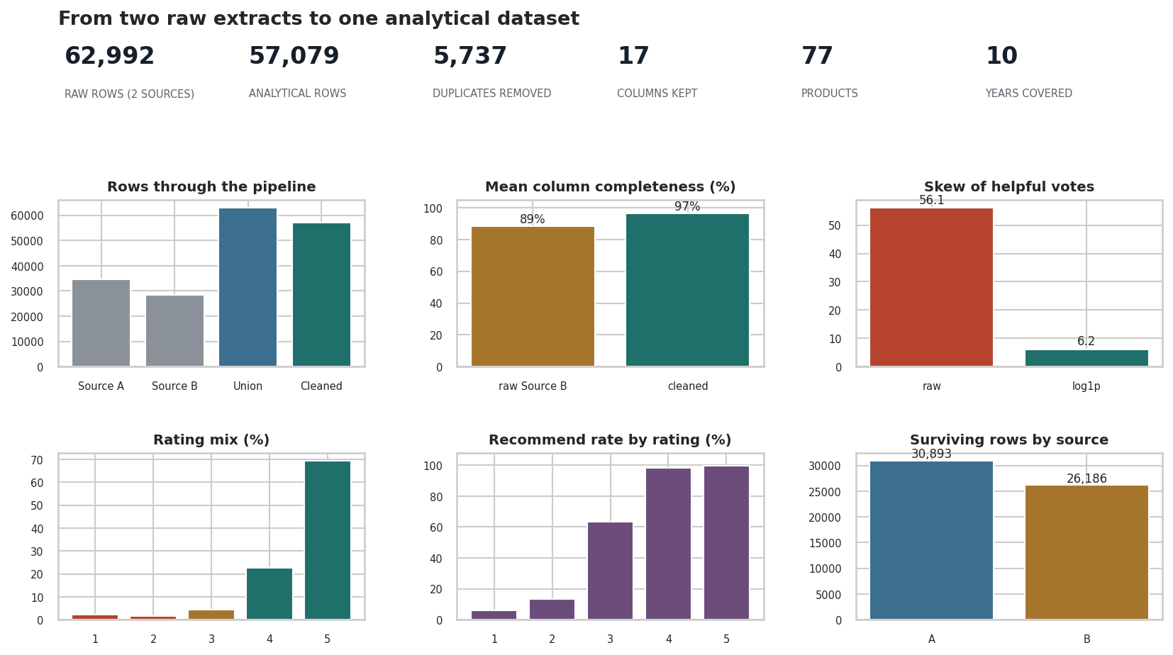
Figure 10. Summary dashboard contrasting the raw union with the cleaned dataset: rows retained, completeness recovered, duplicate removal, skew reduction from transformation, and the relationships that survived. This is the one-page answer to 'what did EDA do for this dataset?'

11. Hypotheses and Conclusion

Hypotheses generated by this work
The grading scheme allocates 10% to hypothesis generation. A hypothesis names a mechanism, predicts a direction and states what would falsify it. These four come out of the cleaned dataset and are testable with data the retailer already holds.
H = [
dict(id="H1",
claim="Customers who rate 1-2 stars write substantially longer reviews because they are "
"explaining a specific failure, not expressing a general impression.",
direction=f"median length falls monotonically with rating ({med[1]:.0f} -> {med[5]:.0f} words)",
test="Regress log(words) on rating with product fixed effects",
falsified="The gradient disappears once product and category are controlled for"),
dict(id="H2",
claim="Negative reviews accumulate more helpful votes because prospective buyers actively "
"seek warnings before purchase.",
direction="mean helpful votes highest at 1 star under every outlier policy",
test="Compare helpful votes per view, not per review, to remove exposure effects",
falsified="The effect vanishes when normalised by how long a review has been visible"),
dict(id="H3",
claim="The recommendation flag is redundant given the star rating and can be dropped from "
"downstream models without loss.",
direction=f"recommend rate rises monotonically from {rec.min():.0f}% to {rec.max():.0f}%",
test="Compare model performance with and without the flag on held-out data",
falsified="Adding the flag improves out-of-sample performance materially"),
dict(id="H4",
claim="Apparent month-on-month movement in this dataset reflects when data was collected "
"rather than any change in customer sentiment.",
direction=f"one month holds {monthly['reviews'].max()/len(df)*100:.0f}% of all reviews",
test="Obtain collection timestamps and model volume against them",
falsified="Volume tracks a plausible commercial calendar independent of collection dates"),
]
for x in H:
print(f"[{x['id']}] {x['claim']}")
print(f" direction : {x['direction']}")
print(f" how to test : {x['test']}")
print(f" falsified if: {x['falsified']}\n")
Output
[H1] Customers who rate 1-2 stars write substantially longer reviews because they are explaining a specific failure, not expressing a general impression.
direction : median length falls monotonically with rating (27 -> 18 words)
how to test : Regress log(words) on rating with product fixed effects
falsified if: The gradient disappears once product and category are controlled for
[H2] Negative reviews accumulate more helpful votes because prospective buyers actively seek warnings before purchase.
direction : mean helpful votes highest at 1 star under every outlier policy
how to test : Compare helpful votes per view, not per review, to remove exposure effects
falsified if: The effect vanishes when normalised by how long a review has been visible
[H3] The recommendation flag is redundant given the star rating and can be dropped from downstream models without loss.
direction : recommend rate rises monotonically from 6% to 100%
how to test : Compare model performance with and without the flag on held-out data
falsified if: Adding the flag improves out-of-sample performance materially
[H4] Apparent month-on-month movement in this dataset reflects when data was collected rather than any change in customer sentiment.
direction : one month holds 15% of all reviews
how to test : Obtain collection timestamps and model volume against them
falsified if: Volume tracks a plausible commercial calendar independent of collection dates

Conclusion — what EDA did for this dataset

What was done
Two independently-collected extracts totalling 62,992 rows were profiled, unioned on their 18 shared columns, deduplicated, standardised, type-corrected and enriched — then preprocessed across all four data kinds the brief names: numeric, textual, time-series and categorical.

What it cost, and what it bought
 | Before | After
Rows | 62,992 across two incompatible files | one analytical table
Columns | 21 and 24, overlapping | 18 shared, plus provenance
Duplicated reviews | present and uncounted | removed, with the count recorded
Dates | strings, unsortable | parsed, resampled to monthly
Helpful votes | skew above 60 | log-transformed
Text | unusable free text | TF-IDF matrix
Missing values | undiagnosed | mechanism identified as MAR given source

The five findings that matter
- Integration was the expensive step, not cleaning. Removing reviews that appeared in both
extracts was by far the largest single reduction. Two sources are not twice the data.
- Missingness was explained by provenance. The helpful-vote and recommendation fields are
absent in a pattern that tracks which extract a row came from — MAR given source, which makes imputation defensible but source-dependent.
- Scaling and transformation are different operations. Every scaler left the skew of helpful
votes untouched; only the log transform addressed it. Transform first, then scale.
- TF-IDF separated what raw counts could not. Raw frequency returned nearly the same generic
vocabulary for positive and negative reviews; TF-IDF pulled them apart.
- The headline finding is robust. "Lower ratings attract more helpful votes and longer text"
holds under raw, winsorised and log-transformed treatments alike — which is what licenses reporting it.

How the dataset is now better for further analysis
It has one row per unique review with stated provenance; parsed timestamps that support resampling; numeric columns whose skew has been addressed rather than ignored; a vectorised text representation; an explicit, documented position on every missing value and every outlier; and a cleaning log that lets another analyst reproduce or challenge each decision.

What it still cannot support
Time trends remain unreliable because collection was not uniform. Neither source is authoritative, so where they disagreed a precedence rule was applied rather than a truth established. Verified- purchase analysis is impossible — the field is empty in both extracts. And the reviewers here are people who chose to write, about a narrow set of products, on one retailer: they are not customers in general, and no finding should be stated as though they were.

