L13-14 — Visual storytelling

L13-14 — Visual storytelling
DATA209 · Advanced Exploratory Data Analysis
Vidyashilp University · School of Engineering and Technology
BTech Hons. (Data Science), Semester III
Week 7 | Module 2 — Core Advanced EDA | Outcome CO2
Slides: DATA209_Module_2_Core_Advanced_EDA.pptx, pages 30–36 | Laboratory: P13-14 (Assignment 1)

Topics covered
- Grammar of graphics
- Good vs. misleading plots
- Visualising non-numeric data
- Dashboard logic and storytelling with data

Notes

The grammar of graphics
A plot is built from layers. Thinking in layers is what lets you answer "which plot?" by reasoning rather than by recall.
- Data — the tidy table being shown, one row per observation.
- Aesthetics — the mapping from variables to visual properties: x, y, colour, size, shape.
- Geometries — the marks that carry the data: points, bars, lines, boxes, tiles.
- Scales — how data values become visual values: axis limits, log scales, colour palettes.
- Facets — small multiples; the same plot repeated across the levels of a variable.
- Coordinates and theme — coordinate system plus the non-data ink: labels, grid, legend.

Choosing a chart
You have | Question | Plot
one numeric | what is its shape? | histogram, density, boxplot, ECDF
one categorical | how common is each level? | bar plot of counts or proportions
two numeric | do they move together? | scatterplot, plus a smoother
numeric + categorical | do the groups differ? | grouped boxplot, violin, overlaid densities
two categorical | are they associated? | cross-tab, stacked bar of proportions, mosaic
many numeric | where is the structure? | correlation heatmap, pair plot, parallel coordinates
numeric over time | what is the trend? | line chart, ordered by time
Pie charts appear nowhere in this table. They ask the reader to compare angles, which people do poorly; a bar chart beats them in almost every case.

Six ways a plot misleads
- Truncated axis — a bar chart not starting at zero exaggerates small differences.
- Dual axes — two scales on one chart manufacture correlation by choice of range.
- 3-D and area encodings — doubling a radius quadruples the perceived size.
- Cherry-picked range — where the time axis starts decides whether the trend rises or falls.
- Rainbow colour maps — non-perceptual palettes create bands that are artefacts of the colours.
- Hidden aggregation — plotting means without spread or sample size conceals both.
The test to apply to your own work: could someone reach the opposite conclusion from this data with a different but equally reasonable choice?

Non-numeric data
Ordered bar plots for ordinal data — never let the software sort alphabetically. Stacked bars of proportions for part-to-whole comparisons. Mosaic plots when both variables are categorical with several levels. Heatmaps for contingency tables, using a perceptually uniform colour scale. For high cardinality, plot the top 15 and aggregate the rest into a labelled "Other".

Assignment 1 preparation
The mini-project due this week is marked on four criteria: technique 30%, interpretation 35%, reproducibility 15%, presentation 20%. Interpretation carries the most weight, which is deliberate — it is the skill the course exists to build.
What to bring to the presentation:
- The problem statement and what a row represents, with the sampling frame stated.
- The dependent/independent split, justified.
- Univariate findings: shape, centre, spread and anomalies per variable.
- Bivariate findings, including at least one relationship you did not expect.
- Multivariate structure — grouping or clustering, interpreted in plain language.
- Three hypotheses, each with a falsification condition and its confounders named.
Two failures cost the most marks: figures with no written interpretation, and absolute file paths that only run on your own machine. Restart the kernel and run all before submitting.

Narrative
Lead with the finding, not the method: "Glucose separates the classes" beats "we plotted glucose". One figure, one message — if a plot needs two sentences to explain, it is two plots. Sequence the report: what the data is → what is wrong with it → what it shows → what you cannot conclude. Annotate directly on the figure. State limitations in the same breath as the finding.
A dashboard answers recurring questions; a report answers one question well. Know which you are building before you start.

Worked examples
Every example below was executed against the course datasets; the output shown is the real result, not an illustration. The primary dataset is Online Shoppers Purchasing Intention (12,330 sessions × 18 columns, UCI). Run the setup block once, then any example.

Setup — run this first
import warnings; warnings.filterwarnings("ignore")
import numpy as np, pandas as pd
import matplotlib.pyplot as plt, seaborn as sns
pd.set_option("display.width", 108)
pd.set_option("display.float_format", lambda v: f"{v:,.3f}")
sns.set_theme(style="whitegrid")
RANDOM_STATE = 42
np.random.seed(RANDOM_STATE)
df = pd.read_csv("online_shoppers_intention.csv") # 12,330 x 18
TARGET = "Revenue"
num = df.select_dtypes(include=[np.number]).columns.tolist()

Example 1 — Grammar of graphics: one dataset, layered choices
A plot is data + aesthetics + geometry + scale. Changing only the geometry, with the same data and mapping, answers a different question.
fig, ax = plt.subplots(1, 3, figsize=(11.4, 2.5))
sns.scatterplot(data=df.sample(2000, random_state=RANDOM_STATE),
x="ProductRelated", y="ExitRates", hue=TARGET, s=8, alpha=.5, ax=ax[0])
ax[0].set_title("geometry = point")
sns.boxplot(data=df, x=TARGET, y="ExitRates", ax=ax[1], showfliers=False)
ax[1].set_title("geometry = box")
sns.kdeplot(data=df, x="ExitRates", hue=TARGET, fill=True, common_norm=False, ax=ax[2])
ax[2].set_title("geometry = density")
plt.tight_layout()
print("Same variables, three geometries, three different questions answered.")
Output
Same variables, three geometries, three different questions answered.
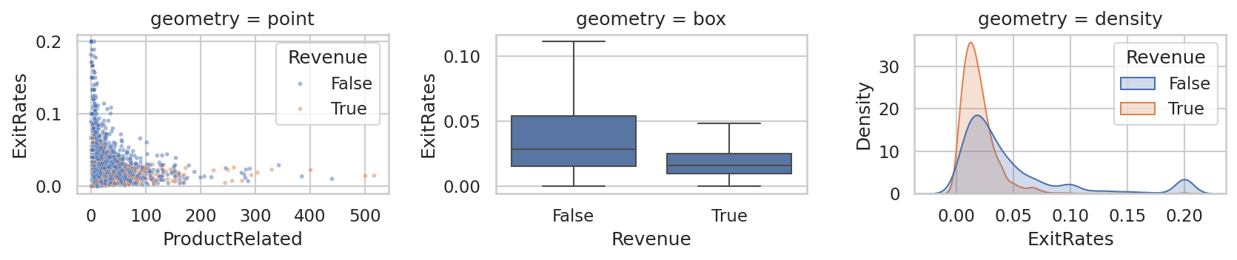

Example 2 — The truncated axis — the commonest way a plot lies
A bar chart that does not start at zero exaggerates small differences. Both panels below are drawn from identical numbers.
rate = df.groupby("VisitorType")[TARGET].mean() * 100
fig, ax = plt.subplots(1, 2, figsize=(9, 2.7))
rate.plot(kind="bar", ax=ax[0], color="#B5432E")
ax[0].set_ylim(rate.min() - 0.4, rate.max() + 0.4)
ax[0].set_title("Truncated axis — looks dramatic"); ax[0].set_xlabel("")
rate.plot(kind="bar", ax=ax[1], color="#1F6F6B")
ax[1].set_ylim(0, 100); ax[1].set_title("Zero baseline — honest"); ax[1].set_xlabel("")
plt.tight_layout()
print(rate.round(2).to_string())
print("\nAsk of your own plots: could a reader reach the opposite conclusion?")
Output
VisitorType
New_Visitor 24.910
Other 18.820
Returning_Visitor 13.930
Ask of your own plots: could a reader reach the opposite conclusion?
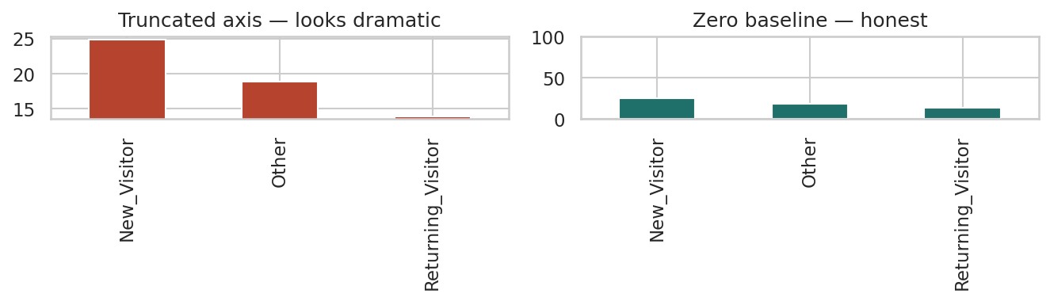

Example 3 — Visualising non-numeric data with high cardinality
Plotting 20 categories produces an unreadable chart. Show the top levels and aggregate the rest into an explicitly labelled 'Other'.
vc = df["TrafficType"].astype(str).value_counts(normalize=True) * 100
top = vc.head(6)
other = pd.Series({"Other (%d levels)" % (len(vc) - 6): vc.iloc[6:].sum()})
shown = pd.concat([top, other])
print(shown.round(2).to_string())
fig, ax = plt.subplots(figsize=(6.4, 2.6))
shown.plot(kind="barh", ax=ax, color="#1F6F6B")
ax.set_xlabel("% of sessions"); ax.set_title("TrafficType — top 6 and the rest")
plt.tight_layout()
Output
2 31.740
1 19.880
3 16.640
4 8.670
13 5.990
10 3.650
Other (14 levels) 13.440
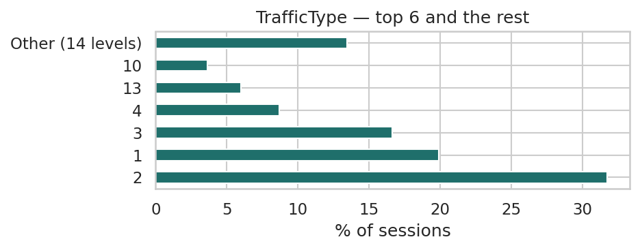

Example 4 — Assignment 1 preparation — a finding-first figure
Marks come from interpretation, not decoration. Title the chart with the finding and annotate the evidence directly on it.
med = df.groupby(TARGET)["PageValues"].median()
fig, ax = plt.subplots(figsize=(6.6, 2.8))
sns.boxplot(data=df, x=TARGET, y="PageValues", ax=ax, showfliers=False)
ax.set_title("Sessions reaching a valued page convert far more often", loc="left")
ax.set_xlabel("session ended in a purchase"); ax.set_ylabel("PageValues")
ax.annotate(f"median {med[True]:.1f}", xy=(1, med[True]), xytext=(1.15, med[True] + 8),
arrowprops=dict(arrowstyle="->", lw=.8), fontsize=8)
ax.annotate(f"median {med[False]:.1f}", xy=(0, med[False]), xytext=(0.15, 12),
arrowprops=dict(arrowstyle="->", lw=.8), fontsize=8)
plt.tight_layout()
print("Checklist: technique 30% | interpretation 35% | reproducibility 15% | presentation 20%")
Output
Checklist: technique 30% | interpretation 35% | reproducibility 15% | presentation 20%
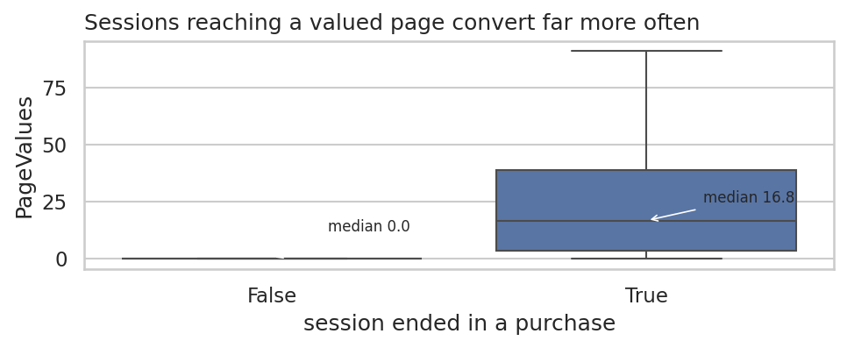

Key terms
Grammar of graphics · Aesthetic mapping · Geometry · Facet · Small multiples · Truncated axis · Perceptually uniform colour map · Data-ink ratio

Common errors to avoid
- Truncating a bar chart's y-axis
- Using a pie chart to compare more than three categories
- Leaving a legend to do work that direct annotation would do better
- Publishing a figure with no sentence stating what it shows

Readings — all free to access
- Wilke — Fundamentals of Data Visualization
https://clauswilke.com/dataviz/
- CMU 36-315 — Statistical Graphics and Visualization
https://cmu-36315.netlify.app/
- seaborn tutorial
https://seaborn.pydata.org/tutorial.html

Test yourself
- Name the six layers of the grammar of graphics.
- When is a truncated y-axis defensible?
- You have two categorical variables with six levels each. Which plot, and why?
- Rewrite 'Figure 3: PageValues by Revenue' as a title that states the finding.

