L5-6 — Unstructured data and ethics

L5-6 — Unstructured data and ethics
DATA209 · Advanced Exploratory Data Analysis
Vidyashilp University · School of Engineering and Technology
BTech Hons. (Data Science), Semester III
Week 3 | Module 1 — Statistical & Data Foundations for EDA | Outcome CO1
Slides: DATA209_Module_1_Statistical_and_Data_Foundations.pptx, pages 31–37 | Laboratory: P5-6

Topics covered
- Image as a matrix; audio as a waveform
- Video as a sequence of frames
- Curse of dimensionality — introduction
- Data bias and ethical concerns

Notes

Everything becomes an array
- Image — a grid of pixel values. Grayscale is (height, width); colour is
(height, width, 3). Explore the intensity histogram: exposure, contrast, and clipping at 0 or 255 tell you what was lost at capture and cannot be recovered.
- Audio — amplitude sampled over time: a 1-D array plus a sample rate. Explore the
waveform for structure, the amplitude histogram for symmetry, and short-term energy for loudness over time. Silence is often the majority of a field recording.
- Video — a sequence of frames, (frames, height, width, channels) plus a frame rate. Each
frame is an image, so image technique applies frame by frame.
Once represented as an array, the ordinary exploratory questions apply unchanged: what is the distribution, where are the extremes, what is missing, and is anything clipped or saturated?

The curse of dimensionality — a flag planted
As dimensions grow, data density collapses exponentially. In a unit cube, the proportion of volume lying within 0.1 of an edge is 20% in one dimension, 49% in three, and 99% in twenty — almost every point is near a boundary. Distances between points converge, so "nearest neighbour" stops carrying information, and distance-based methods (k-NN, k-means) degrade first.
This is introduced here only. The response — feature selection and dimensionality reduction — is Module 4.

Bias enters before you write any code
Four kinds, all present before analysis begins:
- Historical bias — the world the data records was already unequal. Faithful data can encode
unfair outcomes.
- Representation bias — some groups are under-sampled; findings will not transfer to them.
- Measurement bias — the proxy is not the thing. Arrests are not crime; clicks are not interest.
- Aggregation bias — one model for everyone hides subgroup differences. Simpson's paradox is
the statistical form of this, and it appears again in L11-12.

An ethics checklist
Run this before analysing, not after:
- Who is in this dataset, who is missing, and would they have consented to this use?
- Does it contain personal or sensitive attributes, and do you actually need them?
- Could a finding here be used to disadvantage a group represented in the data?
- Are proxy variables standing in for protected attributes?
- What claim would be unsupportable outside the sampling frame — and have you written it down?
The Pima dataset records women of Pima heritage aged 21 and over. Every conclusion drawn from it is conditional on that frame, and a model trained on it must not be presented as a general screener.

Worked examples
Every example below was executed against the course datasets; the output shown is the real result, not an illustration. The primary dataset is Online Shoppers Purchasing Intention (12,330 sessions × 18 columns, UCI). Run the setup block once, then any example.

Setup — run this first
import warnings; warnings.filterwarnings("ignore")
import numpy as np, pandas as pd
import matplotlib.pyplot as plt, seaborn as sns
pd.set_option("display.width", 108)
pd.set_option("display.float_format", lambda v: f"{v:,.3f}")
sns.set_theme(style="whitegrid")
RANDOM_STATE = 42
np.random.seed(RANDOM_STATE)
df = pd.read_csv("online_shoppers_intention.csv") # 12,330 x 18
TARGET = "Revenue"
num = df.select_dtypes(include=[np.number]).columns.tolist()

Example 1 — An image is a matrix of numbers
Once an image is an array, the same exploratory questions apply: what is the distribution, where are the extremes, was anything clipped at capture?
from PIL import Image
img = np.array(Image.open(IMAGE).convert("RGB"))
gray = np.array(Image.fromarray(img).convert("L"))
print("shape :", img.shape, "-> height x width x channels")
print("dtype :", img.dtype, "| range", img.min(), "to", img.max())
print("pixels:", f"{img.shape[0]*img.shape[1]:,} per channel")
print(f"clipped at 0: {(gray==0).mean()*100:.2f}% at 255: {(gray==255).mean()*100:.2f}%")
fig, ax = plt.subplots(1, 3, figsize=(9.6, 2.5))
ax[0].imshow(img); ax[0].axis("off"); ax[0].set_title("Image")
ax[1].imshow(gray, cmap="gray"); ax[1].axis("off"); ax[1].set_title("Grayscale matrix")
ax[2].hist(gray.ravel(), bins=64, color="#3B6E8F"); ax[2].set_title("Pixel intensity")
plt.tight_layout()
Output
shape : (648, 1170, 3) -> height x width x channels
dtype : uint8 | range 30 to 255
pixels: 758,160 per channel
clipped at 0: 0.00% at 255: 83.32%
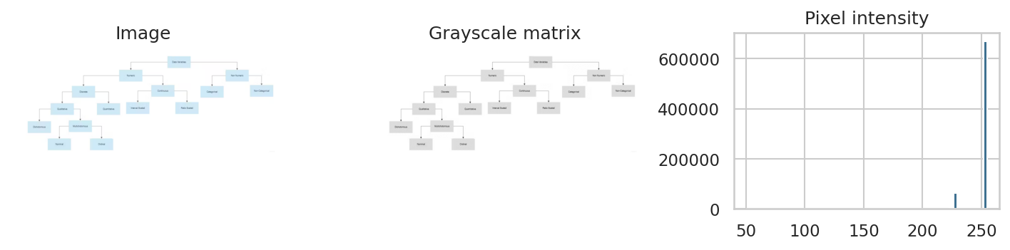

Example 2 — Audio is amplitude sampled over time
A waveform is a 1-D array plus a sample rate. The standard library reads WAV files, so no extra package is needed to look at the signal.
import wave
with wave.open(AUDIO, "rb") as w:
ch, width, rate, n = w.getnchannels(), w.getsampwidth(), w.getframerate(), w.getnframes()
raw = w.readframes(n)
sig = np.frombuffer(raw, dtype={1: np.uint8, 2: np.int16, 4: np.int32}[width]).astype(np.float32)
if ch > 1: sig = sig.reshape(-1, ch).mean(axis=1)
sig = sig / (np.abs(sig).max() or 1)
print(f"sample rate {rate:,} Hz | channels {ch} | duration {len(sig)/rate:.2f} s | samples {len(sig):,}")
print(f"peak amplitude {np.abs(sig).max():.3f} | RMS {np.sqrt((sig**2).mean()):.3f}")
fig, ax = plt.subplots(1, 2, figsize=(9.2, 2.4))
ax[0].plot(np.arange(len(sig))/rate, sig, lw=.4, color="#3B6E8F")
ax[0].set_title("Waveform"); ax[0].set_xlabel("seconds")
ax[1].hist(sig, bins=80, color="#3B6E8F"); ax[1].set_title("Amplitude distribution")
plt.tight_layout()
Output
sample rate 44,100 Hz | channels 2 | duration 5.94 s | samples 262,094
peak amplitude 1.000 | RMS 0.391
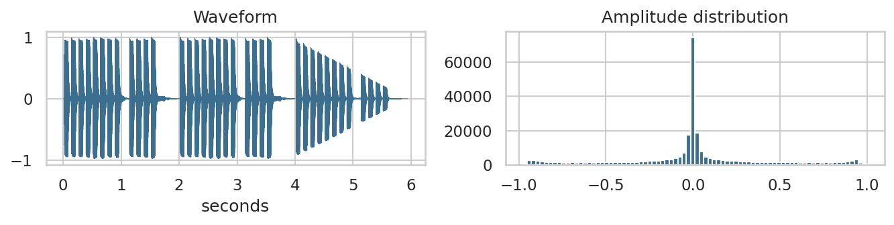

Example 3 — The curse of dimensionality, demonstrated
Rather than assert that distance loses meaning in high dimensions, measure it. The ratio of nearest to farthest neighbour approaches 1 as dimensions grow.
rng = np.random.RandomState(RANDOM_STATE)
rows = []
for d in [2, 5, 10, 50, 200, 1000]:
X = rng.rand(500, d)
dist = np.sqrt(((X[0] - X[1:])**2).sum(axis=1))
rows.append({"dimensions": d, "nearest": dist.min(), "farthest": dist.max(),
"near/far ratio": dist.min()/dist.max()})
print(pd.DataFrame(rows).round(3).to_string(index=False))
print("\nAs the ratio approaches 1, 'nearest neighbour' stops being a meaningful idea.")
print("Distance-based methods (k-NN, k-means) degrade first. Module 4 responds to this.")
Output
dimensions nearest farthest near/far ratio
2 0.024 1.040 0.023
5 0.125 1.418 0.088
10 0.618 2.199 0.281
50 2.035 3.398 0.599
200 5.020 6.237 0.805
1000 12.359 13.878 0.891
As the ratio approaches 1, 'nearest neighbour' stops being a meaningful idea.
Distance-based methods (k-NN, k-means) degrade first. Module 4 responds to this.

Example 4 — Bias is visible in the data before any model
Representation bias is measurable. If a group is thinly sampled, findings will not transfer to it — and the sample size, not the rate, is what tells you.
grp = (df.groupby("VisitorType")
.agg(sessions=(TARGET, "size"), conversion_pct=(TARGET, lambda s: 100*s.mean())))
grp["share_of_data_%"] = (grp["sessions"] / len(df) * 100).round(2)
grp["reliable"] = grp["sessions"] >= 100
print(grp.round(2).to_string())
print("\n'Other' is a small group: its conversion estimate is noisy whatever the rate says.")
print("Reporting it beside the large groups without the denominator would mislead.")
Output
sessions conversion_pct share_of_data_% reliable
VisitorType
New_Visitor 1694 24.910 13.740 True
Other 85 18.820 0.690 False
Returning_Visitor 10551 13.930 85.570 True
'Other' is a small group: its conversion estimate is noisy whatever the rate says.
Reporting it beside the large groups without the denominator would mislead.

Key terms
Modality · Sample rate · Pixel intensity · Clipping · Curse of dimensionality · Historical bias · Representation bias · Proxy variable · Aggregation bias

Common errors to avoid
- Reporting image statistics without stating shape, dtype and value range
- Treating a proxy variable as if it were the quantity of interest
- Presenting a model trained on one population as generally applicable
- Leaving the ethics review to the end of the project

Readings — all free to access
- scikit-image — images as NumPy arrays
https://scikit-image.org/docs/stable/user_guide/numpy_images.html
- Wilke — Fundamentals of Data Visualization
https://clauswilke.com/dataviz/
- Berkeley Data 100 — course notes
https://ds100.org/course-notes/

Test yourself
- An 8-bit grayscale image has 12% of pixels at exactly 255. What happened, and can it be undone?
- Why do distance-based methods degrade first in high dimensions?
- Give an example of a proxy variable that could stand in for a protected attribute.
- State one claim you could not defend from the Pima dataset.

