L7-8 — Univariate EDA

L7-8 — Univariate EDA
DATA209 · Advanced Exploratory Data Analysis
Vidyashilp University · School of Engineering and Technology
BTech Hons. (Data Science), Semester III
Week 4 | Module 2 — Core Advanced EDA | Outcome CO2
Slides: DATA209_Module_2_Core_Advanced_EDA.pptx, pages 3–10 | Laboratory: P7-8

Topics covered
- Numerical variables: boxplot, density, distribution comparison
- Categorical variables: frequency tables, bar plots
- Detecting skewness and anomalies

Notes

Two families, used in order
Non-graphical technique produces numerical summaries — quantiles, moments, frequency and contingency tables, correlation matrices. It is precise, reproducible and easy to tabulate, and it is blind to shape. Anscombe's quartet is four datasets sharing means, variances and correlation coefficients while looking completely different.
Graphical technique reveals shape, gaps, clusters and outliers instantly, and is sensitive to choices you make — bin width, axis limits, smoothing bandwidth.
Use both, in this order: compute the summary, plot it, then reconcile the two when they disagree.

The four questions
Answer all four for every column before looking at a single relationship.
- What is the centre? Mean or median, whichever the skew justifies. State which you used.
- What is the spread? Standard deviation or IQR, plus the range — which exposes impossible values.
- What is the shape? Symmetric, skewed, bimodal, uniform, zero-inflated. This decides everything downstream.
- What is unusual? Outliers, gaps, spikes at round numbers, impossible values.

Choosing a distribution plot
Plot | Shows | Weakness
Histogram | frequency per bin | bin width changes the story
Density (KDE) | smoothed shape | bandwidth invents smoothness; spills past data limits
Boxplot | five-number summary | hides multimodality completely
Violin | density plus summary | cluttered with many groups
ECDF | cumulative proportion | less intuitive to a general audience
Default to histogram plus boxplot. Add a density overlay when comparing groups; reach for the ECDF when bin width is contested, since it requires no binning choice at all.

Reading anomalies off a plot
- A spike at exactly zero usually means "not recorded", not "measured as zero".
- Two humps mean two populations are mixed — find the variable that separates them.
- A hard wall at a round number suggests a cap, truncation or data-entry limit.
- Spikes at multiples of 5 or 10 indicate self-reported or rounded data.
- A long thin tail is skew; isolated far points are candidate outliers. Different problems.
In pima.csv this reading finds 374 zeros in Insulin and 227 in SkinThickness — every one a disguised missing value that isna() cannot see. Module 3 treats them; Module 2 finds them.

Categorical univariate
Frequency tables with counts and proportions. Check cardinality (5 levels is a bar plot, 500 is a grouping problem) and imbalance. The shoppers Revenue flag is roughly 84.5% / 15.5%; the Pima outcome is 65% / 35%. Record this now — imbalance discovered here changes your sampling and evaluation strategy in Module 4, where a model predicting "never" would score 84.5% accuracy.

Worked examples
Every example below was executed against the course datasets; the output shown is the real result, not an illustration. The primary dataset is Online Shoppers Purchasing Intention (12,330 sessions × 18 columns, UCI). Run the setup block once, then any example.

Setup — run this first
import warnings; warnings.filterwarnings("ignore")
import numpy as np, pandas as pd
import matplotlib.pyplot as plt, seaborn as sns
pd.set_option("display.width", 108)
pd.set_option("display.float_format", lambda v: f"{v:,.3f}")
sns.set_theme(style="whitegrid")
RANDOM_STATE = 42
np.random.seed(RANDOM_STATE)
df = pd.read_csv("online_shoppers_intention.csv") # 12,330 x 18
TARGET = "Revenue"
num = df.select_dtypes(include=[np.number]).columns.tolist()

Example 1 — A reusable univariate sweep
Centre, spread, shape and anomalies for every column, in one table. Write it once and reuse it in every project, including the final one.
def sweep(frame, cols):
out = []
for c in cols:
s = frame[c].dropna()
q1, q3 = s.quantile([.25, .75]); iqr = q3 - q1
out.append({"column": c, "median": s.median(), "IQR": iqr, "skew": s.skew(),
"kurtosis": s.kurtosis(), "zeros_%": (s == 0).mean()*100,
"iqr_out_%": (((s < q1-1.5*iqr) | (s > q3+1.5*iqr)).mean()*100)})
return pd.DataFrame(out).set_index("column")
t = sweep(df, num)
print(t.round(2).to_string())
print("\nstrongly skewed (|skew| > 1):", t.index[t["skew"].abs() > 1].tolist())
Output
median IQR skew kurtosis zeros_% iqr_out_%
column
Administrative 1.000 4.000 1.960 4.700 46.780 3.280
Administrative_Duration 7.500 93.260 5.620 50.560 47.880 9.510
Informational 0.000 0.000 4.040 26.930 78.660 21.340
Informational_Duration 0.000 0.000 7.580 76.320 80.490 19.510
ProductRelated 18.000 31.000 4.340 31.210 0.310 8.000
ProductRelated_Duration 598.940 1,280.020 7.260 137.170 6.120 7.790
BounceRates 0.000 0.020 2.950 7.720 44.750 12.580
ExitRates 0.030 0.040 2.150 4.020 0.620 8.910
PageValues 0.000 0.000 6.380 65.640 77.860 22.140
SpecialDay 0.000 0.000 3.300 9.910 89.850 10.150
OperatingSystems 2.000 1.000 2.070 10.460 0.000 0.900
Browser 2.000 0.000 3.240 12.750 0.000 35.430
Region 3.000 3.000 0.980 -0.150 0.000 4.140
TrafficType 2.000 2.000 1.960 3.480 0.000 17.040
strongly skewed (|skew| > 1): ['Administrative', 'Administrative_Duration', 'Informational', 'Informational_Duration', 'ProductRelated', 'ProductRelated_Duration', 'BounceRates', 'ExitRates', 'PageValues', 'SpecialDay', 'OperatingSystems', 'Browser', 'TrafficType']

Example 2 — Five views of one variable — each hides something
Bin width changes the histogram's story; the KDE invents density beyond the data's limits; the boxplot conceals multimodality. This is the argument for using more than one.
s = df["BounceRates"]
fig, ax = plt.subplots(1, 5, figsize=(12.6, 2.3))
sns.histplot(s, bins=40, ax=ax[0], color="#1F6F6B"); ax[0].set_title("Hist, 40 bins")
sns.histplot(s, bins=6, ax=ax[1], color="#1F6F6B"); ax[1].set_title("Hist, 6 bins")
sns.kdeplot(s, ax=ax[2], fill=True, color="#1F6F6B"); ax[2].set_title("Density")
sns.boxplot(x=s, ax=ax[3], color="#1F6F6B"); ax[3].set_title("Boxplot")
sns.ecdfplot(s, ax=ax[4], color="#1F6F6B"); ax[4].set_title("ECDF")
for a in ax: a.set_xlabel(""); a.set_ylabel("")
plt.tight_layout()
print(f"BounceRates: {(s == 0).mean()*100:.1f}% of sessions are exactly zero.")
print("At 6 bins that spike is invisible. The KDE puts density below 0, which is impossible.")
Output
BounceRates: 44.8% of sessions are exactly zero.
At 6 bins that spike is invisible. The KDE puts density below 0, which is impossible.
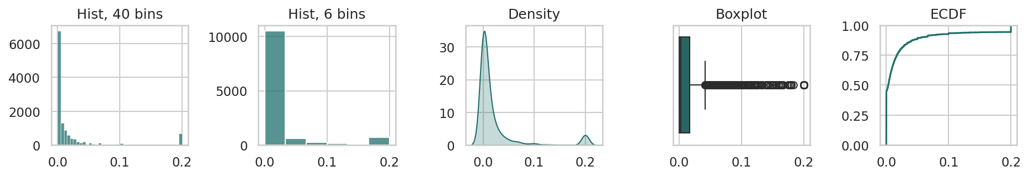

Example 3 — Categorical variables: frequency tables and imbalance
For a categorical variable the frequency table is the analysis. Cardinality and imbalance recorded here change the split and the metric in Module 4.
for c in ["VisitorType", "Weekend"]:
vc = df[c].value_counts()
tab = pd.DataFrame({"count": vc, "share_%": (vc/len(df)*100).round(2)})
print(f"--- {c}\n{tab.to_string()}\n")
print("target imbalance:", f"{df[TARGET].mean()*100:.1f}% positive")
print("-> a model predicting 'no purchase' always would be "
f"{(1-df[TARGET].mean())*100:.1f}% accurate. Accuracy is the wrong metric here.")
Output
--- VisitorType
count share_%
VisitorType
Returning_Visitor 10551 85.570
New_Visitor 1694 13.740
Other 85 0.690
--- Weekend
count share_%
Weekend
False 9462 76.740
True 2868 23.260
target imbalance: 15.5% positive
-> a model predicting 'no purchase' always would be 84.5% accurate. Accuracy is the wrong metric here.

Example 4 — Comparing distributions across the target
The univariate question becomes useful when asked separately per group: which variables actually separate converting sessions from the rest?
cols = ["PageValues", "ProductRelated", "BounceRates", "ExitRates"]
cmp = df.groupby(TARGET)[cols].median().T
cmp.columns = ["no purchase", "purchase"]
print(cmp.round(3).to_string())
fig, ax = plt.subplots(1, 4, figsize=(11.5, 2.4))
for a, c in zip(ax, cols):
sns.boxplot(data=df, x=TARGET, y=c, ax=a, showfliers=False); a.set_title(c); a.set_xlabel("")
plt.tight_layout()
Output
no purchase purchase
PageValues 0.000 16.758
ProductRelated 16.000 29.000
BounceRates 0.004 0.000
ExitRates 0.029 0.016
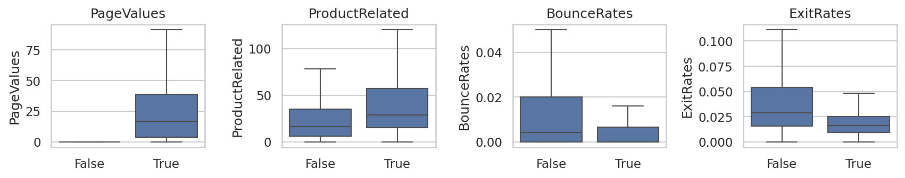

Key terms
Non-graphical EDA · Graphical EDA · Anscombe's quartet · Kernel density estimate · ECDF · Zero-inflation · Multimodality · Class imbalance

Common errors to avoid
- Presenting a single histogram without checking a second bin width
- Trusting a KDE that extends past the physical limits of the variable
- Using a boxplot alone on data that turns out to be bimodal
- Failing to record class imbalance during univariate analysis

Readings — all free to access
- seaborn — visualising distributions
https://seaborn.pydata.org/tutorial/distributions.html
- NIST/SEMATECH — graphical techniques
https://www.itl.nist.gov/div898/handbook/eda/eda.htm
- Berkeley Data 100 — EDA notes
https://ds100.org/course-notes/

Test yourself
- Two variables share a mean and standard deviation. Name two plots that would distinguish them.
- A rate variable's KDE shows density below zero. What went wrong?
- Why is a spike at exactly zero worth more attention than a point in the far tail?
- At 15% positive class, what accuracy does a model that never predicts positive achieve?

