L9-10 — Bivariate relationships

L9-10 — Bivariate relationships
DATA209 · Advanced Exploratory Data Analysis
Vidyashilp University · School of Engineering and Technology
BTech Hons. (Data Science), Semester III
Week 5 | Module 2 — Core Advanced EDA | Outcome CO2
Slides: DATA209_Module_2_Core_Advanced_EDA.pptx, pages 11–20 | Laboratory: P9-10

Topics covered
- Correlation and covariance
- Scatterplots and what they hide
- Relationships between categorical variables

Notes

Covariance and correlation
Covariance is the average product of paired deviations from the two means. Its sign gives the direction; its magnitude is uninterpretable because it carries the units of both variables. Changing metres to centimetres changes the number without changing the relationship.
Correlation is covariance divided by the two standard deviations: bounded in [−1, 1], unitless, and therefore comparable across pairs. That comparability is the entire point.

Choosing a coefficient
Coefficient | Measures | Use when | Robust
Pearson r | linear association | both continuous, roughly linear | no
Spearman ρ | monotonic association on ranks | non-linear but consistently increasing; ordinal | yes
Kendall τ | concordance of pairs | small samples; many ties | yes
Cramér's V | association between categoricals | two nominal variables | n/a
Correlation ratio η | categorical vs numeric | group means differ across a category | partly
Comparing Pearson with Spearman is a cheap non-linearity test: a large gap means the relationship is monotonic but not straight.

Correlation is not causation, and not shape
Correlation measures co-movement. It says nothing about which variable moved first, or whether a third moved both. And it says nothing about shape — hence the rule:
A correlation coefficient reported without its scatterplot is an unverified claim.
Five patterns worth naming when you look: linear, non-linear (Pearson understates it), heteroscedastic (spread widens along the axis), clustered (a single correlation over all points is meaningless — split first), and outlier-driven (a few points create or destroy the association; recompute without them and compare).

Relationships involving categories
- Numeric vs categorical — grouped boxplots or violins; compare medians and spreads, not just
means. Quantify with a group-means table.
- Categorical vs categorical — cross-tabulation with row or column percentages, never raw
counts. Quantify with chi-square, then Cramér's V for strength.
Percentages beat counts: 20 purchases from 40 sessions beats 100 from 1,000, and raw counts hide that. Always report the denominator alongside the rate.
With 12,330 rows almost every chi-square test returns a significant p-value. Read the effect size, not the p-value.

From pattern to hypothesis
A hypothesis names a mechanism, predicts a direction, and states what would falsify it.
- Weak: "Glucose is related to the outcome." This restates the correlation and predicts nothing.
- Better: "Elevated fasting glucose precedes diagnosis, so glucose will separate the classes better
than BMI — falsified if the separation vanishes after conditioning on age."
Name the confounders you cannot rule out with this data. Age confounds almost everything in the Pima dataset; the promotional calendar is unobserved in the shoppers dataset.

Worked examples
Every example below was executed against the course datasets; the output shown is the real result, not an illustration. The primary dataset is Online Shoppers Purchasing Intention (12,330 sessions × 18 columns, UCI). Run the setup block once, then any example.

Setup — run this first
import warnings; warnings.filterwarnings("ignore")
import numpy as np, pandas as pd
import matplotlib.pyplot as plt, seaborn as sns
pd.set_option("display.width", 108)
pd.set_option("display.float_format", lambda v: f"{v:,.3f}")
sns.set_theme(style="whitegrid")
RANDOM_STATE = 42
np.random.seed(RANDOM_STATE)
df = pd.read_csv("online_shoppers_intention.csv") # 12,330 x 18
TARGET = "Revenue"
num = df.select_dtypes(include=[np.number]).columns.tolist()

Example 1 — Covariance carries units; correlation does not
Covariance changes when you change units, which makes its magnitude uninterpretable. Correlation is covariance standardised, and that is why it is the one you report.
a, b = df["ProductRelated"], df["ProductRelated_Duration"]
print(f"covariance (as recorded) : {np.cov(a, b)[0,1]:,.1f}")
print(f"covariance (duration in hours): {np.cov(a, b/3600)[0,1]:,.1f}")
print(f"correlation (as recorded) : {a.corr(b):.4f}")
print(f"correlation (duration in hours): {a.corr(b/3600):.4f}")
print("\nThe covariance moved by a factor of 3,600. The relationship did not.")
Output
covariance (as recorded) : 73,274.7
covariance (duration in hours): 20.4
correlation (as recorded) : 0.8609
correlation (duration in hours): 0.8609
The covariance moved by a factor of 3,600. The relationship did not.

Example 2 — Pearson vs. Spearman — a cheap non-linearity test
Pearson measures straight-line association; Spearman works on ranks. A large gap between them says the relationship is real but not linear.
d = df[num + [TARGET]].copy(); d[TARGET] = d[TARGET].astype(int)
cmp = pd.DataFrame({"pearson": d.corr()[TARGET].drop(TARGET),
"spearman": d.corr(method="spearman")[TARGET].drop(TARGET)})
cmp["gap"] = (cmp["spearman"] - cmp["pearson"]).abs()
print(cmp.reindex(cmp["gap"].sort_values(ascending=False).index).round(3).to_string())
print("\nLargest gaps = monotonic but non-linear. Those are transformation candidates (L23-24).")
Output
pearson spearman gap
PageValues 0.493 0.626 0.134
Administrative_Duration 0.094 0.164 0.070
ProductRelated_Duration 0.152 0.217 0.064
ExitRates -0.207 -0.254 0.047
Informational_Duration 0.070 0.112 0.042
ProductRelated 0.159 0.199 0.040
Administrative 0.139 0.168 0.029
Informational 0.095 0.114 0.019
OperatingSystems -0.015 -0.027 0.013
Browser 0.024 0.016 0.008
SpecialDay -0.082 -0.087 0.005
TrafficType -0.005 -0.001 0.004
Region -0.012 -0.015 0.003
BounceRates -0.151 -0.149 0.002
Largest gaps = monotonic but non-linear. Those are transformation candidates (L23-24).

Example 3 — The correlation matrix, and what to plot next
Rank the pairs, then plot the top few. Plotting every pair blindly wastes time and hides the finding among the noise.
corr = df[num].corr()
pairs = (corr.where(np.triu(np.ones(corr.shape), k=1).astype(bool))
.stack().rename("r").reset_index())
pairs.columns = ["var_1", "var_2", "r"]
print("most correlated predictor pairs")
print(pairs.reindex(pairs["r"].abs().sort_values(ascending=False).index)
.head(5).round(3).to_string(index=False))
fig, ax = plt.subplots(figsize=(6.2, 4.4))
sns.heatmap(corr, mask=np.triu(np.ones_like(corr, dtype=bool)), cmap="RdBu_r",
center=0, vmin=-1, vmax=1, annot=True, fmt=".2f",
annot_kws={"size": 6}, cbar_kws={"shrink": .7}, ax=ax)
plt.tight_layout()
Output
most correlated predictor pairs
var_1 var_2 r
BounceRates ExitRates 0.913
ProductRelated ProductRelated_Duration 0.861
Informational Informational_Duration 0.619
Administrative Administrative_Duration 0.602
Administrative ProductRelated 0.431
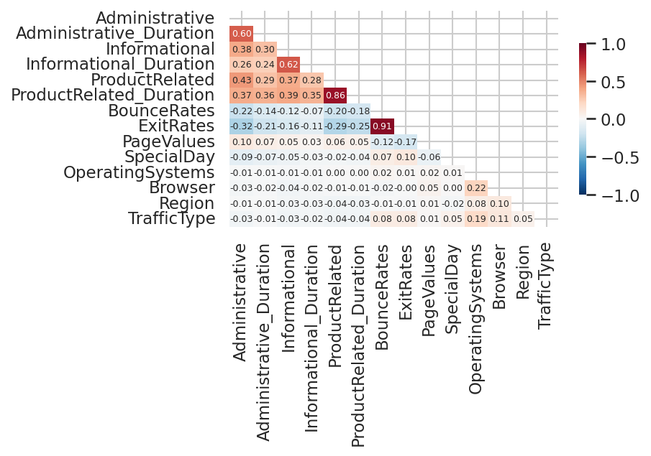

Example 4 — Categorical relationships: percentages, not counts
Raw counts compare groups of different sizes and mislead. Row percentages answer the question; chi-square says whether an association exists and Cramer's V how strong.
from scipy.stats import chi2_contingency
tab = pd.crosstab(df["VisitorType"], df[TARGET])
pct = pd.crosstab(df["VisitorType"], df[TARGET], normalize="index") * 100
print("counts\n" + tab.to_string())
print("\nrow percentages\n" + pct.round(2).to_string())
for c in ["VisitorType", "Weekend", "Month"]:
t = pd.crosstab(df[c], df[TARGET])
chi2, p, _, _ = chi2_contingency(t)
v = np.sqrt(chi2 / (t.values.sum() * (min(t.shape) - 1)))
print(f"{c:14} chi2={chi2:9.1f} p={p:.3g} Cramers V={v:.3f}")
print("\nWith 12,330 rows nearly everything is 'significant'. Read the effect size.")
Output
counts
Revenue False True
VisitorType
New_Visitor 1272 422
Other 69 16
Returning_Visitor 9081 1470
row percentages
Revenue False True
VisitorType
New_Visitor 75.090 24.910
Other 81.180 18.820
Returning_Visitor 86.070 13.930
VisitorType chi2= 135.3 p=4.27e-30 Cramers V=0.105
Weekend chi2= 10.4 p=0.00127 Cramers V=0.029
Month chi2= 384.9 p=2.24e-77 Cramers V=0.177
With 12,330 rows nearly everything is 'significant'. Read the effect size.

Key terms
Covariance · Pearson correlation · Spearman correlation · Kendall tau · Cramér's V · Heteroscedasticity · Cross-tabulation · Chi-square test · Effect size · Confounder

Common errors to avoid
- Running Pearson correlation on a nominal or ordinal column
- Reporting a correlation without plotting the pair
- Comparing raw counts across groups of very different sizes
- Treating a small p-value on 12,000 rows as evidence of a large effect

Readings — all free to access
- scikit-learn — clustering and metrics
https://scikit-learn.org/stable/modules/clustering.html
- seaborn — relational and categorical plots
https://seaborn.pydata.org/tutorial.html
- James et al. — Introduction to Statistical Learning
https://www.statlearning.com/

Test yourself
- Pearson r = 0.15 and Spearman ρ = 0.61 for the same pair. What does that tell you?
- Why is covariance rarely reported directly?
- Two categories show conversion rates of 50% and 10%. What must you also report?
- Rewrite 'sales correlate with advertising' as a falsifiable hypothesis.

