**Dictionary Practice Problems**

1. Write a program in the following steps

a. Roll a die and find the number between 1 to 6

b. Repeat the Die roll and find the result each time

c. Store the result in a dictionary

d. Repeat till any one of the number has reached 10 times

e. Find the number that reached maximum times and the one that was for minimum times

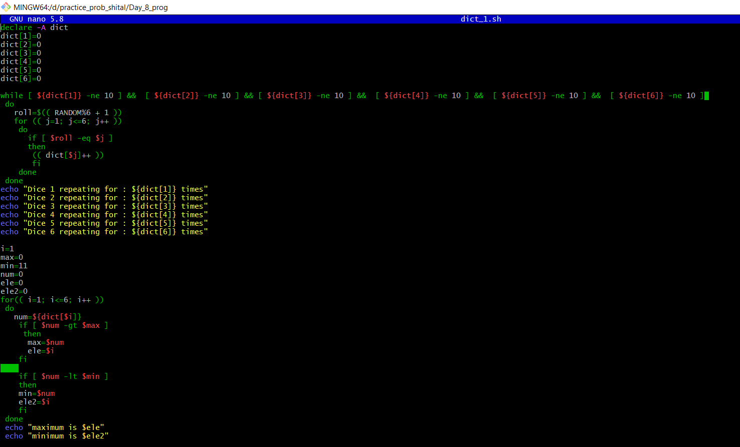

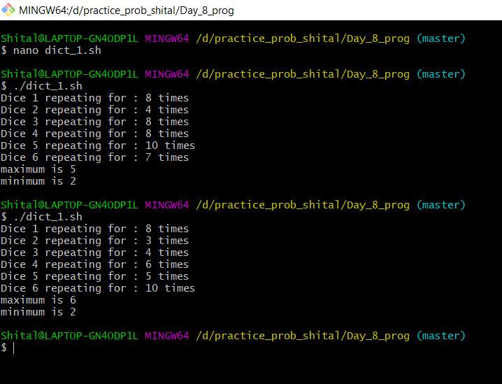

2. Write a Program to generate a birth month of 50 individuals between the year 92 & 93. Find all the individuals having birthdays in the same month. Store it to finally print.

