**POC1**

To create node js app with folder structure

**Step 1 🡪 npm init**

Creates package.json

Give entry file name in “main”

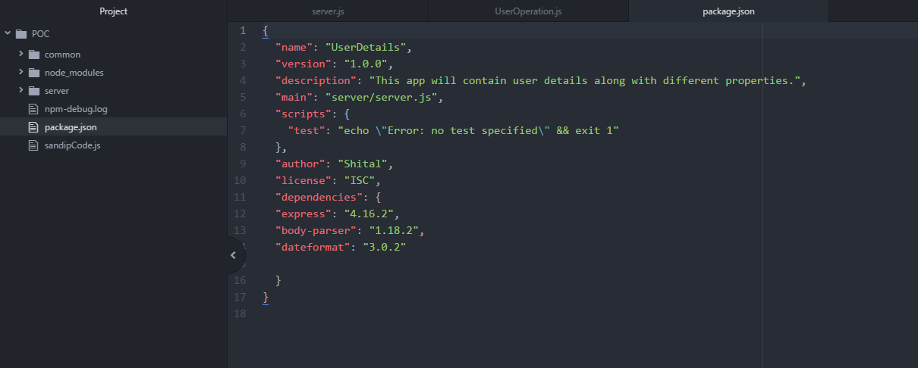

**2 Server.js is the entry file**

It will start the server and require routing file will call routing file flow

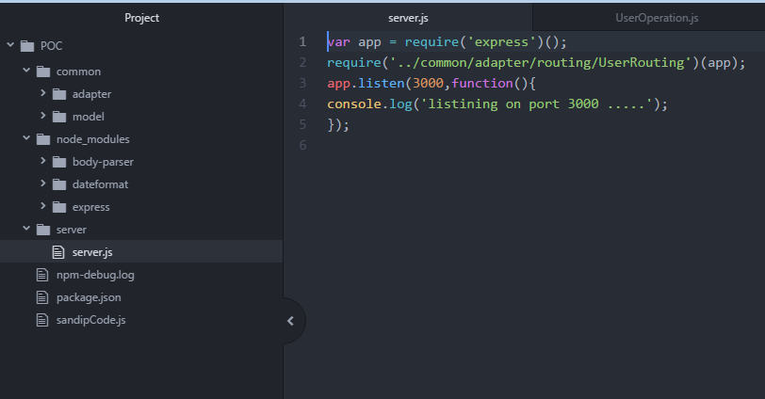

**3 user.json file is sample data file**

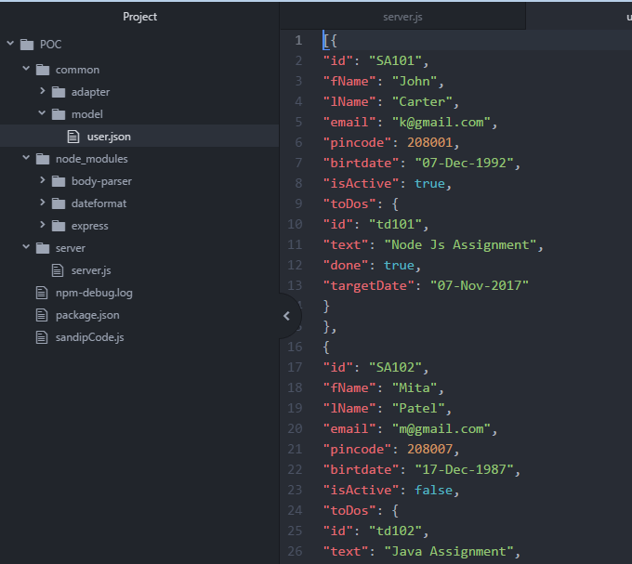

**4** This is the **routing file** called from server.js

This needs whole module.exports and function(app) is important as we are going to use app inside this 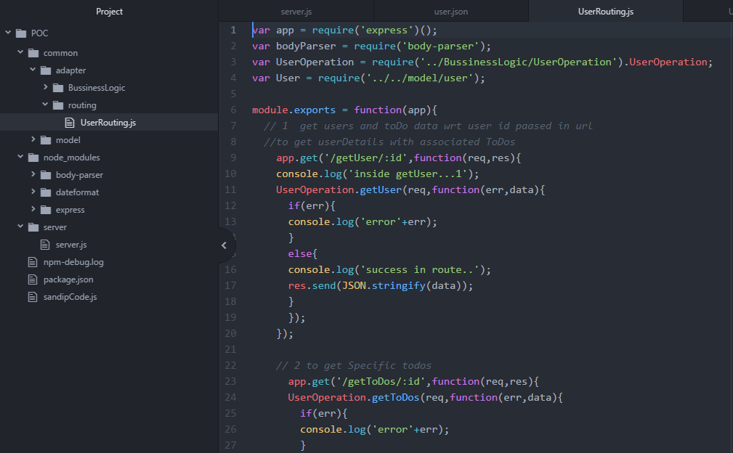

5 This is **business logic file** called from routing .

UserOperation modules needs to exports.

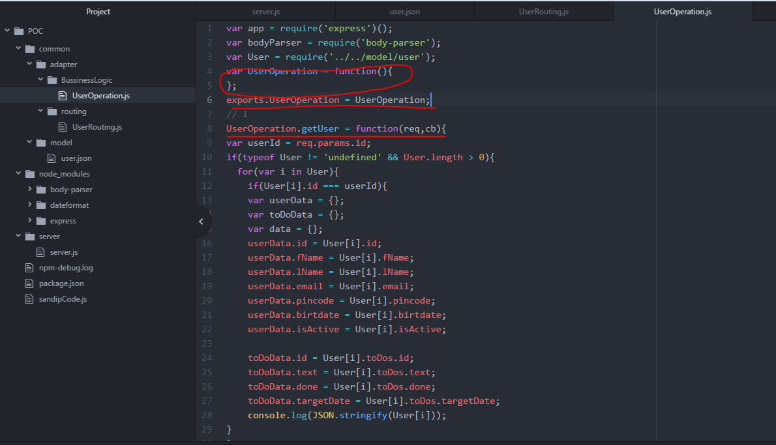

User json file

[{

"id": "SA101",

"fName": "John",

"lName": "Carter",

"email": "k@gmail.com",

"pincode": 208001,

"birtdate": "07-Dec-1992",

"isActive": true,

"toDos": {

"id": "td101",

"text": "Node Js Assignment",

"done": true,

"targetDate": "07-Nov-2017"

}

},

{

"id": "SA102",

"fName": "Mita",

"lName": "Patel",

"email": "m@gmail.com",

"pincode": 208007,

"birtdate": "17-Dec-1987",

"isActive": false,

"toDos": {

"id": "td102",

"text": "Java Assignment",

"done": false,

"targetDate": "31-Oct-2017"

}

},

{

"id": "SA103",

"fName": "Neha",

"lName": "Shekh",

"email": "n@gmail.com",

"pincode": 238001,

"birtdate": "07-Dec-1992",

"isActive": true,

"toDos": {

"id": "td103",

"text": "Node Js requirement",

"done": true,

"targetDate": "01-Nov-2017"

}

}

]

UserRouting.js file

var app = require('express')();

var bodyParser = require('body-parser');

var UserOperation = require('../BussinessLogic/UserOperation').UserOperation;

var User = require('../../model/user');

module.exports = function(app){

// 1 get users and toDo data wrt user id paased in url

//to get userDetails with associated ToDos

app.get('/getUser/:id',function(req,res){

console.log('inside getUser...1');

UserOperation.getUser(req,function(err,data){

if(err){

console.log('error'+err);

}

else{

console.log('success in route..');

res.send(JSON.stringify(data));

}

});

});

// 2 to get Specific todos

app.get('/getToDos/:id',function(req,res){

UserOperation.getToDos(req,function(err,data){

if(err){

console.log('error'+err);

}

else{

console.log('success in route..');

res.send(JSON.stringify(data));

}

});

});

// 3 to get all active users

app.get('/getActiveUsers',function(req,res){

UserOperation.getActiveUsers(req,function(err,data){

if(err){

console.log('error'+err);

}

else{

console.log('success in route..');

res.send(JSON.stringify(data));

}

});

});

}

UserOpeartion.js file

var app = require('express')();

var bodyParser = require('body-parser');

var User = require('../../model/user');

var UserOperation = function(){

};

// 1

UserOperation.getUser = function(req,cb){

var userId = req.params.id;

if(typeof User != 'undefined' && User.length > 0){

for(var i in User){

if(User[i].id === userId){

var userData = {};

var toDoData = {};

var data = {};

userData.id = User[i].id;

userData.fName = User[i].fName;

userData.lName = User[i].lName;

userData.email = User[i].email;

userData.pincode = User[i].pincode;

userData.birtdate = User[i].birtdate;

userData.isActive = User[i].isActive;

toDoData.id = User[i].toDos.id;

toDoData.text = User[i].toDos.text;

toDoData.done = User[i].toDos.done;

toDoData.targetDate = User[i].toDos.targetDate;

console.log(JSON.stringify(User[i]));

}

}

}

data.userData = userData;

data.toDoData = toDoData;

console.log('data is ....'+JSON.stringify(data));

cb(null,data);

}

// 2 get specific ToDos

UserOperation.getToDos = function(req,cb){

var toDoId = req.params.id;

if(typeof User != 'undefined' && User.length > 0){

for(var i in User){

if(User[i].toDos.id === toDoId){

var userData = {};

var toDoData = {};

var data = {};

toDoData.id = User[i].toDos.id;

toDoData.text = User[i].toDos.text;

toDoData.done = User[i].toDos.done;

toDoData.targetDate = User[i].toDos.targetDate;

data.toDoData = toDoData;

}

}

}

console.log('data is ....'+JSON.stringify(data));

cb(null,data);

}

// 3 get all active users

UserOperation.getActiveUsers = function(req,cb){

var dataActiveArray =[];

var userId = req.params.id;

if(typeof User != 'undefined' && User.length > 0){

for(var i in User){

if(User[i].isActive === true){

var userData = {};

var toDoData = {};

var data = {};

userData.id = User[i].id;

userData.fName = User[i].fName;

userData.lName = User[i].lName;

userData.email = User[i].email;

userData.pincode = User[i].pincode;

userData.birtdate = User[i].birtdate;

userData.isActive = User[i].isActive;

toDoData.id = User[i].toDos.id;

toDoData.text = User[i].toDos.text;

toDoData.done = User[i].toDos.done;

toDoData.targetDate = User[i].toDos.targetDate;

data.userData = userData;

data.toDoData = toDoData;

dataActiveArray.push(data);

}

}

}

cb(null,dataActiveArray);

}

exports.UserOperation = UserOperation;

sfsa