Hibernate

(of a person) remain inactive or indoors for an extended period

Hibernate Framework

Hibernate framework simplifies the development of java application to interact with the database. Hibernate is an open source, lightweight, [ORM (Object Relational Mapping)](http://en.wikipedia.org/wiki/Object-relational_mapping) tool.

An ORM tool simplifies the data creation, data manipulation and data access. It is a programming technique that maps the object to the data stored in the database.

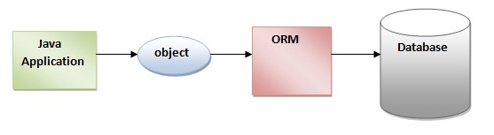

The ORM tool internally uses the JDBC API to interact with the database.

Advantages of Hibernate Framework

There are many advantages of Hibernate Framework. They are as follows:

**1) Opensource and Lightweight:** Hibernate framework is opensource under the LGPL license and lightweight.

**2) Fast performance:** The performance of hibernate framework is fast because cache is internally used in hibernate framework. There are two types of cache in hibernate framework first level cache and second level cache. First level cache is enabled bydefault.

**3) Database Independent query:** HQL (Hibernate Query Language) is the object-oriented version of SQL. It generates the database independent queries. So you don't need to write database specific queries. Before Hibernate, If database is changed for the project, we need to change the SQL query as well that leads to the maintenance problem.

**4) Automatic table creation:** Hibernate framework provides the facility to create the tables of the database automatically. So there is no need to create tables in the database manually.

**5) Simplifies complex join:** To fetch data form multiple tables is easy in hibernate framework.

**6) Provides query statistics and database status:** Hibernate supports Query cache and provide statistics about query and database status.

**Struts** is an open source framework that extends the**Java** Servlet API and employs a Model, View, Controller (MVC) architecture. It enables you to create maintainable, extensible, and flexible web applications based on standard technologies, such as JSP pages, JavaBeans, resource bundles, and XML.

**Hibernate** is a persistence framework and is used to persist Java objects in a relational database. **Spring** can be used to wire all this together and to provide declarative transaction management

**MVC** Pattern stands for **Model-View-Controller** Pattern. This pattern is used to separate application's concerns. Model - Model represents an object or **JAVA** POJO carrying data. It can also have logic to update controller if its data changes.

Spring

Servlet

***Jenkins***

Jenkins is an open-source **continuous** integration software tool written in the Java programming language for testing and reporting on isolated changes in a larger code base in real time. The software enables developers to find and solve defects in a code base rapidly and to automate testing of their builds.

**Jenkins** is the leading open-source continuous integration tool developed by Hudson lab. It is cross-platform and can be used on Windows, Linux, Mac OS and Solaris environments.

Jenkins is a powerful application that allows continuous integration and continuous delivery of projects, regardless of the platform you are working on. It is a free source that can handle any kind of build or continuous integration. You can integrate Jenkins with a number of testing and deployment technologies.

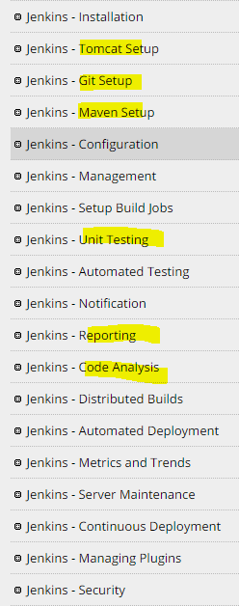

***Maven***

**Maven** is a build automation tool used primarily for **Java** projects. The word **maven** means "accumulator of knowledge" in Yiddish.**Maven** addresses two aspects of building software: first, it describes how software is built, and second, it describes its dependencies.

Why Maven is used in eclipse?

**Maven** is a powerful project management tool that is based on POM (project object model). It is **used** for projects build, dependency and documentation. It simplifies the build process like ANT. But it is too much advanced than ANT

What is a POM XML file?

A Project Object Model or **POM** is the fundamental unit of work in Maven. It is an **XML** file that contains information about the project and configuration details used by Maven to build the project. It contains default values for most projects.

Why do we use build tools?

A **build tool** can be run on the command or inside an IDE, both triggered by you. ... As a Java developer, the most popular **build tools** are Ant and Maven. Both can be run in IDEs like IntelliJ or Eclipse or NetBeans. They can also be **used** by continuous integration **tools** like Cruise Control or Hudson

Angular.js

React.js