Service Fee Collection Software

After successful installation of the software, you will find an exe file by the name "ServiceFee.exe" in the installed directory.

When you run the program for the first time (till you feed the outstanding details of at least one Unit), the following Dialog box will be displayed, wherein you have to enter the 12 digit Member ID.

Pic 1
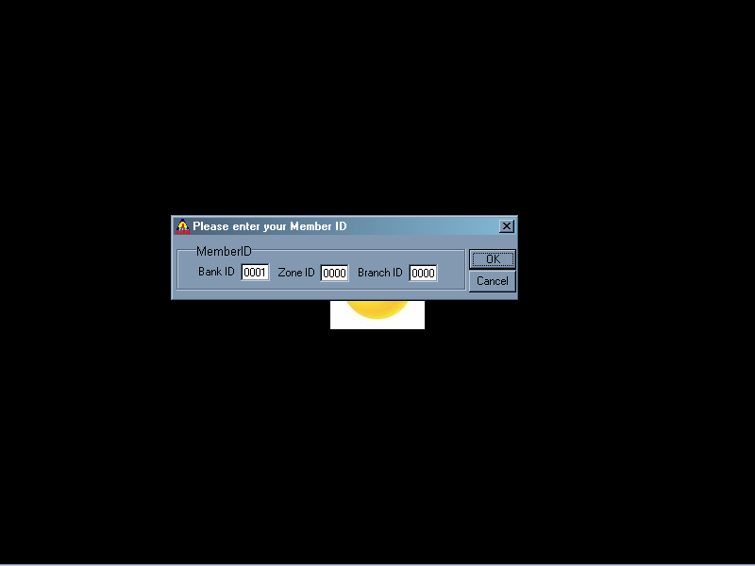

After entering the Member ID, click on OK button (or "Enter" key) to proceed further, which shows a dialog box (Pic 2) using which you can feed the data. If invalid Member ID is entered, it shows the same message and prompts you to enter the correct Member ID. When "Cancel" button is clicked, the application is terminated.
Pic 2:
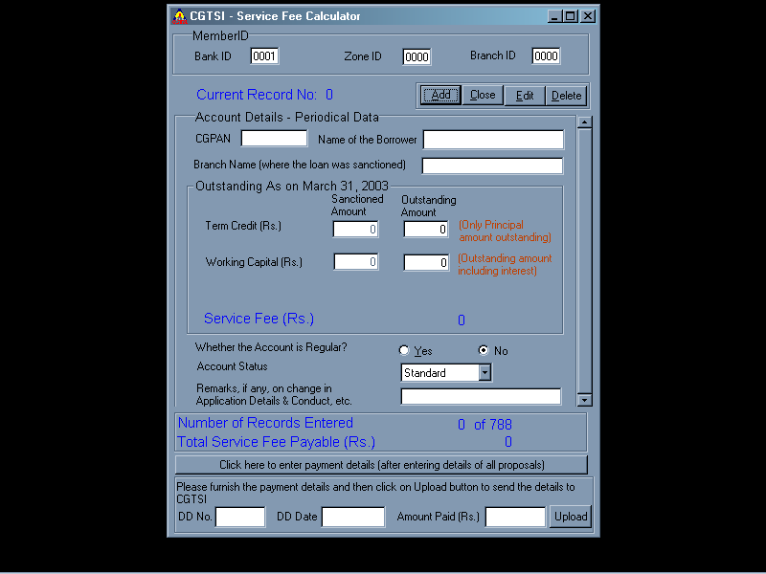
This Dialog box (Input Screen) contains the following fields:

Sl. No | Field Label | Field Type | Input Reqd? | Remarks
1 | Member ID | Numeric | Display Item | Value is split into Bank ID, Zone ID and Branch ID.
2 | CGPAN | Alpha Numeric | Yes | Pl enter the CGPAN of the Unit for which you wish to feed the Outstanding (as on 31/03/2002) details
3 | Name of the Borrower | Alpha Numeric | No | The SSI Unit name will be automatically displayed for the given CGPAN, when it is valid. Otherwise, an error is displayed stating that the CGPAN is invalid
4 | Branch Name | Alpha | Yes | Name of the Branch that has sanctioned this loan.
Outstanding Details as on 31/03/2003
Note: The Outstanding Term Credit should not include the Interest portion.
5 | Service Fee | Numeric | Display | Displays the Service Fee Payable in respect of the current input. The amount is rounded off to the nearest Re.
6 | Whether the Account is regular? | Boolean | Selection | Select either "Yes" or "No" depending on the status
7 | Account Status | List | Selection | Whether the account is 'Standard', 'Substandard', 'Doubtful' or 'Loss'
8 | Remarks, if any, on changes in Application Details & Conduct, etc. | Alpha Numeric | Input | Any Remarks the user may want to furnish regarding the conduct of the unit or any other details pertaining to the unit
9 | DD No | Number | Input | The service fee has to be paid by way of Demand Draft favouring 'CGTSI' payable at Mumbai. You need to enter the DD No in this field.
10 | DD Date | Date | Input | Date of Demand Draft
11 | Amount Paid | Number | Input | Though amount paid is shown as 'Total Service Fee Payable', the user is required to enter the value again. It should be equal to the value suggested by the abovementioned label.

Sr. No | Button Label | Functionality | Remarks
1 | Add | Click this button to Add a new entry | This is a toggle button, i.e., this changes as "Save" button once clicked
2 | Save | Click this button to save the entry | After clicking, this button changes back to "Add" button
3 | Edit | To edit current record, click this button | This button changes as "Save" button. This button is disabled when "Add" button is clicked
4 | Delete | To delete current record, click this button | This button is disabled when "Add" button is clicked
5 | Close | To exit from the Application, use this button | This button changes to "Cancel" button when one of "Add" or "Edit" is clicked
6 | Cancel | To cancel the current "Add", "Edit" operation | The "Close" button changes to "Cancel" button when "Add" or "Edit" is clicked.
7 | Click here to enter payment details | To display / hide the fields pertaining to payment details entry. | Payment details are to be entered after entering outstanding details of all the proposals
8 | Upload | Click this button to Upload the details to CGTSI | Please ensure that the Internet connectivity is available before trying to upload the data.
Note: In the field label, one letter appears underlined. Using the combination of "Alt + letter underlined" is similar to clicking on that button using mouse. This combination acts as a shortcut key.

e.g.: "Add" button → Click Alt + A as shortcut.

