Assemblies
Assemblies are the building blocks of .NET Framework applications. An assembly is a collection of types and resources that are built to work together and form a logical unit of functionality. An assembly provides the common language runtime with the information it needs to be aware of type implementations. To the runtime, a type does not exist outside the context of an assembly.
Every project after compilation will generate an output file known as assembly. The name of an assembly file will be same as the project name. The assembly corresponding to a project will be present under bin\Debug folder of that project folder. Assemblies are known as units of deployment because once the project development is completed what we carry and install on the client systems is the assembly files only. The extension of an assembly file will be either .exe (executable) or .dll (dynamic link library).
Windows Forms Applications, Console Applications, WPF Applications and Windows Services projects will generate an .exe assembly. Class Library and Windows Forms Control Library projects will generate a .dll assembly.
Exe assemblies are known as in-process components which were capable of running on their own as well as provide the support for others to execute. When we work with project templates like Windows Forms Applications, Console Applications, WPF Applications and Windows Services they generate an exe assembly when compiled.
Dll assemblies are known as out-process components which were not capable of running on their own they can only support others to execute. When we work with project templates like Class Library and Windows Forms Control Library they generate a dll assembly when compiled.
Note: every application is a blend of both .dll and .exe assemblies combined together to give better efficiency.
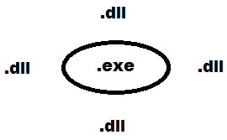
Assemblies are of 2 types:
- Private Assemblies 2. Shared Assemblies
Private Assemblies:
By default every assembly is private, if reference of these assemblies was added to any project; a copy of the assembly is created and given to that project, so that each project maintains a private copy of that assembly.
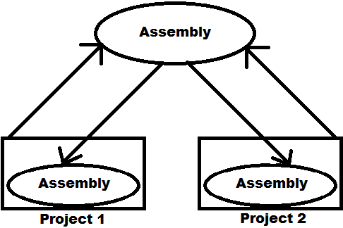
Creating an assembly to test it is by default private:
Open a new project of type Class Library and name it as “PAssembly”, which will by default come with a class Class1 under the file Class1.cs. Now write the following code under the class:
public string SayHello() {
return "Hello from private assembly.";
}
Now compile the project by opening the Solution Explorer, right click on the project and select “Build” which will compile and generate an assembly with the name as PAssembly.dll.
Note: we can find path of assembly in the output window present at bottom of the studio after build.
Testing the assembly we have created:
Open a new project of type Windows, name it as “TestPAssembly”, place a button on Form and set its text as “Call SayHello() Method of Class1 in PAssembly.dll”. Now add the reference of PAssembly.dll from its physical location and write the following code under click of button:
PAssembly.Class1 obj = new PAssembly.Class1();
MessageBox.Show(obj.SayHello());
Run the project to test it, then go and verify under bin/debug folder of current project where we can find a copy of PAssembly.dll as it is private assembly.

Note: the advantage of a private assembly is faster execution as it was in the local folder, whereas the draw back was multiple copies gets created when multiple projects adds the reference to consume it.
Shared Assemblies:
If we intend to use an assembly among several applications private assemblies are not feasible, in such cases we can install it into a centralized location known as the global assembly cache. Each computer where the common language runtime is installed has this machine-wide code cache. The global assembly cache stores assemblies specifically designated to be shared by several applications on the computer. All BCL assemblies are shared .dll assemblies only, so we can find them under GAC. If an assembly is shared multiple copies of the assembly will not be created even if being consumed by multiple projects, only a single copy under GAC serves all the projects.
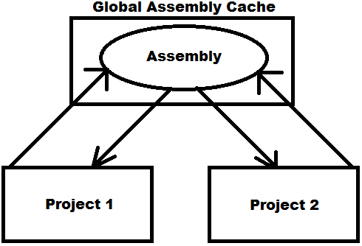
Note: administrators often protect the Windows directory using an access control list (ACL) to control write and execute access. Because the global assembly cache is installed in the Windows directory, it inherits that directory's ACL. It is recommended that only users with Administrator privileges be allowed to add or delete files from the global assembly cache.
Managing assemblies in Global Assembly Cache:
To manage assemblies in GAC like install, un-install and view we are provided with a tool known as Gacutil.exe (Global Assembly Cache Tool). This tool is automatically installed with Visual. To run the tool, use the Visual Studio Command Prompt. These utilities enable you to run the tool easily, without navigating to the installation folder. To use Global Assembly Cache on your computer: On the taskbar, click Start, click All Programs, click Visual Studio, click Visual Studio Tools, and then click Visual Studio Command Prompt and type the following:
gacutil [/i | /u | /l] <assembly name>
/i: Install
/u: Un-install
/l: List
Note: assemblies deployed in the global assembly cache must have a strong name. When an assembly is added to the global assembly cache, integrity checks are performed on all files that make up the assembly.
Strong Name:
A strong name consists of the assembly's identity - its simple text name, version number, and public key.

- Name: it was the name of an assembly used for identification. Every assembly by default has name.
- Version: software’s maintain versions for discriminating changes that has been made from time to time. As an assembly is also a software component it will maintain versions, whenever the assembly is created it has a default version for it i.e. 1.0.0.0, which can be changed when required.
- Public Key: as GAC contains multiple assemblies in it, to identify each assembly it will maintain a key value for the assembly known as public key, which should be generated by us and associate with the assembly to make it Strong Named.

You can ensure that a name is globally unique by signing an assembly with a strong name. In particular, strong names satisfy the following requirements:
Strong names guarantee name uniqueness by relying on unique key pairs. No one can generate the same assembly name that you can. Strong names protect the version lineage of an assembly.
A strong name can ensure that no one can produce a subsequent version of your assembly. Users can be sure that a version of the assembly they are loading comes from the same publisher that created the version the application was built with.
Strong names provide a strong integrity check. Passing the .NET Framework security checks guarantees that the contents of the assembly have not been changed since it was built.

Generating a Public Key:
To sign an assembly with a strong name, you must have a public key pair. This public cryptographic key pair is used during compilation to create a strong-named assembly. You can create a key pair using the Strong Name tool (Sn.exe) from visual studio command prompt as following:
sn -k <file name>
E.g.: sn -k Key.snk
Note: the above statement generates a key value and writes it into the file “Key.snk”. Key pair files usually have .snk extension.
Creating a Shared Assembly:

Step 1: generate a public key. Open VS command prompt, go into your folder and generate a public key as following: <drive>:\<folder> sn -k key.snk

Step 2: develop a new project and associate the key file to it before compilation so that the assembly which is generated will be Strong Named.
To do this open a new project of type Class Library, name it as “SAssembly” and write the following code under the class Class1:

public string SayHello() {
return "Hello from shared assembly 1.0.0.0";
}
To associate key file we have generated with the project, open project properties window, select Signing tab on LHS, which displays a CheckBox as “Sign the Assembly” select it, now in the ComboBox below select browse, select the key.snk file from its physical location which adds the file under solution explorer, then compile the project using “Build” option that will generate SAssembly.dll which is Strong Named.
Step 3: installing assembly into GAC by using the “Global Assembly Cache Tool”.
To install the assembly into open Visual Studio Command Prompt, go to the location where SAssembly.dll was present and write the following:
<drive>:\<folder\SAssembly\SAssembly\bin\Debug> gacutil -i SAssembly.dll

Step 4: testing the Shared Assembly.
Open a new project of type Windows, name it as “TestSAssembly”, place a button on the form and set its text as “Call SayHello method of Class1 in SAssembly.dll 1.0.0.0”. Now add reference of SAssembly.dll from its physical location and write the following code under click of button:
SAssembly.Class1 obj = new SAssembly.Class1();
MessageBox.Show(obj.SayHello());
Run the project, test it and verify under bin/debug folder of current project where we will not find any copy of SAssembly.dll as it is shared assembly.
Versioning Assemblies:
Every assembly is associated with a set of attributes that describes about general info of an assembly like Title, Company, Description, Version etc. These attributes will be under AssemblyInfo.cs file of each project. To view them expand properties node under the project in Solution Explorer where we find AssemblyInfo.cs file. We can change values of any attribute as per our requirements. In bottom of the file we find an attribute “AssemblyVersion” which is a combination of 4 values:
- Major Version
- Minor Version
- Build Number
- Revision
The default version of every assembly is 1.0.0.0; we can change the version no. of an assembly whenever we make modifications to the code under assembly.

Testing the process of changing version no of an assembly:
Open the SAssembly project we have developed earlier and add a new method under the class Class1 as following:
public string SayHello(string name) {
return "Hello from shared assembly 1.0.1.0";
}
Now open “AssemblyInfo.cs” file and change the AssemblyVersion and AssemblyFileVersion attributes to 1.0.1.0, re-build the project and add the new version of SAssembly.dll also into GAC using the Gacutil Tool.
Note: GAC allows placing of multiple versions of an assembly in it and provides different applications using different versions of the assembly to execute correctly using their required version. Now open the GAC folder where we find 2 versions of SAssembly i.e. 1.0.0.0 and 1.0.1.0

Assemblies and Side-by-Side Execution:
Side-by-side execution is the ability to store and execute multiple versions of an application or component on the same computer. Support for side-by-side storage and execution of different versions of the same assembly is an integral part of strong naming and is built into the infrastructure of the runtime. Because the strong-named assembly's version number is part of its identity, the runtime can store multiple versions of the same assembly in the global assembly cache and load those assemblies at run time. To test this open a new project of type Windows, name it as “TestSAssemblyNew”, place a button on the form and set its text as “Call SayHello method of Class1 in SAssembly.dll 1.0.1.0”. Now add reference of SAssembly 1.0.1.0 version from its physical location and write the following code under click of button:
SAssembly.Class1 obj = new SAssembly.Class1();
MessageBox.Show(obj.SayHello(“Raju”));
To check side by side execution of projects run the exe files of TestSAssembly and TestSAssemblyNew projects at the same time, where each project will use its required version of SAssembly and execute, as following:
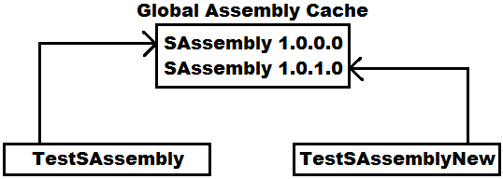
Multi-Module Assemblies:
If you are programming with .Net framework, you will deal with Assemblies all the time. After all, assemblies are the building blocks of .Net framework. Assemblies can have single file, or can have multiple files. We typically refer an assembly with multiple files as Multi-Module Assembly, and each file as a module. The main advantage of multi-module assemblies is we can combine modules written in different languages into one single assembly.
A multi-module assembly is divided into 2 parts like Main-Module and Sub-Modules where we can have only one main module and all the other are sub-modules. First we need to compile the sub-module files each individually by using their corresponding compilers, so that they will generate an output file with the extension as .netmodule and then we need to compile the main-module file by adding all the sub-modules we compiled to it, so that it generates and assembly file with an extension of either .exe or .dll.
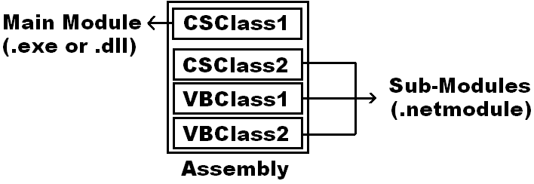
Note: here any file or class can be chosen as main module and rest of the others will become sub-modules.

Developing a Multi-Module Assembly:
Currently there is no tool can create the assembly from source code written in different languages. Those sources have to be compiled into modules by the corresponding compilers, and then a separate tool will merge them into a single assembly. To test this process first define two classes in 2 separate .net languages using notepad as following:
Imports System using System;
Namespace MyNSP namespace MyNsp {
Public Class VBTest public class CSTest {
Public Function SayHello() As String public string SayHello() {
Return "Hello from Visual Basic Language" return “Hello from Visual CSharp Lang”;
End Function }
End Class }
End Namespace }
Compiling Sub-Modules:
vbc /target:module <vb file name>
csc /target:module <cs file name>

Compiling Main-Module:
vbc [/target:library] /addmodule:<list of sub modules> <vb file name>
csc [/target:library] /addmodule:<list of sub modules> <cs file name>

Note: if /target:library is used it will generate a .dll assembly or else will generate a .exe assembly, but to generate a .exe assembly we need to define Main method under the main-module class.

Making VBTest as a Sub-Module:
drive:\folder> vbc /target:module VBTest.vb

Making CSTest as a Main-Module:
drive:\folder> csc /target:library /addmodule:VBTest.netmodule CSTest.cs
Consuming the multi-module assembly:
Open a new project of type windows and name it as TestMulti, place 2 buttons on the form and set the text as “Call SayHello() of CSTest” and “Call SayHello() of VBTest”. Now add reference of the CSTest.dll we have generated above from its physical location and write the following code under click of the buttons:

Under “Call SayHello() of CSTest” Button:
MyNSP.CSTest obj = new MyNSP.CSTest(); MessageBox.Show(obj.SayHello());

Under “Call SayHello() of VBTest” Button:
MyNSP.VBTest obj = new MyNSP.VBTest(); MessageBox.Show(obj.SayHello());
Globalization and Localization using Satellite Assemblies:
In the past, the term localization often referred to a process that began after an application developer compiled the source files in the original language. Another team then began the process of reworking the source files for use in another language. The original language, for example, might be English, and the second language might be German. That approach, however, is prohibitively expensive and results in inconsistencies among versions. It has even caused some customers to purchase the original-language version instead of waiting months for the localized version. A more cost effective and functional model divides the process of developing world-ready applications into three distinct parts, globalization, localizability, and localization. The primary advantages of designing and implementing your application to be sensitive and appropriate to regional conventions, data in a variety of world languages, and alternate format are:
- You can launch your application onto the market more rapidly. No additional development is necessary to localize an application once the initial version is complete.
- You use resources more efficiently. Implementing world-readiness as part of the original development process requires fewer development and testing resources than if you add the support after the initial development work starts.
- Your application is easier to maintain.

Globalization: it is the process of designing and developing a software product that functions in multiple cultures/locales. This process involves:
- Identifying the culture/locale that must be supported
- Designing features which support those cultures/locales
- Writing code that functions equally well in any of the supported cultures/locales

In other words, globalization adds support for input, display, and output of a defined set of language scripts that relate to specific geographic areas. The most efficient way to globalize these functions is to use the concept of cultures/locales. A culture/locale is a set of rules and a set of data that are specific to a given language and geographic area. These rules and data include information on:
- Date and time formatting
- Numeric, currency, weight, and measure conventions
- Sorting rules

Localizability: it is an intermediate process for verifying that a globalized application is ready for localization. In an ideal situation, this is only a quality assurance phase. If you designed and developed your application with an eye towards localization, this phase will primarily consist of localizability testing.
Localizability is also the process of preparing an application for localization. An application prepared for localization has two conceptual blocks, a data block and a code block. The data block exclusively contains all the user-interface string resources. The code block exclusively contains only the application code applicable for all cultures/locales. In theory, you can develop a localized version of your application by changing only the data block. The code block for all cultures/locales should be the same. The combination of the data block with the code block produces a localized version of your application. The keys to successful world-ready software design and subsequent localization success is separation of the code block from the data block. Once localizability is complete, your application is ready for localization.

Localization: it is the process of adapting a globalized application, which you have already processed for localizability, to a particular culture/locale. The localization process refers to translating the application user interface (UI) or adapting graphics for a specific culture/locale. The localization process can also include translating any help content associated with the application.

Culture: the utmost basic entity in this scenario is Culture usually called as CultureInfo provides information about a specific culture. The information includes the names for the culture, the writing system, the calendar used, and formatting for dates and sort strings. The CultureInfo class renders culture-specific information, such as the associated language, sublanguage, country/region, calendar, and cultural conventions.
The CultureInfo class present under the System.Globalization specifies a unique name for each culture which is a combination of a two-letter lowercase culture code associated with a language and a two-letter uppercase subculture code associated with a country or region. Examples include ja-JP for Japanese (Japan), en-US for English (United States), fr-FR for French (France), hi-IN for Hindi (India) and te-In for Telugu (India) etc.
When object of this class is created by passing the culture name as a parameter will change the culture of our application, i.e. if we make an application in English culture, and create an object of CultureInfo class for French language, and automatically everything will start working in French.
To develop culture neutral application, for each culture’s UI the text we want to see over the forms, we will have to define the translations explicitly and this information is known as resources, and they exist in the form of .resx files. These are XML files and to manage them there are classes listed under System.Resources namespace.

To develop an application for Globalization and Localization, open a new project of type windows, name the project as “MultiLang” and design the form as following:
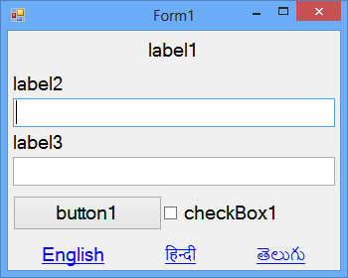
Now add 3 resources files under the project from the “Add New Item” window naming them as “MyRes.en-US.resx”, “MyRes.hi-IN.resx” and “MyRes.te-IN.resx” and enter the text for Labels, Button and Checkbox separately for each language under the resources files as following:

Name Value (MyRes.en-US.resx) Value (MyRes.hi-IN.resx) Value (MyRes.te-IN.resx)
L1 Sign in साइन इन करें సైన్ ఇన్ చేయండి
L2 Username उपयोगकर्ता नाम వినియోగదారు పేరు
L3 Password पासवर्ड పాస్‌వర్డ్
B1 Sign in साइन इन करें సైన్ ఇన్ చేయండి
CB1 Stay signed in साइन इन रहें సైన్ ఇన్ చేసి ఉండండి
Note: while naming the resource files we need to adopt a pattern that is <base name>.<culture name>, where base name is a common name for all the resource files (MyRes in our case). These resource files once after compilation of the project will be converted into assemblies and we call those assemblies as satellite assemblies.

using System.Reflection; using System.Resources; using System.Globalization;
Declarations: CultureInfo ci; ResourceManager rm;
Under Form Load: rm = new ResourceManager("MultiLang.MyRes", Assembly.GetExecutingAssembly());
private void GetValues() {
label1.Text = rm.GetString("L1", ci); label2.Text = rm.GetString("L2", ci); label3.Text = rm.GetString("L3", ci);
button1.Text = rm.GetString("B1", ci); checkBox1.Text = rm.GetString("CB1", ci);
}
Under English Link Label: ci = new CultureInfo("en-US"); GetValues();
Under Hindi Link Label: ci = new CultureInfo("hi-IN"); GetValues();
Under Telugu Link Label: ci = new CultureInfo("te-IN"); GetValues();
ResourceManager class under the System.Resources namespace is used for accessing the culture specific information at runtime by reading the values from resource files.
System.Resources.ResourceManager(string baseName, Assembly assembly)
baseName is the root name of the resource files without its extension but including the fully qualified namespace name.
Assembly is the main assembly for the resource, to get that use the method GetExecutingAssembly() under Assembly class of System.Reflection namespace.
Note: after compilation and execution of the project, now go and verify under the bin\Debug folder of the current project where we find a separate folder created for each resource file, with the culture name and in that folder we find the satellite assemblies that got created.
In general, an assembly consists of four elements:
- The assembly manifest, which contains assembly metadata.
- Type metadata.
- Microsoft intermediate language (MSIL) code or CIL Code that implements the types.
- A set of resources.
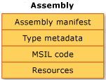
Assembly Manifest: contains information about the attributes that are associated with an assembly like Assembly Name, Version Number, Culture, Strong Name Information, List of files in the assembly etc.

Type Metadata: describes every type and member defined in your code in a language-neutral manner. Metadata stores the following information:
- Description of the assembly.
    - Identity (name, version, culture, public key).
    - Other assemblies that this assembly depends on.
    - Security permissions needed to run.
- Description of types.
    - Name, visibility, base class, and interfaces implemented.
    - Members (methods, fields, properties, events, nested types).
Metadata provides the following major benefits:
- Self-describing files, common language runtime modules and assemblies are self-describing.
- Language interoperability, metadata provides all the information required about compiled code for you to inherit a class from a file written in a different language.

MSIL Code or CIL Code: during compilation of any .net programming languages, the source code is translated into CIL code rather than platform or processor-specific code. CIL is a CPU and platform-independent instruction set that can be executed in any environment supporting the Common Language Infrastructure, such as the .NET runtime on Windows, or the cross-platform Mono runtime.
Compilation and Execution Process of a CSharp Project:
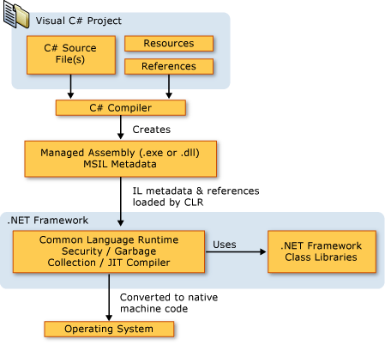
Setup and Deployment
The final stage in the development of an application is deploying the project on client machines, which should be managed carefully. To organize the things in a proper fashion and install required files on the required folders we were provided with Setup and Deployment project under .net. This has to be added under the same solution where we developed our application.

Note: Before preparing Setup for an application in the top of the Visual Studio we find a ComboBox showing the options Debug and Release, default will be Debug change it as Release and then right click on the solution node in solution explorer and Select Build, which will compile all the Projects and re-generates the assemblies again but not in the bin\Debug folder but in bin\Release folder and these assemblies will be used in the setup process.

To add Setup and Deployment Project, open “Add New Project” window and in LHS panel expand the option "Other Project Types" and also expand the “Setup and Deployment” option and select Visual Studio Installer, now in the RHS panel choose "Setup Project" and give a name to the project.
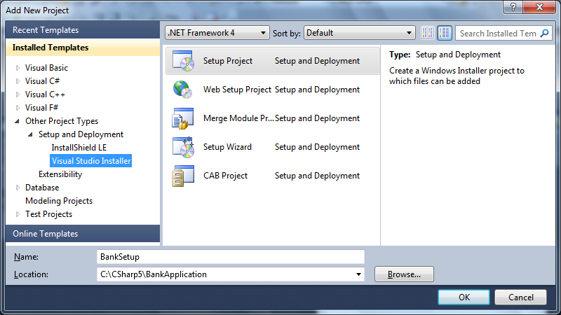
When Setup Project is selected and opened it shows the options as following:
- File System on Target Machine
  - Application Folder
  - User's Desktop
  - User's Programs Menu
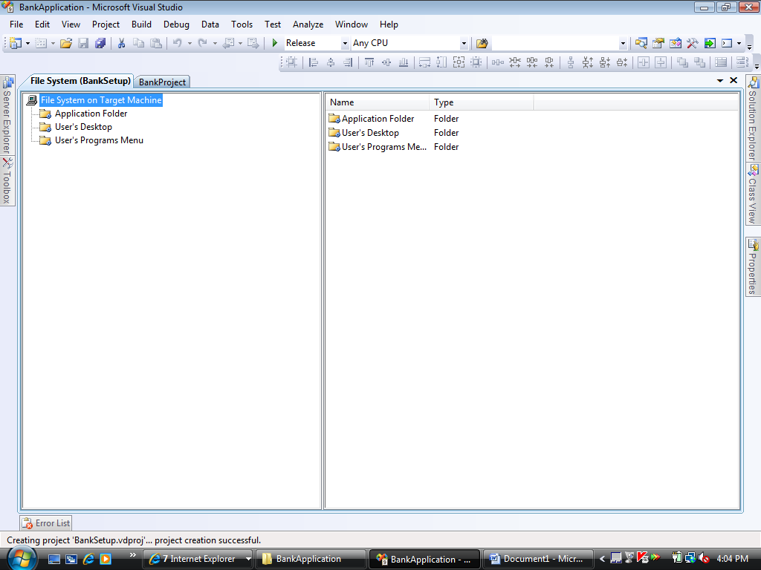
File System on Target Machine in sense the target system where the project is being installed referring to folders on that machine. Application Folder refers to the project installation folder, which has to be specified while installing. User's Desktop refers to the desktop folder of target machine. User's Programs Menu refers to the programs menu folder of target machine.
We can still add other folders referring to the target machine like Program Files, Fonts, and Global Assembly Cache Folders etc. To add a new folder right click on "File System on Target Machine" and select "Add Special Folder" which displays a list of options as below, choose the required folder from the list.
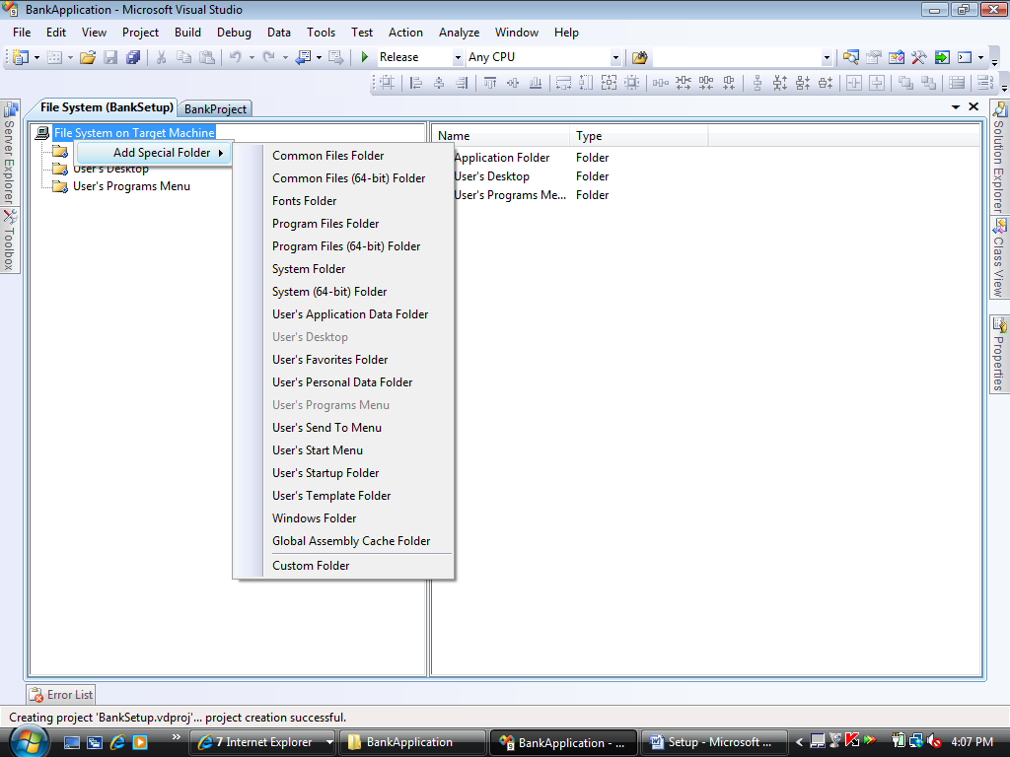
Now copy the appropriate content into the appropriate folders so that they gets installed on the target machine in appropriate locations. Under Application Folder copy the assemblies (exe’s, dll’s) that has to be installed on the target machine, to do this right click on the Application Folder and select the option Add -> Project Output as following:
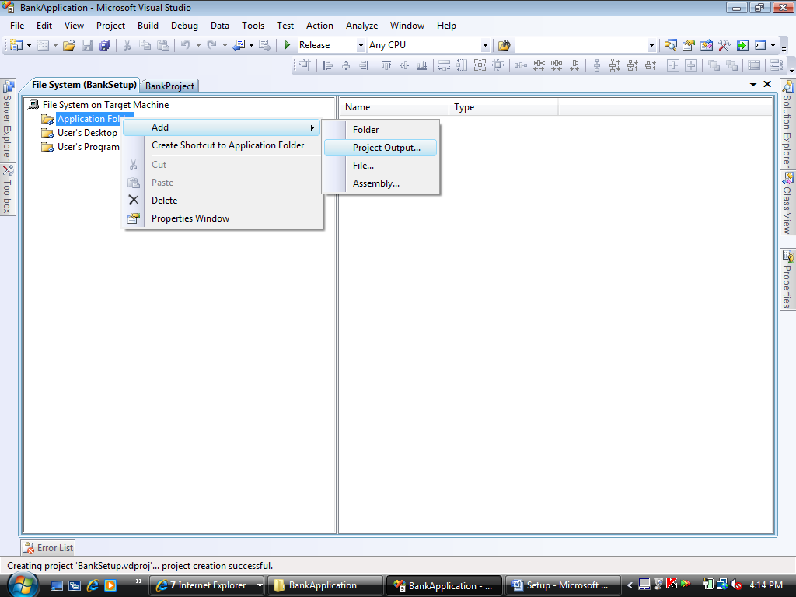
This opens a window showing the list of projects, select the exe project from it: 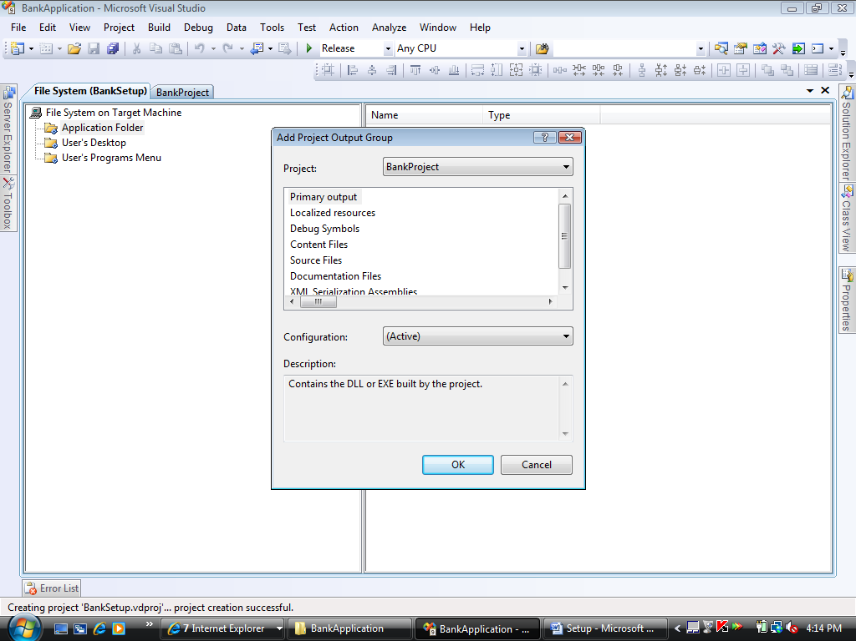
This will add the necessary exe's, dll's and config file to the project as following:
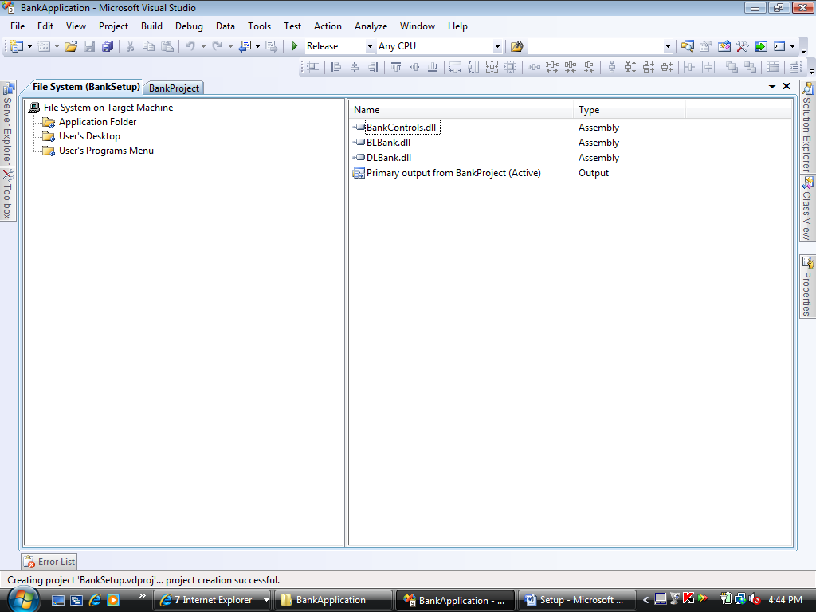
Apart from Project Output we can also choose Folder or File or Assembly and add them under the Application Folder. Add Folder is used for adding a new folder for storing any images. Add File is used for adding any help documents. Add Assembly is used for adding any assemblies that are created outside of the solution.
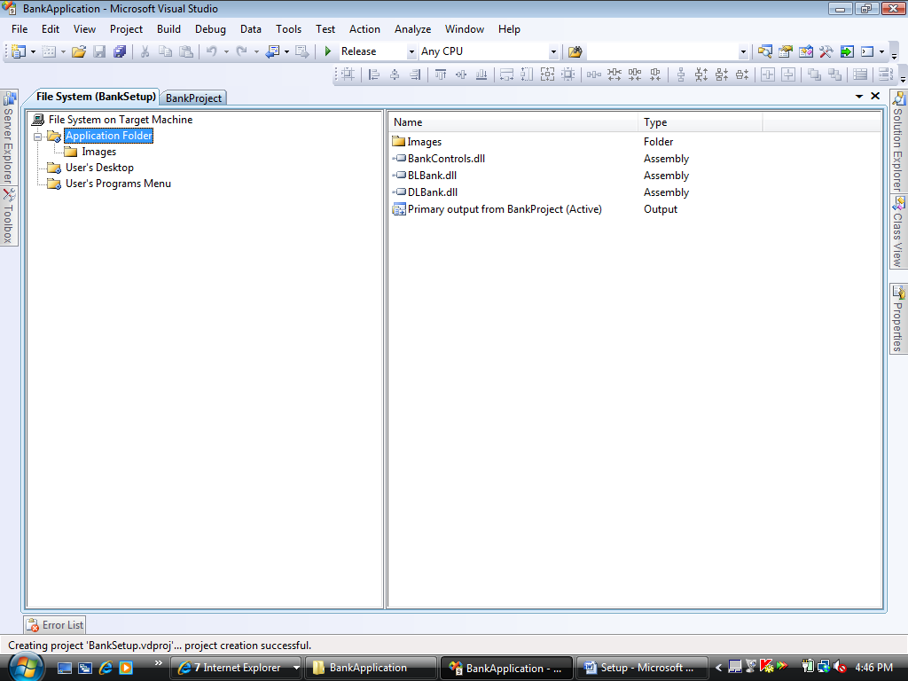
If we want any shortcuts to be created for our application and place them either on desktop or added to programs menu do the following: Right click on the exe assembly (item of type output) under the application folder and select "Create Shortcut":
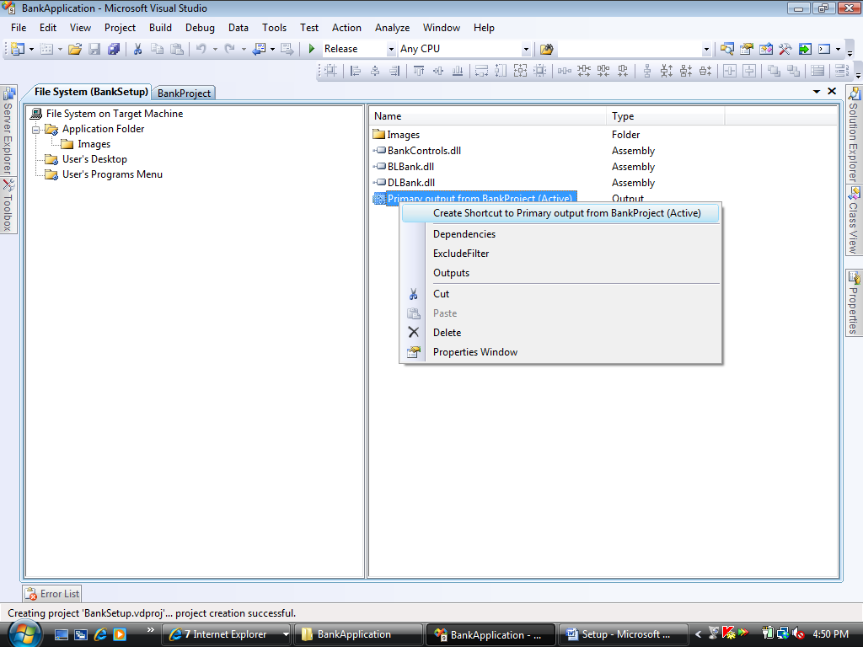
This will create a shortcut specify a name to it.
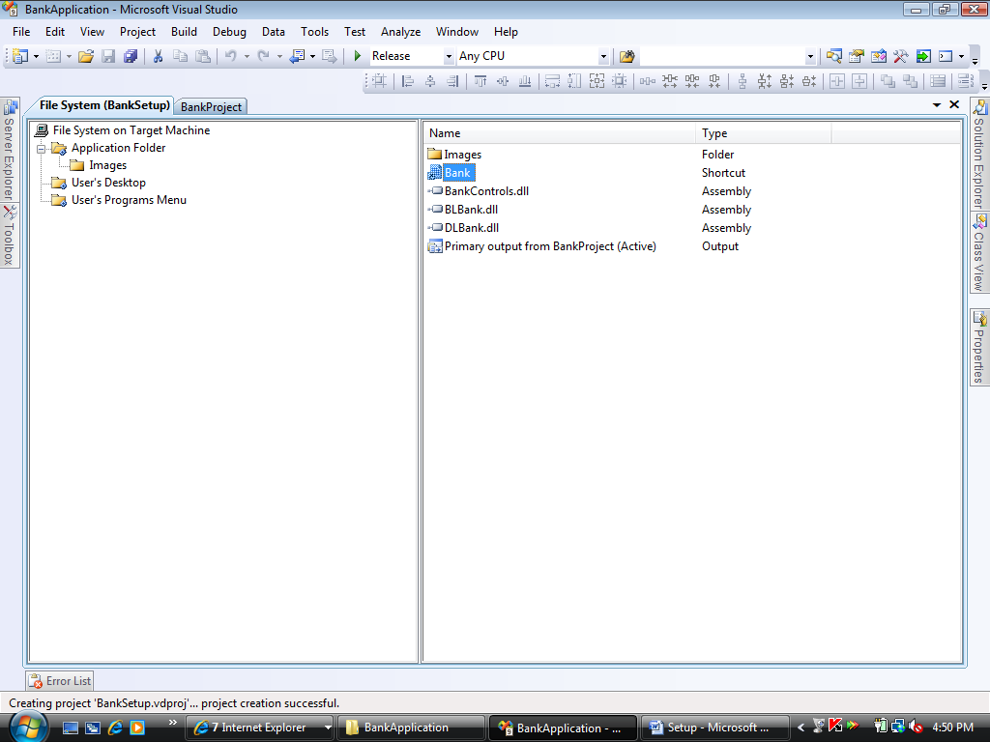
For a shortcut we need to bind an display image of type Icon (.ico), to add an icon image go to the properties of shortcut -> select icon property and select browse from the list, which opens a window -> click on browse -> select application folder -> Images folder -> click on the add file button -> select the image from its physical location -> click on ok button -> again ok button.
Now to place the short cut on desktop or program's menu folder, go to properties of shortcut again and select the property "Folder" -> click on the button beside it which opens a window, from it select user's desktop or user's programs menu folder which copies the shortcut to the selected folder.
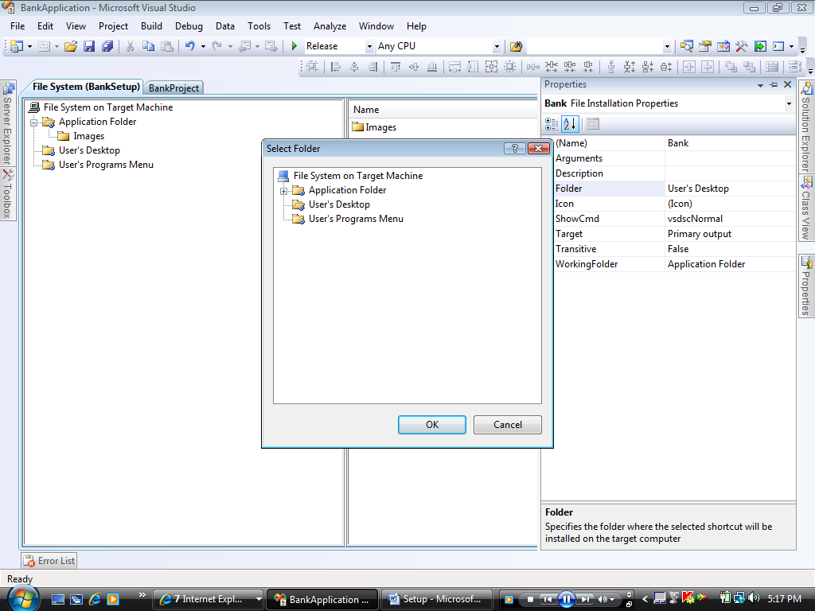
Installation additional user interface dialog boxes:
Setup project provides a number of predefined dialog boxes that you can use to display information or gather input during an installation. The following is a list of available dialog boxes. Not all dialog boxes are available for all deployment project types or for Admin installers. To view the current interfaces in the setup go to view menu -> Editor -> Select User Interface.
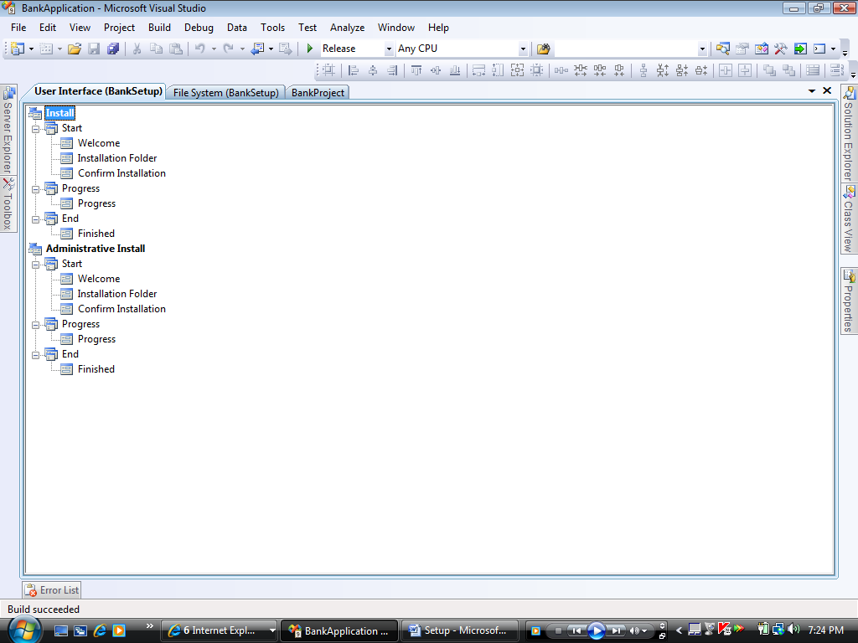
We can still add new user interfaces like Splash, License Agreement, Register User, Read Me, Customer Information etc. To add a new user interface right click on the node Start -> select add dialog which displays the list of interface, choose what u require. e.g.: Splash, License Agreement.
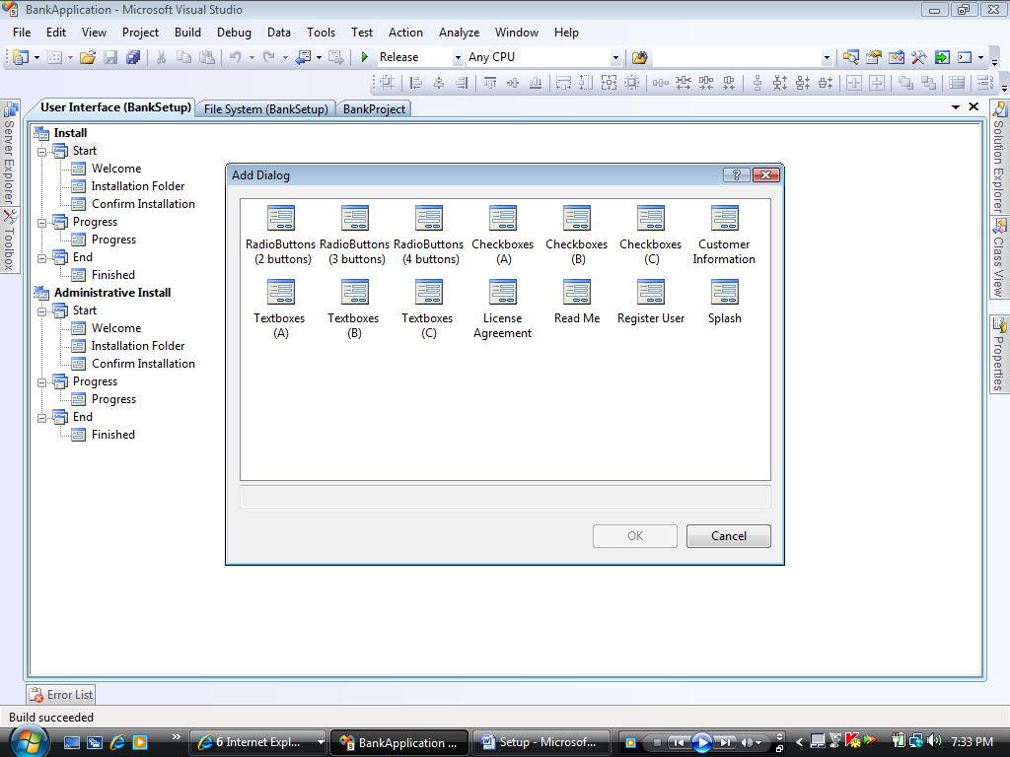
After adding required user interfaces, we can order them by right clicking on them and select MoveUp and MoveDown options.
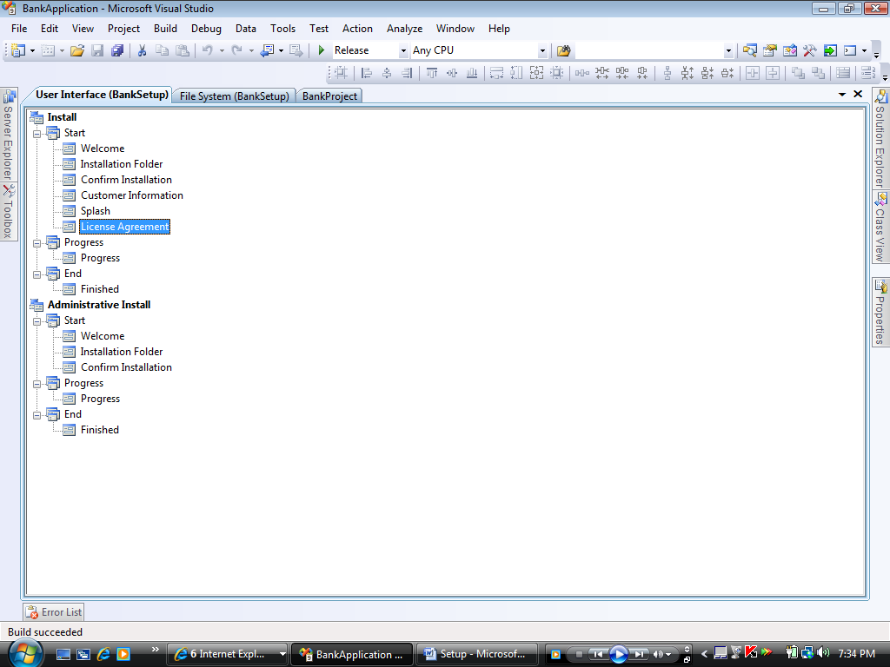

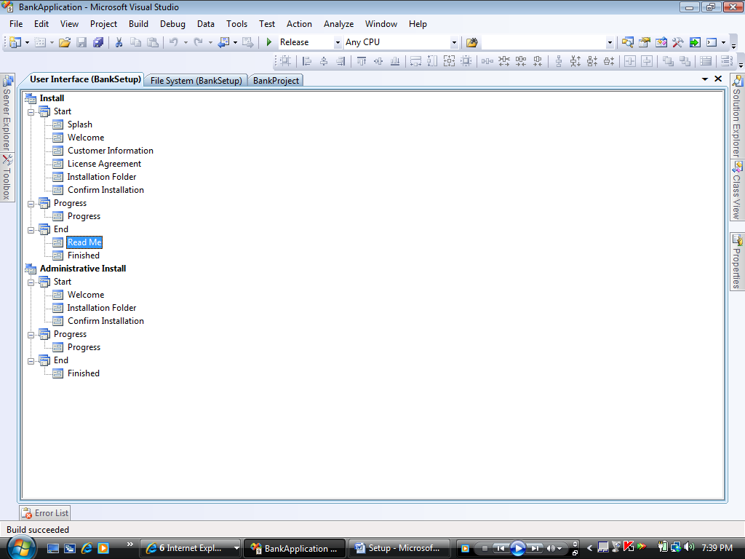
Splash requires a bitmap image to be set that has to be displayed, to set it go to the properties of splash interface -> under SplashBitmap property -> select browse -> choose an .bmp or .jpg image from its physical location same as we selected the .ico image previously for the shortcut.
License Agreement and ReadMe requires any .rtf file to be set for displaying, which needs to be added same as above using the LicenseFile property and ReadMeFile properties of the interfaces.
Customer Information will prompt for Name, Organization and Serial Number options; by default Serial Number Options will not be visible to make it visible set the ShowSerialNumber property as true:
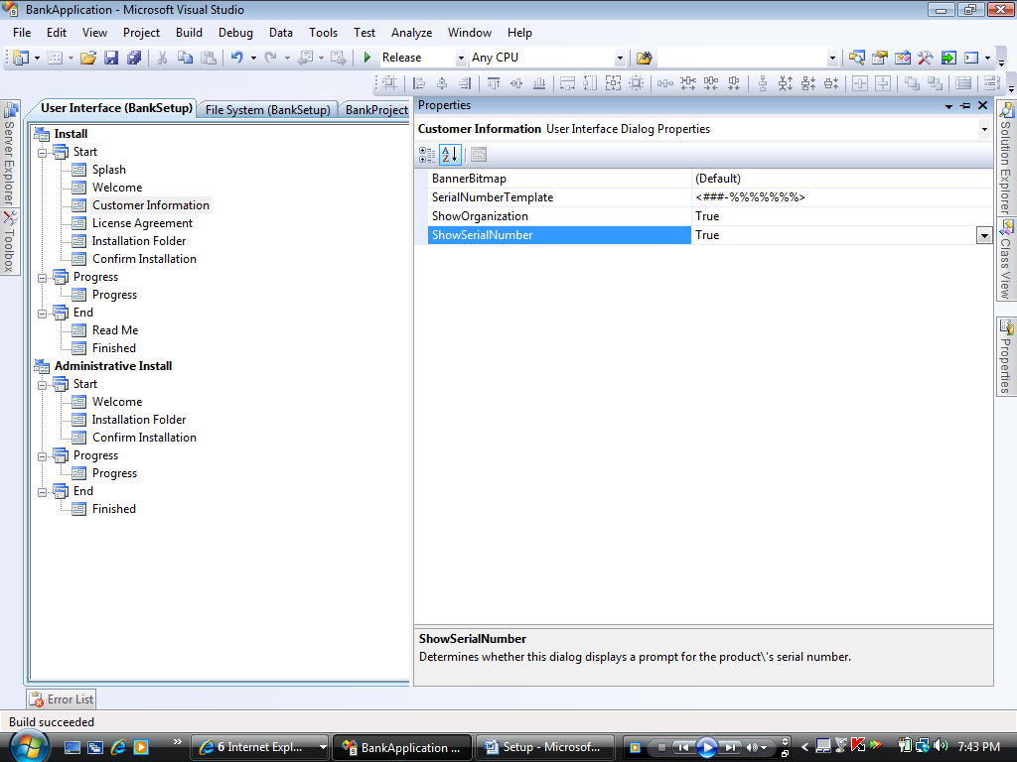
Setting the SerialNumberTemplate property to "<### - %%%%>" creates two text boxes separated by a dash surrounded by spaces. Validation for the first box (###) simply verifies that the user has entered three digits. The second box (%%%%) is validated by an algorithm that adds the digits together and divides the sum by 7. If the remainder is 0, validation succeeds; otherwise, it fails.
After configuring all the things under the Setup project, right click on the SetUp Project in the solution explorer and Select Build, which will compile all the Projects and prepare's the SetUp File which u can find them under the SetUp Projects, Release Folder which can be copied on to a CD or a DVD, which is carried to the client system for installing.

Note: Before installing the Setup on the Client Machine make sure that the .Net Framework is installed on it.
Remoting
Application Architecture’s:
While installing an application after the development of it, as per the usage of that application they adopt different architecture's for installing like:
- Single Tier Architecture: in this case the application as well as the database will be residing on the same machine for execution. So as the DB is also present on every machine changes made on 1 machine will not be reflected to the other.
- 2-Tier Architecture: in this model the application sits on all the client machines, moving the DB to a centralized location, so all the clients connect with the same DB Server to store and access data. In this model changes made on 1 machine reflects to the other.
- 3-Tier or N-Tier Architecture: in this model the application is again divided into 2 parts like: UI and Logic (Business Logic + Data Logic) and put on different machines for execution. On the client’s machine what we have is only light weight UI which will connect with the Logic sitting on application Server that in turn connects with the DB Server.
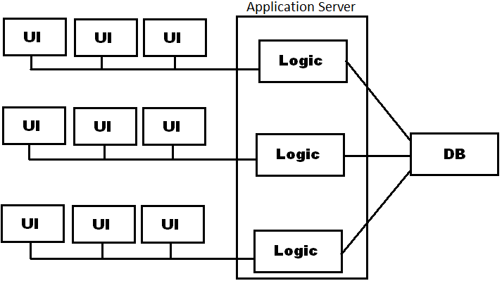
To develop a 3-Tier application in desktop model we have various distributed technologies like:
- RPC (Remote Procedure Call)
- CORBA (Common Object Request Broker Architecture)
- RMI (Remote Method Invocation (Java)-
- DCom (Distributed Component Object Model)
- Remoting (.Net Languages)
Remoting:
It is a technology from Microsoft for developing distributed applications replacing traditional DCOM available under COM. All distributed technologies speak about the same i.e. consuming of libraries present on remote machines. In .Net libraries were implemented as Assemblies, where we can consume an assembly residing on local machine by adding its reference. We can now consume Assemblies residing on remote machines also using Remoting.
Developing Remoting Application:
To develop a Remoting Application first we need to understand various things regarding the process of communication, those are:

- Serialization and De-Serialization:
To exchange information between client and server they will make use of a process known as Serialization and De-serialization. As applications represent the data in High Level (Object Format) which is not freely transferrable, needs to be converted into Low Level (Binary or Text) and then transferred to the other system where on the target machine Low Level data has to be converted back into High Level. Serialization is a process of converting high level data to low level and De-Serialization is in opposite of serialization that converts low level data to high level.
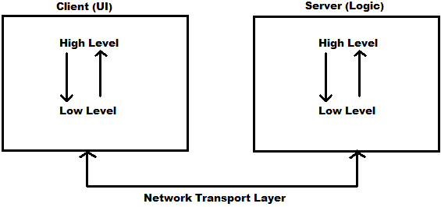
To perform serialization and deserialization remoting provides Formatter Classes under BCL, those are:
    - Binary Formatters: TCPServerChannel TCPClientChannel
    - Soap Formatters: HttpServerChannel HttpClientChannel
Binary Formatters are used for binary serialization and de-serialization and Soap Formatters are used for text serialization and de-serialization. Traditional DCOM supports only binary formatting.
- Marshalling and UnMarshalling:
After serializing the data which has to be sent to the target machine it packages the data into packets and associates IP Address of the target machine where information has to be sent which is known as Marshalling. Un-Marshalling is opposite to marshalling which open the packets of data for de-serializing.

IP-Address: Every system in a network is identified by using a unique id known as IP-Address. It is a 4 part numeric value where each part will be ranging between 0-255. E.g.: 0-255.0-255.0-255.0-255
We can mask IP Address of a system by specifying an alias name to it known as Host Name. Systems under a network will be configured as following:
IP Address Host Name
192.168.26.0 (Server)
192.168.26.1 (Nit1)
......
192.168.26.25 (nit25)
Remote Class:
In distributed application, we put libraries (assemblies) on application server which will be consumed by clients (UI), these libraries contains classes and those class objects are required for clients to invoke methods of the classes, we call these classes as remote classes and these classes must be inherited from a pre-defined class known as MarshalByRefObject of System namespace then only Serialization and De-serialization of those objects can be performed.
- Activation Models:
In execution of Remoting application clients’ needs object of remote class to invoke methods under it. Activation Models decide where the remote class objects resides in execution of the application. Remoting supports 2 different activation models:

- Server Activated Objects (SAO)
- Client Activated Objects (CAO)

In SAO model object of remote class sits on server machine and a reference of that object is maintained on client machine using which clients can invoke the methods of remote class. In CAO model the object of remote class will be present on client machine only using which clients can invoke the methods of remote class. In SAO model we were again provided with 2 types like Singleton and SingleCall.
- SingleTon:
In this case whenever a first request comes from a client an object of remote class gets created and it's reference is given to the client, from then every new request coming from a new client, server provides the reference of same object which is already created, so changes made by 1 client gets reflected to the other. Used in the development of application like public chat, cricket scores, share prices etc.
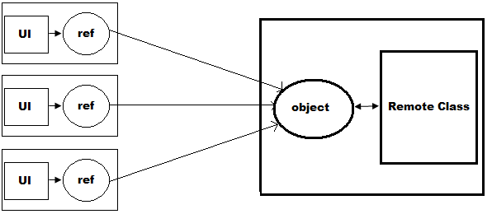
- SingleCall:
In this mode whenever a request comes from a client 1 object of remote class gets created and it's reference is given to client, once the request is served immediately object gets destroyed without allowing him to make any other requests on that object, for a new request a new object gets created again and destroyed. Used in the development of single request app like "Railway PNR Status Enquiry", "ATM Machines" and "Examination Results".
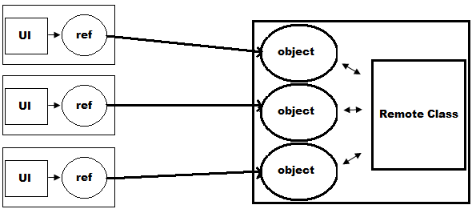
Note: this is very highly secured model used in app development.

Client Activated Objects:
In this case whenever the first request from a client an object of remote class is created and provided using which the client can make any no. of requests. Here a separate object will be given for each client so changes made by 1 client will never reflect to the other. Used in the development of applications that requires multiple requests for a single client like "Traditional ATM Machines", where we can perform multiple transactions once we insert the card.
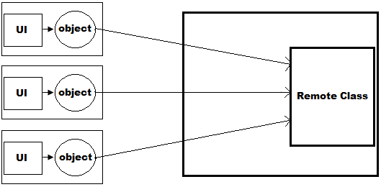
- Application Server or Remote Server:
When we want to develop an application to be consumed from remote machines we require someone to take the request from clients. To take a request from client we use server software’s, which works on the principles request and response. We can install multiple server software’s on a machine, but each server should be running on a separate logical address known as port.
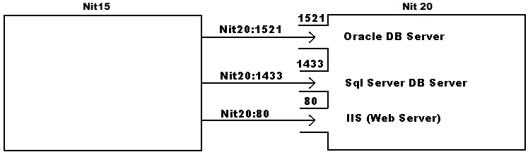
In process of developing remoting application it is our responsibility to develop a server that takes requests of clients to the Remote Class, because a class is not capable of taking the request. The server should be running on a unique port of the OS. By default every machine has port's that are ranging between 0-65535 in which 0-1023 were OS reserved ports, rest can be used by any application.
After developing a Remote Server every Remote Class on the machine has to be registered under the Server with an alias name, so that clients can send their request to required class.
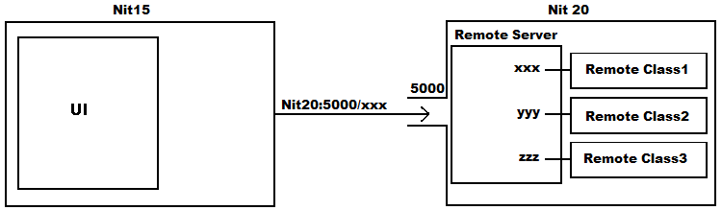
- Remote Interface:
In remoting the methods what we want to define under Remote Class, that are accessible to clients should be first declared under an interface and then implemented in remote class which was a rule. The same interface will also be provided to clients that act as a Proxy to Remote Class on client machine, which will be used in 2 ways:
- Using it client [UI] can recognize methods of remote class.
- Using it we can also hold reference of remote class on client machines.
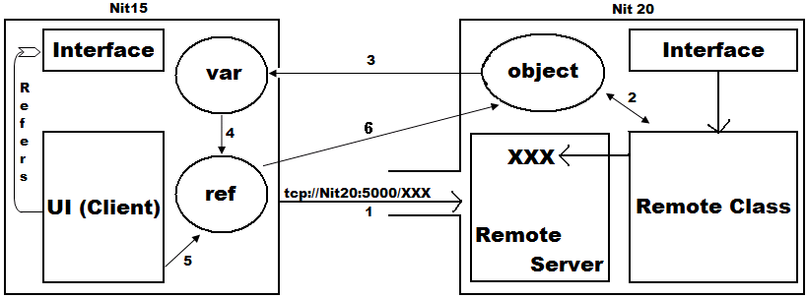
Execution of a Remoting Application:
- Client sends a request to server.
- Server creates object of Remote Class.
- Sends reference of that object to client which is captured under an interface variable.
- After capturing, the variable gets converted into reference pointing to the object on Server.
- Now UI can invoke methods on the reference.
- Method execution takes place on server machine as the reference points to object on server.
To develop a Remoting Application we require the following:
- Interface (Class Library (.dll))
- Remote Class (Class Library (.dll))
- Remote Server (Windows Service (.exe))
- Client (UI) (Windows or Console Application (.exe))
Developing an Interface:
Open a new project of type class library and name it as InterfaceProject. Delete the Class1.cs file under the project, add an Interface to the project naming it as IRemoteApp.cs, and write the following code:
public interface IRemoteApp {
string Get_Ename(int eno); decimal? Get_Balance(int custid); string SayHello();
}
Now open solution explorer and build the project which generates an assembly InterfaceProject.dll.
Developing a Remote Class:
Remote Classes needs to be inherited from MarshalByRefObject class and implement all the methods that are declared under interface. MarshalByRefObject should be the base class for objects that communicate across application domain boundaries by exchanging messages using a proxy in applications that support remoting.
Open a new project of type class library and name it as ClassProject, rename the class Class1.cs as ClsRemoteApp.cs, add reference of InterfaceProject.dll we have created previously and write the following code:
using InterfaceProject; using System.Data.SqlClient;
public class ClsRemoteApp : MarshalByRefObject, IRemoteApp {
SqlConnection con; SqlCommand cmd; int x = 0;
public ClsRemoteApp() {
con = new SqlConnection("<con str>“); cmd = new SqlCommand(); cmd.Connection = con;
}
public string Get_Ename(int eno) {
string name = null;
try {
cmd.CommandText = "Select Ename From Employee Where Eno=" + eno;
con.Open(); name = cmd.ExecuteScalar().ToString();
}
catch (Exception ex) { ex = null; } finally { con.Close(); }
return name;
}
public decimal? Get_Balance(int custid) {
decimal? balance = null;
try {
cmd.CommandText = "Select Balance From Customer Where Custid=" + custid;
con.Open(); balance = Convert.ToDecimal(cmd.ExecuteScalar());
}
catch (Exception ex) { ex = null; } finally { con.Close(); }
return balance;
}
public string SayHello() { x += 1; return "Hello: " + x; }
public string Demo() { return "Not accessible to remote clients."; }
}
Now open solution explorer and build the project to generate an assembly ClassProject.dll
Process to develop a RemoteServer:
If you want to develop a remote server that should be started along with OS, develop it as a windows service. A Windows Service is an application which runs in the background process without any knowledge to end users they will be under the control of OS and gets started when OS is started and stopped when we shut down the system. DB’s, Web Servers, etc., will be implemented as Windows Services only. Every system by default has no. of services installed on it; you can view the Services that are present on a machine making use of Services Window under Control Panel -> Administrative Tools -> Services or use services.msc under Start Menu -> Run.

Every service will have 4 attributes to it, those are:
- Display Name: It is the name for identification.
- Description: It is brief information about the service.
- Startup Type: It decides how a service gets started on the machine, which can be set with 3 options:
    - Automatic starts the services at system logon.
    - Manual starts a service as required or when called from an application.
    - Disabled completely disable the service and prevent it and its dependencies from running.
- LogOnAs (Account): Indicates the account type under which the service runs, can be set with 3 options like User, Local System and Network Service.
Note: While developing an windows service it is our responsibility to set all the above 4 attributes.
How to develop a Windows Service?
If we want to develop a windows service we can make use of "Windows Service" Project template under VS. To choose Windows Service project template, under new project Window expand the Language node i.e. Visual C# in the LHS panel and select the option Windows which displays Windows Service template on RHS panel.
Every Windows Service Class is a sub class of pre-defined class ServiceBase present under the namespace System.ServiceProcess. In a Windows Service code has to be written under few overridden methods like OnStart, OnStop, OnPause, OnContinue etc., which were declared as virtual under parent class ServiceBase. Code under OnStart executes when service is started, OnStop executes before the service is getting stopped, OnPause executes when the service is paused, OnContinue executes when the service is resumed.
After writing code in a service class we need to set the 4 attributes discussed previously, for this, under the project we are given with "Add Installer" option using which we can set the attributes. Once we build the project it will generate an exe assembly that should be installed on a machine by using "installutil" tool. Once the service is installed we can view this under Services Window.
Developing Remote Server:
Open a New Project of type Windows Service and name it as RemoteServer and add the reference of 3 assemblies to the project:
- System.Runtime.Remoting.dll (.net)
- ClassProject.dll (browse)
- InterfaceProject.dll (browse)

Now write the following code in Code View:
using System.Runtime.Remoting; using System.Runtime.Remoting.Channels;
using System.Runtime.Remoting.Channels.Tcp;
Under OnStart Method:
TcpServerChannel chan = new TcpServerChannel(5000);
ChannelServices.RegisterChannel(chan, true);
RemotingConfiguration.RegisterWellKnownServiceType(typeof(ClassProject.ClsRemoteApp), “XXX", WellKnownObjectMode.Singleton);
Now go to design view of the project, right click on it and select Add Installer which adds 2 components ServiceInstaller1 and ServiceProcessInstaller1 using which u need to set the 4 attributes of service. Under serviceProcessInstaller1 Properties set Account property as “Local System” and under serviceInstaller1 Properties set the following 3 attributes:
1. DisplayName: Remote Server
2. Description: Takes request from remote clients on Port No. 5000
3. StartupType: Automatic
Now build the project which creates an assembly RemoteServer.exe.
Installing the service on your machine:
To Install the service on a machine we were given with a command line utility "installutil", which has to be used as following: Installutil [-u] <service exe name>
Note: To un-install an installed service use the “–u” option.
Open VS Command Prompt and go into the location where RemoteServer.exe is present and write the following: <drive>:\<folder>\RemoteServer\RemoteServer\bin\Debug>installutil RemoteServer.exe
Now we can find our service under Services Window, right click on it and select start which will start the server. To check the server running or not, open VS Command Prompt and use the statement "netstat -a".
To develop remote server we follow the below process:
Step 1: Create an object of TcpServerChannel or HttpServerChannel by passing port no as argument to the constructor.
System.Runtime.Remoting.Channels.Tcp.TcpServerChannel(int port)
System.Runtime.Remoting.Channels.Http.HttpServerChannel(int port)
Step 2: Register the channel under OS using RegisterChannel static method of ChannelServices class.
System.Runtime.Remoting.Channels.ChannelServices.RegisterChannel(Channel obj, bool security)
true - secured; false - unsecured
Step 3: Register the remote class under remote server with an alias name using the static method RegisterWellKnownServiceType of the class RemotingConfiguration.
System.Runtime.Remoting.RemotingConfiguration.RegisterWellKnownServiceType(
Type type, string alias, Mode mode)
Note: Mode can be SingleTon or SingleCall.
Developing the Client (UI):
Now we need to develop the client application for installing on the client system and to develop it we need to follow the below process:
Step 1: Create object of appropriate client channel class which doesn't require any port no.
Step 2: Register the channel under OS.
Step 3: Send request from client to remote server requesting for reference of Remote Class using the static method GetObject of Activator class present under System namespace.
Activator.GetObject(Type type, string url) -> Object
URL: Uniform Resource Locator Format: <protocol>://<hostname>:<port>/<requestfor>
e.g.: http://www.yahoo.com:80/index.htm tcp://<server name>:5000/XXX

Step 4: Server takes request and provides reference of RemoteClass to client in object format as return type of GetObject method is object. eg: Object obj = Activator.GetObject(<type>, <url>)
Step 5: Now client needs to convert reference of Remote Class present in object format to Interface format. eg: IRemoteApp ira = (IRemoteApp)obj;
Step 6: Now using the reference invoke methods of Remote Class that executes on server machine only.
Developing Client Application (UI):
Open a new project of type windows, name it as RemoteClient and design the form as following:
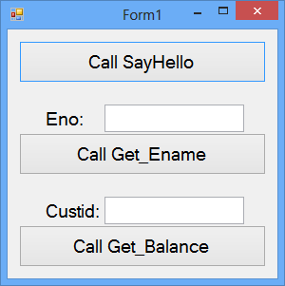
Write the below code by adding reference of following assemblies:
1. System.Runtime.Remoting.dll (.net) 2. System.Configuration.dll (.net) 3. InterfaceProject.dll (browse)
Open the "Application Configuration File" under the project and write the following between <configuration> and </configuration> tags:
<appSettings> <add key ="URL" value ="tcp://Server:5000/XXX"/> </appSettings>
using InterfaceProject; using System.Configuration;
using System.Runtime.Remoting.Channels; using System.Runtime.Remoting.Channels.Tcp;

Declarations: IRemoteApp ira;
Under Form Load:
string url = ConfigurationManager.AppSettings.Get("URL");
TcpClientChannel chan = new TcpClientChannel(); ChannelServices.RegisterChannel(chan, true);
Object obj = Activator.GetObject(typeof(IRemoteApp), url); ira = (IRemoteApp) obj;
Under Call SayHello Button: button1.Text = ira.SayHello();
Under Call Get_Ename Button: button2.Text = ira.Get_Ename(int.Parse(textBox1.Text));
Under Call Get_Balance Button: button3.Text = ira.Get_Balance(int.Parse(textBox2.Text)).ToString();
Execution of the Application:
As our Remote Server is a windows service it gets started automatically whenever OS is started. Now run the Remote Client application we have developed and test it. Once it was working perfectly prepare a set-up for the application which includes RemoteClient.exe, ConfigFile and InterfaceProject.dll which can be carried and installed on any other system in the network. To run client application on a machine, first open the config file, edit the "URL" and then start the application.
Singleton Vs Singlecall:
Right now remote class is registered under remote server in singleton mode, in this mode whenever the first request comes from first client an object of remote class is created and it's reference is provided to the client, from then for any new request coming from a new client server provides reference of same object that is already created, so all clients share same object memory because of this changes made by 1 client gets reflected to others. To change mode of application from Singleton to SingleCall follow the below process:
- Open visual studio command prompt, go into the folder where RemoteServer.exe was present and Un-install it using installutil tool. Eg: installutil -u RemoteServer.exe
- Now open RemoteServer project in VS and under it change the mode from Singleton to Singlecall with in the 3rd statement of OnStart method and rebuild the project.
- Re-install RemoteServer from VS Command Prompt again. Eg: installutil RemoteServer.exe
- Open the service's window, start the server for first time and then run the client application again to check the difference in results.

