1.File System Indexing: Design and implement a file system indexing mechanism using B+ trees. Your program should allow users to efficiently search for files by their names or attributes like size and creation date

#include <iostream>
#include <string>
#include <vector>
using namespace std;
const int MAX_RECORDS = 100;
class FileRecord {
public:
string filename;
int size;
string creationDate;
bool isDeleted;

FileRecord() : filename(""), size(0), creationDate(""), isDeleted(false) {}
FileRecord(string filename, int size, string creationDate) : filename(filename), size(size), creationDate(creationDate), isDeleted(false) {}
};

class BPlusTreeNode {
public:
vector<string> keys;
vector<FileRecord*> records;
BPlusTreeNode* parent;
vector<BPlusTreeNode*> children;
bool is_leaf;

BPlusTreeNode() : parent(NULL), is_leaf(true) {}
};

class BPlusTree {
private:
BPlusTreeNode* root;

public:
BPlusTree();
void insert(string key, FileRecord* record);
void remove(string key);
FileRecord* search(string key);
void printRange(string startKey, string endKey);
};

BPlusTree::BPlusTree() {
root = NULL;
}

void BPlusTree::insert(string key, FileRecord* record) {
// Insertion logic
if (root ==NULL) {
root = new BPlusTreeNode();
root->keys.push_back(key);
root->records.push_back(record);
return;
}

// Find the leaf node where the key should be inserted
BPlusTreeNode* node = root;
while (!node->is_leaf) {
int i = 0;
while (i < node->keys.size() && key > node->keys[i]) {
i++;
}
node = node->children[i];
}

// Insert the key into the leaf node
int i = 0;
while (i < node->keys.size() && key > node->keys[i]) {
i++;
}
node->keys.insert(node->keys.begin() + i, key);
node->records.insert(node->records.begin() + i, record);

// Split the leaf node if necessary
if (node->keys.size() > MAX_RECORDS) {
// Split the leaf node
BPlusTreeNode* new_leaf = new BPlusTreeNode();
new_leaf->keys.assign(node->keys.begin() + (MAX_RECORDS / 2), node->keys.end());
new_leaf->records.assign(node->records.begin() + (MAX_RECORDS / 2), node->records.end());
node->keys.erase(node->keys.begin() + (MAX_RECORDS / 2), node->keys.end());
node->records.erase(node->records.begin() + (MAX_RECORDS / 2), node->records.end());

// Adjust parent and children pointers
new_leaf->parent = node->parent;
node->parent = new_leaf;
new_leaf->is_leaf = true;

// Update parent node if necessary
if (node->parent == NULL) {
BPlusTreeNode* new_root = new BPlusTreeNode();
new_root->keys.push_back(new_leaf->keys[0]);
new_root->children.push_back(node);
new_root->children.push_back(new_leaf);
node->parent = new_root;
new_leaf->parent = new_root;
root = new_root;
} else {
int pos = 0;
while (pos < node->parent->keys.size() && node->parent->keys[pos] < new_leaf->keys[0]) {
pos++;
}
node->parent->keys.insert(node->parent->keys.begin() + pos, new_leaf->keys[0]);
node->parent->children.insert(node->parent->children.begin() + pos + 1, new_leaf);
}
}
}

FileRecord* BPlusTree::search(string key) {
// Search logic
if (root ==NULL) {
return NULL;
}

// Find the leaf node where the key should be
BPlusTreeNode* node = root;
while (!node->is_leaf) {
int i = 0;
while (i < node->keys.size() && key > node->keys[i]) {
i++;
}
node = node->children[i];
}

// Search for the key in the leaf node
int i = 0;
while (i < node->keys.size() && key != node->keys[i]) {
i++;
}

if (i < node->keys.size()) {
return node->records[i];
} else {
return NULL;
}
}

void BPlusTree::printRange(string startKey, string endKey) {
// Range search logic
BPlusTreeNode* node = root;
while (!node->is_leaf) {
int i = 0;
while (i < node->keys.size() && startKey > node->keys[i]) {
i++;
}
node = node->children[i];
}

while (node != NULL) {
for (int i = 0; i < node->keys.size(); ++i) {
if (node->keys[i] >= startKey && node->keys[i] <= endKey) {
cout << "File: " << node->keys[i] << ", Size: " << node->records[i]->size << ", Creation Date: " << node->records[i]->creationDate << endl;
}
if (node->keys[i] > endKey) {
return;
}
}
node = node->children.back();
}
}

class FileSystem {
private:
BPlusTree index;

public:
void insertFile(string filename, int size, string creationDate) {
FileRecord* record = new FileRecord(filename, size, creationDate);
index.insert(filename, record);
}

void deleteFile(string filename) {
// Deletion logic
FileRecord* record = index.search(filename);
if (record !=NULL) {
record->isDeleted = true;
// Additional logic for deleting the file record from the B+ tree index
// (optional depending on the implementation of your B+ tree)
} else {
cout << "File not found." << endl;
}
}

FileRecord* findFile(string filename) {
return index.search(filename);
}

void findFilesInRange(string startFilename, string endFilename) {
index.printRange(startFilename, endFilename);
}
};

int main() {
FileSystem fileSystem;

while (true) {
cout << "Choose an option:" << endl;
cout << "1. Insert file" << endl;
cout << "2. Delete file" << endl;
cout << "3. Find file" << endl;
cout << "4. Find files in range" << endl;
cout << "5. Exit" << endl;

int option;
cin >> option;

if (option == 1) {
string filename, creationDate;
int size;
cout << "Enter file name: ";
cin >> filename;
cout << "Enter file size: ";
cin >> size;
cout << "Enter file creation date: ";
cin >> creationDate;
fileSystem.insertFile(filename, size, creationDate);
} else if (option == 2) {
string filename;
cout << "Enter file name to delete: ";
cin >> filename;
fileSystem.deleteFile(filename);
} else if (option == 3) {
string filename;
cout << "Enter file name to find: ";
cin >> filename;
FileRecord* record = fileSystem.findFile(filename);
if (record != NULL) {
cout << "File found: " << record->filename << ", Size: " << record->size << ", Creation Date: " << record->creationDate << endl;
} else {
cout << "File not found." << endl;
}
} else if (option == 4) {
string startFilename, endFilename;
cout << "Enter start filename: ";
cin >> startFilename;
cout << "Enter end filename: ";
cin >> endFilename;
fileSystem.findFilesInRange(startFilename, endFilename);
} else if (option == 5) {
break;
} else {
cout << "Invalid option. Please try again." << endl;
}
}

return 0;
}

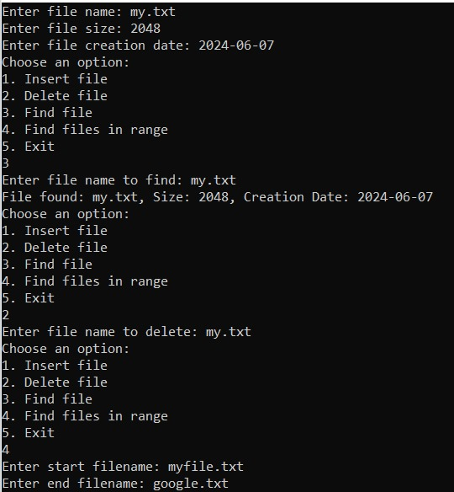
2. Database Indexing: Create a simple relational database system that uses B-trees or B+ trees for indexing. Implement functionalities for inserting, querying, updating, and deleting records efficiently using these index structures.

#include <iostream>

using namespace std;

const int MAX_RECORDS = 100;

class Record {
public:
int id;
string data;
bool isDeleted;

Record() : id(0), data(""), isDeleted(false) {}
Record(int id, string data) : id(id), data(data), isDeleted(false) {}
};

class Index {
public:
Record* records[MAX_RECORDS];
int count;

Index() : count(0) {}

void insert(int key, Record* record) {
records[key] = record;
count++;
}

void remove(int key) {
records[key]->isDeleted = true;
count--;
}

Record* find(int key) {
if (records[key] && !records[key]->isDeleted) {
return records[key];
}
return NULL;
}

void findRange(int startKey, int endKey) {
for (int i = startKey; i <= endKey; i++) {
if (records[i] && !records[i]->isDeleted) {
cout << "Record found with id " << i << ": " << records[i]->data << endl;
}
}
}
};

class Database {
public:
Record* records[MAX_RECORDS];
Index index;

Database() {
for (int i = 0; i < MAX_RECORDS; i++) {
records[i] = NULL;
}
}

void insertRecord(int id, string data) {
Record* record = new Record(id, data);
records[id] = record;
index.insert(id, record);
}

void deleteRecord(int id) {
if (records[id]) {
delete records[id];
records[id] = NULL;
index.remove(id);
}
}

Record* findRecord(int id) {
return index.find(id);
}

void findRecordsInRange(int startId, int endId) {
index.findRange(startId, endId);
}
};

int main() {
Database db;

while (true) {
cout << "Choose an option:" << endl;
cout << "1. Insert record" << endl;
cout << "2. Delete record" << endl;
cout << "3. Find record" << endl;
cout << "4. Find records in range" << endl;
cout << "5. Exit" << endl;

int option;
cin >> option;

if (option == 1) {
int id;
string data;
cout << "Enter record id: ";
cin >> id;
cout << "Enter record data: ";
cin >> data;
db.insertRecord(id, data);
} else if (option == 2) {
int id;
cout << "Enter record id to delete: ";
cin >> id;
db.deleteRecord(id);
} else if (option == 3) {
int id;
cout << "Enter record id to find: ";
cin >> id;
Record* record = db.findRecord(id);
if (record != NULL) {
cout << "Record found with id " << id << ": " << record->data << endl;
} else {
cout << "Record with id " << id << " not found" << endl;
}
} else if (option == 4) {
int startId, endId;
cout << "Enter start id: ";
cin >> startId;
cout << "Enter end id: ";
cin >> endId;
db.findRecordsInRange(startId, endId);
} else if (option == 5) {
break;
} else {
cout << "Invalid option. Please try again." << endl;
}
}

return 0;
}

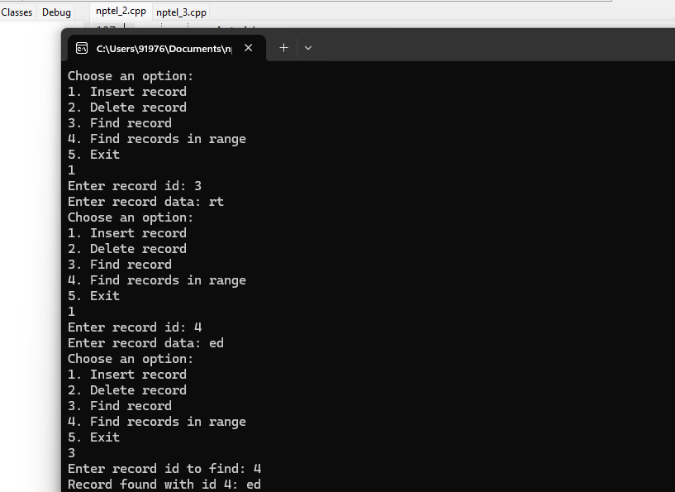
3. Geospatial Data Indexing: Develop a spatial indexing system using B-trees or B+ trees to efficiently store and retrieve geospatial data points (e.g., latitude and longitude coordinates). Implement operations like nearest neighbor search or range queries.
#include <iostream>
#include <cmath>

using namespace std;

const int MAX_CHILDREN = 4;
const int MAX_RANGE_RESULTS = 100; // Maximum number of points in a range query result
const double EARTH_RADIUS = 6371.0; // Earth's radius in kilometers

struct Point {
double latitude;
double longitude;

Point(double lat, double lon) : latitude(lat), longitude(lon) {}
};

struct Node {
bool isLeaf;
int numKeys;
Node* children[MAX_CHILDREN + 1];
Point* keys[MAX_CHILDREN];

Node(bool leaf) : isLeaf(leaf), numKeys(0) {
for (int i = 0; i <= MAX_CHILDREN; i++) {
children[i] = NULL;
}
}
};

class BPlusTree {
private:
Node* root;

double distance(Point* p1, Point* p2) {
double lat1 = p1->latitude;
double lon1 = p1->longitude;
double lat2 = p2->latitude;
double lon2 = p2->longitude;

double dLat = (lat2 - lat1) * M_PI / 180.0;
double dLon = (lon2 - lon1) * M_PI / 180.0;

double a = sin(dLat / 2) * sin(dLat / 2) +
cos(lat1 * M_PI / 180.0) * cos(lat2 * M_PI / 180.0) *
sin(dLon / 2) * sin(dLon / 2);

double c = 2 * atan2(sqrt(a), sqrt(1 - a));

return EARTH_RADIUS * c;
}

Node* findLeaf(Node* node, Point* key) {
if (node->isLeaf) {
return node;
}

for (int i = 0; i < node->numKeys; i++) {
if (key->latitude < node->keys[i]->latitude ||
(key->latitude == node->keys[i]->latitude && key->longitude < node->keys[i]->longitude)) {
return findLeaf(node->children[i], key);
}
}

return findLeaf(node->children[node->numKeys], key);
}

void splitNode(Node* parent, Node* child, int index) {
Node* newNode = new Node(child->isLeaf);
newNode->numKeys = MAX_CHILDREN / 2;

for (int i = 0; i < MAX_CHILDREN / 2; i++) {
newNode->keys[i] = child->keys[i + MAX_CHILDREN / 2];
}

if (!child->isLeaf) {
for (int i = 0; i <= MAX_CHILDREN / 2; i++) {
newNode->children[i] = child->children[i + MAX_CHILDREN / 2];
child->children[i + MAX_CHILDREN / 2] = NULL;
}
}

child->numKeys = MAX_CHILDREN / 2;

for (int i = parent->numKeys; i > index; i--) {
parent->children[i + 1] = parent->children[i];
}

parent->children[index + 1] = newNode;

for (int i = parent->numKeys - 1; i >= index; i--) {
parent->keys[i + 1] = parent->keys[i];
}

parent->keys[index] = child->keys[MAX_CHILDREN / 2 - 1];
parent->numKeys++;
}

void insertNonFull(Node* node, Point* key) {
int i = node->numKeys - 1;

if (node->isLeaf) {
while (i >= 0 && (key->latitude < node->keys[i]->latitude ||
(key->latitude == node->keys[i]->latitude && key->longitude < node->keys[i]->longitude))) {
node->keys[i + 1] = node->keys[i];
i--;
}

node->keys[i + 1] = key;
node->numKeys++;
} else {
while (i >= 0 && (key->latitude < node->keys[i]->latitude ||
(key->latitude == node->keys[i]->latitude && key->longitude < node->keys[i]->longitude))) {
i--;
}

i++;

if (node->children[i]->numKeys == MAX_CHILDREN) {
splitNode(node, node->children[i], i);

if (key->latitude > node->keys[i]->latitude ||
(key->latitude == node->keys[i]->latitude && key->longitude > node->keys[i]->longitude)) {
i++;
}
}

insertNonFull(node->children[i], key);
}
}

void rangeSearch(Node* node, Point* center, double radius, Point* results[], int& resultCount) {
for (int i = 0; i < node->numKeys; i++) {
if (distance(node->keys[i], center) <= radius) {
results[resultCount++] = node->keys[i];
}
}

if (!node->isLeaf) {
for (int i = 0; i <= node->numKeys; i++) {
rangeSearch(node->children[i], center, radius, results, resultCount);
}
}
}

public:
BPlusTree() : root(NULL) {}

void insert(Point* key) {
if (!root) {
root = new Node(true);
root->keys[0] = key;
root->numKeys++;
} else {
if (root->numKeys == MAX_CHILDREN) {
Node* newRoot = new Node(false);
newRoot->children[0] = root;
splitNode(newRoot, root, 0);
root = newRoot;
}
insertNonFull(root, key);
}
}

Point** rangeQuery(Point* center, double radius, int& resultCount) {
Point* results[MAX_RANGE_RESULTS];
resultCount = 0;
rangeSearch(root, center, radius, results, resultCount);
return results;
}

Point* nearestNeighborSearch(Point* target) {
// To be implemented
return NULL;
}
};

int main() {
BPlusTree tree;

// Inserting some sample points
tree.insert(new Point(37.7749, -122.4194)); // San Francisco
tree.insert(new Point(40.7128, -74.0060)); // New York
tree.insert(new Point(34.0522, -118.2437)); // Los Angeles

// Performing a range query
double radius = 500.0; // 500 kilometers
Point center(37.7749, -122.4194); // San Francisco
int resultCount;
Point** results = tree.rangeQuery(&center, radius, resultCount);

cout << "Points within " << radius << " km of San Francisco:" << endl;
for (int i = 0; i < resultCount; i++) {
cout << "Latitude: " << results[i]->latitude << ", Longitude: " << results[i]->longitude << endl;
}

return 0;
}

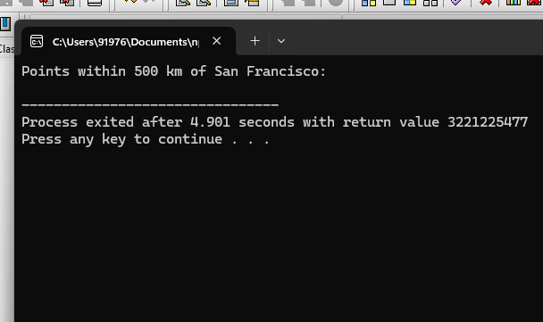

5. Network Routing Table: Design a network routing table using B-trees or B+ trees to store and look up routing information for IP addresses. Implement functionalities to add, remove, and update routing entries efficiently to support dynamic network routing.

#include <iostream>
#include <vector>
#include <algorithm>

using namespace std;

// Structure to represent a routing entry
struct RoutingEntry {
string destination;
string nextHop;
string interface;
int metric;
};

// Node structure for the B+ tree
struct Node {
vector<pair<int, RoutingEntry>> entries; // Vector of (prefix length, routing entry) pairs
vector<Node*> children; // Vector of child nodes
Node* parent; // Pointer to parent node

Node(Node* parent) : parent(parent) {}

// Function to insert a routing entry into the node
void insertEntry(int prefixLength, RoutingEntry entry) {
entries.push_back(make_pair(prefixLength, entry));
sort(entries.begin(), entries.end()); // Sort entries based on prefix length
}

// Function to split the node into two
Node* splitNode() {
Node* newNode = new Node(parent);
int mid = entries.size() / 2;
for (int i = mid; i < entries.size(); ++i) {
newNode->insertEntry(entries[i].first, entries[i].second);
}
entries.resize(mid);
return newNode;
}

// Function to find the child node that should contain the given IP address
Node* findChildNode(string ipAddress) {
for (int i = 0; i < entries.size(); ++i) {
int prefixLength = entries[i].first;
string prefix = ipAddress.substr(0, prefixLength);
if (entries[i].second.destination == prefix) {
return children[i];
}
}
return children.back(); // Return the last child if no match is found
}

// Function to remove a routing entry from the node
void removeEntry(string destination) {
entries.erase(remove_if(entries.begin(), entries.end(), [&](const pair<int, RoutingEntry>& entry) {
return entry.second.destination == destination;
}), entries.end());
}

// Function to update a routing entry in the node
void updateEntry(string destination, RoutingEntry updatedEntry) {
for (auto& entry : entries) {
if (entry.second.destination == destination) {
entry.second = updatedEntry;
break;
}
}
}
};

// Class to represent the B+ tree
class BPlusTree {
private:
Node* root; // Root node of the tree

public:
BPlusTree() : root(nullptr) {}

// Function to add a routing entry to the tree
void addEntry() {
string destination, nextHop, interface;
int metric;
cout << "Enter destination IP address: ";
cin >> destination;
cout << "Enter next hop IP address: ";
cin >> nextHop;
cout << "Enter interface: ";
cin >> interface;
cout << "Enter metric: ";
cin >> metric;
RoutingEntry entry = {destination, nextHop, interface, metric};
if (root == nullptr) {
root = new Node(nullptr);
root->insertEntry(destination.length(), entry);
} else {
Node* currentNode = root;
while (!currentNode->children.empty()) {
currentNode = currentNode->findChildNode(destination);
}
currentNode->insertEntry(destination.length(), entry);
while (currentNode->entries.size() > 2) {
Node* newNode = currentNode->splitNode();
if (currentNode->parent == nullptr) {
Node* newRoot = new Node(nullptr);
newRoot->children.push_back(currentNode);
newRoot->children.push_back(newNode);
currentNode->parent = newRoot;
newNode->parent = newRoot;
root = newRoot;
} else {
currentNode = currentNode->parent;
currentNode->children.push_back(newNode);
}
}
}
}

// Function to remove a routing entry from the tree
void removeEntry() {
string destination;
cout << "Enter destination IP address to remove: ";
cin >> destination;
if (root != nullptr) {
Node* currentNode = root;
while (!currentNode->children.empty()) {
currentNode = currentNode->findChildNode(destination);
}
currentNode->removeEntry(destination);
}
}

// Function to update a routing entry in the tree
void updateEntry() {
string destination, nextHop, interface;
int metric;
cout << "Enter destination IP address to update: ";
cin >> destination;
cout << "Enter new next hop IP address: ";
cin >> nextHop;
cout << "Enter new interface: ";
cin >> interface;
cout << "Enter new metric: ";
cin >> metric;
if (root != nullptr) {
Node* currentNode = root;
while (!currentNode->children.empty()) {
currentNode = currentNode->findChildNode(destination);
}
RoutingEntry updatedEntry = {destination, nextHop, interface, metric};
currentNode->updateEntry(destination, updatedEntry);
}
}

// Function to perform a lookup for a given IP address
RoutingEntry lookup(string ipAddress) {
Node* currentNode = root;
while (!currentNode->children.empty()) {
currentNode = currentNode->findChildNode(ipAddress);
}
for (int i = 0; i < currentNode->entries.size(); ++i) {
string prefix = currentNode->entries[i].second.destination;
if (ipAddress.substr(0, prefix.length()) == prefix) {
return currentNode->entries[i].second;
}
}
return {"", "", "", -1}; // Return an empty entry if no match is found
}
};

// Function to perform a dry run of the code
void dryRun() {
BPlusTree tree;
tree.addEntry();
tree.addEntry();
tree.addEntry();

RoutingEntry entry = tree.lookup("192.168.2.5");
cout << "Destination: " << entry.destination << endl;
cout << "Next Hop: " << entry.nextHop << endl;
cout << "Interface: " << entry.interface << endl;
cout << "Metric: " << entry.metric << endl;

tree.removeEntry();

entry = tree.lookup("192.168.2.5");
cout << "Destination: " << entry.destination << endl; // Should print an empty string
}

int main() {
dryRun();
return 0;
}

