BIRLA INSTITUTE OF TECHNOLOGY AND SCIENCE, PILANI
Work Integrated Learning Programmes
Machine Learning Operations (MLOps) - AIMLCZG523
Assignment 01
End-to-End MLOps Pipeline for Heart Disease Risk Prediction
Submitted by
Name: Shiv Shankar Nath
Student ID: 2025AE05150
GitHub Repository: https://github.com/shiv-bits/mlops-heart-disease-2025ae05150
Lab environment: BITS Prayogshala virtual lab
Date of submission: 20 October 2026

Table of Contents
1. Introduction and Problem Statement
2. System Architecture
3. Setup and Installation
4. Data Acquisition and Exploratory Data Analysis
4.1 Acquisition
4.2 Cleaning and preprocessing decisions
4.3 EDA findings
5. Feature Engineering and Model Development
5.1 Preprocessing pipeline
5.2 Model selection and tuning
5.3 Evaluation results
6. Experiment Tracking with MLflow
7. Model Packaging and Reproducibility
8. CI/CD Pipeline and Automated Testing
8.1 Unit tests
8.2 GitHub Actions workflow
9. Model Containerization
10. Production Deployment on Kubernetes
11. Monitoring and Logging
12. Conclusion and Future Work
Deliverables and links

1. Introduction and Problem Statement
Cardiovascular disease is one of the leading causes of death worldwide, and early identification of high-risk patients is a well-studied machine-learning problem. The goal of this assignment is to build a classifier that predicts the presence of heart disease from routine clinical measurements and - more importantly - to wrap that model in a reproducible, automated and observable MLOps pipeline that mirrors a production setting.
The delivered system covers the full lifecycle: scripted data acquisition from the UCI repository, exploratory data analysis, a leakage-free scikit-learn preprocessing and modelling pipeline, hyper-parameter tuning with cross-validation, experiment tracking in MLflow, a FastAPI inference service packaged in Docker, deployment to Kubernetes with health probes, a GitHub Actions CI pipeline, and Prometheus-format request metrics.
Repository: https://github.com/shiv-bits/mlops-heart-disease-2025ae05150
Assignment task | Where it is implemented
1. Data acquisition & EDA | src/mlops_heart/acquire_data.py, src/mlops_heart/eda.py, reports/figures/
2. Feature engineering & models | src/mlops_heart/train.py (ColumnTransformer + GridSearchCV)
3. Experiment tracking | MLflow (sqlite backend) - params, metrics, models, artifacts
4. Packaging & reproducibility | artifacts/heart_disease_pipeline.joblib, MLflow model, requirements.txt
5. CI/CD & testing | .github/workflows/ci.yml, tests/ (13 pytest tests)
6. Containerization | Dockerfile, src/mlops_heart/api.py (FastAPI /predict)
7. Production deployment | k8s/deployment.yaml, k8s/service.yaml
8. Monitoring & logging | prometheus_client middleware, /metrics endpoint

2. System Architecture
The pipeline is organised into three layers. The data & training layer pulls the dataset, profiles it and trains two candidate models, logging every run to MLflow and persisting the selected pipeline with joblib. The CI/CD layer re-executes the whole chain on every push to main in a clean GitHub-hosted runner and then builds the container image. The serving layer packages the trained pipeline together with a FastAPI application into a Docker image, which is deployed to Kubernetes and exposes Prometheus metrics.
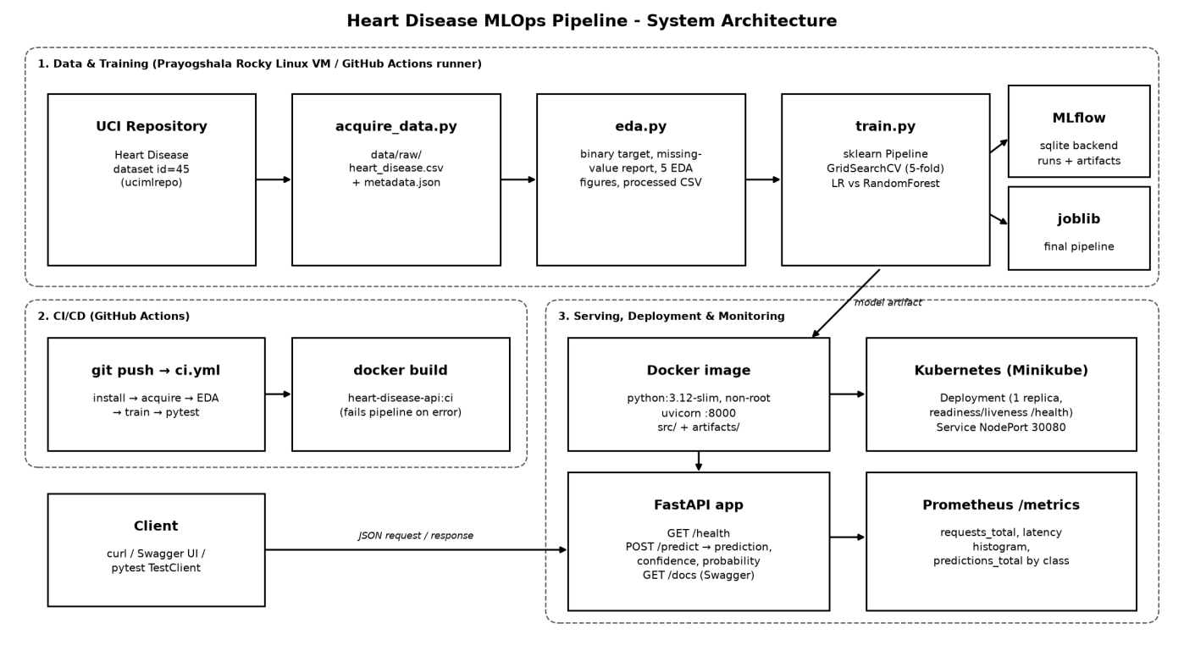
Figure 1: End-to-end architecture of the heart-disease MLOps pipeline

3. Setup and Installation
All steps run from a clean checkout using only requirements.txt (Python 3.12). The same sequence is executed by the CI pipeline, which guarantees that the instructions stay correct.
# 1. Clone and create an isolated environment
git clone https://github.com/shiv-bits/mlops-heart-disease-2025ae05150.git
cd mlops-heart-disease-2025ae05150
python3.12 -m venv .venv && source .venv/bin/activate
pip install -r requirements.txt

# 2. Data -> EDA -> training (writes data/, reports/, artifacts/, mlflow.db)
python -m src.mlops_heart.acquire_data
python -m src.mlops_heart.eda
python -m src.mlops_heart.train

# 3. Tests and experiment UI
python -m pytest -v
mlflow ui --backend-store-uri sqlite:///mlflow.db --port 5000

# 4. Serve locally, then with Docker
uvicorn src.mlops_heart.api:app --host 0.0.0.0 --port 8000
docker build -t heart-disease-api:1.1.1 .
docker run -p 8000:8000 heart-disease-api:1.1.1

# 5. Kubernetes (local cluster, image loaded into the node)
kubectl apply -f k8s/deployment.yaml -f k8s/service.yaml
kubectl get pods,svc # API reachable on NodePort 30080

Access instructions: the API is not hosted publicly. After deployment it is reachable at http://<node-ip>:30080 (Kubernetes) or http://localhost:8000 (Docker). Interactive documentation is served at /docs, the health check at /health and Prometheus metrics at /metrics.

4. Data Acquisition and Exploratory Data Analysis

4.1 Acquisition
acquire_data.py downloads the Cleveland Heart Disease dataset (UCI id 45) programmatically through the ucimlrepo client, merges features and target, and writes data/raw/heart_disease.csv together with a metadata.json describing source, shape and target values. The dataset has 303 rows and 13 features plus the original target num (0–4).

4.2 Cleaning and preprocessing decisions
- Binary target: num > 0 is mapped to target = 1 (disease present), otherwise 0, matching the problem statement. The original column is preserved for traceability.
- Schema validation: eda.py fails fast if the target column is missing or the row count is not 303, so silent upstream changes break the pipeline instead of the model.
- Missing values: only ca (4 rows) and thal (2 rows) are missing. They are deliberately not imputed in the saved CSV; imputation happens inside the model pipeline, fitted on the training folds only, which avoids data leakage.
- Encoding: categorical clinical codes (cp, thal, slope, …) are one-hot encoded inside the pipeline rather than treated as ordinal numbers.

4.3 EDA findings
The classes are reasonably balanced - 164 patients without disease (54%) and 139 with disease (46%) - so accuracy is meaningful, but ROC-AUC was still chosen as the primary metric and class_weight="balanced" was included in the search space.
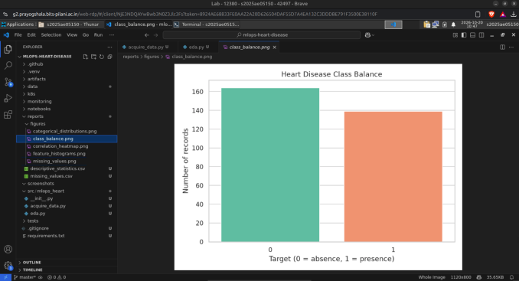  Figure 2: Binary target class balance | 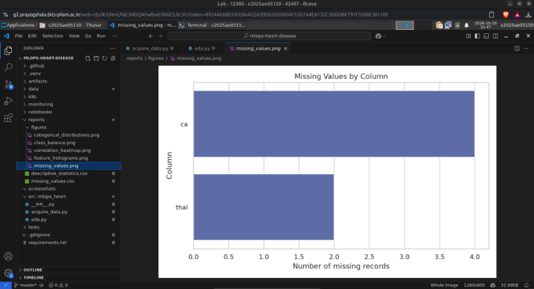  Figure 3: Missing values per column (ca, thal)
Age is roughly normal around 55 years; cholesterol and resting blood pressure are right-skewed with a few extreme values, and oldpeak is heavily concentrated at zero. These skewed scales motivated standard scaling for the linear model. The categorical plots show that the cohort is about two-thirds male and that asymptomatic chest pain (cp = 4) is the most frequent category.
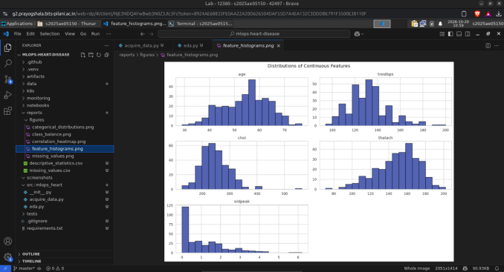  Figure 4: Distributions of continuous features | 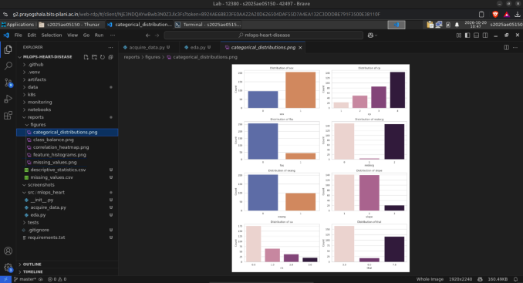  Figure 5: Distributions of categorical features
The correlation heatmap shows the strongest associations with the target for thal (0.53), ca (0.46), exang (0.43), oldpeak (0.42) and cp (0.41), and a negative association with maximum heart rate thalach (−0.42). No pair of features is so strongly correlated (max |r| ≈ 0.58 between oldpeak and slope) that it required removal, so all 13 features were retained.
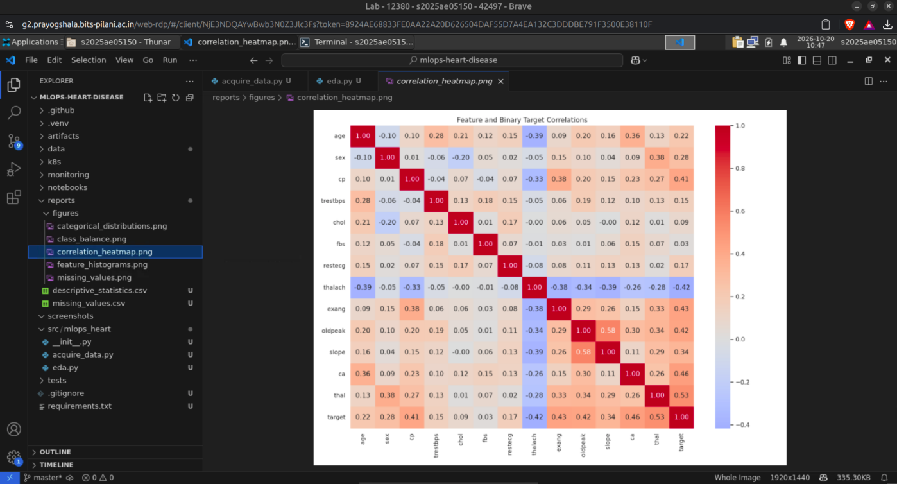
Figure 6: Correlation heatmap of features and binary target (Prayogshala lab VM, VS Code)

5. Feature Engineering and Model Development

5.1 Preprocessing pipeline
A single scikit-learn Pipeline combines preprocessing and the classifier so that exactly the same transformations are applied during cross-validation, test evaluation and online inference:
Feature group | Columns | Transformations
Numeric (5) | age, trestbps, chol, thalach, oldpeak | SimpleImputer(median) → StandardScaler
Categorical (8) | sex, cp, fbs, restecg, exang, slope, ca, thal | SimpleImputer(most_frequent) → OneHotEncoder(handle_unknown=ignore)

5.2 Model selection and tuning
Data were split 80/20 with stratification (random_state=42; 242 training, 61 test rows). Two model families were tuned with GridSearchCV using 5-fold stratified cross-validation and ROC-AUC as the scoring metric. The final model is chosen on cross-validated ROC-AUC, not test performance, so the held-out test set remains an unbiased estimate.
Model | Search space | Best parameters | CV ROC-AUC
Logistic Regression | C ∈ {0.1, 1, 10}; class_weight ∈ {None, balanced} (6 configs) | C = 0.1, class_weight = balanced | 0.9028
Random Forest | n_estimators = 200; max_depth ∈ {None, 5, 10}; min_samples_leaf ∈ {1, 2}; class_weight ∈ {None, balanced} (12 configs) | max_depth = 5, min_samples_leaf = 1, class_weight = balanced | 0.9017

5.3 Evaluation results
Model | Accuracy | Precision | Recall | F1 | Test ROC-AUC | CV ROC-AUC
Logistic Regression (selected) | 0.885 | 0.839 | 0.929 | 0.881 | 0.965 | 0.903
Random Forest | 0.885 | 0.839 | 0.929 | 0.881 | 0.951 | 0.902

Both models produce the same confusion matrix on the 61-row test set (26 true positives, 2 false negatives, 28 true negatives, 5 false positives), but Logistic Regression ranks patients better (test ROC-AUC 0.965 vs 0.951) and is marginally ahead in cross-validation. Combined with its interpretability and low latency, Logistic Regression was selected as the production model. The high recall (0.93) is desirable in a screening context, where missing a positive case is costlier than a false alarm.
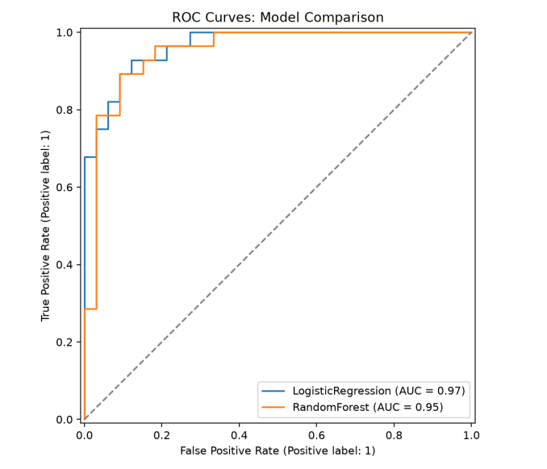  Figure 7: ROC curves on the held-out test set | 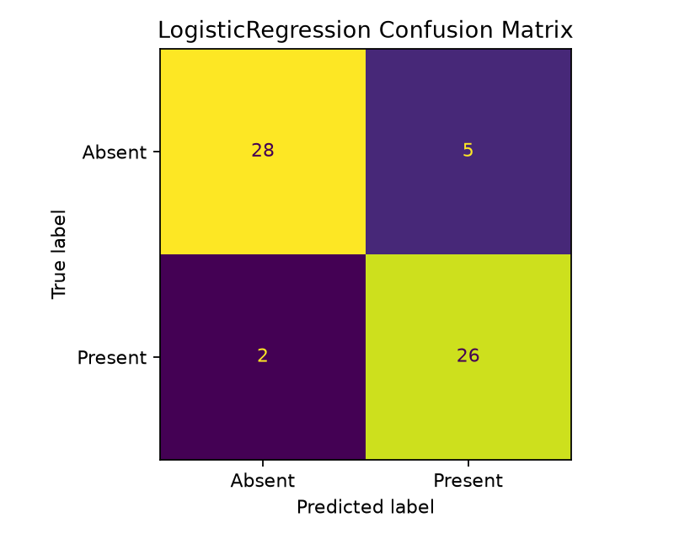  Figure 8: Confusion matrix - selected Logistic Regression

6. Experiment Tracking with MLflow
Every model family is trained inside its own MLflow run in the experiment heart-disease-classification, using a SQLite tracking store. For each run the following are logged:
- Parameters: model name, CV folds, test size, random state, selection metric and the best hyper-parameters found by the grid search.
- Metrics: best cross-validated ROC-AUC and test accuracy, precision, recall, F1 and ROC-AUC.
- Artifacts: the full fitted pipeline as an MLflow model (with inferred signature and input example), the classification report (JSON), the complete grid-search results (CSV) and the confusion-matrix plot.
The Training runs view below shows the iterations performed on the Prayogshala VM: two early runs failed while the pipeline was being developed and were fixed and re-run, which illustrates how MLflow preserves the full history of experiments, including unsuccessful ones.
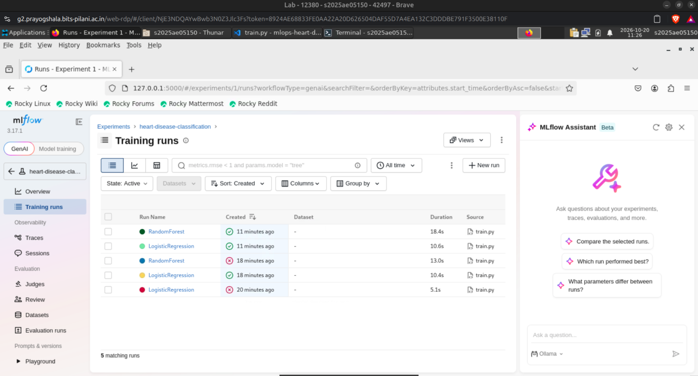
Figure 9: MLflow Training runs for experiment heart-disease-classification (Prayogshala lab VM)
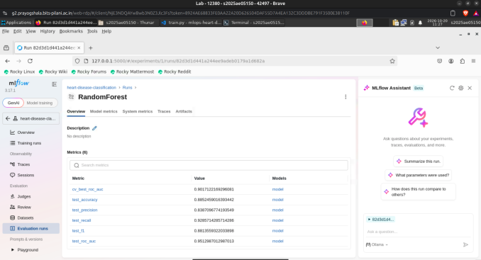  Figure 10: RandomForest run - logged metrics | 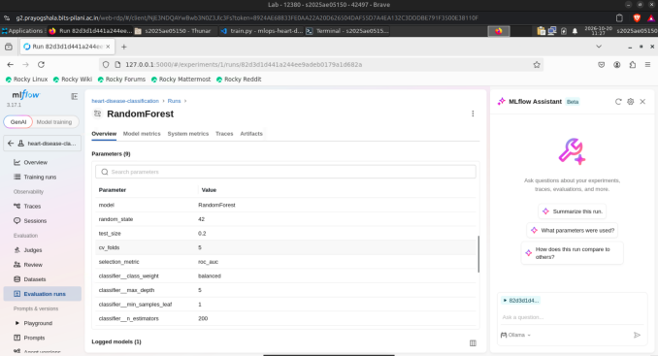  Figure 11: RandomForest run - logged parameters
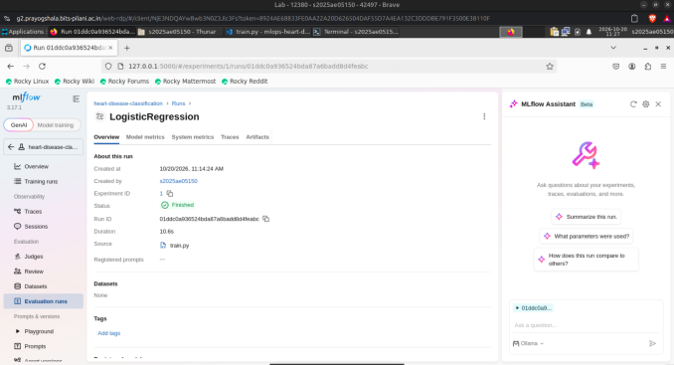  Figure 12: LogisticRegression run - run details | 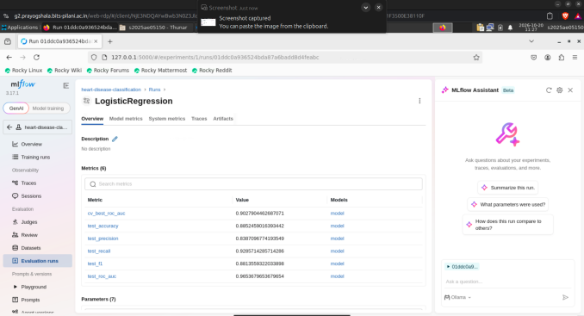  Figure 13: LogisticRegression run - logged metrics
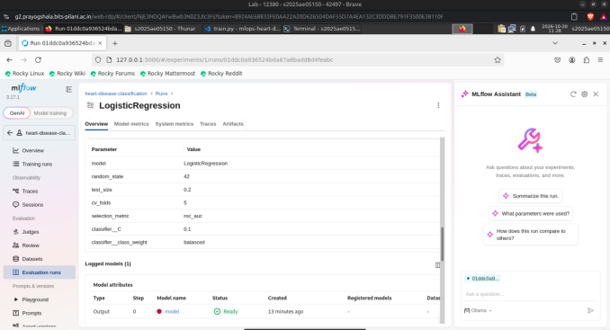  Figure 14: LogisticRegression - parameters and logged model | 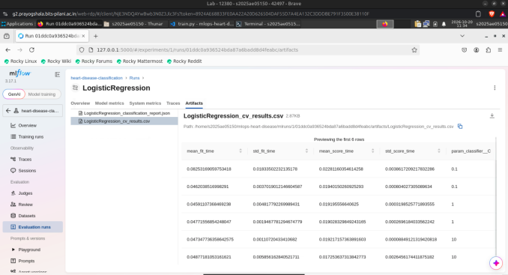  Figure 15: Artifacts - grid-search CV results
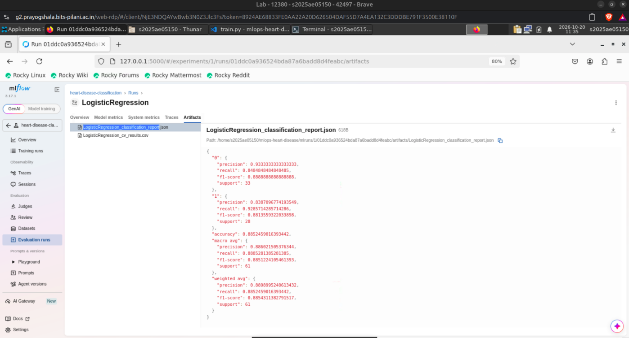
Figure 16: Artifacts - classification report JSON for Logistic Regression

7. Model Packaging and Reproducibility
- Model format: the selected end-to-end pipeline (preprocessing + classifier) is serialised to artifacts/heart_disease_pipeline.joblib; each candidate is also logged as an MLflow sklearn model with signature and input example. artifacts/model_metadata.json records the selected model, selection metric, feature list and test metrics.
- Preprocessing travels with the model: because imputation, scaling and encoding live inside the pipeline, the API sends raw JSON features straight to predict_proba - there is no separate preprocessing code to drift out of sync.
- Determinism: fixed random_state=42 for the split, CV shuffling and the Random Forest; scikit-learn is pinned to an exact version (1.9.1) because pickled estimators are version-sensitive, while other libraries use bounded ranges.
- Clean-environment proof: the CI pipeline rebuilds everything from requirements.txt on a fresh Ubuntu runner on every push (Section 8).

8. CI/CD Pipeline and Automated Testing

8.1 Unit tests
The tests/ folder contains 13 pytest tests across data, model and API layers:
File | What is verified
tests/test_data.py (5) | raw file exists; shape 303×14; target values ⊆ {0..4}; exactly 4/2 missing values in ca/thal; processed data has binary target
tests/test_model.py (3) | model artifact exists; prediction is 0/1; class probabilities are valid and sum to 1
tests/test_api.py (5) | /health returns ok + model_loaded; /predict response schema; invalid age → 422; unexpected field → 422; /metrics exposes all custom counters

8.2 GitHub Actions workflow
.github/workflows/ci.yml runs on every push and pull request to main and can be triggered manually. The single test-and-build job executes the complete pipeline in order: checkout → set up Python 3.12 with pip caching → install requirements → download dataset → EDA → train and log models → pytest -v → docker build. Each step is a separate, clearly named stage, so the run log shows exactly where a failure occurred, and any non-zero exit code (failing test, schema check, training error, broken Dockerfile) fails the workflow.
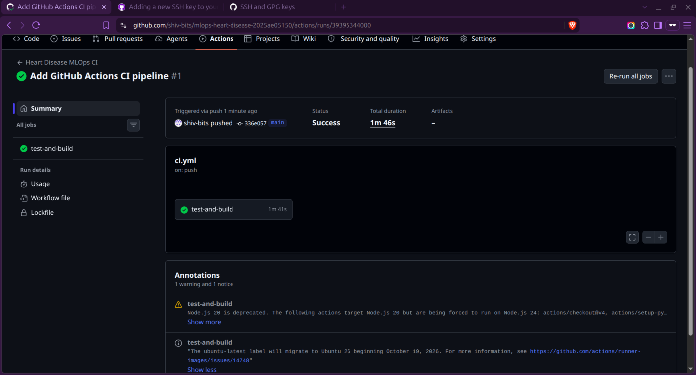
Figure 17: Successful GitHub Actions run (test-and-build, 1m 46s) triggered by push to main

9. Model Containerization
The Dockerfile builds on python:3.12-slim, installs the pinned requirements, copies only src/ and artifacts/, and runs as an unprivileged user (uid 10001) for security. The container starts uvicorn on port 8000. A .dockerignore keeps the virtual environment, MLflow store and raw data out of the image.
The FastAPI service validates inputs with a strict Pydantic schema - value ranges for numeric fields, allowed codes for categorical fields, and extra="forbid" to reject unknown keys - and loads the model once at start-up via a lifespan hook (the app refuses to start without it). POST /predict returns the class, a human-readable label, the confidence of the predicted class and the probability of disease, plus an educational-use disclaimer.
curl -X POST http://localhost:8000/predict -H 'Content-Type: application/json' \
-d '{"age":63,"sex":1,"cp":3,"trestbps":145,"chol":233,"fbs":1,"restecg":0,
"thalach":150,"exang":0,"oldpeak":2.3,"slope":1,"ca":0,"thal":6}'

{"prediction": 0|1, "label": "Heart disease ...", "confidence": 0.xx,
"probability_presence": 0.xx, "disclaimer": "For educational use only, ..."}

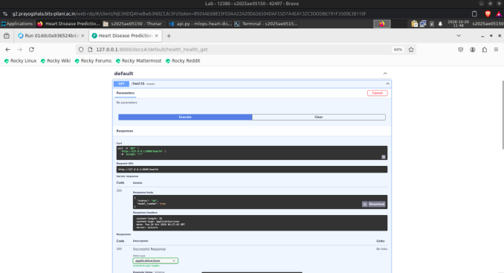  Figure 18: Swagger UI - GET /health returns status ok, model_loaded true | 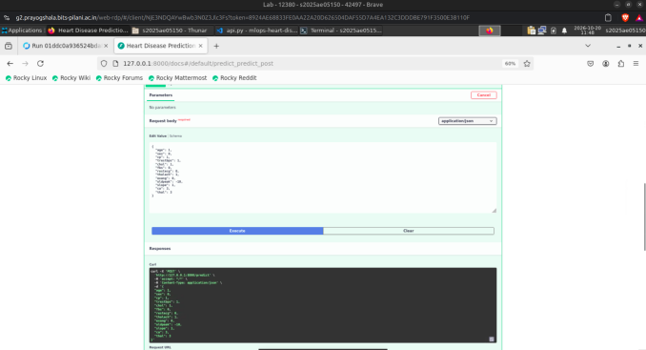  Figure 19: Swagger UI - POST /predict with JSON request body
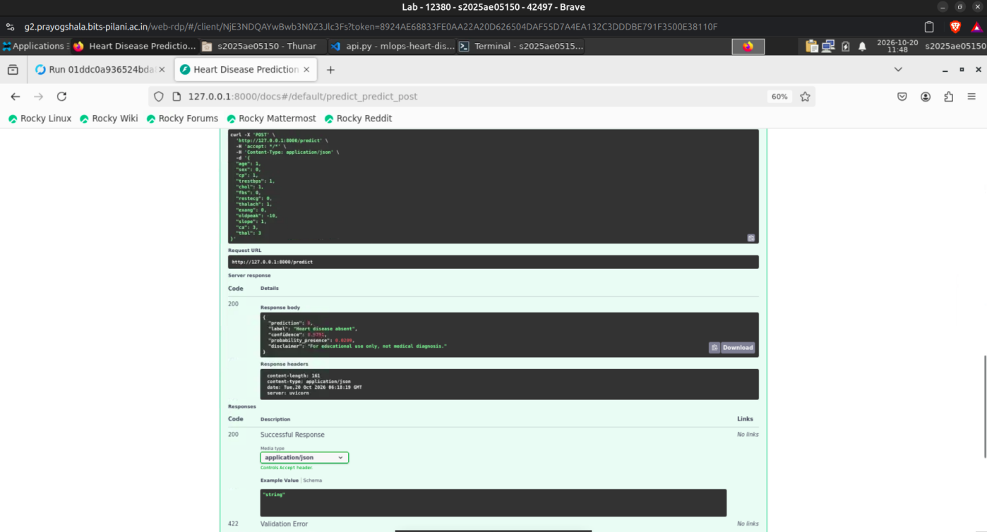
Figure 20: POST /predict response: prediction 0 (absent), confidence 0.9791, probability_presence 0.0209
The image was built and run inside the Prayogshala VM. docker build completes all 7 Dockerfile stages (layers are cached on a rebuild) and tags heart-disease-api:1.1.1; the resulting image ID d4b895c993ba is the same image later deployed to Kubernetes. The container is started detached with host port 8002 mapped to container port 8000 and answers /health and /predict with the sample patient (prediction 0, confidence 0.6741).
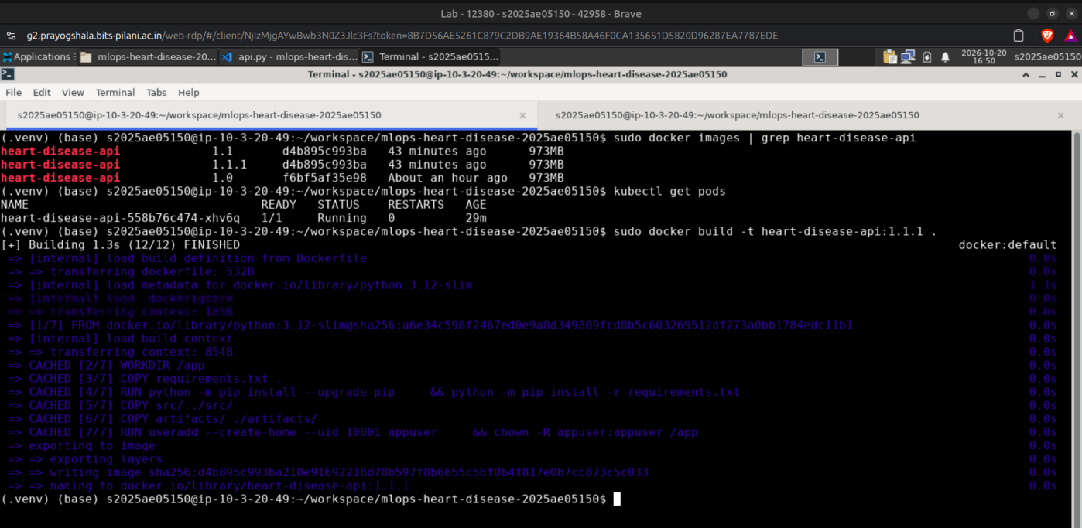
Figure 21: docker images and docker build -t heart-disease-api:1.1.1 (12/12 steps finished)
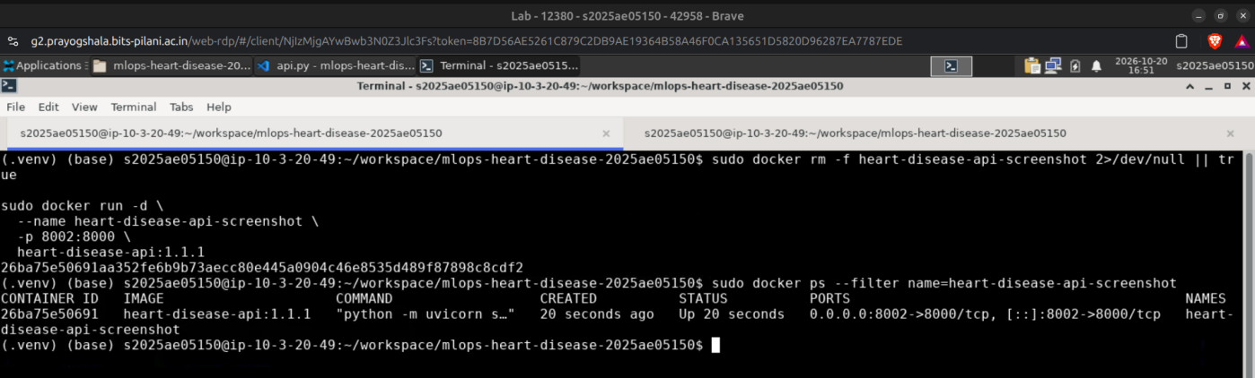
Figure 22: docker run -d -p 8002:8000 heart-disease-api:1.1.1 and docker ps showing the container Up
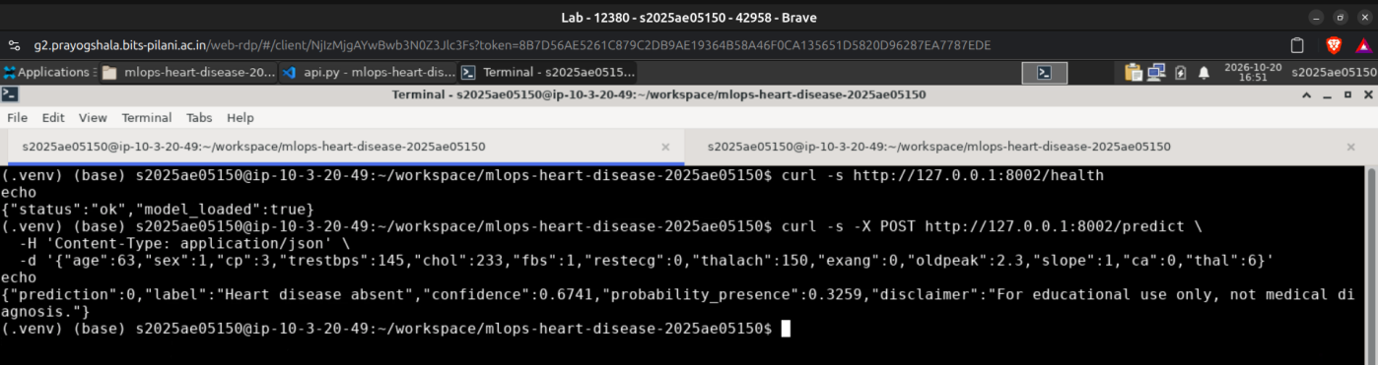
Figure 23: curl /health and POST /predict against the running Docker container

10. Production Deployment on Kubernetes
The image is deployed to a local Minikube Kubernetes cluster on the Prayogshala VM using plain manifests in k8s/ (kubectl apply -f k8s/):
- Deployment heart-disease-api - image heart-disease-api:1.1.1 with imagePullPolicy: Never (image loaded directly into the local cluster), container port 8000.
- Readiness probe on /health (after 10 s, every 5 s) so traffic only reaches a pod once the model has loaded; liveness probe on /health (after 20 s, every 10 s) restarts a hung container.
- Resource requests/limits - 100m CPU / 256 Mi requested, capped at 1 CPU / 1 Gi - to protect the node from runaway inference.
- Service of type NodePort exposing port 8000 on node port 30080, which provides external access to the API on a local cluster without a cloud load balancer.
Verification: the deployment reports 1/1 ready and the pod heart-disease-api-558b76c474-xhv6q is Running with 0 restarts on node minikube. The NodePort service maps 8000 → 30080. Using the node address from minikube ip (192.168.49.2), GET /health returns HTTP/1.1 200 OK and POST /predict returns the same prediction as the standalone container. The pod's imageID (sha256:d4b895c993ba…) matches the image built in Section 9, proving that the tested image is the one running in the cluster. kubectl port-forward provides a second access path on localhost:8000.
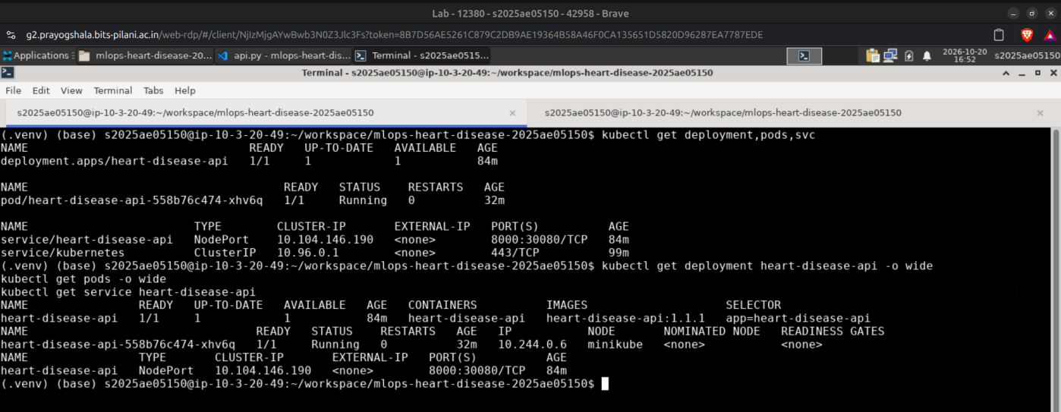
Figure 24: kubectl get deployment,pods,svc - heart-disease-api 1/1 Running, NodePort 8000:30080
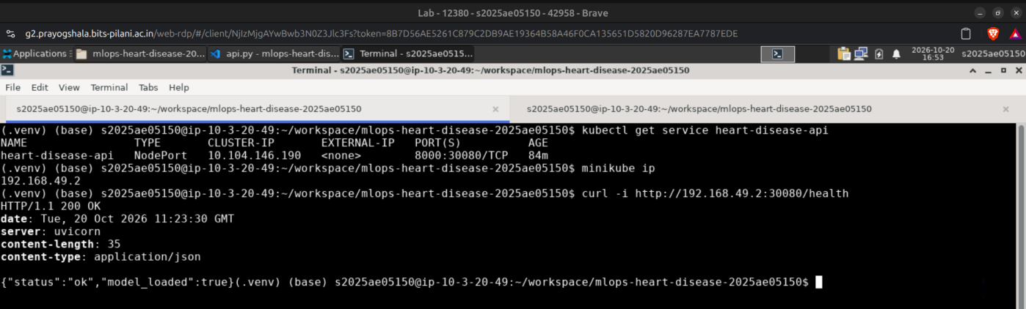
Figure 25: minikube ip and curl http://192.168.49.2:30080/health → HTTP 200, model_loaded true
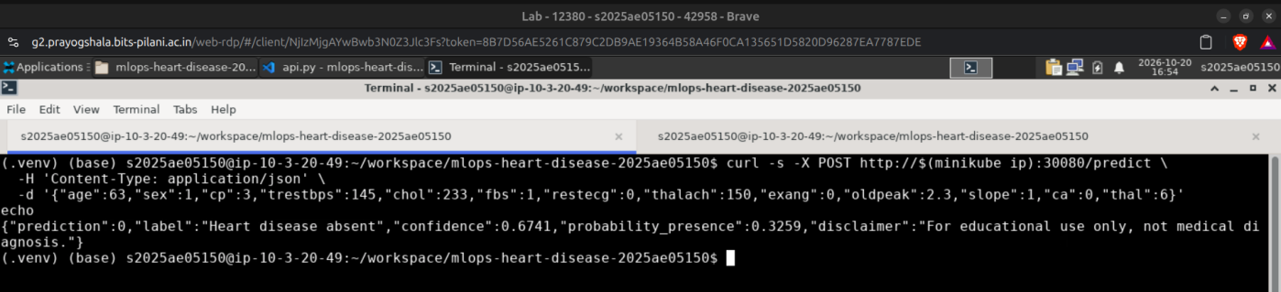
Figure 26: POST /predict through the NodePort service on Minikube
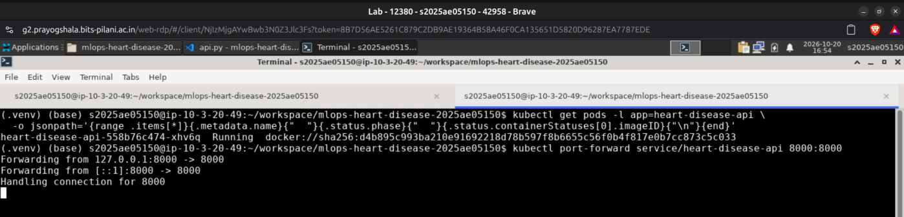
Figure 27: Pod image ID matches the built image; kubectl port-forward service/heart-disease-api 8000:8000

11. Monitoring and Logging
Monitoring is built into the API with prometheus_client. An HTTP middleware wraps every request and records three custom metrics, exposed in Prometheus text format at /metrics:
Metric | Type | Labels / purpose
heart_disease_http_requests_total | Counter | method, endpoint, status - traffic and error rate
heart_disease_http_request_duration_seconds | Histogram | method, endpoint - latency percentiles
heart_disease_predictions_total | Counter | prediction (0/1) - drift in predicted class mix

Scrapes of /metrics itself are excluded so that monitoring traffic does not inflate application metrics, and failed requests are still counted (status defaults to 500 inside a finally block). Uvicorn writes an access log line for each request, which is visible with docker logs or kubectl logs. The endpoint can be scraped directly by a Prometheus server and visualised in Grafana.
The screenshots below were taken from the pod running in Kubernetes (through the port-forward). They show 625 GET /health requests - almost entirely generated by the Kubernetes readiness and liveness probes, which demonstrates that the probes are working - all completing in under 5 ms, plus the /predict calls with their latency buckets. After further prediction requests, heart_disease_predictions_total{prediction="0"} counts 3 predictions of the negative class.
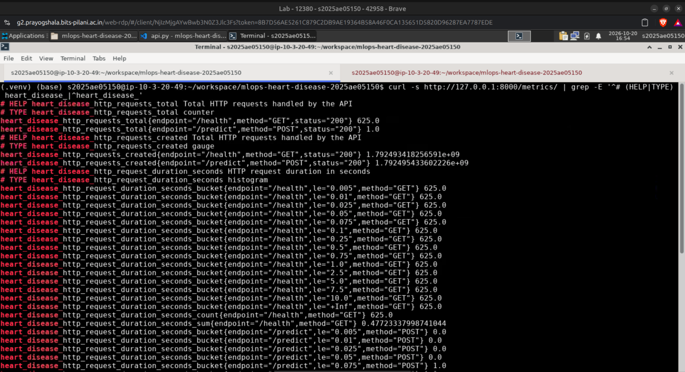
Figure 28: Prometheus /metrics from the deployed pod - request counter and latency histogram
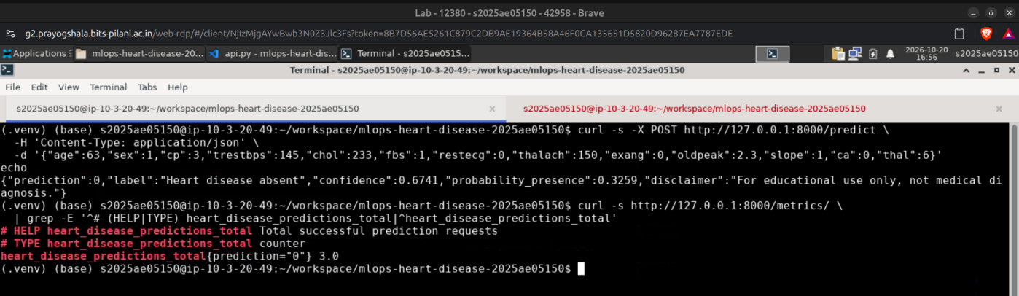
Figure 29: Prediction request followed by heart_disease_predictions_total counter

12. Conclusion and Future Work
The project delivers a complete, reproducible MLOps workflow for heart-disease risk prediction. A tuned Logistic Regression pipeline reaches 0.903 cross-validated ROC-AUC and 0.965 test ROC-AUC with 0.93 recall. Every run is tracked in MLflow, every push is verified end-to-end by GitHub Actions, and the model is served by a validated FastAPI service in a non-root Docker container, deployed to Kubernetes with health probes and instrumented with Prometheus metrics.
Limitations and next steps: the dataset is small (303 patients) and from a single centre, so external validation is needed before any clinical use. Natural extensions are pushing images to a registry and adding a CD stage that deploys to a managed cluster (GKE/EKS), an Ingress with TLS, a Prometheus + Grafana stack with alerting, data-drift checks on incoming requests, and registering the selected model in the MLflow Model Registry.

Deliverables and links
- Code repository: https://github.com/shiv-bits/mlops-heart-disease-2025ae05150
- Screenshots: screenshots/ folder in the repository, numbered 01–26 in the order they appear in this report
- Pipeline video: https://drive.google.com/file/d/1_a1rJQyjB0ox3Oe3ICUkEYi0QCY54Rk7/view?usp=sharing

