AZ-Cloud

Monday, October 7, 2024

23:55

**What is cloud computing?**

The cloud" refers to servers that are accessed over the Internet, and the software and databases that run on those servers. Cloud servers are located in [data centers](https://www.cloudflare.com/learning/cdn/glossary/data-center/) all over the world.

By using cloud computing, users and companies do not have to manage physical servers themselves or run software applications on their own machines.

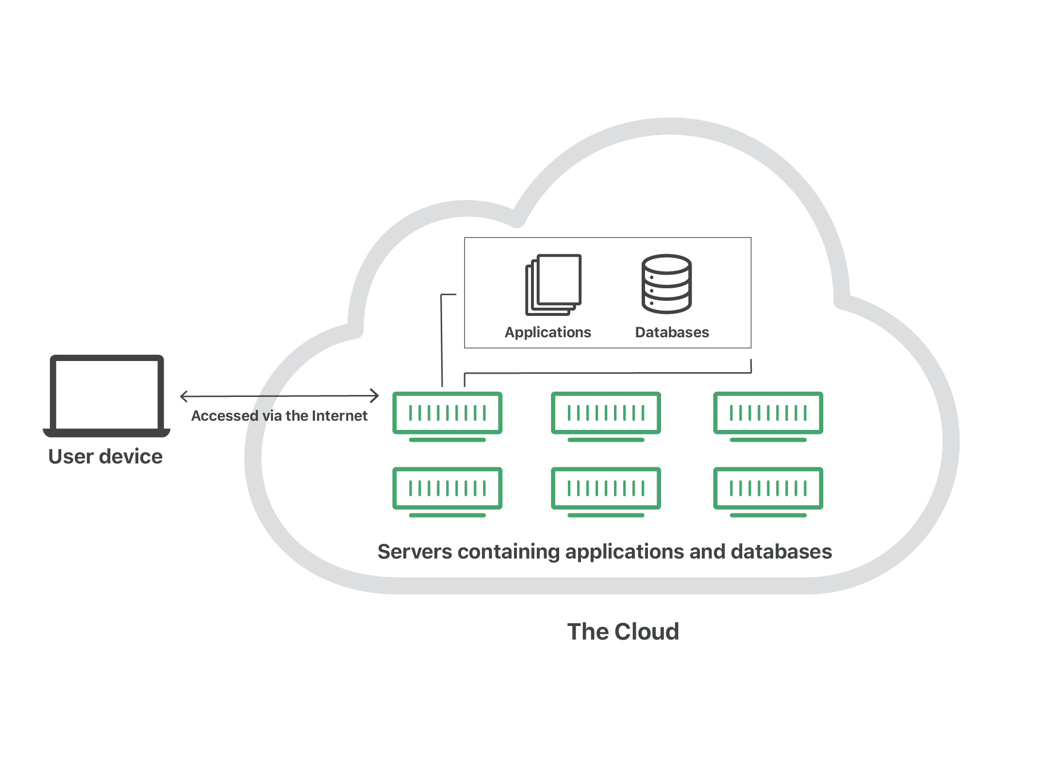

* + For businesses, switching to cloud computing removes some IT costs and overhead

* + for instance, they no longer need to update and maintain their own servers, as the cloud vendor they are using will do that.

* + This especially makes an impact for small businesses that may not have been able to afford their own internal infrastructure but can outsource their infrastructure needs affordably via the cloud.

* + The cloud can also make it easier for companies to operate internationally, because employees and customers can access the same files and applications from any location.

**What are cloud services?**

The resources available in the cloud are known as "services,"

since they are actively managed by a cloud provider.

Cloud services include infrastructure, applications, development tools, and data storage, among other products.

These services are sorted into several different categories, or *service models*.

**What is cloud infrastructure?**

Cloud infrastructure refers to the resources needed for hosting and building applications in the cloud. IaaS and PaaS services are often included in an organization's cloud infrastructure.

**What are the different types of cloud deployments?**

In contrast to the models discussed above, which define how services are offered via the cloud, these different cloud deployment types have to do with where the cloud servers are and who manages them.

The most common cloud deployments are:

* **Private cloud**: A [private cloud](https://www.cloudflare.com/learning/cloud/what-is-a-virtual-private-cloud/) is a server, data center, or distributed network wholly dedicated to one organization.
* **Public cloud**: A [public cloud](https://www.cloudflare.com/learning/cloud/what-is-a-public-cloud/) is a service run by an external vendor that may include servers in one or multiple data centers. Unlike a private cloud, public clouds are shared by multiple organizations. Using virtual machines, individual servers may be shared by different companies, a situation that is called "[multitenancy](https://www.cloudflare.com/learning/cloud/what-is-multitenancy/)" because multiple tenants are renting server space within the same server.
* **Hybrid cloud**: [hybrid cloud](https://www.cloudflare.com/learning/cloud/what-is-hybrid-cloud/) deployments combine public and private clouds, and may even include on-premises legacy servers. An organization may use their private cloud for some services and their public cloud for others, or they may use the public cloud as backup for their private cloud.
* **Multi-cloud**: [multi-cloud](https://www.cloudflare.com/learning/cloud/what-is-multicloud/) is a type of cloud deployment that involves using multiple public clouds. In other words, an organization with a multi-cloud deployment rents virtual servers and services from several external vendors.

**What are the main service models of cloud computing?**

**Software-as-a-Service (SaaS)**:

Instead of users installing an application on their device, [SaaS](https://www.cloudflare.com/learning/cloud/what-is-saas/) applications are hosted on cloud servers, and users access them over the Internet.

SaaS is like renting a house: the landlord maintains the house, but the tenant mostly gets to use it as if they owned it. Examples of SaaS applications include Salesforce, MailChimp, and Slack.

**Platform-as-a-Service (PaaS)**:

In this model, companies don't pay for hosted applications; instead they pay for the things they need to build their own applications.

[PaaS](https://www.cloudflare.com/learning/serverless/glossary/platform-as-a-service-paas/) vendors offer everything necessary for building an application, including development tools, infrastructure, and operating systems, over the Internet.

PaaS can be compared to renting all the tools and equipment necessary for building a house, instead of renting the house itself.

PaaS examples include Heroku and Microsoft Azure.

**Infrastructure-as-a-Service (IaaS)**:

In this model, a company rents the servers and storage they need from a cloud provider. They then use that cloud infrastructure to build their applications.

[IaaS](https://www.cloudflare.com/learning/cloud/what-is-iaas/) is like a company leasing a plot of land on which they can build whatever they want — but they need to provide their own building equipment and materials. IaaS providers include Digital Ocean, Google Compute Engine, and OpenStack.